Jarron Bailey

9/25/2017

ITMD 455

Homework 3

**Screenshots**

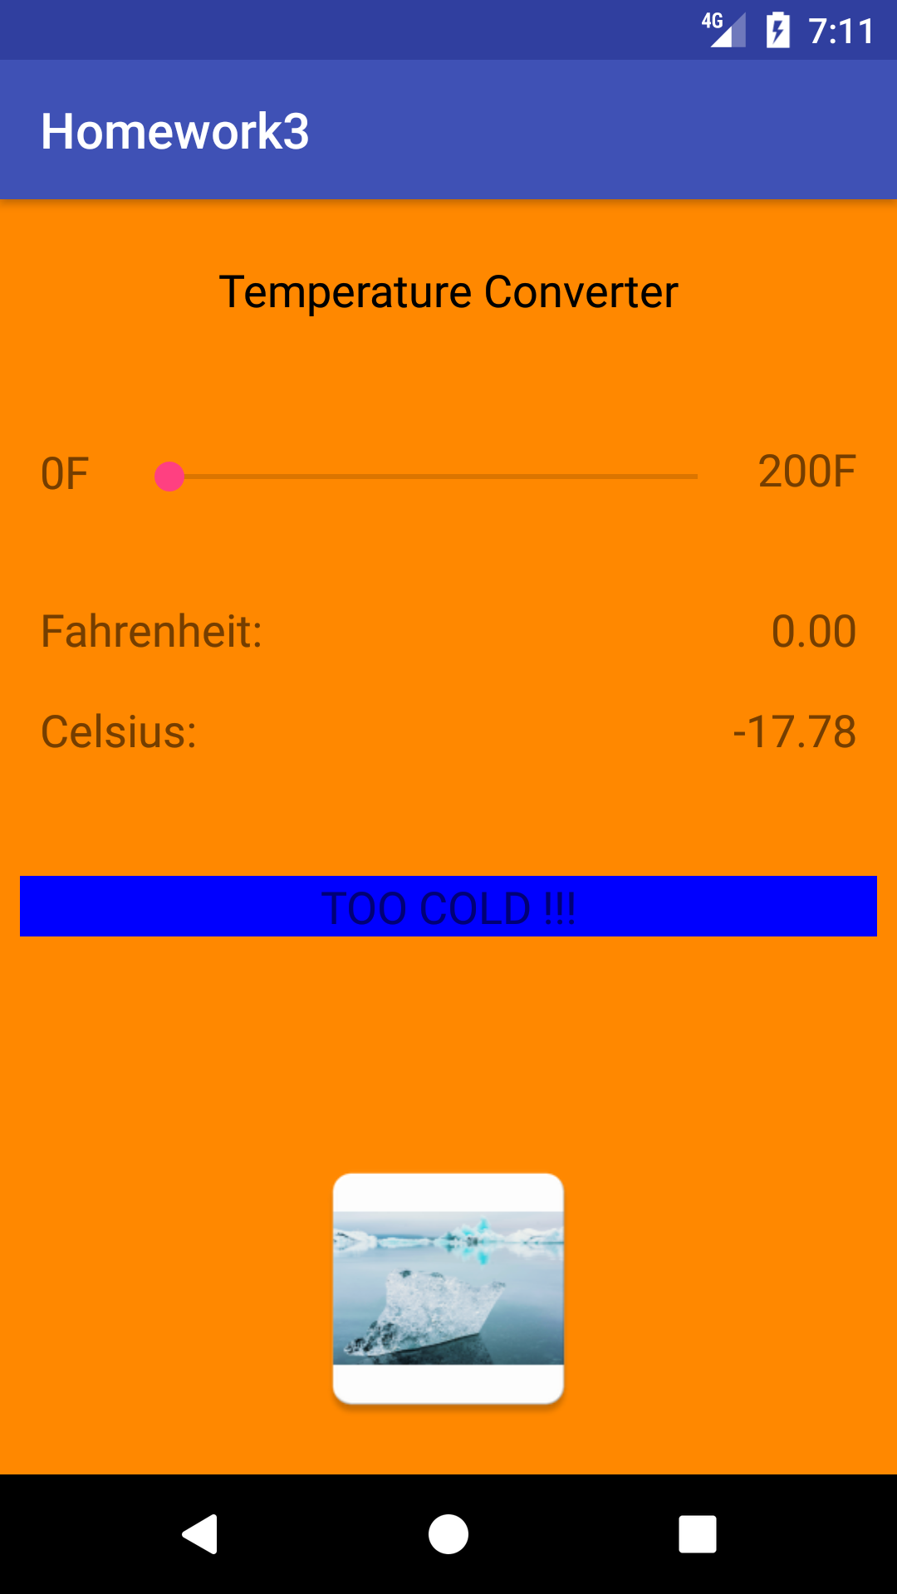

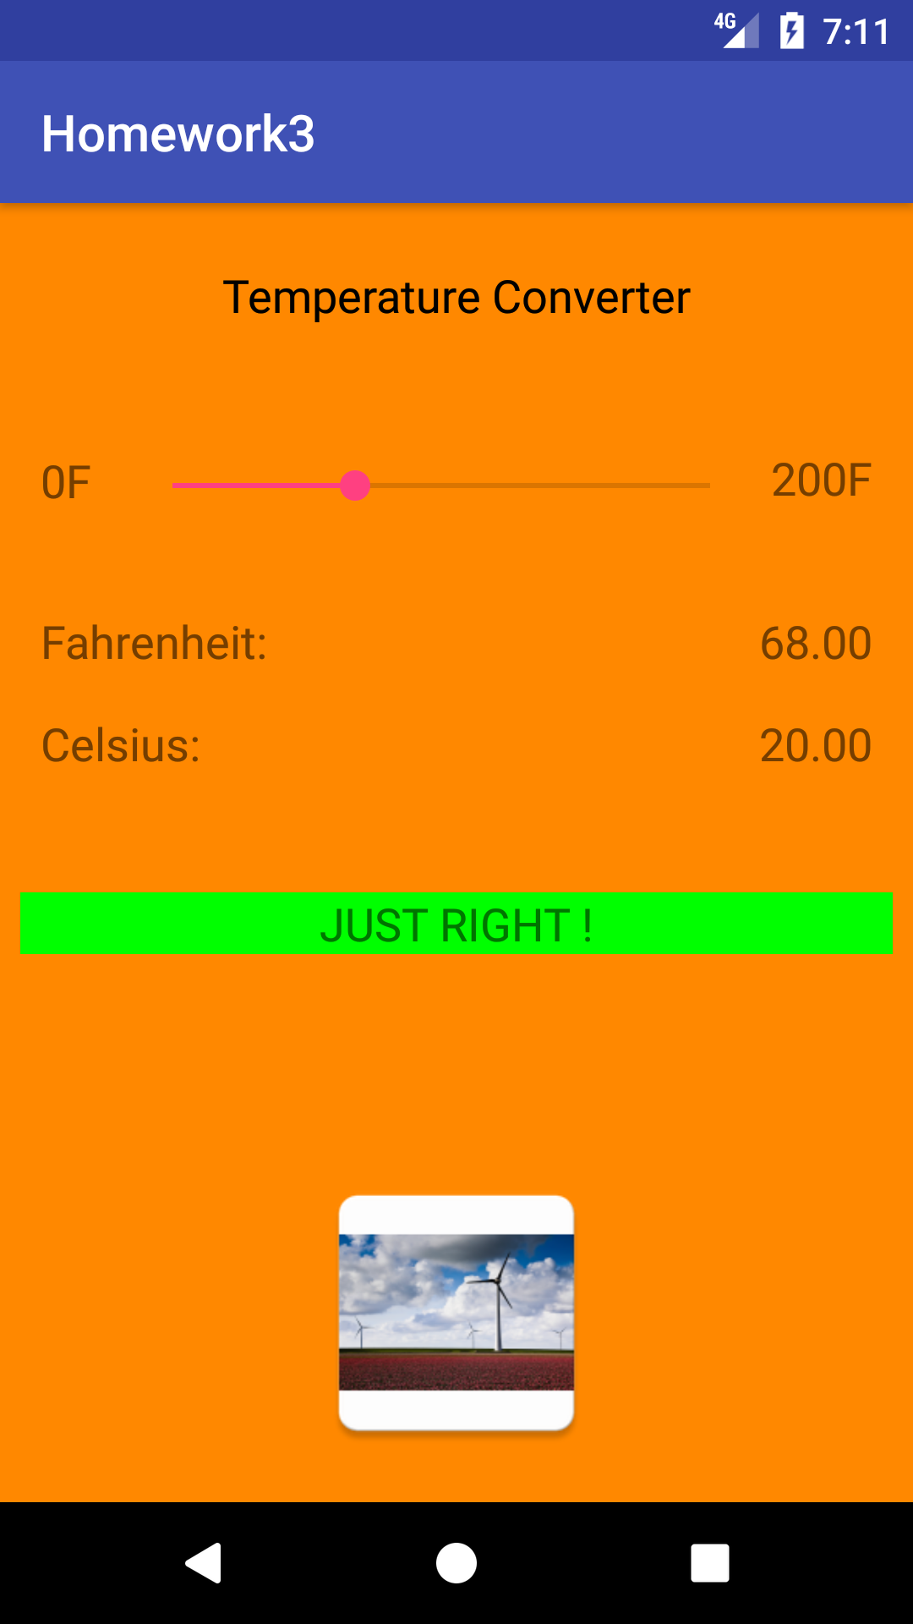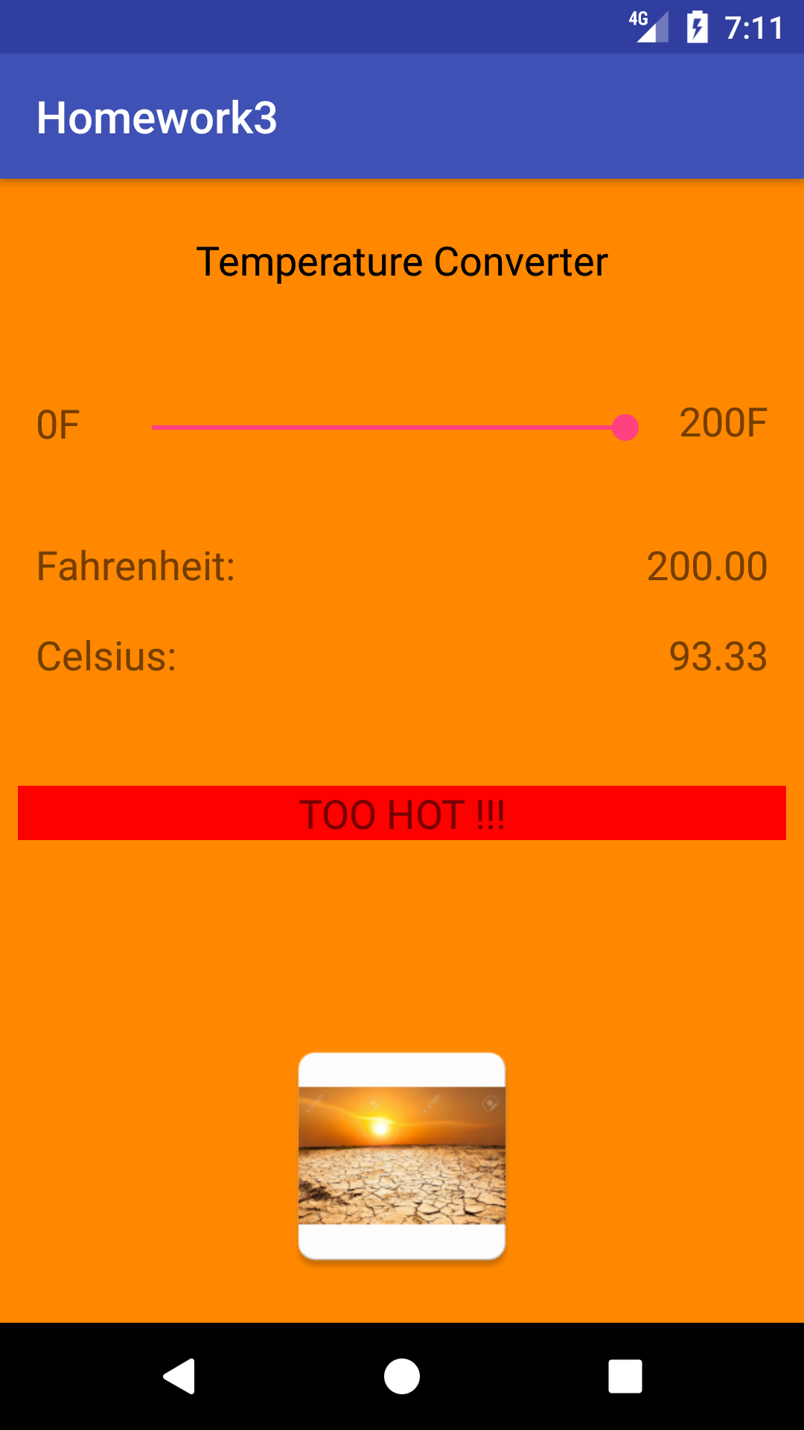

**XML**

*<?***xml version="1.0" encoding="utf-8"***?>*<**android.support.constraint.ConstraintLayout xmlns:android="http://schemas.android.com/apk/res/android"  
 xmlns:app="http://schemas.android.com/apk/res-auto"  
 xmlns:tools="http://schemas.android.com/tools"  
 android:layout_width="match_parent"  
 android:layout_height="match_parent"  
 android:background="@android:color/holo_orange_dark"  
 tools:context="com.example.bailey.homework3.MainActivity"**>  
  
 <**TextView  
 android:id="@+id/tvCelDeg"  
 android:layout_width="wrap_content"  
 android:layout_height="wrap_content"  
 android:layout_marginRight="16dp"  
 android:layout_marginTop="16dp"  
 android:text="0.00"  
 android:textSize="18sp"  
 app:layout_constraintRight_toRightOf="parent"  
 app:layout_constraintTop_toBottomOf="@+id/tvFarDeg"** />  
  
 <**TextView  
 android:id="@+id/tvCel"  
 android:layout_width="wrap_content"  
 android:layout_height="wrap_content"  
 android:layout_marginLeft="16dp"  
 android:layout_marginTop="16dp"  
 android:text="Celsius:"  
 android:textSize="18sp"  
 app:layout_constraintLeft_toLeftOf="parent"  
 app:layout_constraintTop_toBottomOf="@+id/tvFartext"** />  
  
 <**TextView  
 android:id="@+id/tvNameofApp"  
 android:layout_width="0dp"  
 android:layout_height="wrap_content"  
 android:layout_marginLeft="8dp"  
 android:layout_marginRight="8dp"  
 android:layout_marginTop="24dp"  
 android:text="@string/activity_name"  
 android:textAlignment="center"  
 android:textColor="@android:color/black"  
 android:textSize="18sp"  
 app:layout_constraintHorizontal_bias="0.0"  
 app:layout_constraintLeft_toLeftOf="parent"  
 app:layout_constraintRight_toRightOf="parent"  
 app:layout_constraintTop_toTopOf="parent"** />  
  
 <**SeekBar  
 android:id="@+id/sb"  
 android:layout_width="0dp"  
 android:layout_height="wrap_content"  
 android:layout_marginBottom="8dp"  
 android:layout_marginLeft="16dp"  
 android:layout_marginRight="8dp"  
 app:layout_constraintBottom_toTopOf="@+id/guideline"  
 app:layout_constraintLeft_toRightOf="@+id/tvMinFar"  
 app:layout_constraintRight_toLeftOf="@+id/tvMaxFar"** />  
  
 <**TextView  
 android:id="@+id/tvMinFar"  
 android:layout_width="0dp"  
 android:layout_height="wrap_content"  
 android:layout_marginBottom="7dp"  
 android:layout_marginLeft="16dp"  
 android:text="0F"  
 android:textSize="18sp"  
 app:layout_constraintBottom_toTopOf="@+id/guideline"  
 app:layout_constraintLeft_toLeftOf="parent"** />  
  
 <**TextView  
 android:id="@+id/tvMaxFar"  
 android:layout_width="wrap_content"  
 android:layout_height="wrap_content"  
 android:layout_marginBottom="8dp"  
 android:layout_marginRight="16dp"  
 android:text="200F"  
 android:textSize="18sp"  
 app:layout_constraintBottom_toTopOf="@+id/guideline"  
 app:layout_constraintRight_toRightOf="parent"** />  
  
 <**android.support.constraint.Guideline  
 android:layout_width="wrap_content"  
 android:layout_height="wrap_content"  
 android:id="@+id/guideline"  
 android:orientation="horizontal"  
 app:layout_constraintGuide_percent="0.25048923"** />  
  
 <**TextView  
 android:id="@+id/tvFartext"  
 android:layout_width="wrap_content"  
 android:layout_height="wrap_content"  
 android:layout_marginLeft="16dp"  
 android:layout_marginTop="32dp"  
 android:text="Fahrenheit:"  
 android:textSize="18sp"  
 app:layout_constraintLeft_toLeftOf="parent"  
 app:layout_constraintTop_toTopOf="@+id/guideline"  
 app:srcCompat="@drawable/warmclimate"** />  
  
 <**TextView  
 android:id="@+id/tvFarDeg"  
 android:layout_width="wrap_content"  
 android:layout_height="wrap_content"  
 android:layout_marginRight="16dp"  
 android:layout_marginTop="32dp"  
 android:text="0.00"  
 android:textSize="18sp"  
 app:layout_constraintRight_toRightOf="parent"  
 app:layout_constraintTop_toTopOf="@+id/guideline"** />  
  
 <**ImageView  
  
 android:id="@+id/imgPlace"  
 android:layout_width="0dp"  
 android:layout_height="0dp"  
 android:layout_marginBottom="16dp"  
 android:layout_marginLeft="8dp"  
 android:layout_marginRight="8dp"  
 android:layout_marginTop="8dp"  
 app:layout_constraintBottom_toBottomOf="parent"  
 app:layout_constraintHorizontal_bias="0.0"  
 app:layout_constraintLeft_toLeftOf="parent"  
 app:layout_constraintRight_toRightOf="parent"  
 app:layout_constraintTop_toTopOf="@+id/guideline2"  
 app:layout_constraintVertical_bias="1.0"  
 app:srcCompat="@mipmap/ic_launcher"** />  
  
 <**android.support.constraint.Guideline  
 android:layout_width="wrap_content"  
 android:layout_height="wrap_content"  
 android:id="@+id/guideline2"  
 app:layout_constraintGuide_begin="371dp"  
 android:orientation="horizontal"** />  
  
 <**TextView  
 android:id="@+id/textView9"  
 android:layout_width="0dp"  
 android:layout_height="wrap_content"  
 android:layout_marginBottom="75dp"  
 android:layout_marginLeft="8dp"  
 android:layout_marginRight="8dp"  
 android:text="How Does it Feel?"  
 android:textAlignment="center"  
 android:textSize="18sp"  
 app:layout_constraintBottom_toTopOf="@+id/guideline2"  
 app:layout_constraintLeft_toLeftOf="parent"  
 app:layout_constraintRight_toRightOf="parent"** />  
  
</**android.support.constraint.ConstraintLayout**>

**Java**

**package** com.example.bailey.homework3;  
  
**import** android.graphics.Color;  
**import** android.support.v7.app.AppCompatActivity;  
**import** android.os.Bundle;  
**import** android.widget.ImageView;  
**import** android.widget.SeekBar;  
**import** android.widget.TextView;  
**import static** com.example.bailey.homework3.R.id.***sb***;  
  
**public class** MainActivity **extends** AppCompatActivity {  
 TextView **celdeg**, **fardeg**, **celtext**, **fartext**, **minfar**, **maxfar**, **tvfeel**;  
 ImageView **Pic**;  
 SeekBar **myseekbar**;  
 @Override  
 **protected void** onCreate(Bundle savedInstanceState) {  
 **super**.onCreate(savedInstanceState);  
 setContentView(R.layout.***activity_main***);  
 seekbarAction();  
 }  
  
 **public void** seekbarAction() {  
  
 **celdeg** = (TextView) findViewById(R.id.***tvCelDeg***);  
 **fardeg** = (TextView) findViewById(R.id.***tvFarDeg***);  
 **celtext** = (TextView) findViewById(R.id.***tvCel***);  
 **fartext** = (TextView) findViewById(R.id.***tvFartext***);  
 **minfar** = (TextView) findViewById(R.id.***tvMinFar***);  
 **maxfar** = (TextView) findViewById(R.id.***tvMaxFar***);  
 **tvfeel** = (TextView)findViewById(R.id.***textView9***);  
 **myseekbar**=(SeekBar)findViewById(***sb***);  
 **Pic** = (ImageView)findViewById(R.id.***imgPlace***);  
 **myseekbar**.setMax(200);  
 **myseekbar**.setProgress(0);  
  
 **myseekbar**.setOnSeekBarChangeListener(**new** SeekBar.OnSeekBarChangeListener() {  
 @Override  
 **public void** onProgressChanged(SeekBar seekBar, **int** progress, **boolean** fromUser) {  
  
 **double** xprogress = (**double**) progress/1.00;  
 *// C = (5/9)*(F-32)* **double** valcelsius = ((xprogress-32.00) * (5/9.0));  
 String txtcel = String.*format*(**"%.2f"**, valcelsius);  
 String txtfar = String.*format*(**"%.2f"**, xprogress);  
 **celdeg**.setText(txtcel);  
 **fardeg**.setText(txtfar);  
  
 **if** (xprogress <= 40.00) {  
 **tvfeel**.setText(**"TOO COLD !!!"**);  
 **tvfeel**.setBackgroundColor(Color.***BLUE***);  
 **Pic**.setImageResource(R.drawable.***ic_cold***);  
  
 }  
 **if** ((xprogress > 40.00) && (xprogress < 90.00)) {  
 **tvfeel**.setText(**"JUST RIGHT !"**);  
 **tvfeel**.setBackgroundColor(Color.***GREEN***);  
 **Pic**.setImageResource(R.drawable.***ic_warm***);  
 }  
 **if** (xprogress >= 90.00) {  
 **tvfeel**.setText(**"TOO HOT !!!"**);  
 **tvfeel**.setBackgroundColor(Color.***RED***);  
 **Pic**.setImageResource(R.drawable.***ic_hot***);  
 }  
  
  
  
 }  
  
 @Override  
 **public void** onStartTrackingTouch(SeekBar seekBar) {  
  
 }  
  
 @Override  
 **public void** onStopTrackingTouch(SeekBar seekBar) {  
  
 }  
 });  
 }  
}