Jarron Bailey

10/9/2017

ITMD 455

Homework 5

**Screenshots**

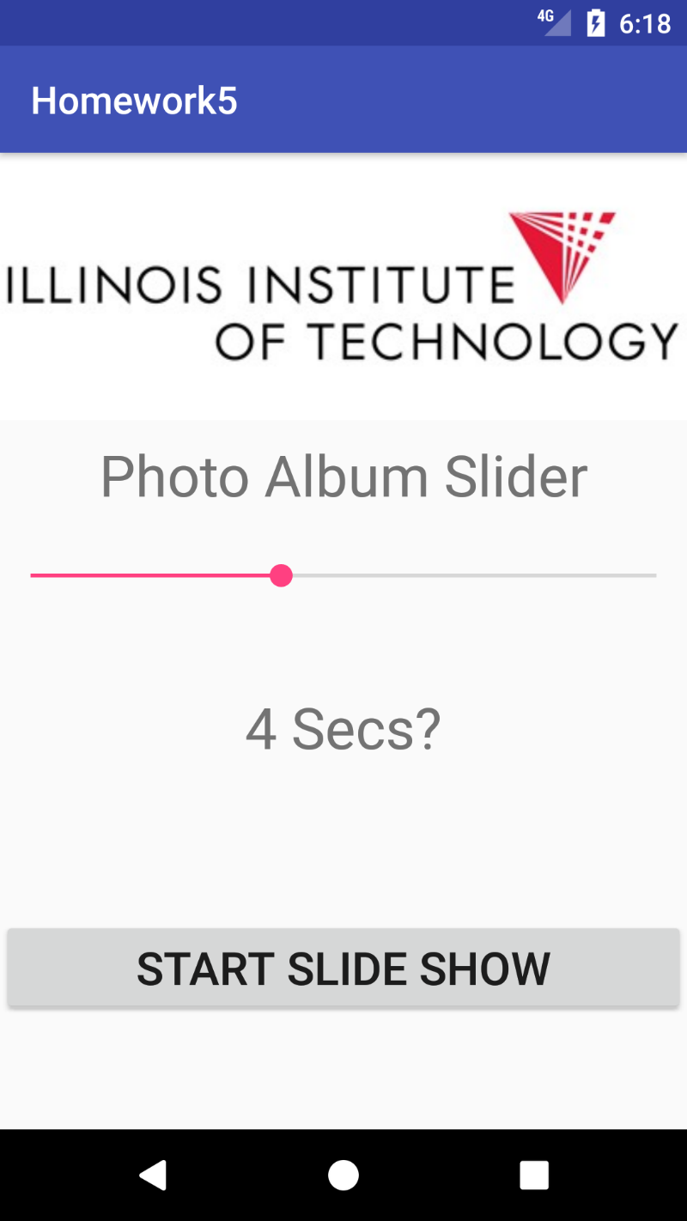

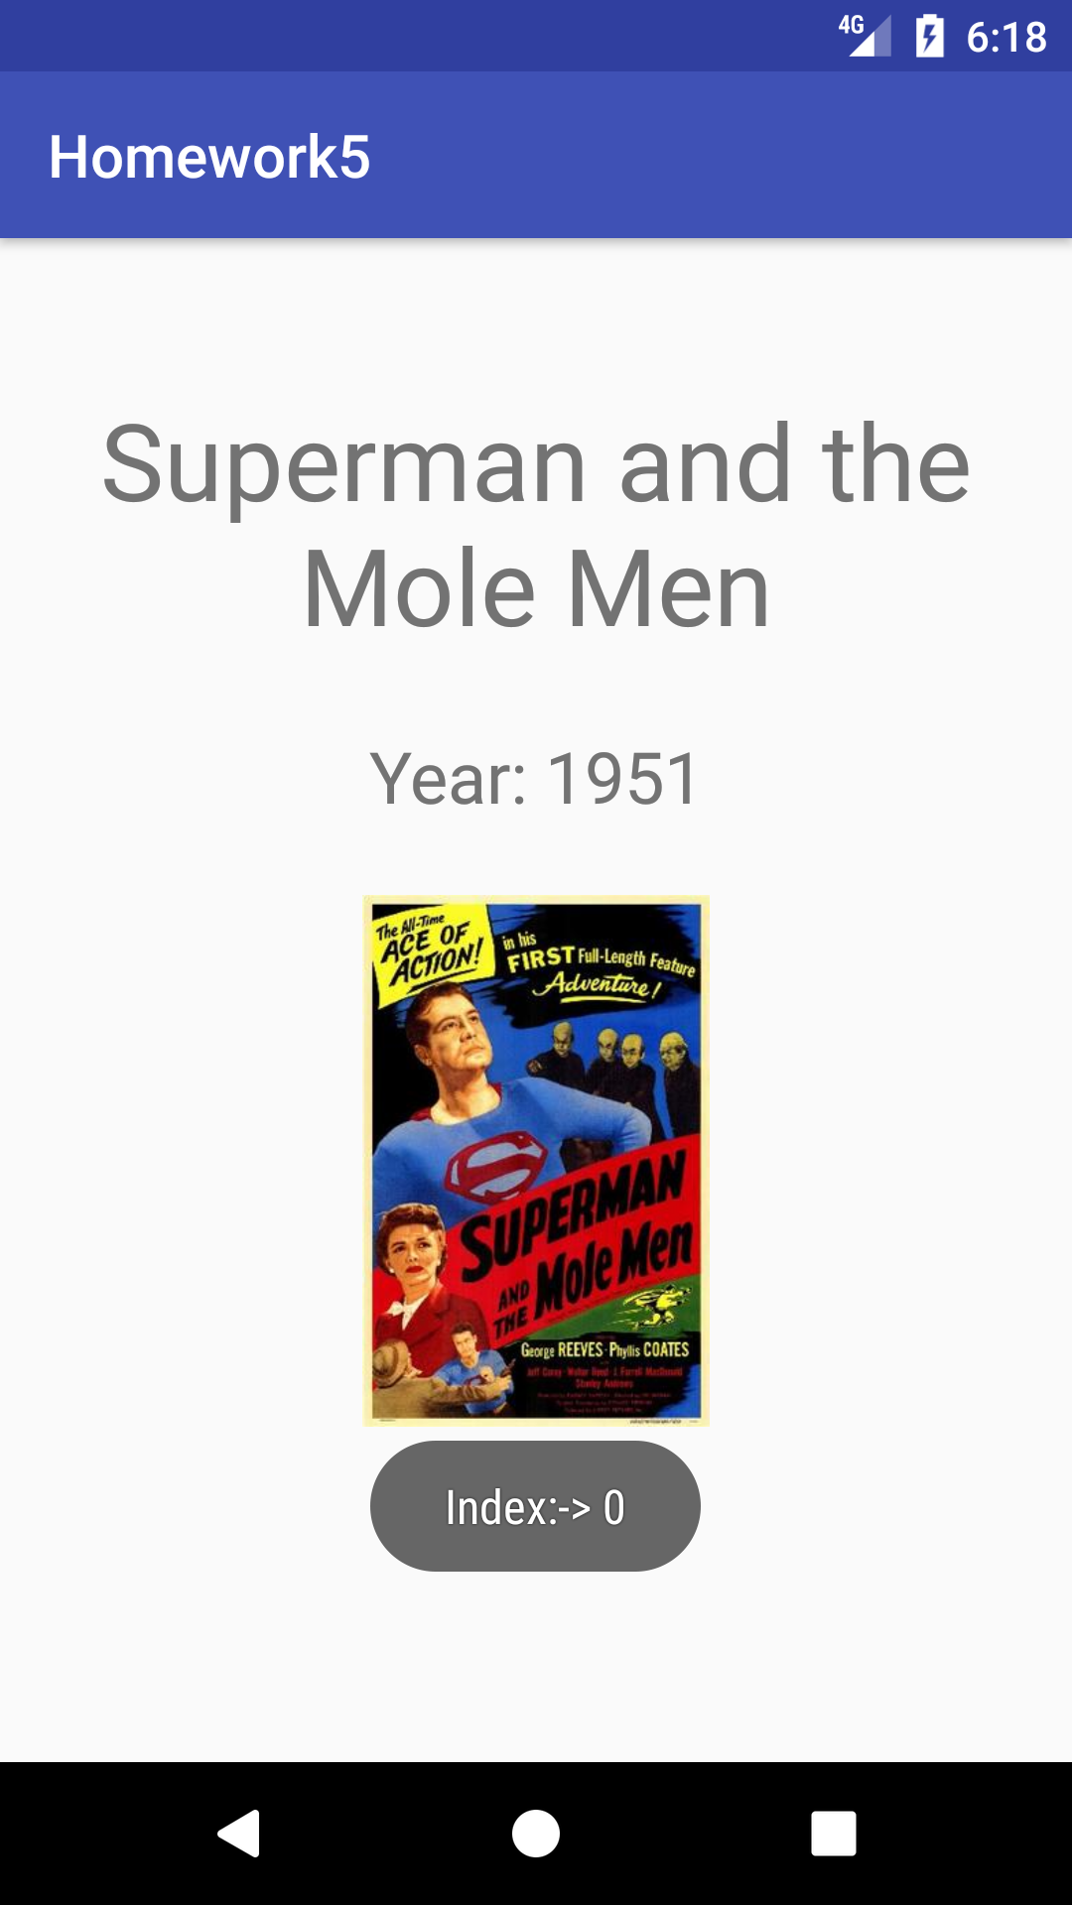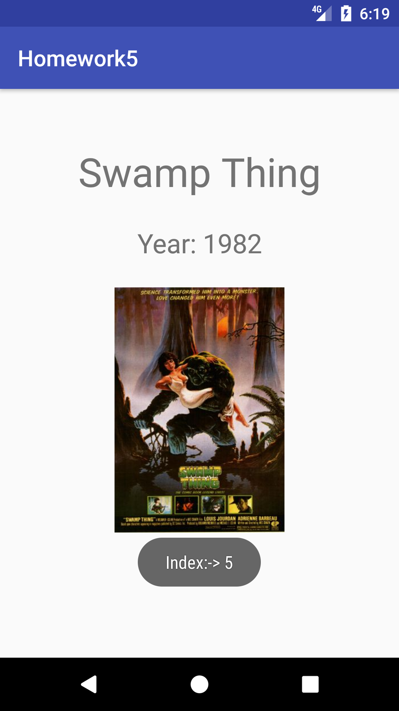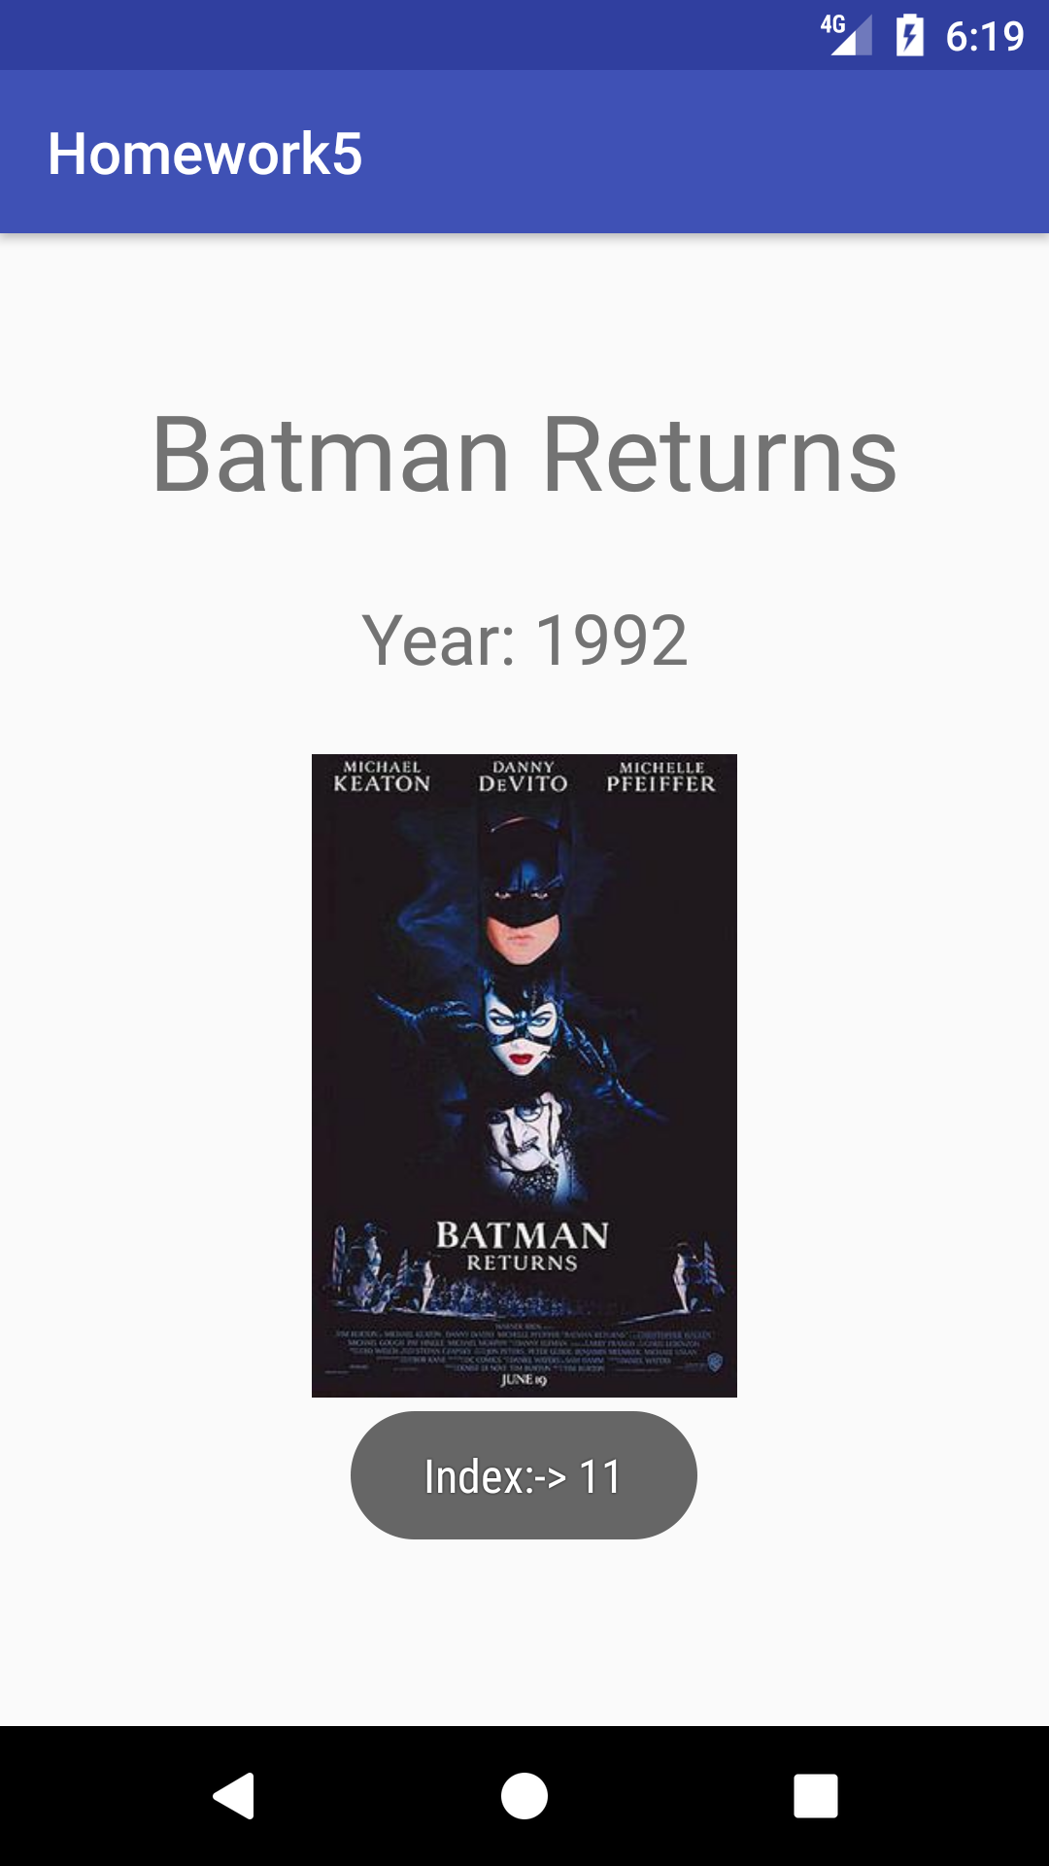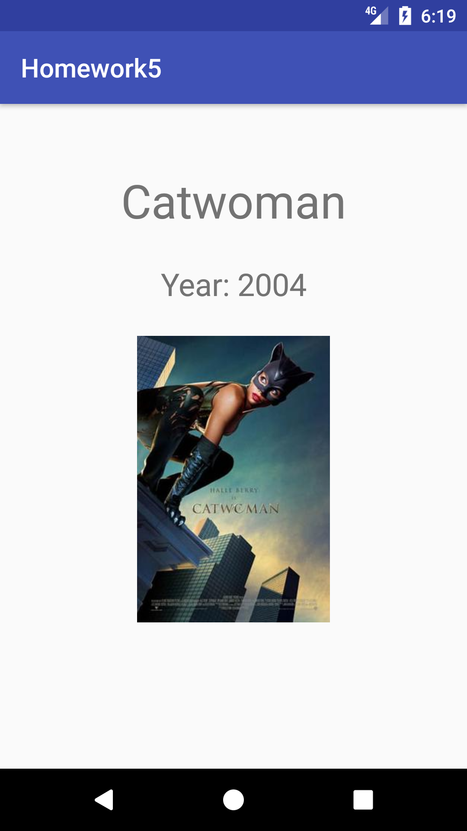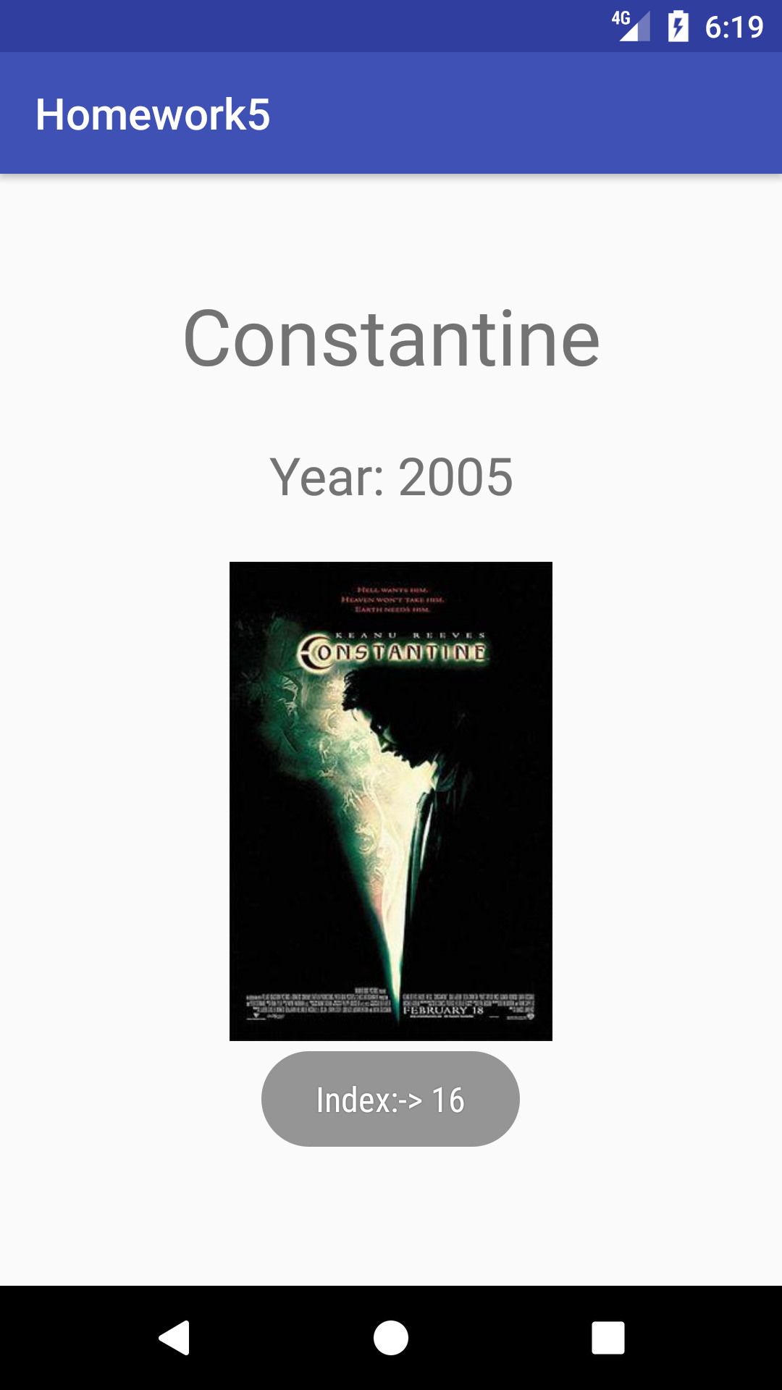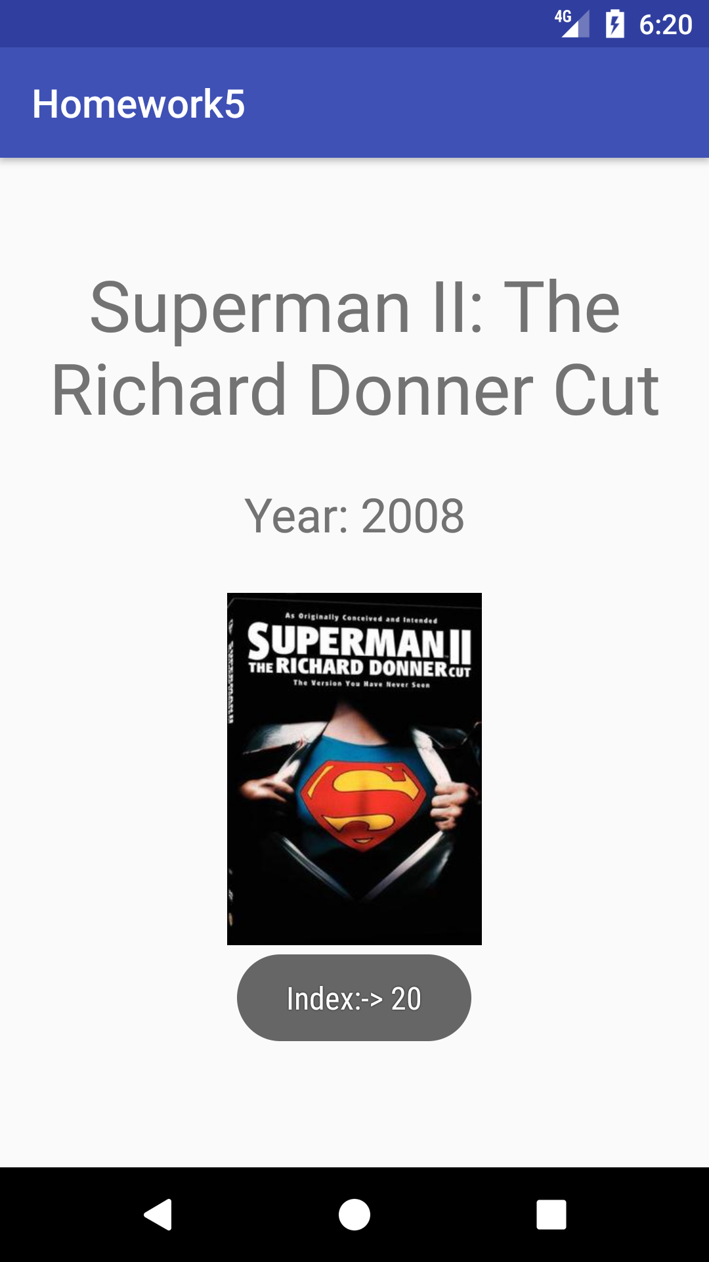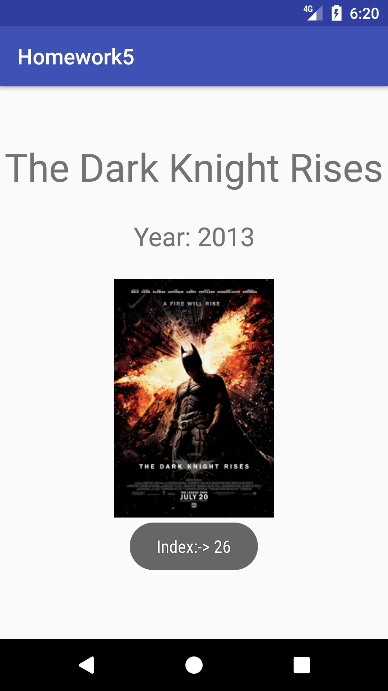

**XML**

*<?***xml version="1.0" encoding="utf-8"***?>*<**android.support.constraint.ConstraintLayout xmlns:android="http://schemas.android.com/apk/res/android"  
 xmlns:app="http://schemas.android.com/apk/res-auto"  
 xmlns:tools="http://schemas.android.com/tools"  
 android:layout_width="match_parent"  
 android:layout_height="match_parent"  
 tools:context="com.example.bailey.homework5.MainActivity"**>  
  
 <**ImageView  
 android:id="@+id/imageview"  
 android:layout_width="0dp"  
 android:layout_height="0dp"  
 android:layout_marginBottom="8dp"  
 android:layout_marginLeft="0dp"  
 android:layout_marginRight="0dp"  
 android:layout_marginTop="0dp"  
 android:scaleType="centerCrop"  
 app:layout_constraintBottom_toTopOf="@+id/guideline"  
 app:layout_constraintHorizontal_bias="0.0"  
 app:layout_constraintLeft_toLeftOf="parent"  
 app:layout_constraintRight_toRightOf="parent"  
 app:layout_constraintTop_toTopOf="parent"  
 app:layout_constraintVertical_bias="0.0"  
 app:srcCompat="@drawable/iit_logo"** />  
  
 <**android.support.constraint.Guideline  
 android:layout_width="wrap_content"  
 android:layout_height="wrap_content"  
 android:id="@+id/guideline"  
 app:layout_constraintGuide_percent="0.29"  
 android:orientation="horizontal"** />  
  
 <**TextView  
 android:id="@+id/tvseekbar_title"  
 android:layout_width="0dp"  
 android:layout_height="wrap_content"  
 android:layout_marginLeft="8dp"  
 android:layout_marginRight="8dp"  
 android:layout_marginTop="8dp"  
 android:text="TextView"  
 android:textAlignment="center"  
 android:textSize="30sp"  
 app:layout_constraintLeft_toLeftOf="parent"  
 app:layout_constraintRight_toRightOf="parent"  
 app:layout_constraintTop_toBottomOf="@+id/imageview"  
 tools:text="@string/seekbar_title"** />  
  
 <**SeekBar  
 android:id="@+id/sb"  
 android:layout_width="0dp"  
 android:layout_height="wrap_content"  
 android:layout_marginTop="24dp"  
 app:layout_constraintTop_toBottomOf="@+id/tvseekbar_title"  
 android:layout_marginLeft="0dp"  
 app:layout_constraintLeft_toLeftOf="parent"  
 android:layout_marginRight="0dp"  
 app:layout_constraintRight_toRightOf="parent"  
 app:layout_constraintHorizontal_bias="0.558"** />  
  
 <**TextView  
 android:id="@+id/tvsecs"  
 android:layout_width="wrap_content"  
 android:layout_height="wrap_content"  
 android:layout_marginLeft="0dp"  
 android:layout_marginRight="0dp"  
 android:layout_marginTop="50dp"  
 android:text="Secs?"  
 android:textSize="30sp"  
 app:layout_constraintLeft_toLeftOf="parent"  
 app:layout_constraintRight_toRightOf="parent"  
 app:layout_constraintTop_toBottomOf="@+id/sb"** />  
  
 <**Button  
 android:id="@+id/btnstartslideshow"  
 android:layout_width="0dp"  
 android:layout_height="wrap_content"  
 android:layout_marginBottom="16dp"  
 android:layout_marginLeft="0dp"  
 android:layout_marginRight="0dp"  
 android:layout_marginTop="0dp"  
 android:text="Start Slide Show"  
 android:textSize="24sp"  
 app:layout_constraintBottom_toBottomOf="parent"  
 app:layout_constraintHorizontal_bias="0.0"  
 app:layout_constraintLeft_toLeftOf="parent"  
 app:layout_constraintRight_toRightOf="parent"  
 app:layout_constraintTop_toBottomOf="@+id/tvsecs"  
 app:layout_constraintVertical_bias="0.649"** />  
</**android.support.constraint.ConstraintLayout**>

**XML(Second_Act)**

*<?***xml version="1.0" encoding="utf-8"***?>*<**android.support.constraint.ConstraintLayout xmlns:android="http://schemas.android.com/apk/res/android"  
 xmlns:app="http://schemas.android.com/apk/res-auto"  
 xmlns:tools="http://schemas.android.com/tools"  
 android:layout_width="match_parent"  
 android:layout_height="match_parent"  
 tools:context="com.example.bailey.homework5.Slideshow"**>  
  
 <**TextView  
 android:id="@+id/tvMoviename"  
 android:layout_width="0dp"  
 android:layout_height="wrap_content"  
 android:layout_marginLeft="0dp"  
 android:layout_marginRight="0dp"  
 android:layout_marginTop="50dp"  
 android:text="TextView"  
 android:textAlignment="center"  
 android:textSize="36sp"  
 app:layout_constraintHorizontal_bias="0.501"  
 app:layout_constraintLeft_toLeftOf="parent"  
 app:layout_constraintRight_toRightOf="parent"  
 app:layout_constraintTop_toTopOf="parent"** />  
  
 <**TextView  
 android:id="@+id/tvMovieyear"  
 android:layout_width="0dp"  
 android:layout_height="wrap_content"  
 android:layout_marginLeft="0dp"  
 android:layout_marginRight="0dp"  
 android:layout_marginTop="24dp"  
 android:text="TextView"  
 android:textAlignment="center"  
 android:textSize="24sp"  
 app:layout_constraintLeft_toLeftOf="parent"  
 app:layout_constraintRight_toRightOf="parent"  
 app:layout_constraintTop_toBottomOf="@+id/tvMoviename"** />  
  
 <**android.support.constraint.Guideline  
 android:layout_width="wrap_content"  
 android:layout_height="wrap_content"  
 android:id="@+id/guideline2"  
 app:layout_constraintGuide_percent="0.78"  
 android:orientation="horizontal"** />  
  
 <**ImageView  
 android:id="@+id/ivMovie"  
 android:layout_width="0dp"  
 android:layout_height="0dp"  
 android:layout_marginBottom="0dp"  
 android:layout_marginLeft="0dp"  
 android:layout_marginRight="0dp"  
 android:layout_marginTop="24dp"  
 app:layout_constraintBottom_toTopOf="@+id/guideline2"  
 app:layout_constraintLeft_toLeftOf="parent"  
 app:layout_constraintRight_toRightOf="parent"  
 app:layout_constraintTop_toBottomOf="@+id/tvMovieyear"  
 app:srcCompat="@mipmap/ic_launcher"** />  
</**android.support.constraint.ConstraintLayout**>

**Java**

**package** com.example.bailey.homework5;  
  
**import** android.content.Intent;  
**import** android.media.Image;  
**import** android.support.v7.app.AppCompatActivity;  
**import** android.os.Bundle;  
**import** android.view.View;  
**import** android.widget.Button;  
**import** android.widget.ImageView;  
**import** android.widget.SeekBar;  
**import** android.widget.TextView;  
  
**import** java.util.Timer;  
**import** java.util.TimerTask;  
  
**public class** MainActivity **extends** AppCompatActivity {  
 ImageView **imageView**;  
 **static** SeekBar *seekbar*;  
 TextView **tvSecs**;  
 Button **btnSlidehow**;  
 TextView **tvseekbar_title**;  
 **int secs**;  
  
 @Override  
 **protected void** onCreate(Bundle savedInstanceState) {  
 **super**.onCreate(savedInstanceState);  
 setContentView(R.layout.***activity_main***);  
  
 **imageView** = (ImageView)findViewById(R.id.***imageview***);  
 **imageView**.setImageResource(R.drawable.***iit_logo***);  
 **tvseekbar_title** = (TextView)findViewById(R.id.***tvseekbar_title***);  
 **tvseekbar_title**.setText(**"Photo Album Slider"**);  
 *seekbar* = (SeekBar)findViewById(R.id.***sb***);  
 *seekbar*.setProgress(0);  
 *seekbar*.setMax(10);  
 startSlideshow();  
 **btnSlidehow**.setOnClickListener(**new** View.OnClickListener() {  
 @Override  
 **public void** onClick(View v) {  
 Intent secondActivity = **new** Intent(MainActivity.**this**,Slideshow.**class**);  
 String dataSecs = **tvSecs**.getText().toString();  
 secondActivity.putExtra(**"secs"**, dataSecs);  
 startActivity(secondActivity);  
  
 }  
 });  
  
 }  
  
 **public void** startSlideshow(){  
 **tvSecs** = (TextView)findViewById(R.id.***tvsecs***);  
 **btnSlidehow** = (Button)findViewById(R.id.***btnstartslideshow***);  
 *seekbar* = (SeekBar)findViewById(R.id.***sb***);  
 *seekbar*.setOnSeekBarChangeListener(**new** SeekBar.OnSeekBarChangeListener() {  
 @Override  
 **public void** onProgressChanged(SeekBar seekBar, **int** progress, **boolean** fromUser) {  
 **int** secs = progress;  
 **tvSecs**.setText(Integer.*toString*(secs) + **" Secs?"**);  
  
 }  
  
 @Override  
 **public void** onStartTrackingTouch(SeekBar seekBar) {  
  
 }  
  
 @Override  
 **public void** onStopTrackingTouch(SeekBar seekBar) {  
  
 }  
 });  
  
 }  
}

**Java(Second_Act)**

**package** com.example.bailey.homework5;  
  
**import** android.content.Intent;  
**import** android.os.Handler;  
**import** android.support.v7.app.AppCompatActivity;  
**import** android.os.Bundle;  
**import** android.widget.ImageView;  
**import** android.widget.TextView;  
**import** android.widget.Toast;  
  
**import** java.util.Timer;  
**import** java.util.TimerTask;  
  
**import static** java.lang.Integer.parseInt;  
  
**public class** Slideshow **extends** AppCompatActivity {  
 Timer **timer**;  
 TextView **tvmoviename**;  
 TextView **tvmovieyear**;  
 ImageView **picmovie**;  
  
 @Override  
 **protected void** onCreate(Bundle savedInstanceState) {  
 **super**.onCreate(savedInstanceState);  
 setContentView(R.layout.***activity_slideshow***);  
  
  
  
  
 **final** String[] movienames = {**"Superman and the Mole Men"**, **"Stamp Day for Superman"**, **"Batman"**,  
 **"Superman"**,**"Superman II"**,**"Swamp Thing"**,**"Superman III"**,**"Supergirl"**,**"Superman IV: The Quest for Peace"**,  
 **"The Return of Swamp Thing"**,**"Batman"**,**"Batman Returns"**, **"Batman Forever"**,**"Batman & Robin"**,  
 **"Steel"**, **"Catwoman"**, **"Constantine"**, **"Batman Begins"**, **"V for Vendetta"**, **"Superman Returns"**,  
 **"Superman II: The Richard Donner Cut"**, **"The Dark Knight"**, **"Watchmen"**, **"The Losers"**,  
 **"Jonah Hex"**, **"Green Lantern"**, **"The Dark Knight Rises"**, **"Man of Steel"**, **"Batman v Superman: Dawn of Justice"**,  
 **"Suicide Squad"**, **"Wonder Woman"** };  
  
 **final** Integer[] imgid= {R.drawable.***supermanmolemen***, R.drawable.***stamp_day_for_superman***, R.drawable.***batman1966poster***,  
 R.drawable.***superman_ver1***, R.drawable.***superman_ii***, R.drawable.***swampthing***, R.drawable.***superman_iii_poster***,  
 R.drawable.***supergirlposter***, R.drawable.***superman_iv***, R.drawable.***returnofswampthing***, R.drawable.***batman_1989_theatrical_poster***,  
 R.drawable.***batman_returns_poster2***, R.drawable.***batman_forever_ver7***, R.drawable.***batman_robin_poster***,R.drawable.***steelposter***,  
 R.drawable.***catwoman_poster***, R.drawable.***constantine_poster***, R.drawable.***batman_begins_poster***, R.drawable.***vforvendettamov***,  
 R.drawable.***superman_returns***, R.drawable.***supermaniiricharddonnercut***, R.drawable.***dark_knight***,  
 R.drawable.***watchmen_film_poster***, R.drawable.***thelosers2010poster*** ,R.drawable.***jonahhexposter***,  
 R.drawable.***green_lantern_poster***, R.drawable.***dark_knight_rises_poster***, R.drawable.***manofsteelfinalposter***,  
 R.drawable.***batman_v_superman_poster***, R.drawable.***suicide_squad_poster***, R.drawable.***wonder_woman_film*** };  
  
 **final** String[] moviedescription = {**"Year: 1951"**,  
 **"Year: 1954"**,  
 **"Year: 1966"**,  
 **"Year: 1978"**,  
 **"Year: 1980"**,  
 **"Year: 1982"**,  
 **"Year: 1983"**,  
 **"Year: 1987"**,  
 **"Year: 1954"**,  
 **"Year: 1989"**,  
 **"Year: 1989"**,  
 **"Year: 1992"**,  
 **"Year: 1995"**,  
 **"Year: 1997"**,  
 **"Year: 1997"**,  
 **"Year: 2004"**,  
 **"Year: 2005"**,  
 **"Year: 2005"**,  
 **"Year: 2006"**,  
 **"Year: 2006"**,  
 **"Year: 2008"**,  
 **"Year: 2009"**,  
 **"Year: 2010"**,  
 **"Year: 2010"**,  
 **"Year: 2011"**,  
 **"Year: 2012"**,  
 **"Year: 2013"**,  
 **"Year: 2016"**,  
 **"Year: 2016"**,  
 **"Year: 2017"** };  
 MyTimer(movienames,imgid,moviedescription);  
 }  
  
 **public void** MyTimer(**final** String[] movienme, Integer[]img, String[] moviedesc) {  
  
 Intent intent = getIntent();  
 Bundle extras = intent.getExtras();  
 **final** String secs = extras.getString(**"secs"**);  
 **tvmoviename** = (TextView) findViewById(R.id.***tvMoviename***);  
 **tvmoviename**.setText(secs);  
 **tvmovieyear** = (TextView) findViewById(R.id.***tvMovieyear***);  
 **picmovie** = (ImageView) findViewById(R.id.***ivMovie***);  
 **final** String[] movienames = movienme;  
 **final** Integer[] imgid = img;  
 **final** String[] moviedescription = moviedesc;  
 **final int** vsecs = Integer.*parseInt*(secs);  
  
  
 **final** Handler handler = **new** Handler();  
 Runnable runnable = **new** Runnable() {  
 **int idx** = vsecs;  
 @Override  
 **public void** run() {  
 **if**( vsecs> 0){  
 **tvmoviename**.setText(movienames[**idx**]);  
 **tvmovieyear**.setText(moviedescription[**idx**]);  
 **picmovie**.setImageResource(imgid[**idx**]);  
 Toast.*makeText*(Slideshow.**this**, **"Index:-> "** + **idx**, Toast.***LENGTH_SHORT***).show();  
 **idx**++;  
 **if** (**idx** == movienames.**length** || **idx**== moviedescription.**length** || **idx**== imgid.**length**){  
 **idx** = 0;  
 }  
 }  
 handler.postDelayed(**this**, (vsecs*1000));  
 }  
 };  
 handler.postDelayed(runnable,2000);  
 }  
  
  
}