Jarron Bailey

10/9/2017

ITMD 455

Homework 6

**Screenshots**

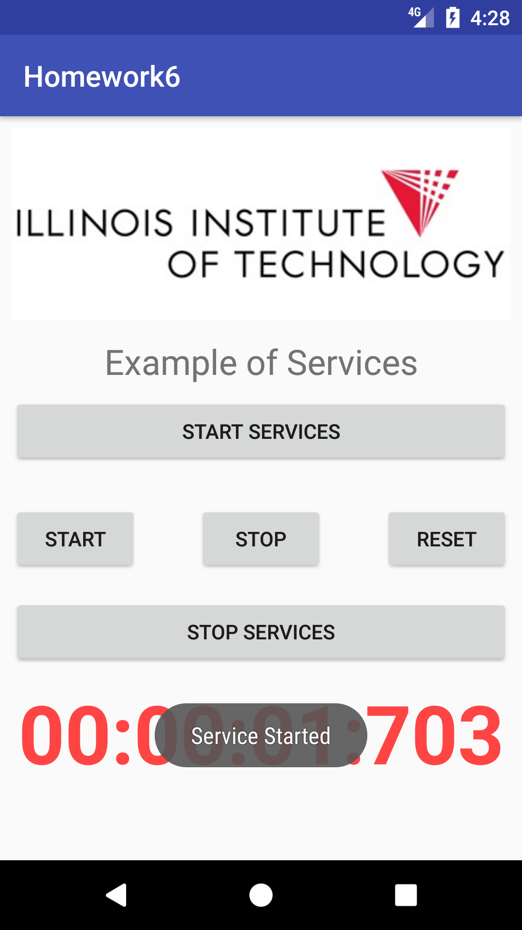

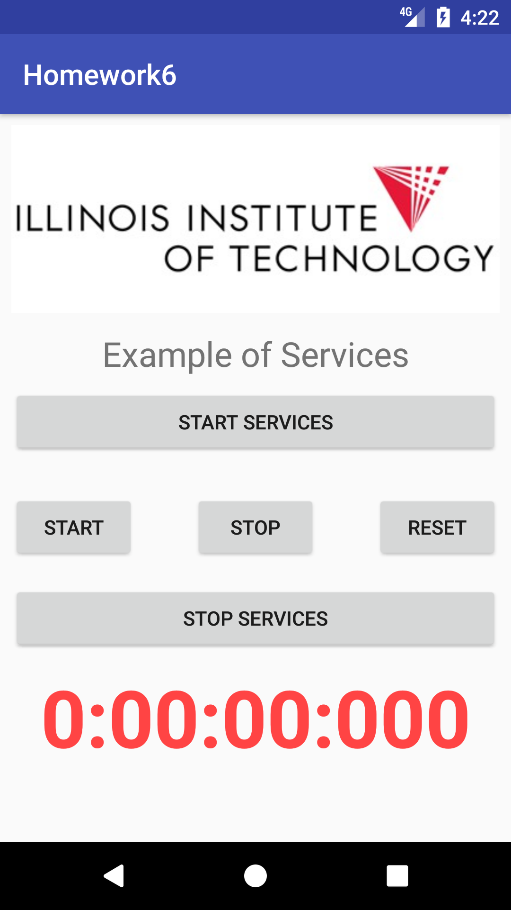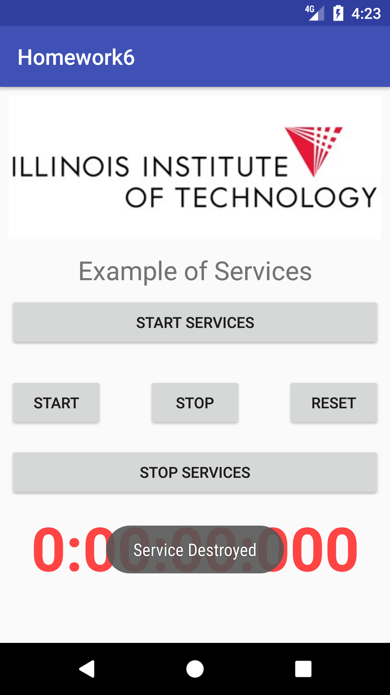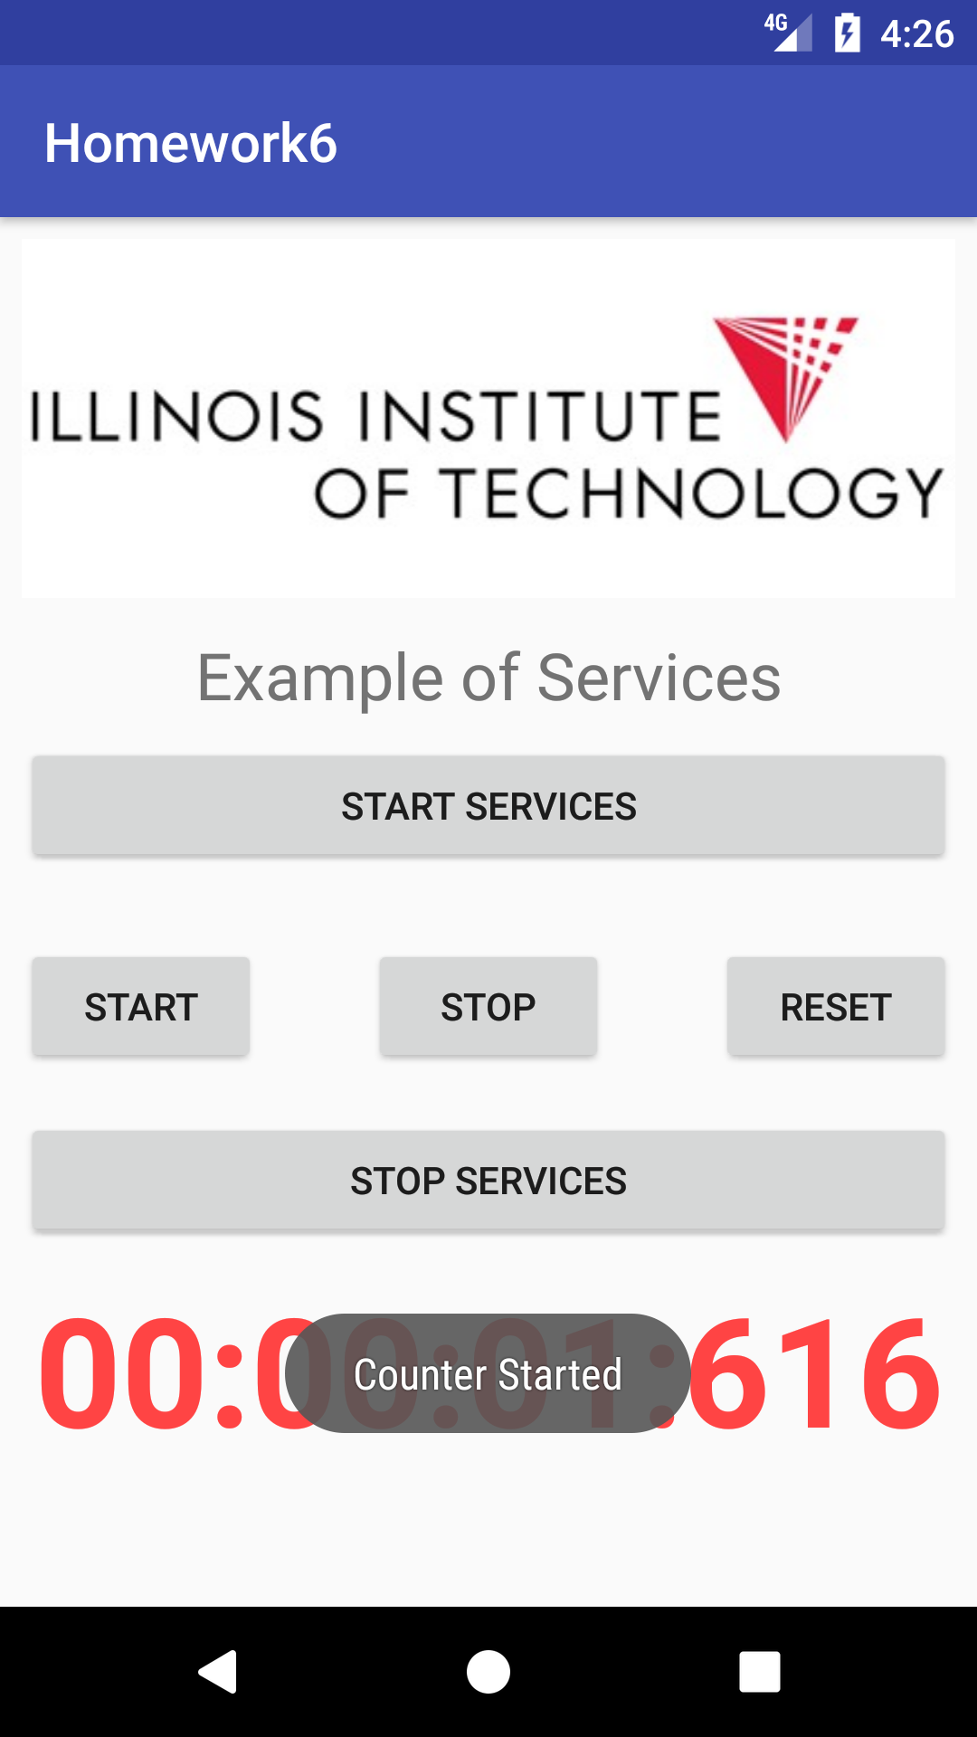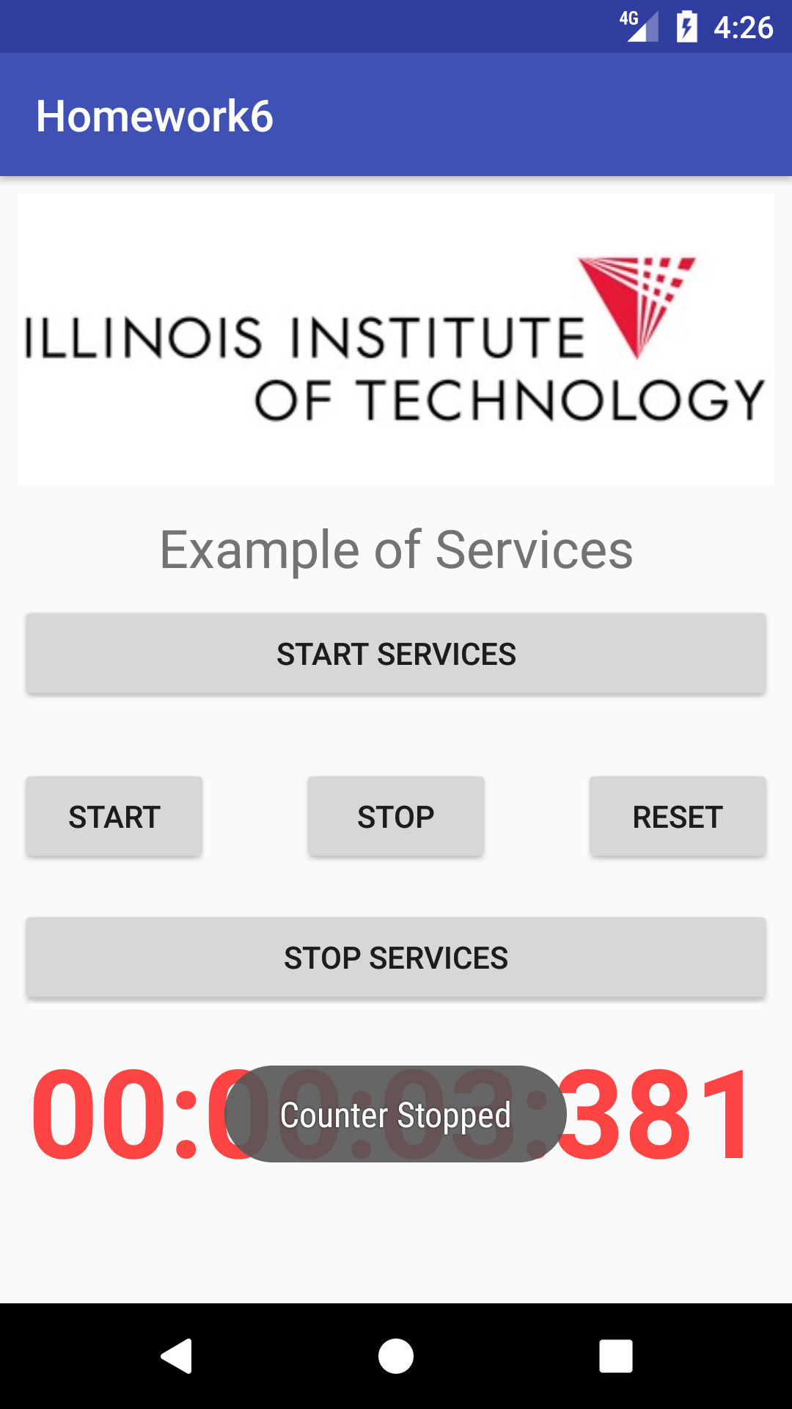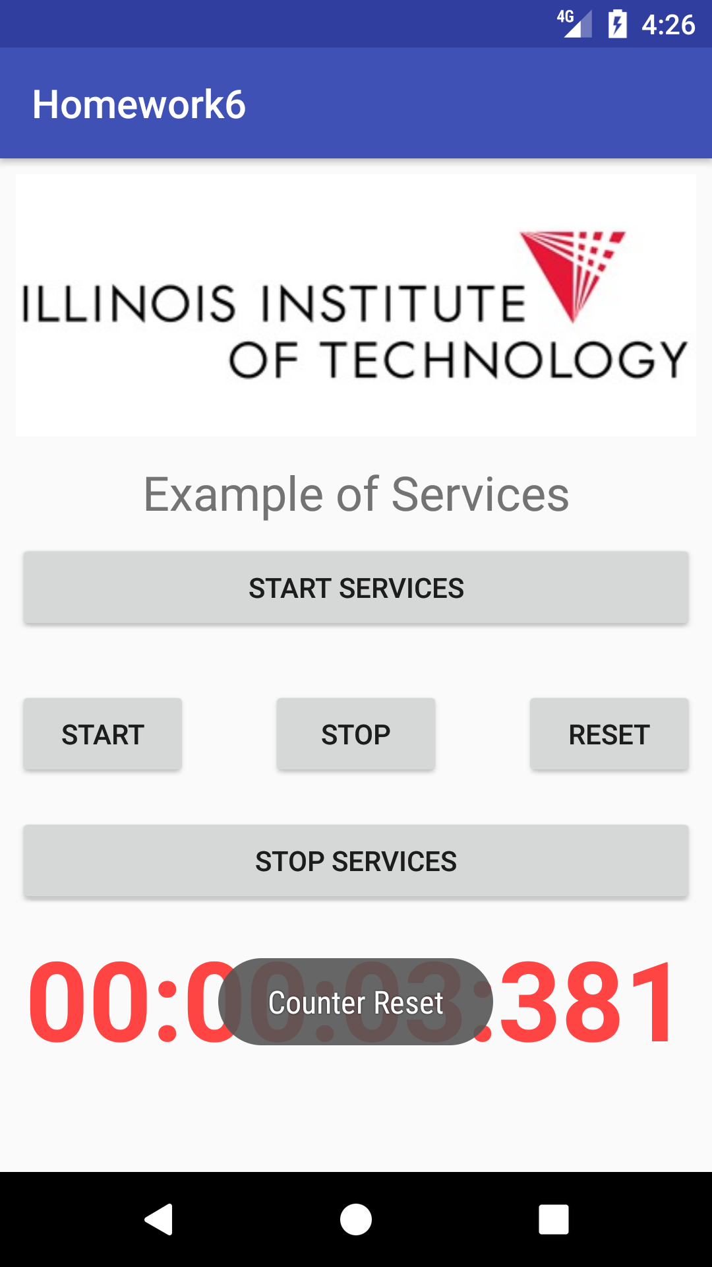

**MainActivity**

**package** com.example.bailey.homework6;  
  
**import** android.content.ComponentName;  
**import** android.content.Context;  
**import** android.content.Intent;  
**import** android.content.ServiceConnection;  
**import** android.os.IBinder;  
**import** android.support.annotation.BoolRes;  
**import** android.support.v7.app.AppCompatActivity;  
**import** android.os.Bundle;  
**import** android.view.View;  
**import** android.widget.Button;  
**import** android.widget.TextView;  
**import** android.widget.Toast;  
  
**import** com.example.bailey.homework6.MyService.MyLocalBinder;  
  
**public class** MainActivity **extends** AppCompatActivity {  
 **private** TextView **mTv_Time**;  
 **private** Button **mBtn_stop**;  
 **private** Button **mBtn_start**;  
 **private** Button **mBtn_reset**;  
 **private** Button **mBtn_startService**;  
 **private** Button **mBtn_stopService**;  
  
 **private** Context **mMainContext**;  
 **private** Chronometer **mChronometer**;  
 **private** Thread **mThreadChrono**;  
  
 MyService **myService**;  
 Boolean **isBound** = **false**;  
  
 @Override  
 **protected void** onCreate(Bundle saveInstanceState) {  
 **super**.onCreate(saveInstanceState);  
 setContentView(R.layout.***activity_main***);  
  
 **mMainContext** = **this**;  
  
 **mTv_Time** = (TextView)findViewById(R.id.***tv_time***);  
 **mBtn_start** = (Button)findViewById(R.id.***btn_start***);  
 **mBtn_reset** = (Button)findViewById(R.id.***btn_reset***);  
 **mBtn_startService** = (Button)findViewById(R.id.***btn_startServices***);  
 **mBtn_stopService** = (Button)findViewById(R.id.***btn_stopServices***);  
 **mBtn_stop** = (Button)findViewById(R.id.***btn_stop***);  
 Intent intent = **new** Intent(**this**, MyService.**class**);  
 bindService(intent,**serviceConnection**, Context.***BIND_AUTO_CREATE***);  
 **mBtn_start**.setOnClickListener(**new** View.OnClickListener() {  
 @Override  
 **public void** onClick(View v) {  
 **if**(**mChronometer** == **null**) {  
 **mChronometer** = **new** Chronometer(**mMainContext**);  
 **mThreadChrono** = **new** Thread(**mChronometer**);  
 **mThreadChrono**.start();  
 **mChronometer**.start();  
 }  
 }  
 });  
 **mBtn_stop**.setOnClickListener(**new** View.OnClickListener() {  
 @Override  
 **public void** onClick(View v) {  
 **if**(**mChronometer** != **null**) {  
 **mChronometer**.stop();  
 }  
 }  
 });  
 **mBtn_reset**.setOnClickListener(**new** View.OnClickListener() {  
 @Override  
 **public void** onClick(View v) {  
 **if**(**mChronometer** != **null**) {  
 **mChronometer**.stop();  
 **mThreadChrono**.interrupt();  
 **mThreadChrono** = **null**;  
 **mChronometer** = **null**;  
 }  
 }  
 });  
 **mBtn_startService**.setOnClickListener(**new** View.OnClickListener() {  
 @Override  
 **public void** onClick(View v) {  
 MyService obj = **new** MyService(**mMainContext**);  
 obj.start();  
 Toast.*makeText*(MainActivity.**this**, **"Service Started"**, Toast.***LENGTH_LONG***).show();  
 }  
 });  
 **mBtn_stopService**.setOnClickListener(**new** View.OnClickListener() {  
 @Override  
 **public void** onClick(View v) {  
 MyService obj = **new** MyService(**mMainContext**);  
 stopService();  
 obj.stop();  
 Toast.*makeText*(MainActivity.**this**, **"Service Destroyed"**, Toast.***LENGTH_LONG***).show();  
 }  
 });  
 }  
 **public void** updateTimerTv(**final** String time) {  
 runOnUiThread(**new** Runnable() {  
 @Override  
 **public void** run() {  
 **mTv_Time**.setText(time);  
 }  
 });  
 }  
 **private** ServiceConnection **serviceConnection** = **new** ServiceConnection() {  
 @Override  
 **public void** onServiceConnected(ComponentName name, IBinder service) {  
 MyLocalBinder binder = (MyLocalBinder) service;  
 **myService** = binder.getSerivce();  
 **isBound** = **true**;  
 }  
  
 @Override  
 **public void** onServiceDisconnected(ComponentName name) {  
 **isBound** = **false**;  
  
 }  
 };  
 **public void** stopService() {  
 stopService(**new** Intent(getBaseContext(), MyService.**class**));  
 }  
}

**Chronometer**

**package** com.example.bailey.homework6;  
  
**import** android.content.Context;  
  
  
*/**  
 * Created by baile on 10/30/2017.  
 */***public class** Chronometer **implements** Runnable {  
 **public static final long *MILLIS_TO_MINUTES*** = 60000;  
 **public static final long *MILLIS_TO_HOURS*** = 3600000;  
 **private** Context **mMainContext**;  
 **private long mStartTime**;  
 **private long mSince**;  
 **private boolean mIsRunning**;  
  
 **public** Chronometer(Context mMainContext) {  
 **this**.**mMainContext** = mMainContext;  
 }  
  
 **public void** start() {  
 **mStartTime** = System.*currentTimeMillis*();  
 **mIsRunning** = **true**;  
 }  
  
 **public void** stop() {  
  
 **mIsRunning** = **false**;  
 }  
 @Override  
 **public void** run() {  
 **while** (**mIsRunning** == **true**) {  
 **long** since = System.*currentTimeMillis*() - **mStartTime**;  
  
 **int** seconds = (**int**) ((since / 1000) %60);  
 **int** minutes = (**int**) ((since / ***MILLIS_TO_MINUTES***) %60);  
 **int** hours = (**int**) ((since / ***MILLIS_TO_HOURS***) %24);  
 **int** millis = (**int**) (since %1000);  
  
 ((MainActivity)**mMainContext**).updateTimerTv(String.*format*(  
 **"%02d:%02d:%02d:%03d"**, hours, minutes, seconds, millis  
 ));  
 }  
 }  
}

**MyService**

**package** com.example.bailey.homework6;  
  
**import** android.app.Service;  
**import** android.content.Context;  
**import** android.content.Intent;  
**import** android.os.IBinder;  
**import** android.os.Binder;  
**import** android.widget.Toast;  
  
  
**public class** MyService **extends** Service {  
 **private** Context **mContext**;  
 **private** Chronometer **mChronometer**;  
 **private** Thread **mThreadChrono**;  
  
 **public** MyService(Context mContext) {  
 **this**.**mContext** = ((MainActivity)mContext);  
 }  
  
 **private** IBinder myBinder = **new** MyLocalBinder();  
  
 **public void** start() {  
 **if**(**mChronometer** == **null**) {  
 **mChronometer** = **new** Chronometer(**mContext**);  
 **mThreadChrono** = **new** Thread(**mChronometer**);  
 **mThreadChrono**.start();  
 **mChronometer**.start();  
 }  
 }  
 **public void** stop() {  
 **if**(**mChronometer** != **null**) {  
 **mChronometer**.stop();  
 **mThreadChrono**.interrupt();  
 **mThreadChrono** = **null**;  
 **mChronometer** = **null**;  
 }  
 }  
 **public** MyService() {  
 }  
  
 @Override  
 **public** IBinder onBind(Intent intent) {  
 **return** myBinder;  
 }  
 **public class** MyLocalBinder **extends** Binder {  
 MyService getSerivce() {  
 **return** MyService.**this**;  
 }  
 }  
}

**XML Activity_main**

*<?***xml version="1.0" encoding="utf-8"***?>*<**android.support.constraint.ConstraintLayout xmlns:android="http://schemas.android.com/apk/res/android"  
 xmlns:app="http://schemas.android.com/apk/res-auto"  
 xmlns:tools="http://schemas.android.com/tools"  
 android:layout_width="match_parent"  
 android:layout_height="match_parent"  
 tools:context="com.example.bailey.homework6.MainActivity"**>  
  
 <**Button  
 android:id="@+id/btn_stopServices"  
 android:layout_width="0dp"  
 android:layout_height="wrap_content"  
 android:layout_marginLeft="8dp"  
 android:layout_marginRight="8dp"  
 android:layout_marginTop="8dp"  
 android:text="Stop Services"  
 app:layout_constraintHorizontal_bias="0.0"  
 app:layout_constraintLeft_toLeftOf="parent"  
 app:layout_constraintRight_toRightOf="parent"  
 app:layout_constraintTop_toTopOf="@+id/guideline2"** />  
  
 <**Button  
 android:id="@+id/btn_start"  
 android:layout_width="0dp"  
 android:layout_height="wrap_content"  
 android:layout_marginBottom="8dp"  
 android:layout_marginLeft="8dp"  
 android:text="Start"  
 app:layout_constraintBottom_toTopOf="@+id/guideline2"  
 app:layout_constraintLeft_toLeftOf="parent"** />  
  
 <**Button  
 android:id="@+id/btn_stop"  
 android:layout_width="wrap_content"  
 android:layout_height="wrap_content"  
 android:layout_marginBottom="8dp"  
 android:layout_marginLeft="8dp"  
 android:layout_marginRight="8dp"  
 android:text="Stop"  
 app:layout_constraintBottom_toTopOf="@+id/guideline2"  
 app:layout_constraintLeft_toRightOf="@+id/btn_start"  
 app:layout_constraintRight_toLeftOf="@+id/btn_reset"** />  
  
 <**android.support.constraint.Guideline  
 android:layout_width="wrap_content"  
 android:layout_height="wrap_content"  
 android:id="@+id/guideline"  
 app:layout_constraintGuide_percent="0.29"  
 android:orientation="horizontal"** />  
  
 <**ImageView  
 android:id="@+id/iv_logo"  
 android:layout_width="0dp"  
 android:layout_height="0dp"  
 android:layout_marginBottom="8dp"  
 android:layout_marginLeft="8dp"  
 android:layout_marginRight="8dp"  
 android:layout_marginTop="8dp"  
 android:scaleType="centerCrop"  
 app:layout_constraintBottom_toTopOf="@+id/guideline"  
 app:layout_constraintLeft_toLeftOf="parent"  
 app:layout_constraintRight_toRightOf="parent"  
 app:layout_constraintTop_toTopOf="parent"  
 app:srcCompat="@drawable/iit_logo"  
 app:layout_constraintHorizontal_bias="0.0"  
 app:layout_constraintVertical_bias="1.0"** />  
  
 <**TextView  
 android:id="@+id/tv_services"  
 android:layout_width="0dp"  
 android:layout_height="wrap_content"  
 android:layout_marginLeft="8dp"  
 android:layout_marginRight="8dp"  
 android:layout_marginTop="12dp"  
 android:text="Example of Services"  
 android:textAlignment="center"  
 android:textSize="24sp"  
 app:layout_constraintLeft_toLeftOf="parent"  
 app:layout_constraintRight_toRightOf="parent"  
 app:layout_constraintTop_toBottomOf="@+id/iv_logo"  
 app:layout_constraintHorizontal_bias="0.0"** />  
  
 <**Button  
 android:id="@+id/btn_startServices"  
 android:layout_width="0dp"  
 android:layout_height="wrap_content"  
 android:layout_marginLeft="8dp"  
 android:layout_marginRight="8dp"  
 android:layout_marginTop="8dp"  
 android:onClick="showTime"  
 android:text="Start Services"  
 app:layout_constraintHorizontal_bias="0.0"  
 app:layout_constraintLeft_toLeftOf="parent"  
 app:layout_constraintRight_toRightOf="parent"  
 app:layout_constraintTop_toBottomOf="@+id/tv_services"** />  
  
 <**Button  
 android:id="@+id/btn_reset"  
 android:layout_width="wrap_content"  
 android:layout_height="wrap_content"  
 android:layout_marginBottom="8dp"  
 android:layout_marginRight="8dp"  
 android:text="Reset"  
 app:layout_constraintBottom_toTopOf="@+id/guideline2"  
 app:layout_constraintRight_toRightOf="parent"** />  
  
 <**android.support.constraint.Guideline  
 android:layout_width="wrap_content"  
 android:layout_height="wrap_content"  
 android:id="@+id/guideline2"  
 app:layout_constraintGuide_percent="0.63"  
 android:orientation="horizontal"** />  
  
 <**TextView  
 android:id="@+id/tv_time"  
 android:layout_width="0dp"  
 android:layout_height="0dp"  
 android:layout_marginBottom="8dp"  
 android:layout_marginLeft="8dp"  
 android:layout_marginRight="8dp"  
 android:layout_marginTop="8dp"  
 android:text="0:00:00:000"  
 android:textAlignment="center"  
 android:textColor="@android:color/holo_red_light"  
 android:textSize="56sp"  
 android:textStyle="bold"  
 app:layout_constraintBottom_toBottomOf="parent"  
 app:layout_constraintLeft_toLeftOf="parent"  
 app:layout_constraintRight_toRightOf="parent"  
 app:layout_constraintTop_toBottomOf="@+id/btn_stopServices"** />  
  
</**android.support.constraint.ConstraintLayout**>