Jarron Bailey

11/23/2017

ITMD 455

Homework 7&8

**Screenshots**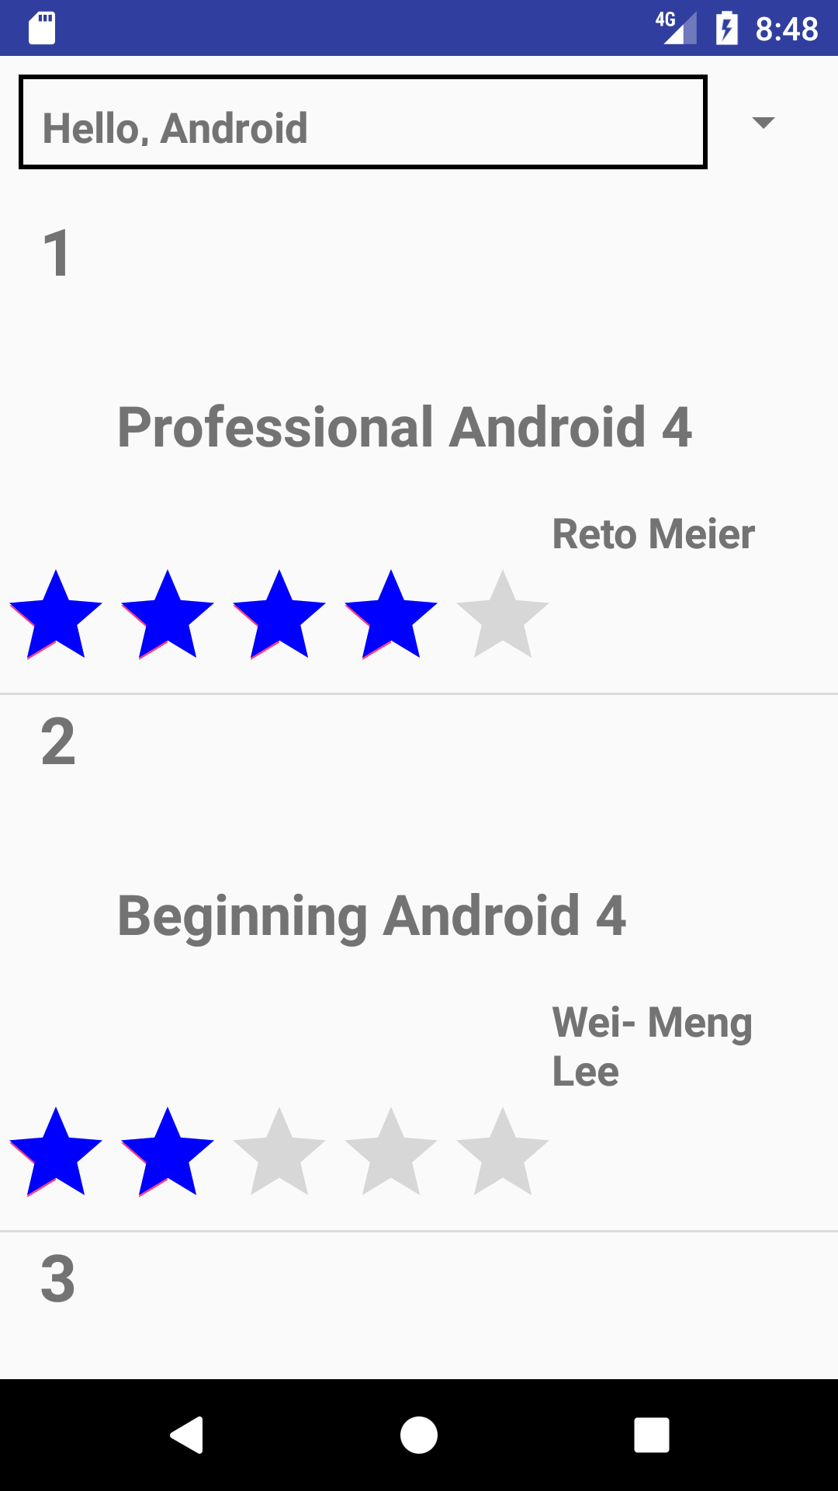

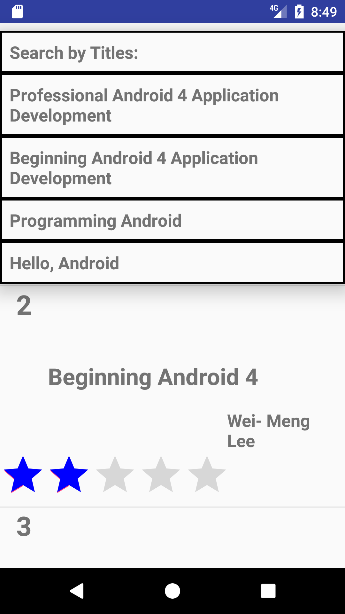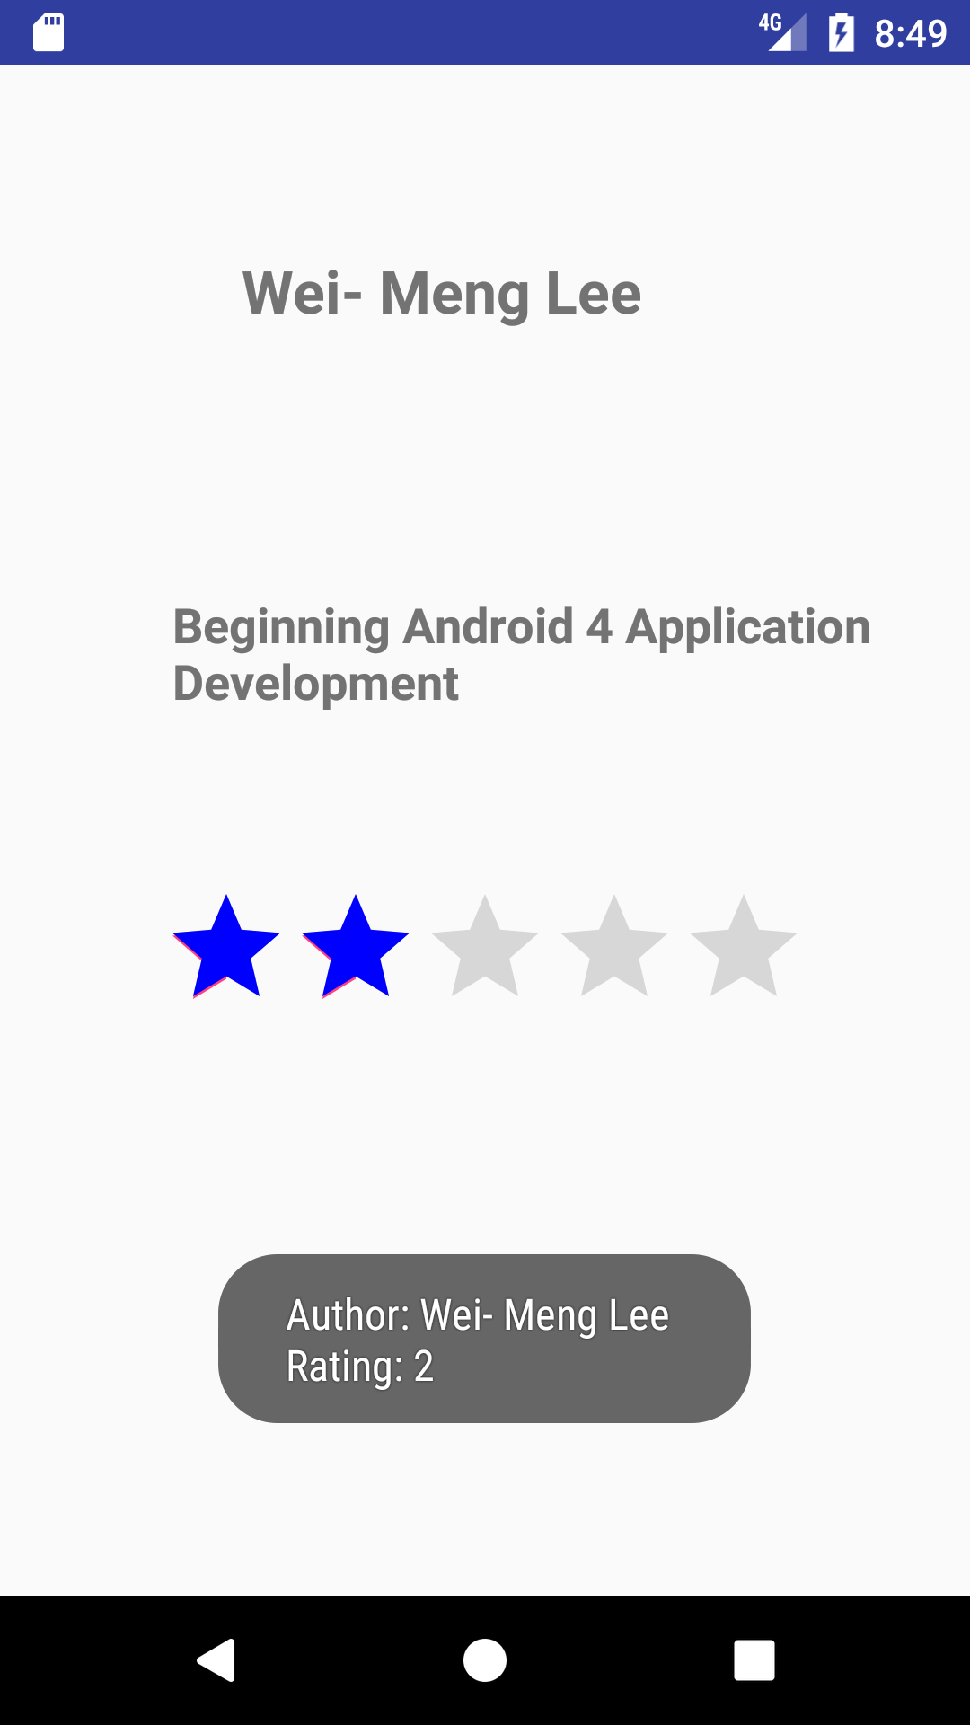

**Book**

**package** com.example.bailey.bookreviews;  
*/**  
 * Created by baile on 11/15/2017.  
 */***public class** Book {  
 **private int id**;  
 **private** String **title**;  
 **private** String **author**;  
 **private int rating**;  
  
  
  
 **public** Book(){}  
  
 **public** Book(String title, String author, **int** rating) { **super**();  
 **this**.**title** = title;  
 **this**.**author** = author;  
 **this**.**rating** = rating;  
 }  
 *//getters & setters* **public int** getId() {  
 **return id**;  
 }  
  
 **public void** setId(**int** id) {  
 **this**.**id** = id;  
 }  
 **public** String getTitle() {  
 **return title**;  
  
 }  
 **public void** setTitle(String title) {  
 **this**.**title** = title;  
 }  
 **public** String getAuthor() {  
  
 **return author**;  
 }  
 **public void** setAuthor(String author) {  
 **this**.**author** = author;  
 }  
 **public int** getRating() {  
 **return rating**;  
 }  
  
 **public void** setRating(**int** rating) {  
 **this**.**rating** = rating;  
 }  
  
 @Override  
  
 **public** String toString() {  
  
 **return "Book [id="** + **id** + **", title="** + **title** + **", author="** + **author** + **" , rating="** + **rating** +**"]"**;  
 }  
}

**CustomAdapter**

**package** com.example.bailey.bookreviews;  
  
**import** android.app.Activity;  
**import** android.app.Notification;  
**import** android.content.ClipData;  
**import** android.content.Context;  
**import** android.database.Cursor;  
**import** android.graphics.Color;  
**import** android.graphics.PorterDuff;  
**import** android.graphics.drawable.LayerDrawable;  
**import** android.support.annotation.NonNull;  
**import** android.support.annotation.Nullable;  
**import** android.util.Log;  
**import** android.view.LayoutInflater;  
**import** android.view.View;  
**import** android.view.ViewGroup;  
**import** android.widget.ArrayAdapter;  
**import** android.widget.BaseAdapter;  
**import** android.widget.ImageView;  
**import** android.widget.RatingBar;  
**import** android.widget.TextView;  
**import** java.util.ArrayList;  
**import** java.util.List;  
  
*/**  
 * Created by baile on 11/20/2017.  
 */* **public class** CustomAdapter **extends** BaseAdapter {  
  
 **private final** Activity **context**;  
 **private final** ArrayList<String> **bookName**;  
 **private final** ArrayList<Integer> **bookRating**;  
 **private final** ArrayList<String> **bookAuthor**;  
 *// private final List<Book> list_books;* SqlHelper **db**;  
  
 **public** CustomAdapter(Activity context, ArrayList<String> bookName, ArrayList<Integer> bookRating, ArrayList<String> bookAuthor) {  
 *//ArrayAdapter(Context context, int resource, T[] objects)* **db** = **new** SqlHelper(context);  
 Cursor data = **db**.getData();  
 List<Book> list = **db**.getAllBooks();  
  
 **this**.**context** = context;  
 **this**.**bookAuthor** = bookAuthor;  
 **this**.**bookName** = bookName;  
 **this**.**bookRating** = bookRating;  
  
  
 }  
  
 @Override  
 **public int** getCount() {  
 **return bookAuthor**.size();  
 }  
  
 @Override  
 **public** Object getItem(**int** position) {  
 **return null**;  
 }  
  
 @Override  
 **public long** getItemId(**int** position) {  
 **return** 0;  
 }  
  
 @Override  
 **public** View getView(**int** position, @Nullable View rowView, @NonNull ViewGroup parent) {  
  
 LayoutInflater inflater = **context**.getLayoutInflater();  
  
 *//inflate(int resource, ViewGroup root, boolean attachToRoot)* rowView = inflater.inflate(R.layout.***listview***,  
 **null**, **true**);  
  
  
 TextView textView_itemNumber = rowView.findViewById(R.id.***tv_itemNumber***);  
 TextView textView_bookName = rowView.findViewById(R.id.***tv_BookName***);  
 TextView textView_bookAuthor = rowView.findViewById(R.id.***tv_BookAuthur***);  
 RatingBar ratingBar = rowView.findViewById(R.id.***rb_ratingBar***);  
 textView_itemNumber.setText(Integer.*toString*(position+1));  
 textView_bookAuthor.setText(**bookAuthor**.get(position));  
 textView_bookName.setText(**bookName**.get(position));  
 ratingBar.setNumStars(5);  
 ratingBar.setRating(**bookRating**.get(position));  
 LayerDrawable stars = (LayerDrawable) ratingBar.getProgressDrawable();  
 stars.getDrawable(2).setColorFilter(Color.***BLUE***, PorterDuff.Mode.***SRC_ATOP***);  
 **return** rowView;  
 }  
  
}

**MainActivity**

**package** com.example.bailey.bookreviews;  
  
**import** java.util.ArrayList;  
**import** java.util.List;  
  
**import** android.app.Activity;  
**import** android.content.Intent;  
**import** android.database.sqlite.SQLiteDatabase;  
**import** android.os.Bundle;  
**import** android.support.v7.app.AppCompatActivity;  
**import** android.util.Log;  
**import** android.view.View;  
**import** android.widget.AdapterView;  
**import** android.widget.ListView;  
**import** android.widget.Spinner;  
  
  
**public class** MainActivity **extends** AppCompatActivity {  
  
ListView **listView**;  
Spinner **spinner**;  
 **private final** ArrayList<String> **bookName** = **new** ArrayList<>();  
 **private final** ArrayList<Integer> **bookRating**= **new** ArrayList<>();  
 **private final** ArrayList<String> **bookAuthor**= **new** ArrayList<>();  
 @Override  
**protected void** onCreate(Bundle savedInstanceState) {  
 **super**.onCreate(savedInstanceState);  
 setContentView(R.layout.***activity_main***);  
 SqlHelper db = **new** SqlHelper(**this**);  
  
*/** CRUD Operations **/  
  
// add Books  
  
 //db.addBook(new Book("Professional Android 4 Application Development","Reto Meier",4));  
 //db.addBook(new Book("Beginning Android 4 Application Development", "Wei- Meng Lee", 2));  
 //db.addBook(new Book("Programming Android", "Wallace Jackson",7));  
 //db.addBook(new Book("Hello, Android", "Wallace Jackson",1));  
  
 // / get all books* List<Book> list = db.getAllBooks();  
*// update one book  
 //int j = db.updateBook(list.get(3), "Hello, Android", "Ben Wallace",1);  
  
// delete one book  
 //db.deleteBook(list.get(0));  
 //db.deleteBook(list.get(1));  
 //db.deleteBook(list.get(2));  
 //db.deleteBook(list.get(3));  
 //db.deleteBook(list.get(4));  
  
// get all books* db.getAllBooks();  
  
  
*// get count* db.getIds();  
  
 **int** length = db.getIds();  
 **for** (**int** i = 0; i < length; i++ ) {  
 **bookAuthor**.add(list.get(i).getAuthor());  
 **bookRating**.add(list.get(i).getRating());  
 **bookName**.add(list.get(i).getTitle());  
 Log.*d*(**"message"**, **" "** + **bookName**.get(i));  
 Log.*d*(**"message"**, **" "** + **bookAuthor**.get(i));  
 Log.*d*(**"message"**, **" "** + **bookRating**.get(i));  
 }  
 ArrayList<String> bookName2= **new** ArrayList<>(**bookName**);  
 bookName2.add(0, **"Search by Titles:"**);  
  
 CustomAdapter adapter = **new** CustomAdapter(MainActivity.**this**, **bookName**, **bookRating**, **bookAuthor**);  
 **listView** = findViewById(R.id.***listview***);  
 **listView**.setAdapter(adapter);  
  
 SpinnerAdapter spinnerAdapter = **new** SpinnerAdapter(MainActivity.**this**, bookName2);  
 **spinner** = findViewById(R.id.***spinner***);  
 **spinner**.setAdapter(spinnerAdapter);  
 **spinner**.setOnItemSelectedListener(**new** AdapterView.OnItemSelectedListener() {  
 @Override  
 **public void** onItemSelected(AdapterView<?> parent, View view, **int** position, **long** id) {  
 Intent secondActivity = **new** Intent(MainActivity.**this**,SpinnerSelection.**class**);  
 **if**(position > 0) {  
 **int** xposition = position -1;  
 secondActivity.putExtra(**"title"**, **bookName**.get(xposition));  
 secondActivity.putExtra(**"author"**, **bookAuthor**.get(xposition));  
 secondActivity.putExtra(**"rating"**, **bookRating**.get(xposition));  
 startActivity(secondActivity);  
 }  
 }  
  
 @Override  
 **public void** onNothingSelected(AdapterView<?> parent) {  
  
 }  
 });  
}  
}

**SpinAdapter**

**package** com.example.bailey.bookreviews;  
  
**import** android.app.Activity;  
**import** android.content.Context;  
**import** android.support.annotation.NonNull;  
**import** android.support.annotation.Nullable;  
**import** android.view.View;  
**import** android.view.ViewGroup;  
**import** android.widget.ArrayAdapter;  
  
**import** java.util.ArrayList;  
**import** java.util.List;  
  
**public class** SpinnerAdapter **extends** ArrayAdapter<String> {  
 **private boolean emptyRemoved** = **false**;  
  
  
 **public** SpinnerAdapter(@NonNull Context context, ArrayList<String> titles) {  
 **super**(context, R.layout.***spinnerlayout***, R.id.***tv_spinTitle***, titles);  
 }  
  
 @NonNull  
 @Override  
 **public** View getView(**int** position, @Nullable View convertView, @NonNull ViewGroup parent) {  
 **return super**.getView(position, convertView, parent);  
 }  
  
  
}

**SpinAdapter Activity**

**package** com.example.bailey.bookreviews;  
  
  
**import** android.content.Intent;  
**import** android.graphics.Color;  
**import** android.graphics.PorterDuff;  
**import** android.graphics.drawable.LayerDrawable;  
**import** android.os.Handler;  
**import** android.support.annotation.Nullable;  
**import** android.support.v7.app.AppCompatActivity;  
**import** android.os.Bundle;  
**import** android.widget.ImageView;  
**import** android.widget.RatingBar;  
**import** android.widget.TextView;  
**import** android.widget.Toast;  
  
*/**  
 * Created by baile on 11/23/2017.  
 */***public class** SpinnerSelection **extends** AppCompatActivity {  
 TextView **tv_title**;  
 TextView **tv_author**;  
 RatingBar **ratingBar**;  
 @Override  
 **protected void** onCreate(@Nullable Bundle savedInstanceState) {  
 **super**.onCreate(savedInstanceState);  
 setContentView(R.layout.***spinner_selection_info***);  
  
 Intent intent = getIntent();  
 Bundle extras = intent.getExtras();  
 **final** String title = extras.getString(**"title"**);  
 **final** String author = extras.getString(**"author"**);  
 **final int** rating = extras.getInt(**"rating"**);  
  
 **tv_title** = (TextView)findViewById(R.id.***tv_Seltitle***);  
 **tv_author** = (TextView)findViewById(R.id.***tv_Selauthor***);  
 **ratingBar** = (RatingBar) findViewById(R.id.***SelratingBar***);  
 **tv_author**.setText(title);  
 **tv_title**.setText(author);  
 **ratingBar**.setNumStars(5);  
 **ratingBar**.setRating(rating);  
 LayerDrawable stars = (LayerDrawable) **ratingBar**.getProgressDrawable();  
 stars.getDrawable(2).setColorFilter(Color.***BLUE***, PorterDuff.Mode.***SRC_ATOP***);  
 Toast.*makeText*(**this**,**"Author: "** + author + **"\nRating: "** + rating, Toast.***LENGTH_LONG***).show();  
 }  
}

**SqlHelper**

**package** com.example.bailey.bookreviews;  
  
**import** java.util.LinkedList;  
**import** java.util.List;  
**import** android.content.ContentValues;  
**import** android.content.Context;  
**import** android.database.Cursor;  
**import** android.database.sqlite.SQLiteDatabase;  
**import** android.database.sqlite.SQLiteOpenHelper;  
**import** android.util.Log;  
  
*/**  
 * Created by baile on 11/15/2017.  
 */***public class** SqlHelper **extends** SQLiteOpenHelper {  
 *// Database Version* **private static final int *DATABASE_VERSION*** = 5;  
 *// Database Name* **private static final** String ***DATABASE_NAME*** = **"BookDB"**;  
 *// Books table name* **private static final** String ***TABLE_BOOKS*** = **"books"**;  
*// Books Table Columns names* SQLiteDatabase **db**;  
 **private static final** String ***KEY_ID*** = **"id"**;  
 **private static final** String ***KEY_TITLE*** = **"title"**;  
 **private static final** String ***KEY_AUTHOR*** = **"author"**;  
 **private static final** String ***KEY_RATING*** = **"rating"**;  
  
 **public** SqlHelper(Context context) {  
  
 **super**(context, ***DATABASE_NAME***, **null**, ***DATABASE_VERSION***);  
  
 }  
  
 @Override  
  
 **public void** onCreate(SQLiteDatabase db) {  
 *// SQL statement to create book table* String CREATE_BOOK_TABLE = **"CREATE TABLE books ( "** +  
 **"id INTEGER PRIMARY KEY AUTOINCREMENT, "** +  
 **"title TEXT, "**+  
 **"author TEXT,"** +  
 **"rating INTEGER )"**;  
 *// create books table* db.execSQL(CREATE_BOOK_TABLE);  
  
 }  
  
 @Override  
 **public void** onUpgrade(SQLiteDatabase db, **int** oldVersion, **int** newVersion)  
 {  
  
*// Drop older books table if existed* db.execSQL(**"DROP TABLE IF EXISTS books"**);  
  
*// create fresh books table* **this**.onCreate(db);  
 }  
  
 */*CRUD operations (create "add", read "get", update, delete) */* **public void** addBook(Book book){  
 Log.*d*(**"addBook"**, book.toString());  
  
*// 1. get reference to writable DB* SQLiteDatabase db = **this**.getWritableDatabase();  
  
*// 2. create ContentValues to add key "column"/value* ContentValues values = **new** ContentValues();  
 values.put(***KEY_TITLE***, book.getTitle()); *// get title* values.put(***KEY_AUTHOR***, book.getAuthor()); *// get author* values.put(***KEY_RATING***, book.getRating());  
*// 3. insert* db.insert(***TABLE_BOOKS***, *// table* **null**, *//nullColumnHack* values); *// key/value -> keys = column names/values  
  
// 4. Close dbase* db.close();  
  
 }  
  
 *// Get All Books* **public** List<Book> getAllBooks() {  
  
 List<Book> books = **new** LinkedList<Book>();  
 *// 1. build the query* String query = **"SELECT * FROM "** + ***TABLE_BOOKS***;  
  
*// 2. get reference to writable DB* SQLiteDatabase db = **this**.getWritableDatabase();  
 Cursor cursor = db.rawQuery(query, **null**);  
  
*// 3. go over each row, build book and add it to list* Book book = **null**;  
  
 **if** (cursor.moveToFirst()) {  
 **do** {  
 book = **new** Book();  
 book.setId(Integer.*parseInt*(cursor.getString(0)));  
 book.setTitle(cursor.getString(1));  
 book.setAuthor(cursor.getString(2));  
 book.setRating(cursor.getInt(3));  
  
*// Add book to books* books.add(book);  
  
 } **while** (cursor.moveToNext());  
 }  
  
 Log.*d*(**"getAllBooks()"**, books.toString());  
 **return** books; *// return books* }  
 *// Updating single book* **public int** updateBook(Book book, String newTitle, String newAuthor, **int** newRating) {  
  
*// 1. get reference to writable DB* SQLiteDatabase db = **this**.getWritableDatabase();  
  
*// 2. create ContentValues to add key "column"/value* ContentValues values = **new** ContentValues();  
 values.put(**"title"**, newTitle); *// get title* values.put(**"author"**, newAuthor); *// get author* values.put(**"rating"**, newRating);  
*// 3. updating row* **int** i = db.update(***TABLE_BOOKS***, *//table* values, *// column/value* ***KEY_ID***+**" = ?"**, *// selections* **new** String[] { String.*valueOf*(book.getId()) + **"\n"** }); *//selection args  
  
// 4. close dbase* db.close();  
 Log.*d*(**"UpdateBook"**, book.toString());  
 **return** i;  
  
 }  
  
 *// Deleting single book* **public void** deleteBook(Book book) {  
  
*// 1. get reference to writable DB* SQLiteDatabase db = **this**.getWritableDatabase();  
  
*// 2. delete* db.delete(***TABLE_BOOKS***, ***KEY_ID***+**" = ?"**,  
 **new** String[] { String.*valueOf*(book.getId()) });  
  
*// 3. close* db.close();  
  
 Log.*d*(**"deleteBook"**, book.toString());  
  
 }  
  
 **public int** getIds()  
  
 {  
 String selectQuery = **"SELECT id FROM books"**;  
 SQLiteDatabase database = **this**.getReadableDatabase();  
 Cursor c = database.rawQuery(selectQuery, **null**);  
 c.moveToFirst();  
 **int** total = c.getCount();  
 Log.*d*(**"getIds"**, String.*valueOf*(total));  
 **return** total;  
 }  
  
 **public** Cursor getData(){  
 SQLiteDatabase db = **this**.getWritableDatabase();  
 String query = **"SELECT * FROM "** + ***TABLE_BOOKS***;  
 Cursor data = db.rawQuery(query, **null**);  
 **return** data;  
 }  
  
}

**Activity_xml**

*<?***xml version="1.0" encoding="utf-8"***?>*<**android.support.constraint.ConstraintLayout xmlns:android="http://schemas.android.com/apk/res/android"  
 xmlns:app="http://schemas.android.com/apk/res-auto"  
 xmlns:tools="http://schemas.android.com/tools"  
 android:layout_width="match_parent"  
 android:layout_height="match_parent"  
 tools:context="com.example.bailey.bookreviews.MainActivity"**>  
  
 <**ListView  
 android:id="@+id/listview"  
 android:layout_width="0dp"  
 android:layout_height="0dp"  
 android:layout_marginTop="8dp"  
 app:layout_constraintBottom_toBottomOf="parent"  
 app:layout_constraintEnd_toEndOf="parent"  
 app:layout_constraintHorizontal_bias="1.0"  
 app:layout_constraintStart_toStartOf="parent"  
 app:layout_constraintTop_toTopOf="@+id/guideline"** />  
  
 <**android.support.constraint.Guideline  
 android:id="@+id/guideline"  
 android:layout_width="wrap_content"  
 android:layout_height="wrap_content"  
 android:orientation="horizontal"  
 app:layout_constraintGuide_percent="0.1"** />  
  
 <**Spinner  
 android:id="@+id/spinner"  
 android:layout_width="0dp"  
 android:layout_height="0dp"  
 android:layout_marginBottom="8dp"  
 android:layout_marginEnd="8dp"  
 android:layout_marginStart="8dp"  
 android:layout_marginTop="8dp"  
 app:layout_constraintBottom_toTopOf="@+id/guideline"  
 app:layout_constraintEnd_toEndOf="parent"  
 app:layout_constraintStart_toStartOf="parent"  
 app:layout_constraintTop_toTopOf="parent"** />  
</**android.support.constraint.ConstraintLayout**>

**Actvity_xml**

*<?***xml version="1.0" encoding="utf-8"***?>*<**android.support.constraint.ConstraintLayout xmlns:android="http://schemas.android.com/apk/res/android"  
 xmlns:app="http://schemas.android.com/apk/res-auto"  
 xmlns:tools="http://schemas.android.com/tools"  
 android:layout_width="match_parent"  
 android:layout_height="match_parent"  
 tools:context="com.example.bailey.bookreviews.MainActivity"**>  
  
 <**ListView  
 android:id="@+id/listview"  
 android:layout_width="0dp"  
 android:layout_height="0dp"  
 android:layout_marginTop="8dp"  
 app:layout_constraintBottom_toBottomOf="parent"  
 app:layout_constraintEnd_toEndOf="parent"  
 app:layout_constraintHorizontal_bias="1.0"  
 app:layout_constraintStart_toStartOf="parent"  
 app:layout_constraintTop_toTopOf="@+id/guideline"** />  
  
 <**android.support.constraint.Guideline  
 android:id="@+id/guideline"  
 android:layout_width="wrap_content"  
 android:layout_height="wrap_content"  
 android:orientation="horizontal"  
 app:layout_constraintGuide_percent="0.1"** />  
  
 <**Spinner  
 android:id="@+id/spinner"  
 android:layout_width="0dp"  
 android:layout_height="0dp"  
 android:layout_marginBottom="8dp"  
 android:layout_marginEnd="8dp"  
 android:layout_marginStart="8dp"  
 android:layout_marginTop="8dp"  
 app:layout_constraintBottom_toTopOf="@+id/guideline"  
 app:layout_constraintEnd_toEndOf="parent"  
 app:layout_constraintStart_toStartOf="parent"  
 app:layout_constraintTop_toTopOf="parent"** />  
</**android.support.constraint.ConstraintLayout**>

**Listview**

*<?***xml version="1.0" encoding="utf-8"***?>*<**android.support.constraint.ConstraintLayout xmlns:android="http://schemas.android.com/apk/res/android"  
 xmlns:app="http://schemas.android.com/apk/res-auto"  
 xmlns:tools="http://schemas.android.com/tools"  
 android:layout_width="match_parent"  
 android:layout_height="match_parent"  
 android:orientation="vertical"  
 android:id="@+id/relativeLayout"**>  
  
 <**TextView  
 android:id="@+id/tv_itemNumber"  
 android:layout_width="50dp"  
 android:layout_height="wrap_content"  
 android:text="0"  
 android:textAlignment="center"  
 android:textSize="28sp"  
 android:textStyle="bold"  
 app:layout_constraintTop_toTopOf="parent"  
 app:layout_constraintStart_toStartOf="parent"** />  
  
 <**TextView  
 android:id="@+id/tv_BookName"  
 android:layout_width="317dp"  
 android:layout_height="31dp"  
 android:layout_marginTop="40dp"  
 android:text="Name of Book"  
 android:textSize="24sp"  
 android:textStyle="bold"  
 app:layout_constraintStart_toEndOf="@+id/tv_itemNumber"  
 app:layout_constraintTop_toBottomOf="@+id/tv_itemNumber"** />  
  
 <**TextView  
 android:id="@+id/tv_BookAuthur"  
 android:layout_width="100dp"  
 android:layout_height="wrap_content"  
 android:layout_marginEnd="23dp"  
 android:layout_marginTop="19dp"  
 android:text="Author"  
 android:textSize="18sp"  
 android:textStyle="bold"  
 app:layout_constraintEnd_toEndOf="parent"  
 app:layout_constraintTop_toBottomOf="@+id/tv_BookName"** />  
  
 <**RatingBar  
 android:id="@+id/rb_ratingBar"  
 android:layout_width="wrap_content"  
 android:layout_height="wrap_content"  
 app:layout_constraintStart_toStartOf="parent"  
 app:layout_constraintTop_toBottomOf="@+id/tv_BookAuthur"** />  
  
</**android.support.constraint.ConstraintLayout**>

**Spinner_selection**

*<?***xml version="1.0" encoding="utf-8"***?>*<**RelativeLayout xmlns:android="http://schemas.android.com/apk/res/android"  
 xmlns:tools="http://schemas.android.com/tools"  
 android:layout_width="match_parent"  
 android:layout_height="match_parent"  
 tools:context="com.example.bailey.bookreviews.SpinnerSelection"**>  
  
 <**TextView  
 android:id="@+id/tv_Seltitle"  
 android:layout_width="200dp"  
 android:layout_height="wrap_content"  
 android:layout_alignParentTop="true"  
 android:layout_alignStart="@+id/tv_Selauthor"  
 android:layout_marginTop="69dp"  
 android:text="Title"  
 android:textAlignment="center"  
 android:textSize="22sp"  
 android:textStyle="bold"** />  
  
 <**TextView  
 android:id="@+id/tv_Selauthor"  
 android:layout_width="wrap_content"  
 android:layout_height="wrap_content"  
 android:layout_alignParentStart="true"  
 android:layout_below="@+id/tv_Seltitle"  
 android:layout_marginStart="64dp"  
 android:layout_marginTop="97dp"  
 android:text="Author"  
 android:textSize="18sp"  
 android:textStyle="bold"** />  
  
 <**RatingBar  
 android:id="@+id/SelratingBar"  
 android:layout_width="wrap_content"  
 android:layout_height="wrap_content"  
 android:layout_below="@+id/tv_Selauthor"  
 android:layout_centerHorizontal="true"  
 android:layout_marginTop="63dp"** />  
  
</**RelativeLayout**>

**Spinner_layout**

*<?***xml version="1.0" encoding="utf-8"***?>*<**LinearLayout xmlns:android="http://schemas.android.com/apk/res/android"  
 xmlns:tools="http://schemas.android.com/tools"  
 android:layout_width="match_parent"  
 android:layout_height="match_parent"  
 android:orientation="vertical"**>  
  
 <**TextView  
 android:id="@+id/tv_spinTitle"  
 android:layout_width="match_parent"  
 android:layout_height="wrap_content"  
 android:background="@drawable/black"  
 android:padding="10dp"  
 android:text="TextView"  
 android:textAlignment="viewStart"  
 android:textSize="18sp"  
 android:textStyle="bold"** />  
  
</**LinearLayout**>