Download sql server 2012

Create database

Table->New query

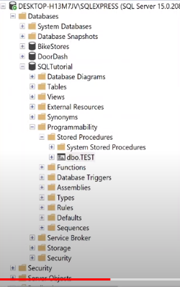

/*

Stored Procedures -> a group of statement can stores in a database

*/

--Create procedure Test

--AS

--Select *

--From EmployeeDemographics

--EXEC Test

CREATE PROCEDURE Temp_Employee2

@JobTitle nvarchar(100)

AS

Create table #temp_employee3 (

JobTitle varchar(100),

EmployeesPerJob int ,

AvgAge int,

AvgSalary int

)

Insert into #temp_employee3

SELECT JobTitle, Count(JobTitle), Avg(Age), AVG(salary)

FROM SQLTutorial..EmployeeDemographics emp

JOIN SQLTutorial..EmployeeSalary sal

ON emp.EmployeeID = sal.EmployeeID

where JobTitle = @JobTitle --- make sure to change this in this script from original above

group by JobTitle

Select *

From #temp_employee3

GO;

exec Temp_Employee2 @jobtitle = 'Salesman'

* execute