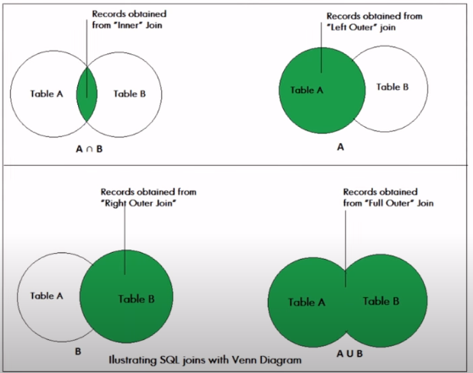

Download sql server 2012

Create database

Table->New query

/\*

Select \* from SQLTutorial.dbo.EmployeeDemographics

Inner Join SQLTutorial.dbo.EmployeeSalary

On EmployeeDemographics.EmployeeID = EmployeeSalary.EmployeeID

\*/

/\*

Select \* from SQLTutorial.dbo.EmployeeDemographics

Full Outer Join SQLTutorial.dbo.EmployeeSalary

On EmployeeDemographics.EmployeeID = EmployeeSalary.EmployeeID

\*/

/\*

Select \* from SQLTutorial.dbo.EmployeeDemographics

Left Outer Join SQLTutorial.dbo.EmployeeSalary

On EmployeeDemographics.EmployeeID = EmployeeSalary.EmployeeID

\*/

/\*

Select \* from SQLTutorial.dbo.EmployeeDemographics

Right Outer Join SQLTutorial.dbo.EmployeeSalary

On EmployeeDemographics.EmployeeID = EmployeeSalary.EmployeeID

\*/

/\*

Select EmployeeDemographics.EmployeeID, FirstName, LastName, JobTitle, Salary

from SQLTutorial.dbo.EmployeeDemographics

Inner Join SQLTutorial.dbo.EmployeeSalary

On EmployeeDemographics.EmployeeID = EmployeeSalary.EmployeeID

\*/

In EmployeeSalary table there is an id 1010 because there is a right join

While in EmployeeDemographic table there is no 1010 id because this table is not in right position

/\*

Select EmployeeSalary.EmployeeID, FirstName, LastName, JobTitle, Salary

from SQLTutorial.dbo.EmployeeDemographics

Right Outer Join SQLTutorial.dbo.EmployeeSalary

On EmployeeDemographics.EmployeeID = EmployeeSalary.EmployeeID

\*/

In EmployeeSalary table there is id 1011 because there is a Left join

While in EmployeeDemographic table there is not 1011 id because this table is on Right position

/\*

Select EmployeeDemographics.EmployeeID, FirstName, LastName, JobTitle, Salary

from SQLTutorial.dbo.EmployeeDemographics

Left Outer Join SQLTutorial.dbo.EmployeeSalary

On EmployeeDemographics.EmployeeID = EmployeeSalary.EmployeeID

\*/

/\*

Select EmployeeDemographics.EmployeeID, FirstName, LastName, Salary

from SQLTutorial.dbo.EmployeeDemographics

Full Outer Join SQLTutorial.dbo.EmployeeSalary

On EmployeeDemographics.EmployeeID = EmployeeSalary.EmployeeID

\*/

/\*

Select EmployeeDemographics.EmployeeID, FirstName, LastName, Salary

from SQLTutorial.dbo.EmployeeDemographics

inner Join SQLTutorial.dbo.EmployeeSalary

On EmployeeDemographics.EmployeeID = EmployeeSalary.EmployeeID

where FirstName <> 'Jim'

Order By Salary Desc

\*/

Select jobTitle, Avg(Salary)

from SQLTutorial.dbo.EmployeeDemographics

inner Join SQLTutorial.dbo.EmployeeSalary

On EmployeeDemographics.EmployeeID = EmployeeSalary.EmployeeID

where JobTitle = 'Salesman'

Group By JobTitle

* execute