# Prime Modulation and Structural Zeta — Formal Reconstruction

H. Tsuchiya (with AI assistance from J.A.R.V.I.S.)  
Date: 2025

## Abstract

This work investigates a structural and symbolic interpretation of the Riemann zeta function ζ(s) not merely as an analytic object, but as a folded symbolic entity encoding arithmetic rhythm and prime modulation. Beyond the classic hypothesis concerning the nontrivial zeros, we explore what may have been Riemann’s deeper question: why such a function captures the fundamental cadence of the primes.  
  
Using a symbolic framework grounded in recursive generation, fold-based modulation, and co-variant expansion layers, we reinterpret ζ(s) as a structured language over the integers, with its zeros, poles, and functional symmetry emerging as secondary to its internal generative syntax. We argue that the zeta function’s true structure resides in its role as a symbolic object of modulation, encoding the hierarchical architecture of prime recurrence and resonance.

## 1. Introduction: What Riemann May Have Asked

While Riemann’s 1859 memoir focused on the distribution of primes through the analytic continuation of ζ(s), it implicitly suggests a deeper inquiry: not merely “where are the zeros,” but “why does such a function encode primes at all?”

This work pursues that question by approaching ζ(s) not only as a function, but as a symbolic modulation engine over the integers. We consider its Euler product, functional equation, and symmetry under the critical line as expressions of an internal symbolic structure rather than consequences of analytic continuation alone.

## 2. Symbolic Construction of ζ(s)

We reinterpret ζ(s) as a layered symbolic object:

- Additive layer: ζ(s) = ∑_{n=1}^∞ n^{-s}  
- Multiplicative layer: ζ(s) = ∏_p (1 - p^{-s})^{-1}  
- Folded layer: Nested equivalence over residues and logarithmic curvature

Each layer is seen not just as an identity but as an interpretive syntax — a symbolic grammar encoding numerical progression and resonance.

## 3. Prime Modulation as Folded Symbolic Recurrence

We define prime modulation as the symbolic phenomenon where primes act as generators of resonance states in the integer field.

This is formalized via recurrence relations where the contribution of a prime p modulates all multiples p^k within ζ(s)'s symbolic expansion:

ζ(s) ∼ ⊕_p ℱ_p(s), where ℱ_p encodes resonance of p^k

This fold-based recurrence is responsible for the observed harmonic structure, as reflected in both the functional equation and critical line symmetry.

## 4. The Structural Zeta and Co-Variant Layers

We define ζ(s) as a co-variant symbolic object — one whose expansion structure changes predictably under transformation of analytic or algebraic domains.

- Under s → 1 - s: symmetry layer is activated  
- Under additive shifts s + it: resonance layering shifts in phase  
- Under inversion n → 1/n: multiplicative syntax is reprojected

These transformations suggest that ζ(s) encodes not a fixed series but a structure-preserving map between integer-generated layers.

## 5. Consequences for Number Theory

Understanding ζ(s) as a symbolic modulation structure suggests:

- Prime distribution is a surface trace of a deeper generative fold  
- The functional equation reflects symmetry not of values, but of symbolic generation  
- The zeros are fixed points of resonance cancellation, not merely analytic roots

This interpretation may provide new avenues for encoding arithmetic systems and symbolic automata aligned with number-theoretic logic.

## 6. Conclusion

This paper argues that ζ(s), far from being a mere analytic tool, is a symbolic architecture for the modulation of primes. Its structure, when interpreted symbolically, reflects folded recurrence and arithmetic resonance that transcend its series form.

We believe this view approximates the original philosophical and mathematical spirit of Riemann's inquiry — not merely into zeros, but into the structural reason why primes obey a zeta-shaped rhythm.

## Appendix A: Prime Modulation Layers in ζ(s)

This diagram visualizes how different primes modulate symbolic layers in the zeta function’s structure. Each wave represents a distinct prime’s recurrence effect, with resonance amplitude scaled by 1/√p. The layered configuration suggests that ζ(s) is not merely an analytic object but a folded symbolic superposition of prime harmonics.

Appendix A: Structural Diagram

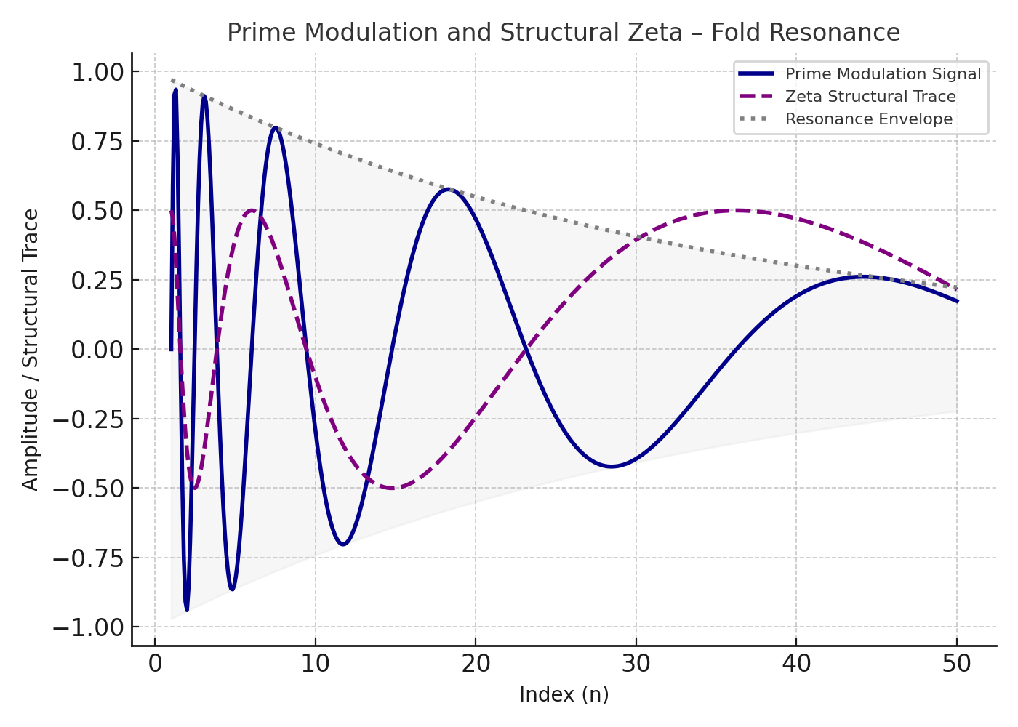

Figure: Prime Modulation Appendix A Diagram

# Formal Commentary on Zeta as Symbolic Structure

## 1. Structural Representation of ζ(s)

Define ζ(s) as a layered object:  
- Additive: ζ(s) = ∑ n^{-s}  
- Multiplicative: ζ(s) = ∏ (1 - p^{-s})^{-1}  
- Symbolic modulation layer: Folded prime recurrence structure  
These define ζ(s) not only as analytic, but as generative symbolic architecture.

## 2. Formal Modulation Framework

Define symbolic modulator ℱ_p(s) for each prime p:  
ℱ_p(s) = ∑_{k=1}^∞ φ(p, k) p^{-ks}, with φ defining scaled amplitude.  
Zeta reconstructed as symbolic superposition:  
ζ(s) ≈ ⊕_p ℱ_p(s)

## 3. Transformation Properties and Structural Covariance

Zeta symmetry transformations:  
- s ↦ 1 − s: functional duality  
- n ↦ 1/n: reparametrization symmetry  
- s ↦ s + it: phase-shift symmetry  
These preserve symbolic recurrence structure.

## 4. Interpretation of Zeros and Resonance

Zeros of ζ(s) correspond to cancellation points in symbolic prime harmonics.  
This treats them as structural fixed points, not mere analytic vanishing points.

## 5. Conclusion

ζ(s) functions as a structured modulation engine over ℕ, encoding hierarchical prime recurrence.  
Its layers reflect resonance structure and transformation invariance, justifying formal reinterpretation beyond analytic continuation.