Problem 12: Building and Testing Every Commit
Detailed Jenkins Continuous Integration Project Report
Repository: jarvis-ctrl69/jenkins-ci-pipeline | Branch: main

Project Summary
This report documents a Node.js continuous integration pipeline that uses GitHub, Jenkins, and Jest to validate changes automatically. A GitHub push starts a Jenkins run, which checks out the repository, prepares the Node.js tool environment, builds the application, runs automated tests, and reports the result. The evidence covers a successful run, a deliberately introduced failing test, and a later successful recovery.
The final submitted repository includes the application source, Jest tests, Dockerfile, Jenkinsfile, package metadata, and this report. The pipeline evidence shows that a test failure is detected and that the next corrected push can return the pipeline to success.

1. Objective and Expected Behaviour
The objective is to demonstrate continuous integration by connecting source control changes to an automated build and test process. Each relevant push should be checked consistently, so defects are visible soon after they are introduced.
- A valid change should pass the build and automated tests.
- A failing test should make the Jenkins run fail, exposing the regression.
- After correcting the defect and pushing the fix, Jenkins should run again and report success.

2. Tools and Project Structure
The repository uses Node.js 22, npm, Jest, GitHub, Jenkins, and Docker. Jenkins obtains the configured NodeJS-22 installation and executes the commands defined in the repository Jenkinsfile.
- src/app.js contains the application functions.
- tests/app.test.js contains Jest checks for the returned status message and number addition.
- package.json defines the build and test scripts and the Jest development dependency.
- Jenkinsfile defines checkout, tool installation, build, test, and post-action stages.
- Dockerfile uses node:22-alpine, installs dependencies, runs the build, and defaults to the test command.

3. Application and Automated Tests
The sample application exports getMessage(), which returns “Jenkins CI Pipeline is Working!”, and addNumbers(a, b), which returns the sum of its arguments. The Jest suite checks the exact message and verifies that 10 + 20 returns 30. These checks provide repeatable pass/fail evidence for the pipeline.
The project scripts are npm run build, which performs a Node.js syntax check on src/app.js, and npm test, which runs Jest in-band. In Jenkins, dependencies are installed before the build and tests run.

4. Jenkins Pipeline Stages
Checkout SCM. Jenkins retrieves the revision associated with the GitHub push.
Tool Install. The job selects the configured NodeJS-22 installation and environment.
Build. The pipeline installs npm dependencies and runs npm run build.
Test. The pipeline runs npm test. A failing Jest assertion marks this stage and the overall run as failed.
Post Actions. The Jenkinsfile prints a success message or failure message and always records that execution completed.

5. GitHub Webhook and Automatic Runs
The supplied Jenkins screenshots identify the runs as started by a GitHub push from jarvis-ctrl69. This confirms the push-to-Jenkins trigger in the captured runs. When a new push is received, GitHub sends the configured webhook event to Jenkins; Jenkins then checks out the pushed revision and runs the pipeline. The webhook starts validation. It does not itself regenerate or publish this Word report.
The Jenkins screenshots show that the webhook-driven job was reached through an ngrok-hosted Jenkins address during the captured session. For future triggers to work when Jenkins is behind a local network, the configured webhook endpoint must remain reachable and the Jenkins job must continue to monitor the repository and branch. A temporary tunnel address may need to be updated if it changes.

6. Build Evidence and Results
The following screenshots were supplied as evidence for the final sequence. They are centered, sized proportionally, and captioned.
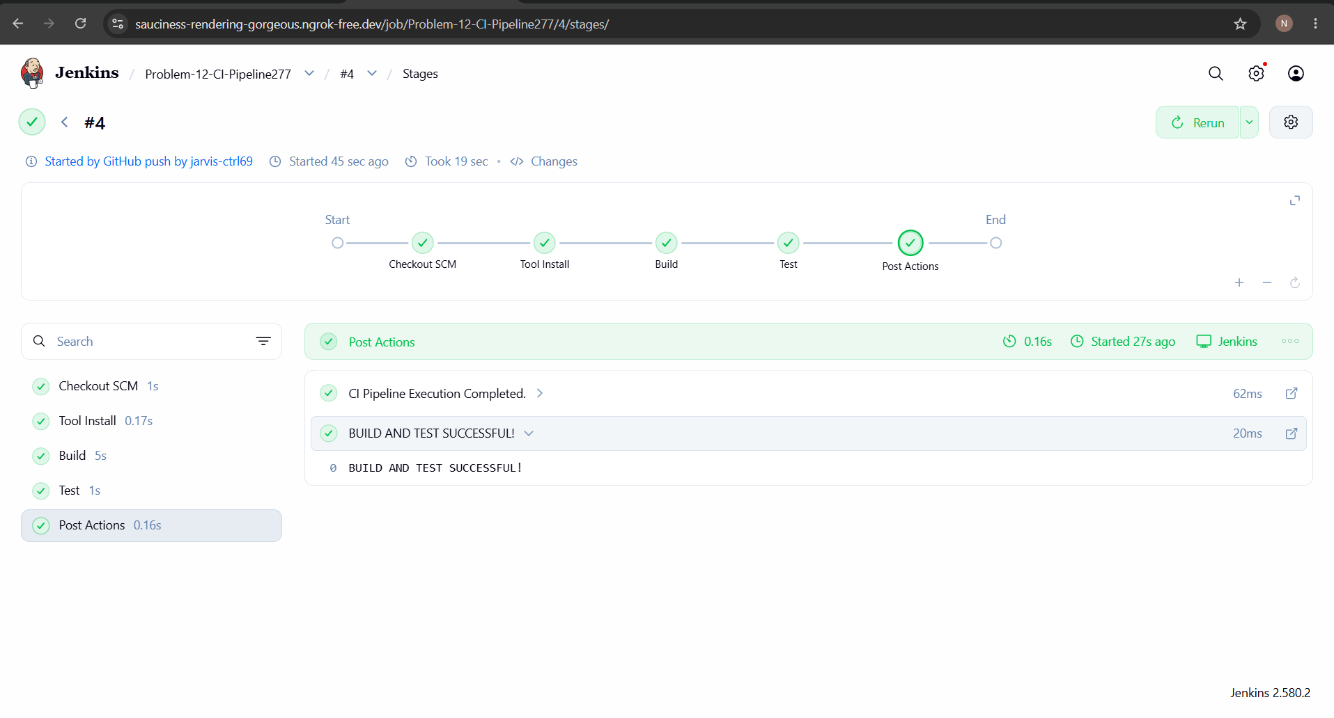
Build 4: automatic GitHub push trigger with successful checkout, tool installation, build, tests, and post actions.
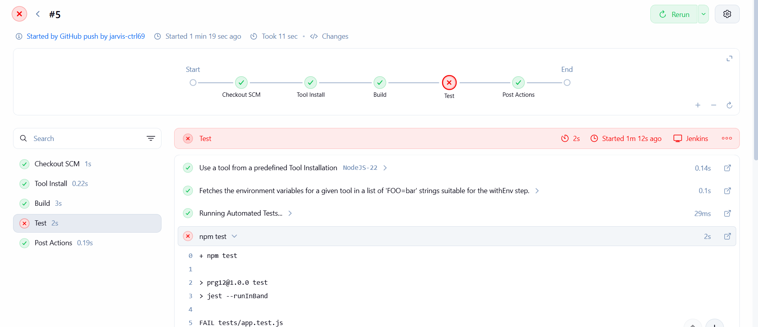
Build 5: controlled test failure. Checkout, tool installation, and build passed; the Test stage failed as expected, while post actions completed.
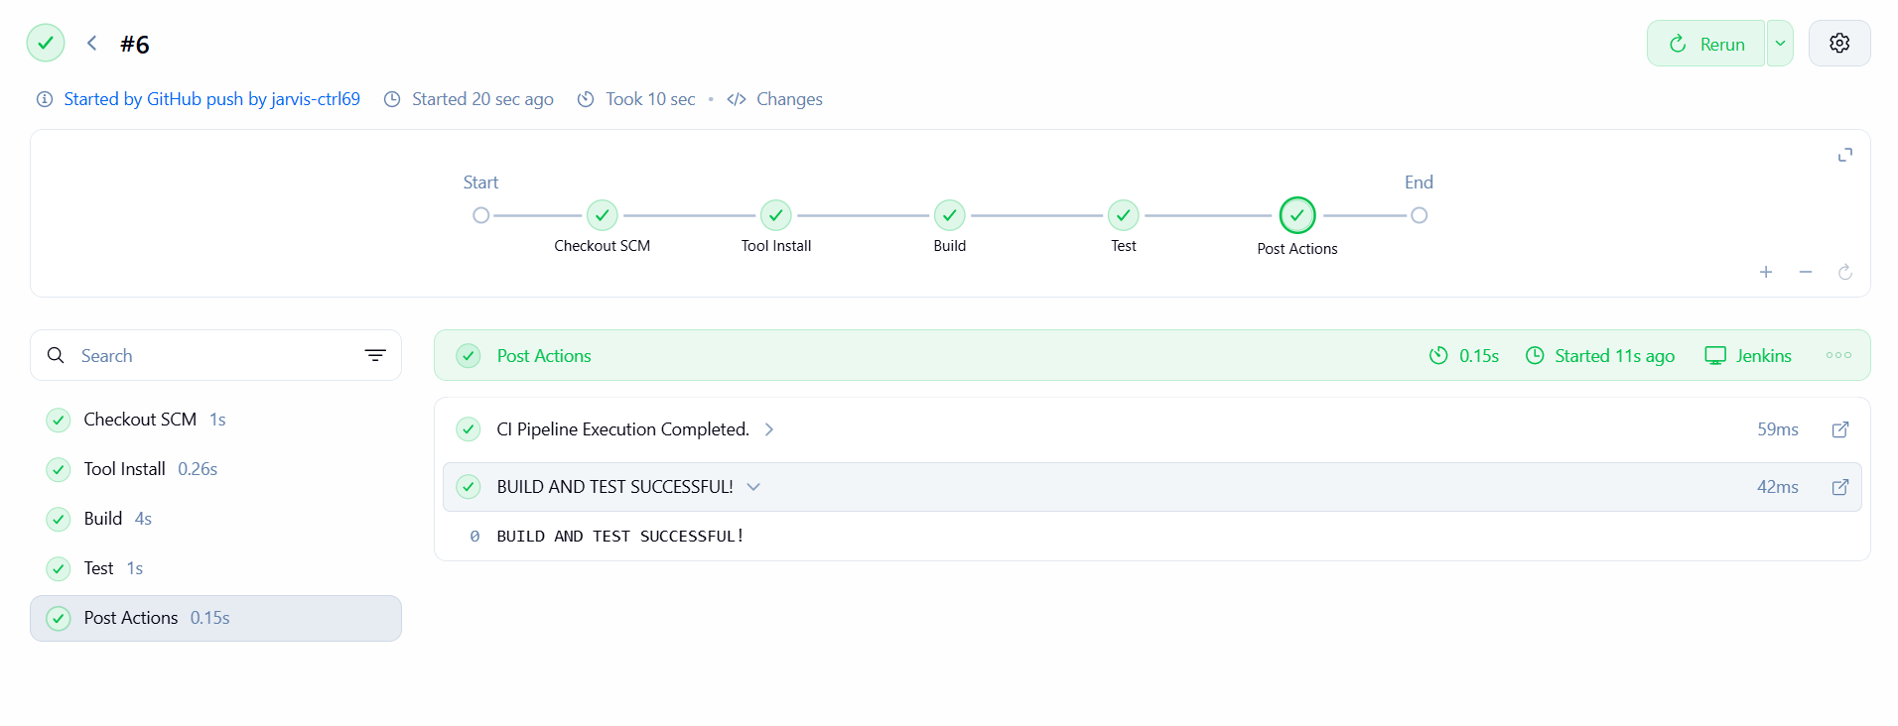
Build 6: recovery after the test correction. The GitHub push started the run, and every stage including Test and Post Actions passed.

7. Interpretation of the Build Sequence
Build 4 is green across Checkout SCM, Tool Install, Build, Test, and Post Actions. Its details identify the run as started by a GitHub push and show the success message “BUILD AND TEST SUCCESSFUL!”.
Build 5 demonstrates failure handling. The test stage fails at npm test, while checkout, tool installation, build, and post actions pass. This is the intended CI outcome: the pipeline detects the failing test and marks the run red instead of reporting a clean result.
Build 6 demonstrates recovery. It is another GitHub-push-triggered run, and all displayed stages pass, including Test and Post Actions. The sequence therefore documents success, detection of a test regression, and a later successful run after correction.

8. Conclusion
The project demonstrates the central continuous integration loop: commit and push code, run a repeatable Jenkins build and test pipeline, detect a test failure, correct the issue, and confirm recovery in a subsequent run. The repository keeps the pipeline definition beside the application and test code, making the CI process reviewable and version controlled.
The screenshots establish the outcomes for Builds 4, 5, and 6. They do not establish a scheduled report-generation process; the automation shown is the GitHub push trigger for Jenkins CI.

