Planting a tree for Keith Jarvis at Victor Harbor

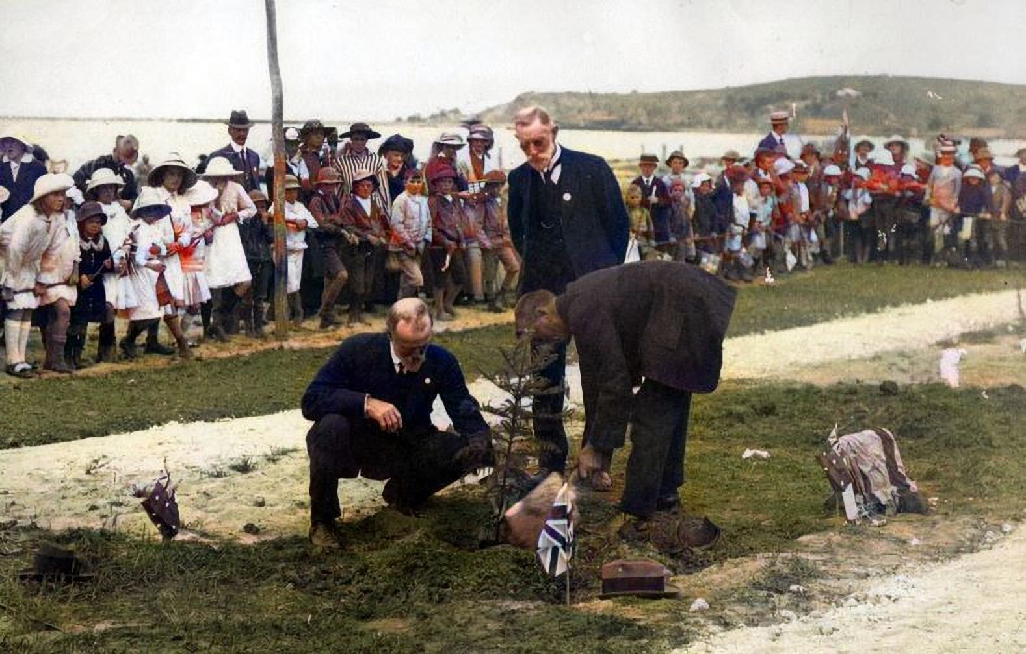

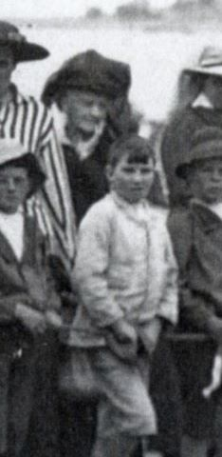
As annotated by Beryl Jarvis

Postcard/photograph Dated 25th April, 1917 “Anzac Day” Victor Harbor.

Notation as follows: Planting a tree in memory of Keith. This card only shows part of the crowd near the enclosure, there are six trees been planted in memory of the Harbor boys that have died or been killed while on Active service. No signature appears on the card. Eliza (Gran) and Les are in the crowd. Photo given by Alice Jarvis.

