Greg's 12 birthday

Back to the album

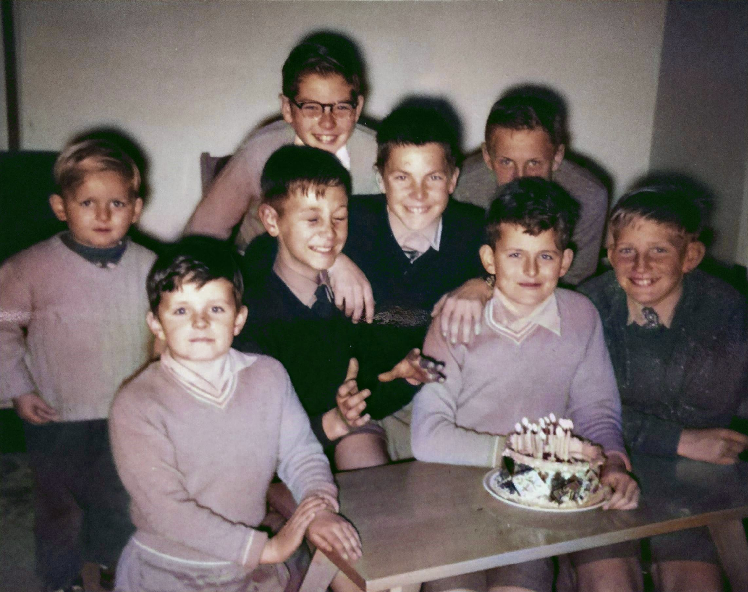

At rear : Lynn Jarvis.
Middle row : Jeffrey Desmond, Chris Stagg, John Whittle Grieg Lyas.
Front : Trevor Desmond, Greg Desmond (with the cake), Kym Just.

