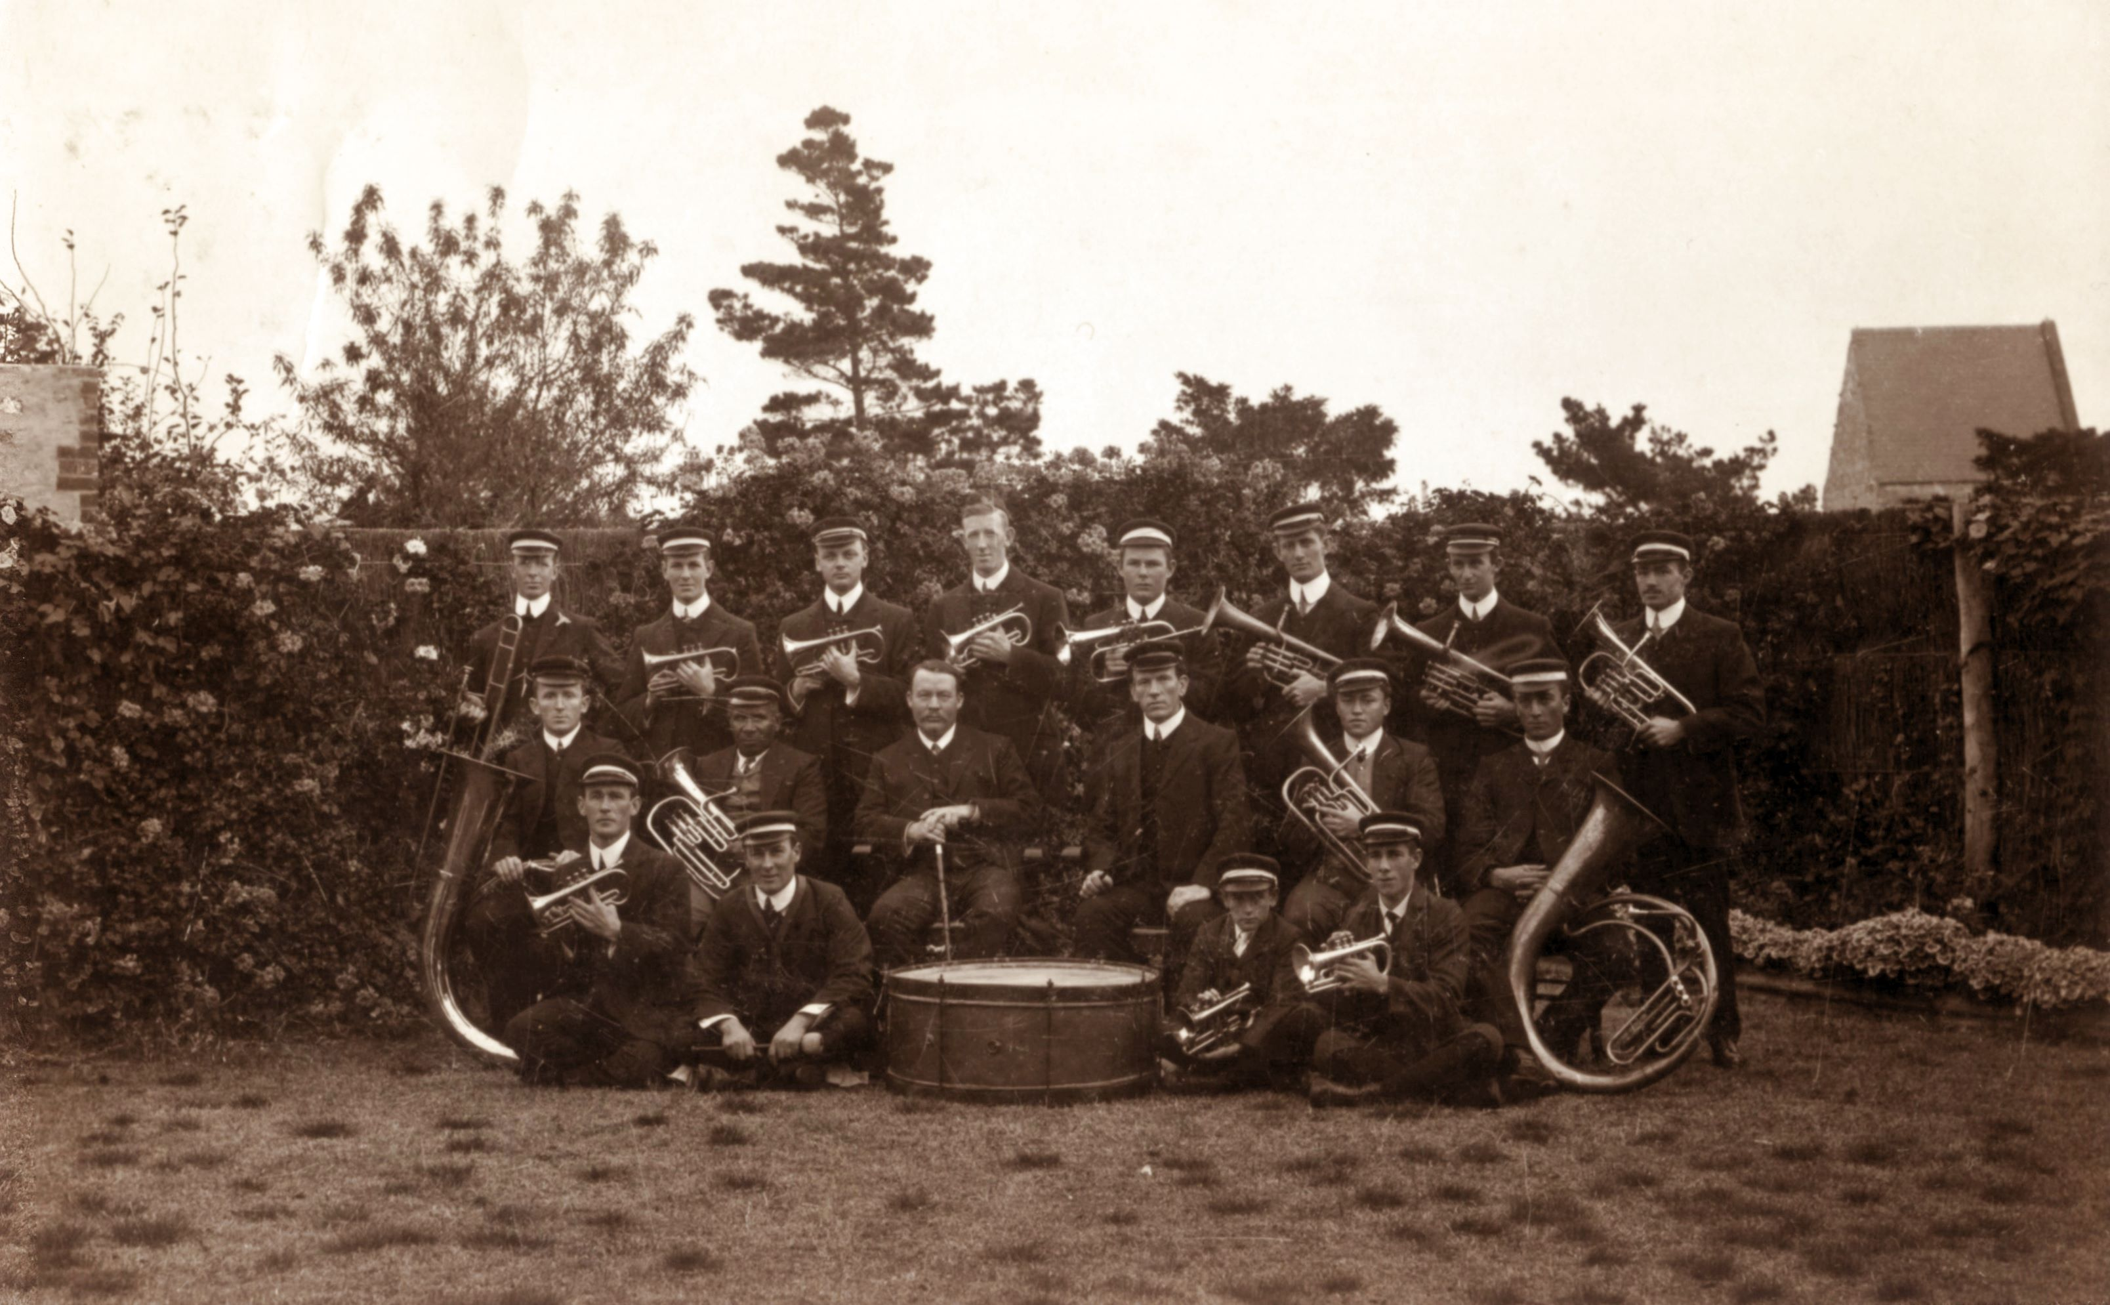
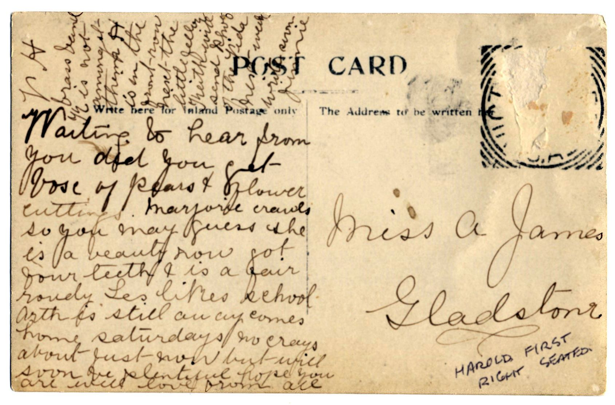
This is a postcard from Jinnie (Eliza) James to Miss A James

To : Miss A James, Gladstone

Waiting to hear from you. Did you get box of pears and flower cuttings. Marjorie crawls so you may guess she is a beauty now. Got four teeth and is a fair rowdy. Les likes school. Keith is still away. Comes home Saturdays. No crays about just now but will soon be plentiful. Hope you are well with love from all.

Top hand written :
VH brass band. K is not amongst them. H is in the front-row next-the little fellow.
Keith will write send photo of the Vida next week. Write soon.

Jinnie

From this we can deduce that the postcard is from Eliza (Jinnie) James to her sister (Miss A James, known as “Al”). Jinnie married Arthur (Pa) Jarvis and the postcard shows their second son Harold (H), born 1894, in the Victor Harbor brass band at bottom right seated on the ground holding the cornet “next to the little fellow”.

Keith (K) was their first son, born 1891, and from other records we know that he had a boat called the Vida. Les was the 5th child, born 1904. Marjorie was the last child, born 1909.

If Marjorie had teeth and was crawling, not walking, she must have been 2 years old or less. The postcard may have been around 1910-11. Then Les would have been 6-7 (liked school) and Keith 19-20 (had a boat and visited weekends). Harold would have been 16-17 (in the brass band at Victor Harbor). War record photos show him as a bugler. There are two more sons that she doesn't mention. Eric Roy, born 1896 and Reginald Lancelot, born 1899.

