Desmond family

Back to the album

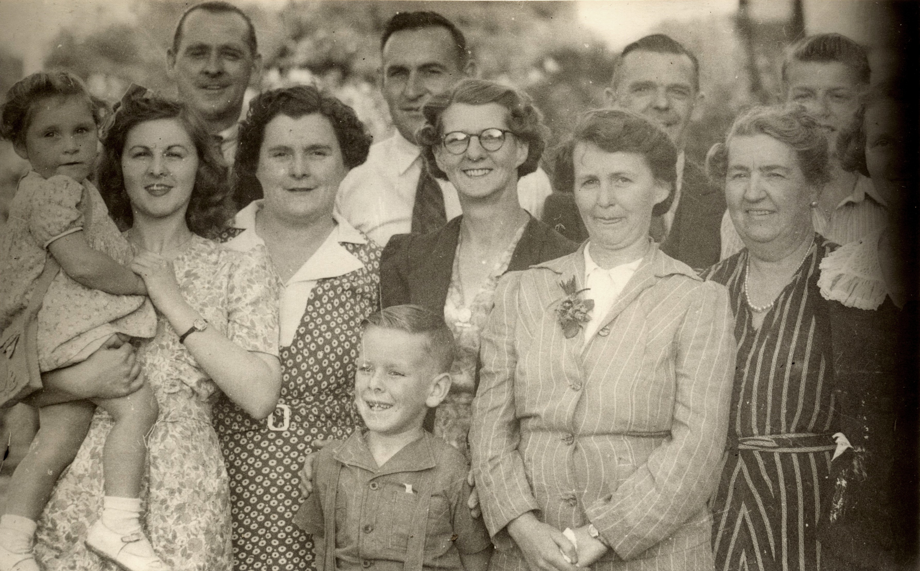

From left to right :
At rear : Arnold Scott, Jack Stennett, Cyrill Scott, unknown
Centre row: Miriam Stennett (child), Norma Scott, Lilly Stennet (Scott), Olive Scott, Violet Scott (Moon), Chrissie (Ellen May) Scott.
At front : Neil Quintrell

