Sanderson family in PortAugusta 1960

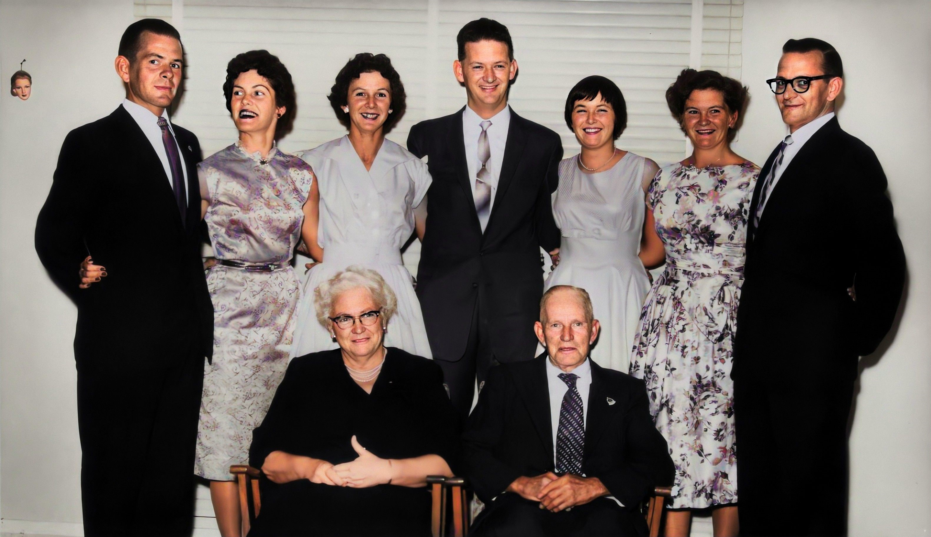

Back row:
Francis Bernard (Frank) Sanderson, Shirley Mary Sanderson, Jennifer Beatrice (Jenny) Sanderson, Arthur Murray Sanderson, Lesley Christine Sanderson, Verna Dawn (Betty) Sanderson, Robert Lindsay (Bob) Sanderson
Front row:
Gertrude Sanderson (nee Spurling), Verner Stuart Lesley Sanderson

