Jarvis, Scott and Quintrell families – group photo

Back to the album

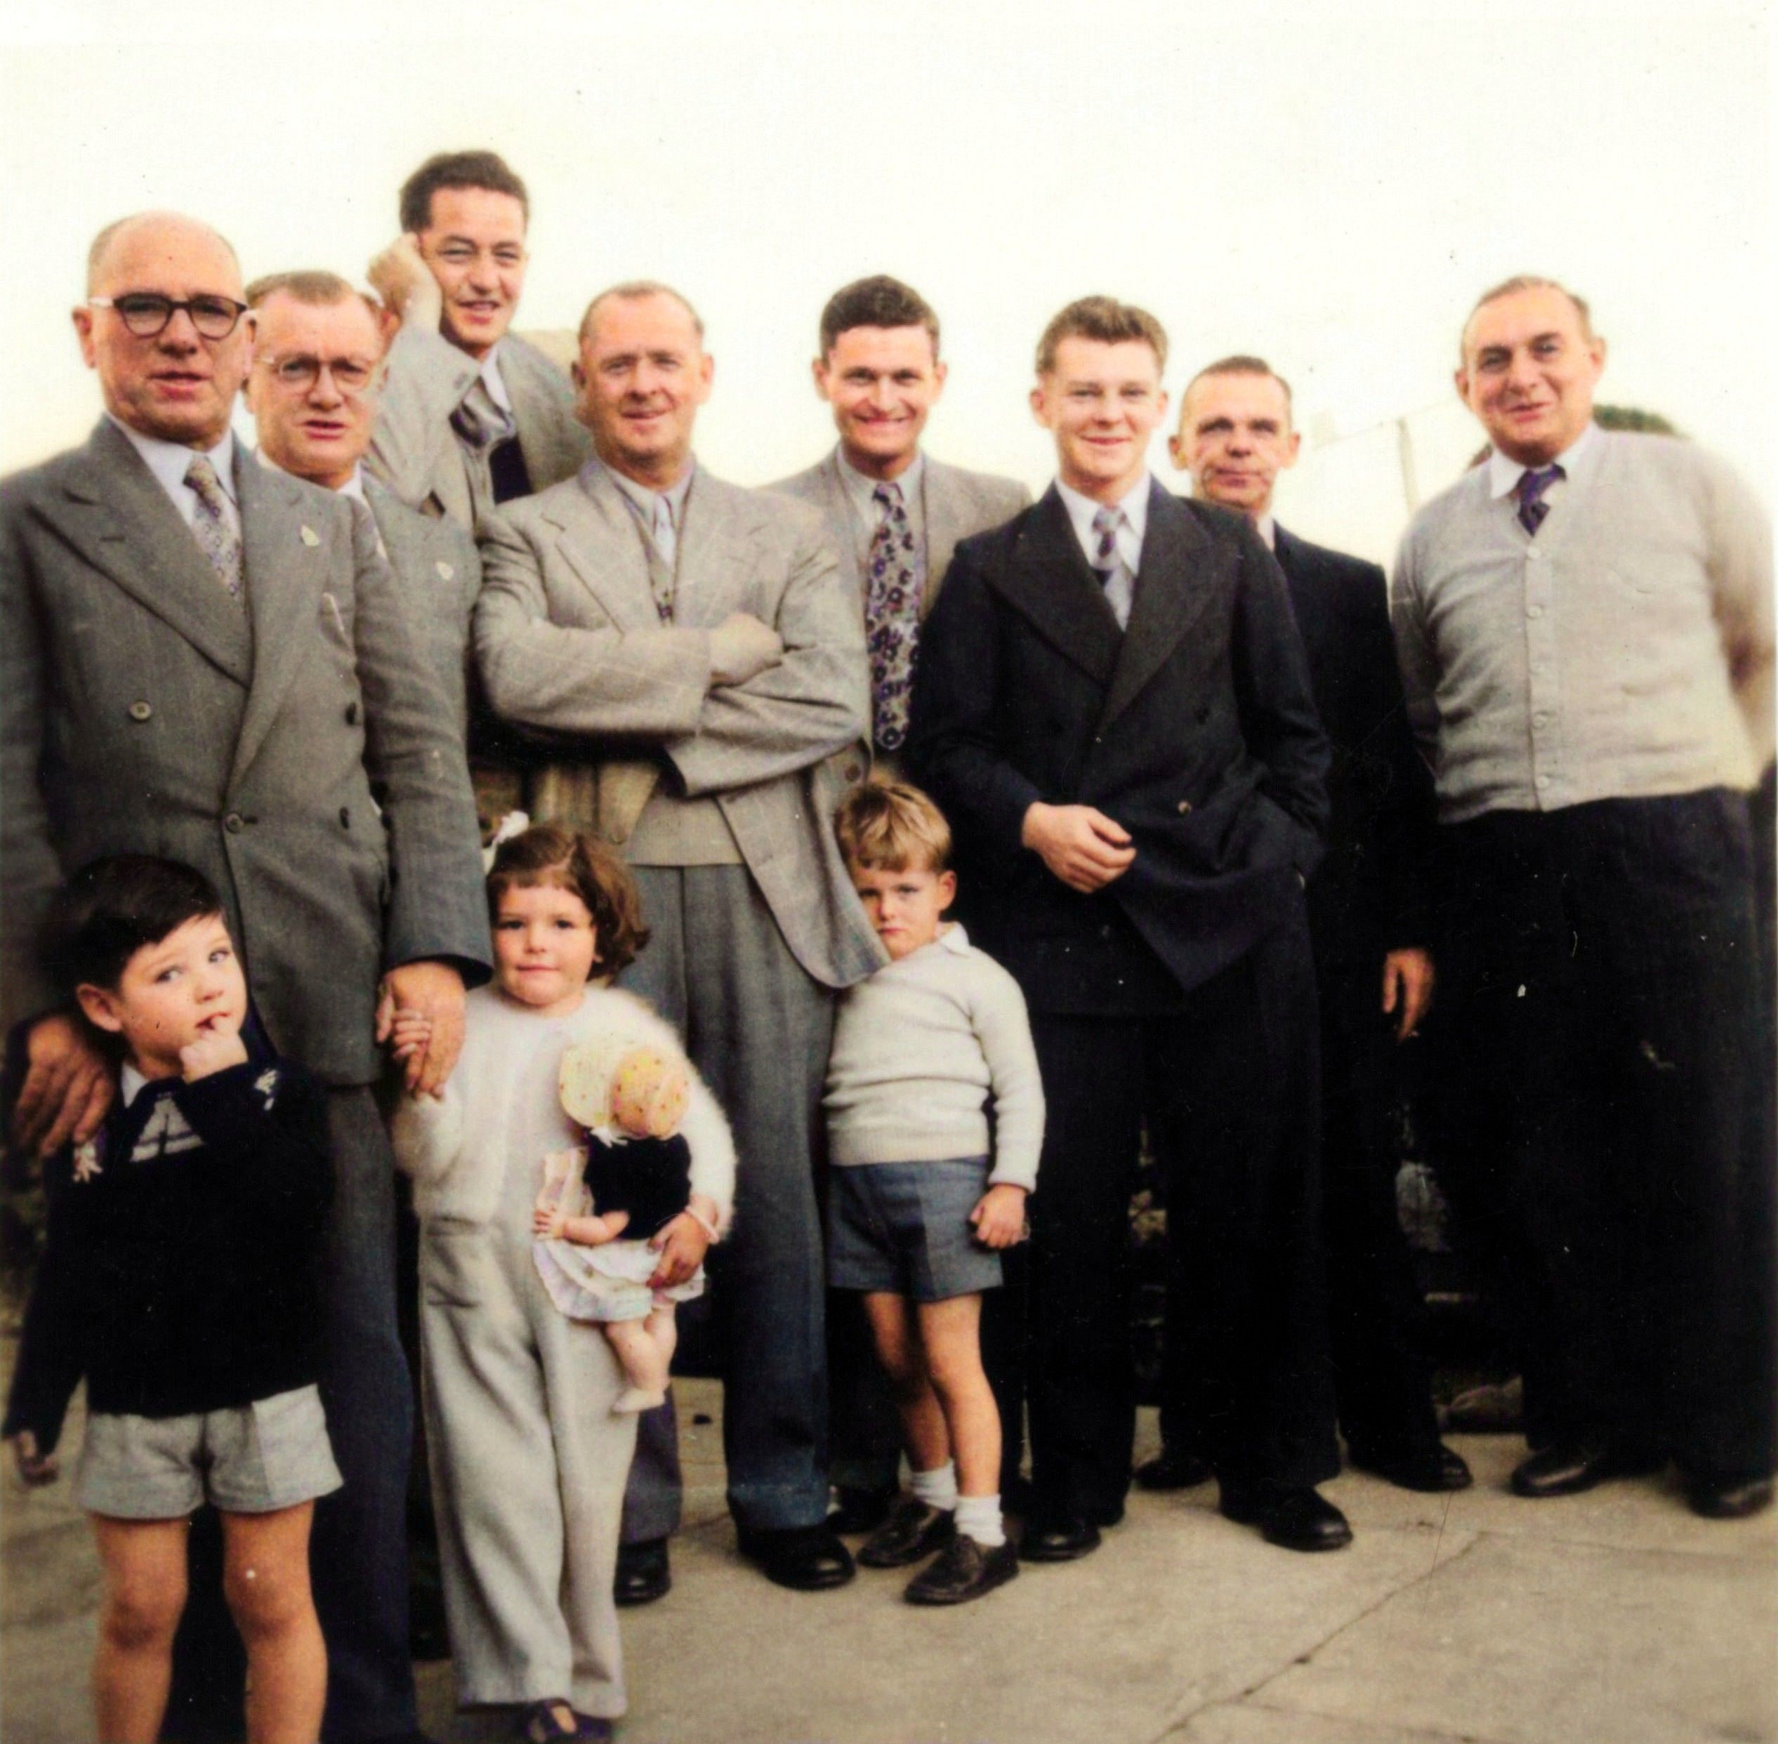
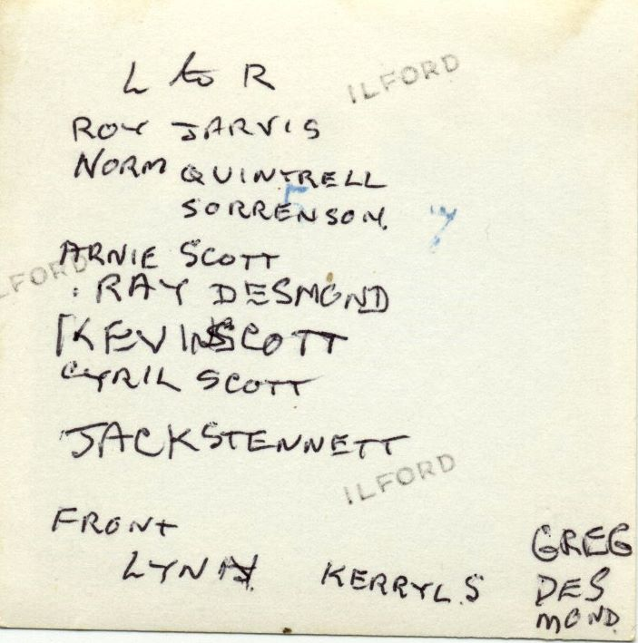
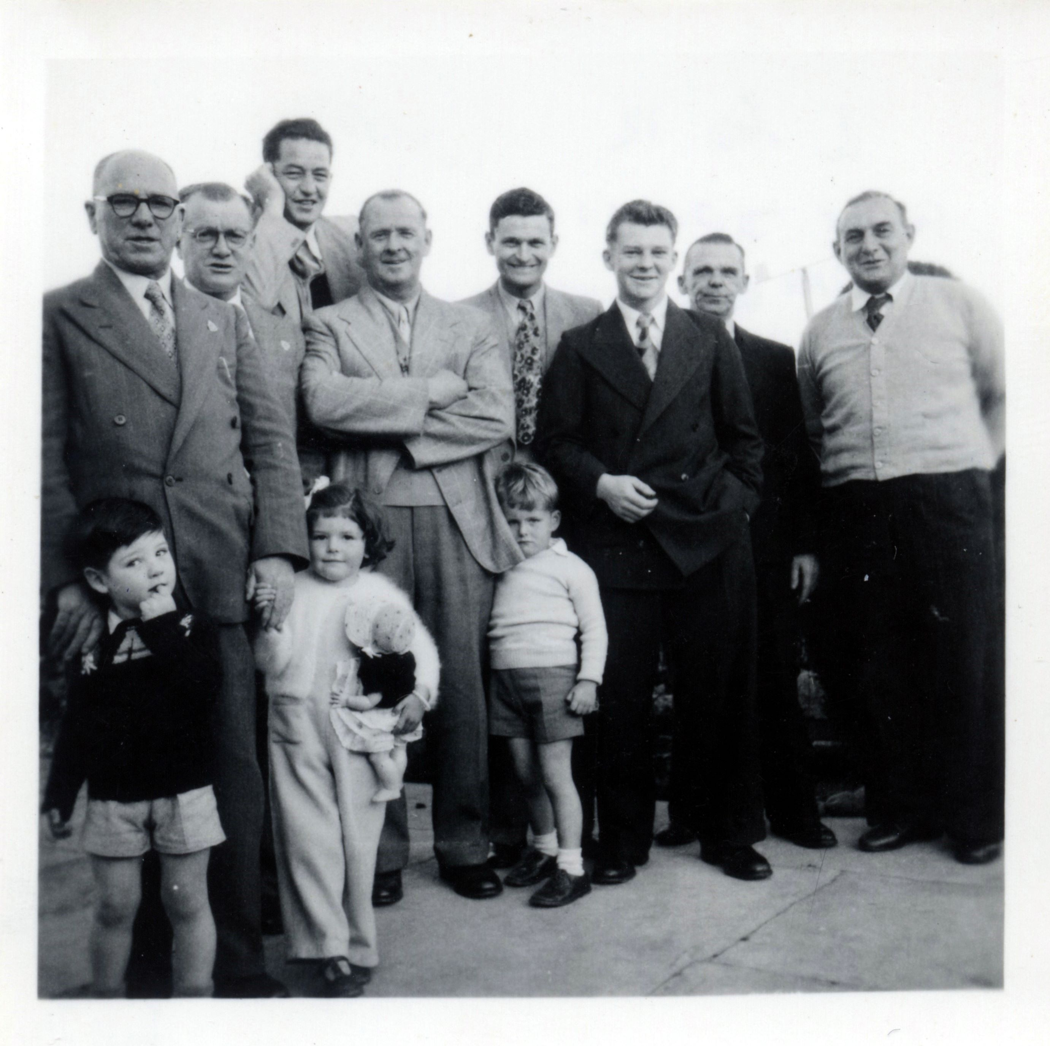

As annotated by Keith Jarvis

From left to right :

Roy Jarvis, Norm Quintrell, Gordon Sorensen, Arnie Scott
Ray Desmond, Kevin Scott, Cyril Scott, Jack Stennett

Front :

Lynn Jarvis, Kerryl Sorensen, Greg Desmond

Scott Family

Frederick James Scott b 1878 d 1947 m (1898) Lily May Pearce b 1882 d 1919
Alice May 1898
Arnold Frederick William Sidney 1900 (Arnie) m Violet Moon
Norma Scott m Ray Desmond (Ray)
Gregory Desmond (Greg)
Cyril Herman 1902 (Cyril)
Olive Myrtle 1905

Alice May Scott m Eric Roy Jarvis
Keith Jarvis m Shirley Sanderson
Lynn
Coralie
Ian
Shirley Jarvis m Gordon Sorensen
Kerryl
Meredith
Rosemary

Olive Myrtle Scott m Norman Quintrell (Norm)

