Scott and Pearce families

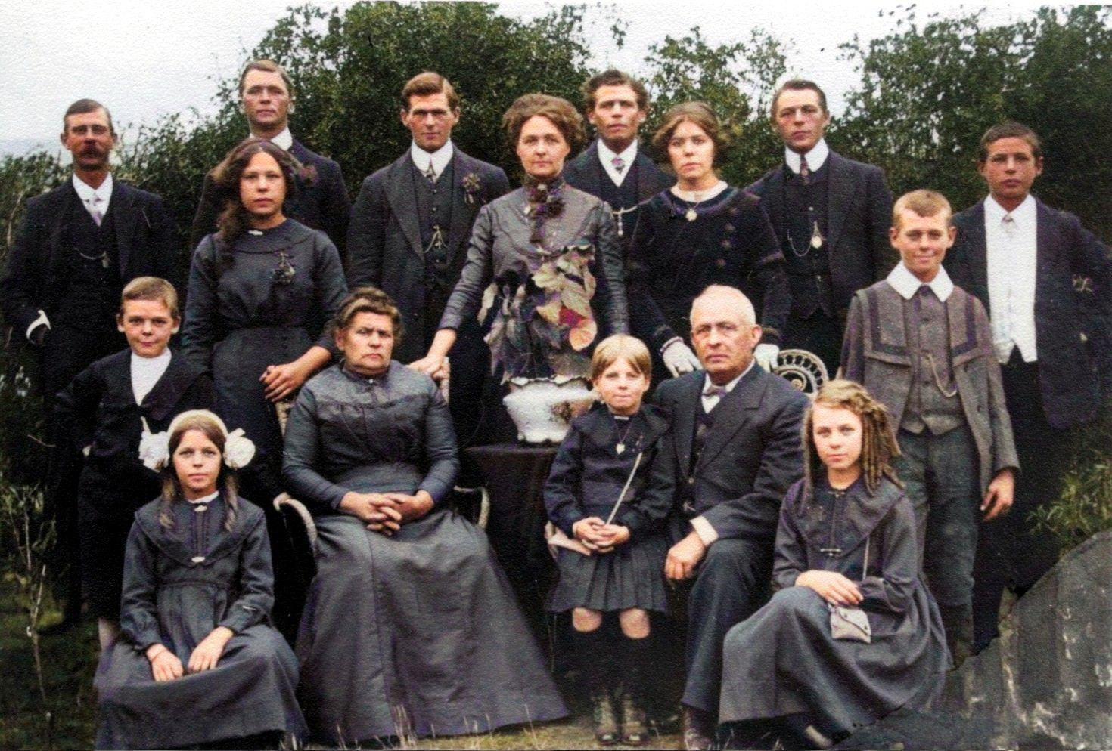

Back row:
Fred Scott, Percy Pearce, Oliver Pearce, Harold Pearce, Sid Pearce, Ernie Pearce
Middle row: Cyril Scott, May Pearce, Lily Scott, Maudie Pearce, Arnie Scott
Front row: Linda Pearce, Caroline Pearce, Olive Scott, Edwin William Pearce, Alice Scott

