Scott family photo

Back to the album

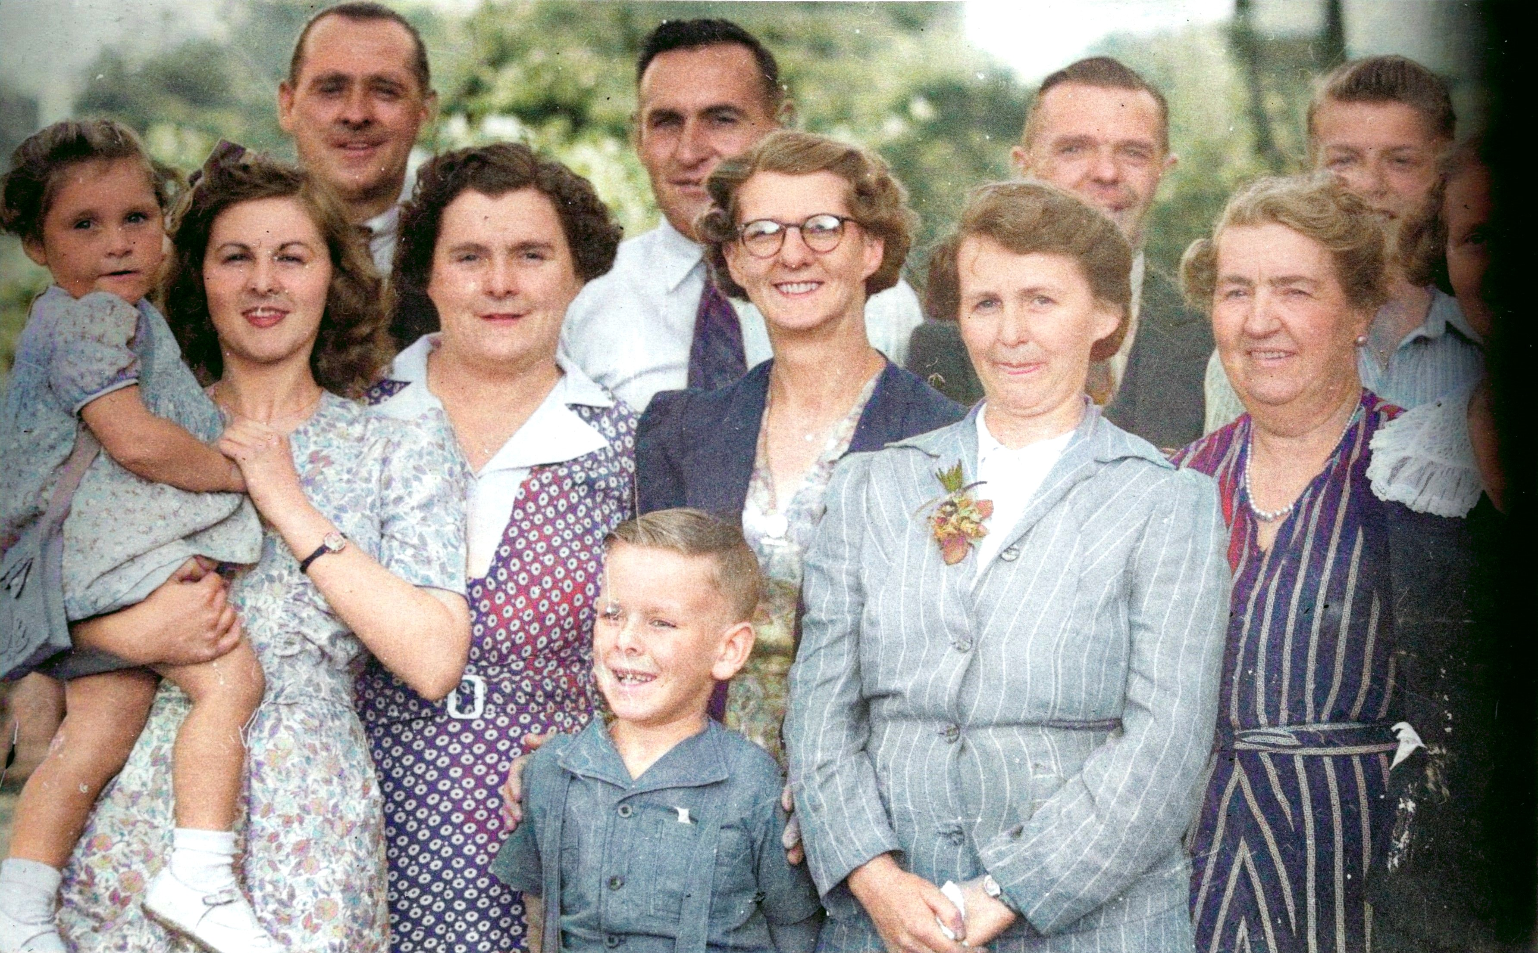

From left to right :

At rear :
Arnold Scott, Jack Stennett, Cyrill Scott, unknown

Centre row:
Miriam Stennett (child), Norma Scott, Lilly Stennett (Scott), Olive Scott, Violet Scott (Moon), Chrissie (Ellen May) Scott, unknown

Boy at front unknown

