Desmond family group photo

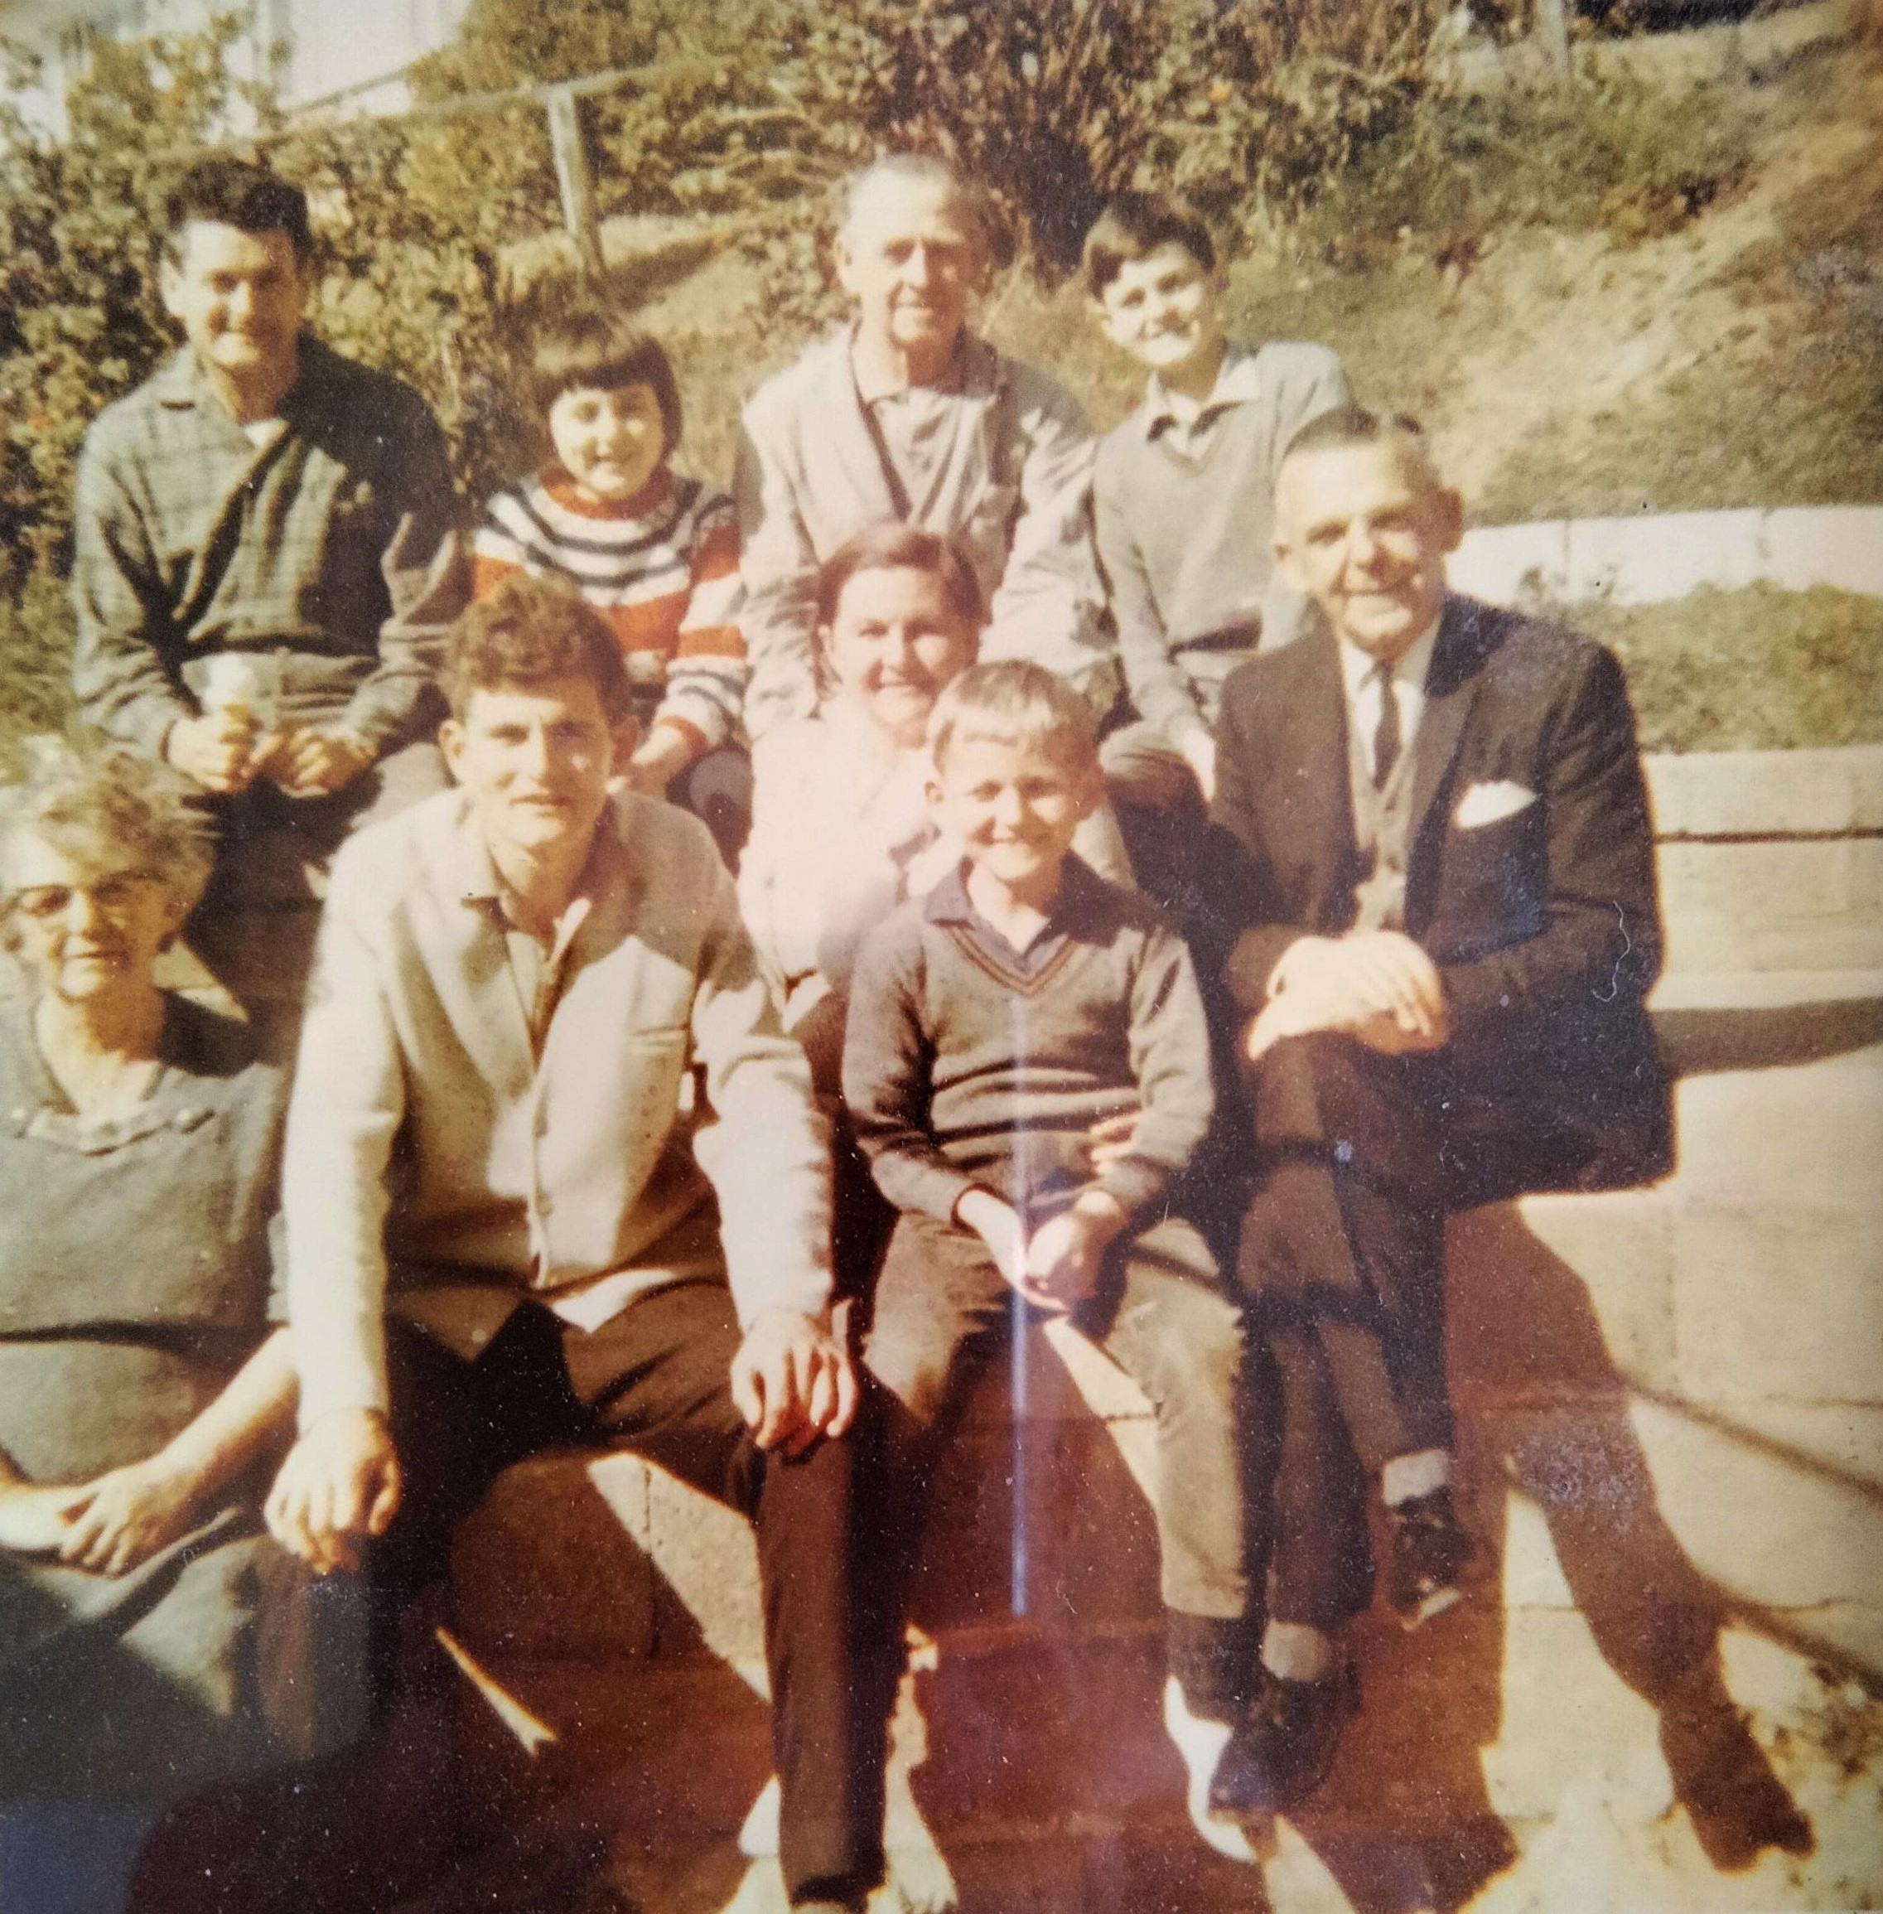

Back row:
Ray Desmond, Helen McBean, Arnold Scott, Trevor Desmond
Front row: Violet Scott, Greg Desmond, Norma Desmond, Jeffrey Desmond, Cyril Scott

