 ASANSOL ENGINEERING COLLEGE

department of computer science & engineering

CSE 2013



Hostel Management System

Vivekanand sarani, kanyapur, asansol west ebngal-713305

A Project Report on

**“HOSTEL MANAGEMENT SYSTEM”**

Submitted to Asansol Engineering College in partial fulfilment of the requirements for the degree

Bachelor of Technology,

(Computer Science & Engineering)

Of

West Bengal University of Technology

Project submitted by:

INDRAJEET MISHRA(09108001099)

PRITISH RANJAN TIWARI(09108001011)

AMRISH KUMAR PANDEY(09108001072)

SAURABH SUMAN (09108001049)

DEEPAK KUMAR MAHTO(09108001094)

ACKNOWLEDGEMENT

We, the final year students of 2013 batch of “ASANSOL ENGINEERING COLLEGE”, ”Computer Science and Engineering Department” are presenting the project on “HOSTEL MANAGEMENT SYSTEM”. It was a great experience indeed in developing the project. There was a friendly environment to work with all our group mates, their useful plans, suggestions and code contributions were highly appreciable.

We are thankful to Asansol Engineering College, for providing us a scope to develop a project.

INDRAJEET MISHRA

PRITISH RANJAN TIWARI

AMRISH KUMAR PANDEY

SAURABH SUMAN

DEEPAK KUMAR MAHTO

### CONTENTS

Chapters Pages

**1. Project Synopsis 5**

**2. Introduction 7**

**3. Project Details**

**3.1. System Requirements 9**

**3.2. Definitions and Theories 10**

**3.3. Entity Relationship Diagram 11**

**3.4. Tables 14**

**3.5. Data Flow Diagram 15**

**3.6. Results 16**

**4. Screen Shots 18**

**5. Conclusion and Future Scope 21**

**6. Bibliography 22**

1. PROJECT SYNOPSIS

As the name specifies “HOSTEL MANAGEMENT SYSTEM” is a software developed for managing various activities in the hostel. This particular project deals with the problems on managing a hostel registration and mess registration as well as fee management for both and avoids the problems which occur when carried manually.

It also provides students with an option to check their present fee account status and due dates for payment of fees. They can also select type of meal they want for the day or if they want to take meal off. An option for application for fee extension date is also provided which will be sent to admin and he needs to review and approve it.

Implemented in Java, MySQL for database connectivity a Hostel Management System is an automated and optimized system developed to facilitate the functioning of the hostel managing authorities. The project consists of client part and server. Server needs to store all the databases and client part can be run on any computer on LAN or INTERNET depending on institution’s requirement.

The system is feasible considering the technical feasibility, operational feasibility, scheduling feasibility. It utilises the utilities of Java Swings for designing the Graphical User Interface. The software can be implemented in any academic institution for different tasks to be managed for hostel. The costs incurred in the development of the system is quite affordable considering the ultimate success of the modules involved.

2. INTRODUCTION

**2.1 Problem definition**

In general in all institutions hostels are managed manually by the hostel office. The Registration form verification to the different data processing is done manually. Thus there are a lot of repetitions which can be easily avoided. And hence there is a lot of strain on the person who are running the hostel and software’s are not usually used in this context. This particular project deals with the problems on managing a hostel and avoids the problems which occur when carried manually Identification of the drawbacks of the existing system leads to the designing of computerized system that will be compatible to the existing system with the system which is more user friendly and more GUI oriented. We can improve the efficiency of the system, thus overcome the drawbacks of the existing system.

**2.2) Scope**

The software can be implemented in any academic institution for hostel management system. Student registration, meal options and account books for individual students can be managed accordingly.

**2.3) Technologies to be used**

This project is designed as a desktop application developed on the platform of

* Java(Front end)
* PHP and MySQL(Back end)

**2.4) Overview**

* Main facilities available in this project are:-
  + Student Registration for hostel and room allotment
  + Managing Student Fee and meal options
  + View seat availability in different hostels
  + Details of Account status to be checked by student
  + Option for fee extension application and meal change options

**2.4.1) Home Panel**

**2.4.1.1 Student Login**

Student login is used by students to login to their individual account and check their account status, meal selection, fee extension application and logout. During login username and password are validated by server and user is granted access.

**2.4.1.2 Admin Login**

Admin login is provided for administrative purposes. The username and password are validated on server and user is provided access. The user is provided with four options seat allotment, mess corner, accounts and logout.

**2.4.1.3 Seat Availability**

This option is provided in the home panel to check if there is seat available in hostels. The benefit of this is user (either student or admin) don’t have to go through the trouble of logging in to check this. Students can check for seat prior to going for registration.

**2.4.1.4 About**

This section provides an overview of functionalities of project and technologies used.

**2.4.2) Student panel**

**2.4.2.1 Account Book**

* Students can check their registration details.
* They can check the dates till their fees are paid for hostel and mess.
* They can view the next due date for payment of fees.

**2.4.2.2 Meal Corner**

Students are provided with 3 options for meal decision for current day.

* Veg meal
* Non-veg meal
* Meal off for the day

**2.4.2.3 Fee Extension**

Students can upload an application for fee extension and send it to admin for review.

**2.4.2.4 Logout**

When user presses logout he is returned to the home panel and session is closed.

**2.4.3) Admin Panel**

**2.4.3.1 Seat Allotment**

The Administrator is provided with a registration form with all the necessary details to be filled. Once he clicks the allot button all necessary changes are made to the database on server. Username and Password of student are generated which is sent to student’s email address automatically by the system if the institution has set up a mail server or it can be given to student manually.

**2.4.3.2 Accounts**

Administrator can manage the accounts of individual students. The functions provided in there are:

* Search student by name.
* Open accounts of particular student by roll number.
* View and approve fee extension application of students.
* Update the accounts of students.

**2.4.3.3 Mess Corner**

Hostel authorities can check how many student have selected vegetarian, non-vegetarian or meal off option.

**2.4.3.4 Logout**

When user presses logout he is returned to the home panel and session is closed.

3. PROJECT DETAILS

**3.1 System Requirements**

**For Server**

|  |  |  |
| --- | --- | --- |
| **Hardware Requirements** | | |
| **Processor** | **RAM** | **Disk Space** |
| i3,i5 | 4 GB or higher | 1TB |
| **Software Requirements** | | |
| **OS** | **For Database** | |
| WXP,W7,W8,LINUX | PHP Triad (PHP 5.02 or above, MySQL, Apache, and PHPMyAdmin) | |

**For Client**

|  |  |  |
| --- | --- | --- |
| **Hardware Requirements** | | |
| **Processor** | **RAM** | **Disk Space** |
| Pentium II,III,IV,CORE i3,i5 | 64 MB or higher | 100 MB |
| **Software Requirements** | | |
| **OS** | | |
| WXP,W7,W8,LINUX | | |

**3.2 Definitions and Theories**

**3.2.1Java Swings**

Java Swings is a library/toolkit released by Oracle as a part of Java language which enables Java programmers to create GUI and rich client applications.

## JFC

## Swing is a part of Java Foundation classes (JFC). JFC consists of the following modules

[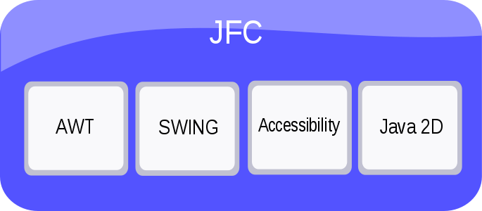](http://en.wikibooks.org/wiki/File:JavaSwing0008.svg)

### Swing GUI Components

Swings GUI components are those which are buttons, labels, combo box, text field, rich text editors, lists etc. Many components have features like drag and drop, sorting, printing, to name a few.

### Pluggable Look-and-Feel Support

Look and feel module defines how the component looks and feels to the user. Java swings application has a separate look and feel effect. The programmers can change the look and feel of their application to Windows look and feel or GTK look and feel. There are many hundreds of look and feel available from various sources.

### Accessibility API

Not all humans are perfect. There is a good chance that disabled person can use our program, hence your program must be accessible to him / her. JFC Accessibility API enables you to create programs that are accessible by providing these people with screen readers, braille displays so that they can get information from the user interface.

**3.2.2 PHP TRIAD**

PHPTriad installs a complete working PHP/MySQL server environment. Installs PHP, MySQL, Apache, and PHPMyAdmin.

**3.2.2.1 PHP**

PHP is a scripting language originally designed for producing dynamic web pages. It has evolved to include a command line interface capability and can be used in standalone graphical applications. While PHP was originally created by Rasmus Lerdorf in 1995, the main implementation of PHP is now produced by The PHP Group and serves as the de facto standard for PHP as there is no formal specification. PHP is free software released under the PHP License, however it is incompatible with the GNU General Public License (GPL), due to restrictions on the usage of the term PHP. It is a widely-used general-purpose scripting language that is especially suited for web development and can be embedded into HTML. It generally runs on a web server, taking PHP code as its input and creating web pages as output. It can be deployed on most web servers and on almost every operating system and platform free of charge. PHP is installed on more than 20 million websites and 1 million web servers.

***Usage***

PHP is a general-purpose scripting language that is especially suited for web development. PHP generally runs on a web server, taking PHP code as its input and creating web pages as output. It can also be used for command-line scripting and client-side GUI applications. PHP can be deployed on most web servers, many operating systems and platforms, and can be used with many relational database management systems. It is available free of charge, and the PHP Group provides the complete source code for users to build, customize and extend for their own use.

PHP primarily acts as a filter, taking input from a file or stream containing text and/or PHP instructions and outputs another stream of data; most commonly the output will be HTML. It can automatically detect the language of the user.

**3.2.2.2 MySql**

MySQL is a database system used on the web. Basically, a MySQL database allows you to create a relational database structure on a web-server somewhere in order to store data or automate procedures

MySQL is also open source in that it’s free and falls under the GNU General Public License (GPL). Interacting with a MySQL database is a little weird as we don’t have the tried and true WYSIWYG interface that something as easy as Microsoft Access affords. When creating tables, we’ll either have to create them by using SQL Statements, In comparing MySQL to Access you’re going to have a truckload of differences. While MySQL isn’t exactly tough to tackle (once the tables are created – you’re pretty much done with it), it’s capabilities extend far beyond that of Microsoft Access when dealing with speed and reliability. It’s simply a better system – and it should be. Microsoft Access (as much as I love it) is only a desktop database system. And while a limit of 10-20 concurrent Microsoft Access users is fine for most small organizations – when you’ve got a webpage getting 10,000 hits a day you’ll need something that can handle all of those queries efficiently.

MySQL tables also have the luxury of using “real” data types – not those little fluffy ones you see in Microsoft Access. Need a text field that can hold over four billion characters? Not a problem, just use the LongText data type. Want the field to hold that many characters and be case-sensitive? Easy, just use the Long Blob data type. Need to store numbers from 0 to 18,446,744,073,709,551,615 (for those of you who are curious, that would be over 18 Quintillion), then use the BigInt data type. Indeed, 18 quintillion is a big integer.

**3.2.2.3 phpMyAdmin**

phpMyAdmin is an open source tool written in PHP intended to handle the administration of MySQL over the World Wide Web. phpMyAdmin supports a wide range of operations with MySQL. Currently it can create and drop databases, create/drop/alter tables, delete/edit/add fields, execute any SQL statement, manage users and permissions, and manage keys on fields. while you still have the ability to directly execute any SQL statement. phpMyAdmin can manage a whole MySQL server (needs a super-user) as well as a single database. To accomplish the latter you’ll need a properly set up MySQL user who can read/write only the desired database. It’s up to you to look up the appropriate part in the MySQL manual.

phpMyAdmin can:

* + browse and drop databases, tables, views, fields and indexes
  + create, copy, drop, rename and alter databases, tables, fields and indexes
  + maintenance server, databases and tables, with proposals on server configuration
  + execute, edit and bookmark any SQL-statement, even batch-queries
  + load text files into tables
  + create and read dumps of tables
  + administer multiple servers
  + manage MySQL users and privileges
  + using Query-by-example (QBE), create complex queries automatically connecting required tables
  + create PDF graphics of your Database layout
  + search globally in a database or a subset of it
  + support mysqli, the improved MySQL extension

**3.2.2.4 Apache Web server**

Often referred to as simply Apache, a public-domain open source Web server developed by a loosely knit group of programmers. The first version of Apache, based on the NCSA httpd Web server, was developed in 1995.

Core development of the Apache Web server is performed by a group of about 20 volunteer programmers, called the Apache Group. However, because the source code is freely available, anyone can adapt the server for specific needs, and there is a large public library of Apache add-ons. In many respects, development of Apache is similar to development of the Linux operating system.

The original version of Apache was written for UNIX, but there are now versions that run under OS/2, Windows and other platforms. The name is a tribute to the Native American Apache Indian tribe, a tribe well known for its endurance and skill in warfare. A common misunderstanding is that it was called Apache because it was developed from existing NCSA code plus various patches, hence the name a patchy server, or Apache server.

Apache consistently rates as the world’s most popular Web server according to analyst surveys. Apache has attracted so much interest because it is full-featured, reliable, and free. Originally developed for UNIX™ operating systems, Apache has been updated to run on Windows, OS/2, and other platforms. One aspect of Apache that some site administrators find confusing — especially those unfamiliar with UNIX-style software — is its configuration scheme. Instead of using a point-and-click graphic user interface (GUI) or Windows Registry keys as most other modern software packages, Apache generally relies on simple text files for its configuration settings.

*Configuration Files*

Apache uses a system of three text files for managing its configuration data. All three of these files (almost always) appear in Apache’s ./conf directory and are designed to be edited by system administrators:

1. httpd.conf for general settings

2. srm.conf for resource settings

3. access.conf for security settings

When Apache first starts, these files are processed in the order shown above. Originally, the initial installation of Apache included default entries within each of the three files. In the most recent versions of Apache, however, the default installation has changed. Now httpd.conf is treated as the “master” configuration file and it contains all of the settings. Both srm.conf and access.conf still exist in the installation, but they contain no settings and are empty except for some comments.

*Inside Httpd.conf*

Traditionally httpd.conf contained general settings such as the Server Name and Port number. These

Entries appear as follows in the file: Server Name compnetworking.about.com Port 80 The term “httpd”

stands for HTTP Daemon. Recall that in a UNIX environment, the term daemon refers to a type of process designed to launch at system boot and continue running for very long periods of time. This file contains a number of other entries (technically called directives), but for most of these, modifications are optional. Probably the most useful of these entries is ServerAdmin.

*Access and Security Settings*

It is recommended practice now for Apache administrators to manage their resource and security settings from httpd.conf. Administrators of older versions of Apache can simply cut their entries from srm.conf and access.conf and paste them into the master file. If an administrator wants to go one step further and delete the two empty files, they should also place the following entries in httpd.conf to prevent Apache from attempting to access them.

**3.3 Goals of proposed system**

1. **Planned approach: -** The scheduling of the whole process would be planned and organized. The data values will be stored properly in data stores, which will help in retrieval of information as well as its storage.

2. **Accuracy: -** The level of accuracy in the proposed system will be higher. All operation would be done correctly and it ensures that whatever information is coming from different sources is accurate.

3. **Reliability:** - The reliability of the proposed system will be high due to the above stated reasons. The reason for the increased reliability of the system is that now there would be proper storage of information.

4. **No Redundancy: -** In the proposed system utmost care would be that no information is repeated anywhere, in storage or otherwise. This would assure economic use of storage space and consistency in the data stored.

5. **Immediate retrieval of information: -** The main objective of proposed system is to provide for a quick and efficient retrieval of information. Any type of information would be available whenever the user requires.

6. **Immediate storage of information: -** In manual system there are many problems to store the largest amount of information.

7. **Easy to Operate: -** The system should be easy to operate and should be such that it can be developed within a short period of time and fit in the limited budget of the user.

**User Characteristics**

Every user should be:

*  Comfortable of working with computer.
*  He must have knowledge in duty scheduling field.
*  He must also have basic knowledge of English too.

**Constraints**

* GUI is only in English &Login and password is used for identification of user and there is no facility for guest.

**3.4 Definitions of problems**

Problems with conventional system

1. **Lack of immediate retrievals: -**In the conventional duty distribution system, the complexity increases due to a slow retrieval of data values and information.
2. **Lack of immediate information storage: -** The information generated by various database transactions takes time and effort to be stored at the appropriate place in time
3. **Lack of prompt updating**: Inability to update the data values in the conventional system immediately.
4. **Establishing distribution and arrangement:** Establishing duty distribution and seating arrangement in the conventional system was a hectic task to be accomplished.

**3.5 Feasibility Study**

Depending on the results of the initial investigation the survey is now expanded to a more detailed feasibility study. “***FEASIBILITY STUDY***” is a test of system proposal according to its workability, impact of the organization, ability to meet needs and effective use of the resources. It focuses on these major questions:

1. What are the user’s demonstrable needs and how does a candidate system meet them?
2. What resources are available for given candidate system?
3. What are the likely impacts of the candidate system on the organization?
4. Whether it is worth to solve the problem?

During feasibility analysis for this project, following primary areas of interest are to be considered. Investigation and generating ideas about a new system does this.

**Steps in feasibility analysis**

Eight steps involved in the feasibility analysis are:

* Form a project team and appoint a project leader.
* Prepare system flowcharts.
* Enumerate potential proposed system.
* Define and identify characteristics of proposed system.
* Determine and evaluate performance and cost effective of each proposed system.
* Weight system performance and cost data.
* Select the best-proposed system.
* Prepare and report final project directive to management.

**Technical feasibility**

A study of resource availability that may affect the ability to achieve an acceptable system. This evaluation determines whether the technology needed for the proposed system is available or not.

* Can the work for the project be done with current equipment existing software technology & available personal?
*  Can the system be upgraded if developed?
* If new technology is needed then what can be developed?

This is concerned with specifying equipment and software that will successfully satisfy the user requirement. The technical needs of the system may include:

**Front-end and back-end selection**

An important issue for the development of a project is the selection of suitable front-end and back-end. When we decided to develop the project we went through an extensive study to determine the most suitable platform that suits the needs of the organization as

well as helps in development of the project.

The aspects of our study included the following factors.

**Front-end selection:**

1. It must have a graphical user interface that assists employees that are not from IT background.

2. Scalability and extensibility.

3. Flexibility.

4. Robustness.

5. According to the organization requirement and the culture.

6. Must provide excellent reporting features with good printing support.

7. Platform independent.

8. Easy to debug and maintain.

9. Event driven programming facility.

10. Front end must support some popular back end like Oracle DB.

**Back-end Selection:**

1. Multiple user support.

2. Efficient data handling.

3. Provide inherent features for security.

4. Efficient data retrieval and maintenance.

5. Stored procedures.

6. Popularity.

7. Operating System compatible.

8. No installation.

According to above stated features we selected MySQL as the backend.

The technical feasibility is frequently the most difficult area encountered at this stage. It is essential that the process of analysis and definition be conducted in parallel with an assessment to technical feasibility. It focuses on the existing computer system (hardware, software etc.) and to what extent it can support the proposed system.

**Economic feasibility**

Economic justification is generally the “Bottom Line” consideration for most systems. Economic justification includes a broad range of concerns that includes cost benefit analysis. In this we weight the cost and the benefits associated with the candidate system and if it suits the basic purpose of the organization i.e. profit making, the project is making to the analysis and design phase. The financial and the economic questions during the preliminary investigation are verified to estimate the following:-

* The cost to conduct a full system investigation.
*  The cost of hardware and software for the class of application being considered.
* The benefits in the form of reduced cost.
* The proposed system will give the minute information, as a result the performance is improved which in turn may be expected to provide increased profits.
* This feasibility checks whether the system can be developed with the available funds. The HMSdoes not require enormous amount of money to be developed. This can be done economically if planned judicially, so it is economically feasible. The cost of project depends upon the number of man hours required.

**Operational Feasibility:**

It is mainly related to human organizations and political aspects. The points to be considered are:

* What changes will be brought with the system?
* What organization structures are disturbed?
* What new skills will be required? Do the existing staff members have these skills? If not, can they be trained in due course of time?

The system is operationally feasible as it very easy for the End users to operate it. It only needs basic information about Windows platform.

**Schedule feasibility**

Time evaluation is the most important consideration in the development of project. The time schedule required for the developed of this project is very important since more development time effect machine time, cost and cause delay in the development of other systems.

A reliable HMS can be developed in the considerable amount of time.

3.3 Entity Relationship Diagram

**HMS**

Student

Admin

Room

Registration of

manages

Approves

sends

views

Meal

Fee application

Accounts

3.4Tables

**Admin**



**Meal Password**

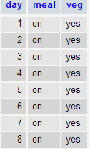 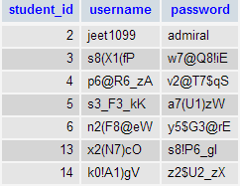

**Fee Application**

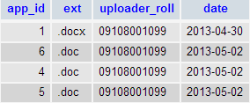

**Room**

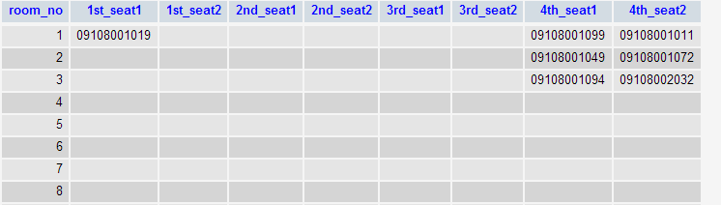

**Student**

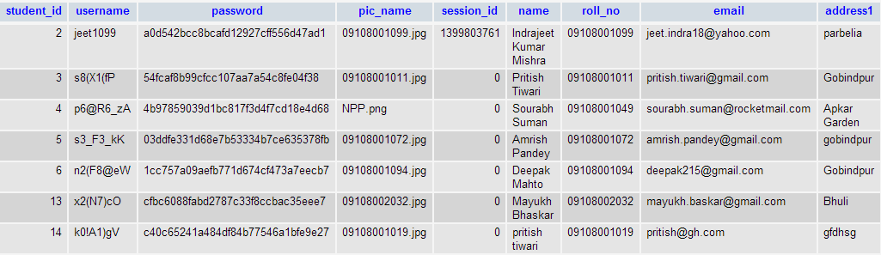

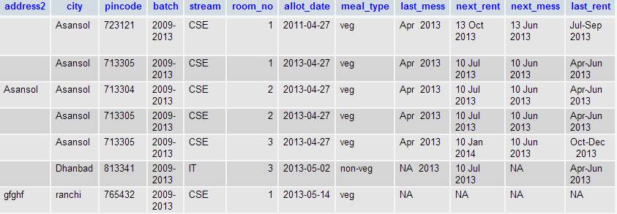

3.5 Data Flow Diagrams

Context diagram (Level 0)

Querry

Admin

registration_&_update_account student_registration_account_&_meal_setup

data_item statistics

Student

Level 1 data_item

query

update_account_&_meal

statistics

registration_data account_&_meal_info

Level 2

Account_info

allot_room

Student_details

Updated_data

Meal_info

3.6 Results

With the application of HMS, managing any hostel, no matter what is the strength of students can be made an easy task. Several parameters have been considered while designing the software. The application includes all the details of every student staying in the hostel and is updated .The accounts are also managed very efficiently. Mess details are also covered in this application through which students can provide their choice of food; they would like to have for a particular day. The administrator can manage and share the list of food items available for a day and can manage the accounts of students on per day basis. . Admin can create, update and view the student’s details and their accounts upon updating.

Additional functionalities have been incorporated into the system viz. The user can request the admin for delay in paying fees.

Thus, Hostel Management System is efficient software designed to ease the functioning and management of hostel.

Several other functionalities and special visual effects have been incorporated in the application that makes it look good and easy to use.

4. SCREEN SHOTS

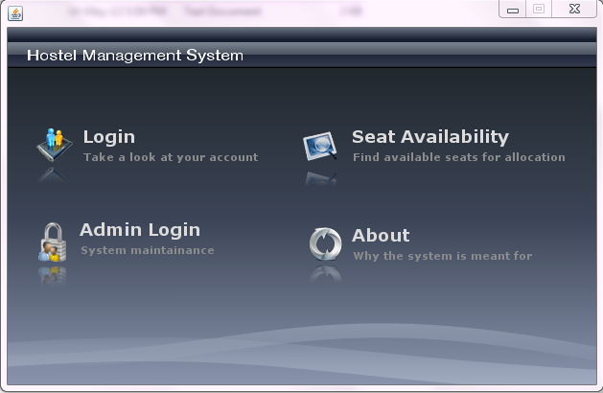

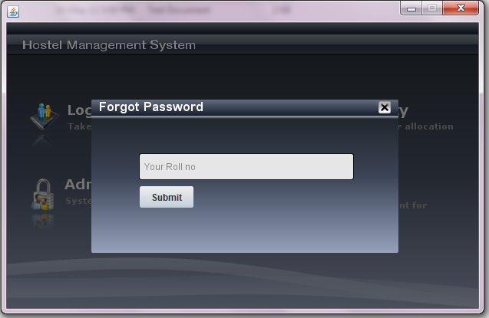

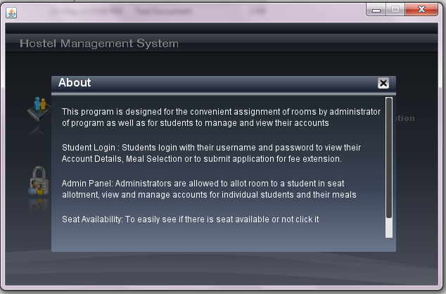

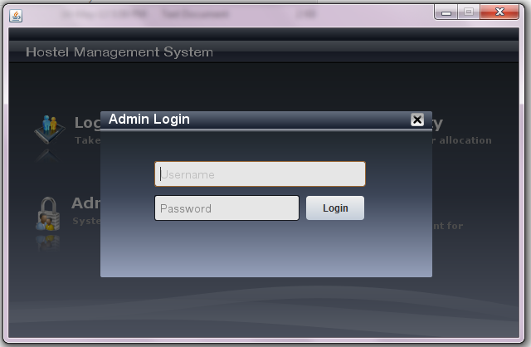

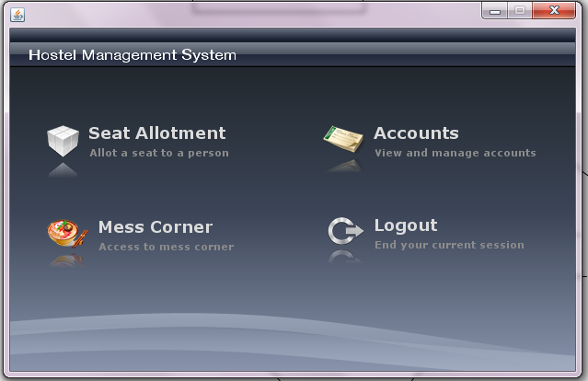

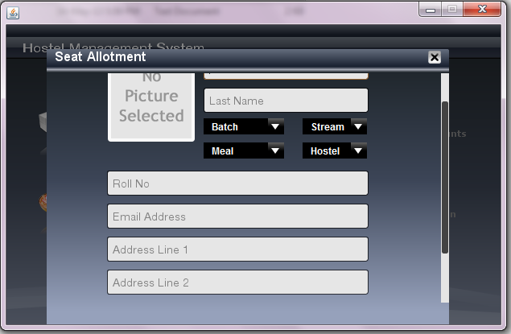

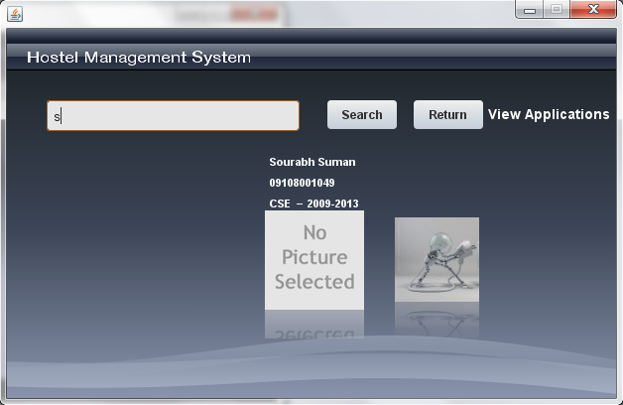

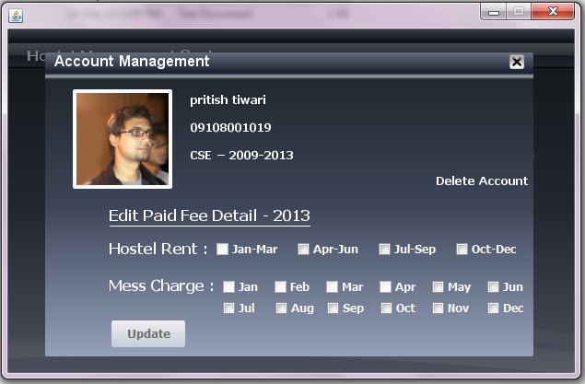

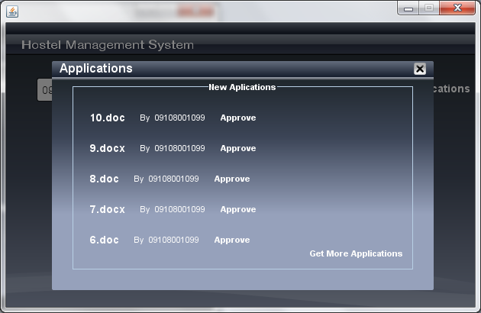

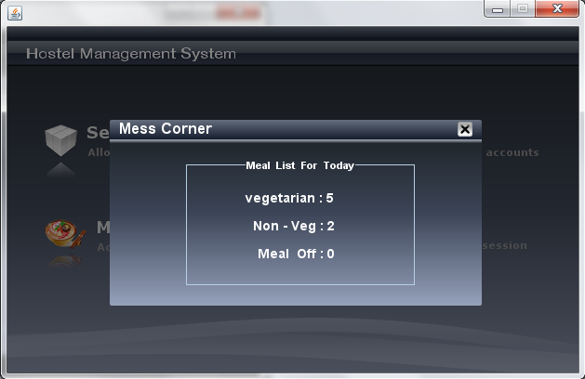

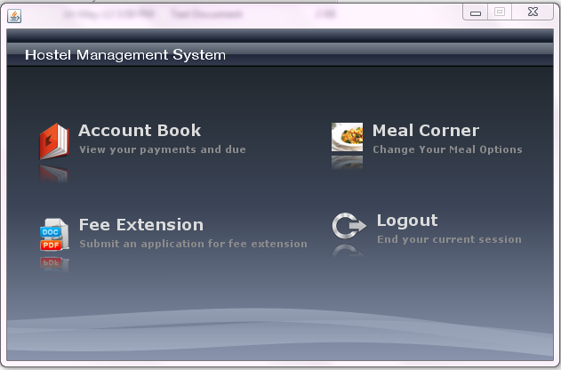

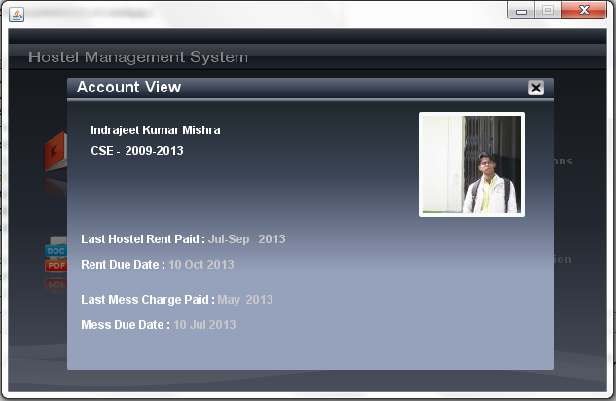

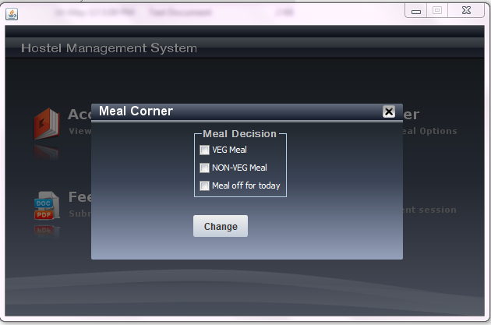

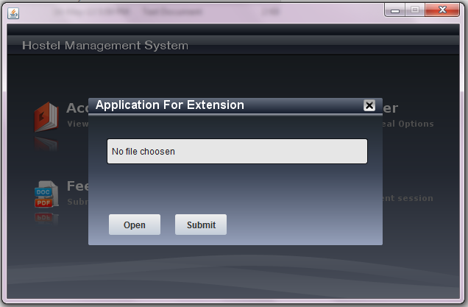

5. CONCLUSION AND FUTURE SCOPE

Through Hostel Management System, the hectic work on paper has reduced, the accuracy and reliability has increased to a very large extent, as it provides the user a simple and easy to read Graphical User Interface. The clear GUI as a result of Java Swing enables an easy navigation throughout the software. Managing student’s account for lodging and mess can be managed very efficiently through computers.

The admin can sit at the server room and can access and operate the application. The admin can update the accounts on payment of the fee from any student. The system provides the admin the privilege to design the whole system

Due to simple applicability, clear GUI and easy to use implementation, the software can be adopted by hostels of institutes. Operational feasibility, financial feasibility, technical feasibility and scheduling feasibility are some of the important points that may enhance its requirement in future. There is a lot of scope for modification in the application in the future and can be very easily made to survive and adapt with the future technology.

6. BIBLIOGRAPHY

* [www.google.com](http://www.google.com)
* [www.bing.com](http://www.bing.com)
* Java swing O’REILLY
* A definitive guide to java swing by John Zukowski
* Mastering Concepts in Core Java
* Complete Reference by Herbert Schildt
* www.stackoverflow.com