Documentation on the work of employee tracking project .

INITIAL STEPS:(steps after done with GCP billing with credit card)
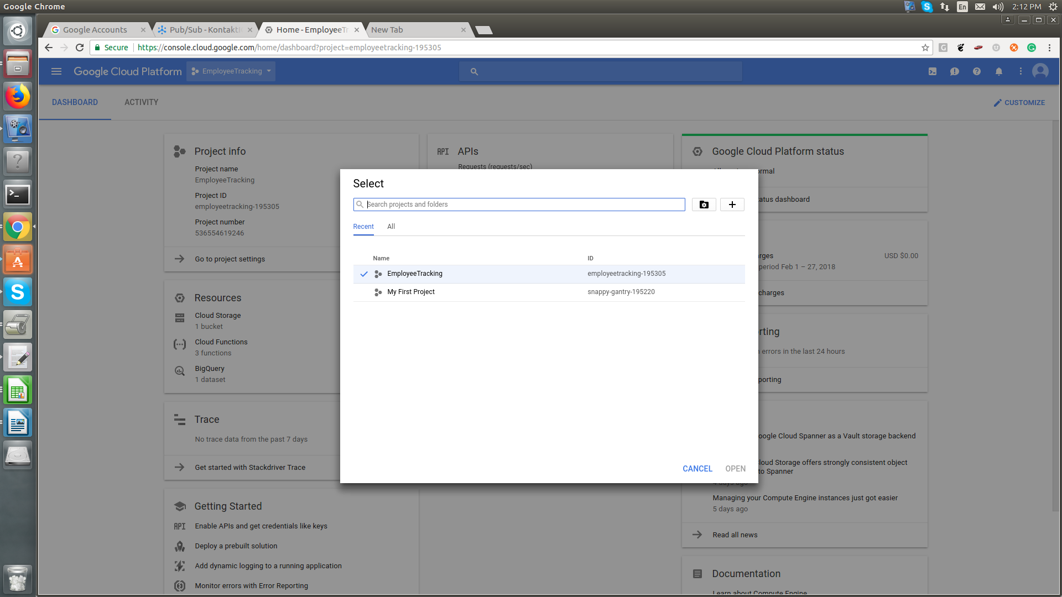
- Create a project on the google cloud console.

- After creation of project we have to enable the api’s in the following project on the functonality we are using
- We have enable of pub-sub api , spanner cloud api,cloud functiion api and we are using bigquery but bigquery doesn’t require the api enabling.
- On search bar type the pub-sub API and enable it same is the case with every other feature mentioned.
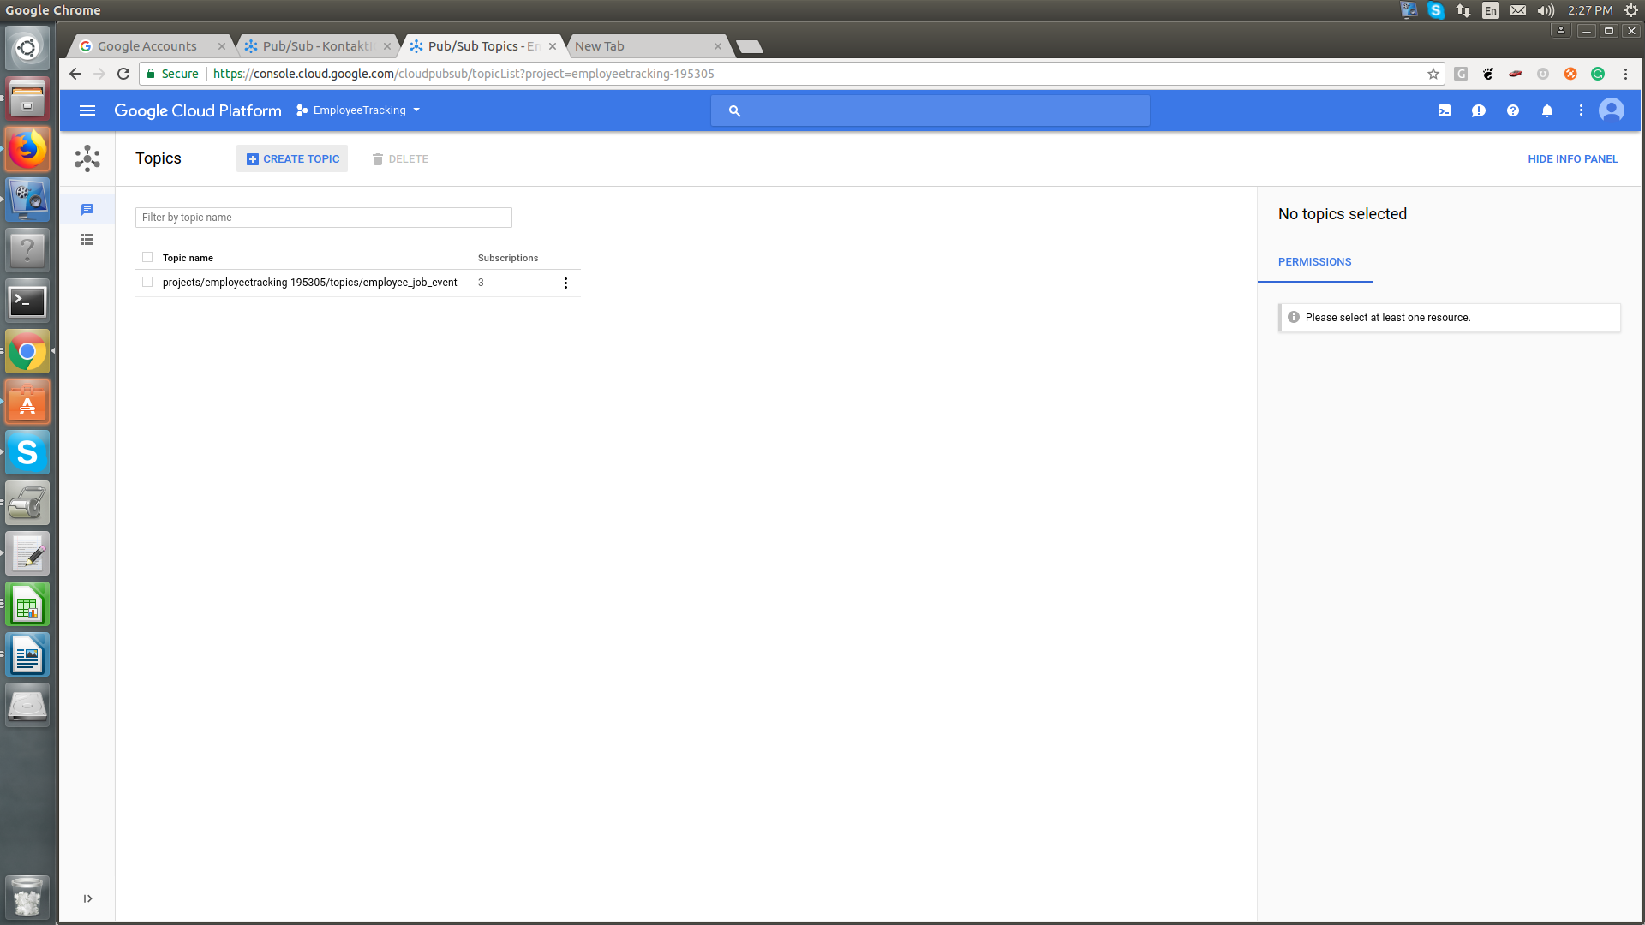
CREATING PUBLISHING AND SUBSCRIPTION LINK ON GOOGLE CLOUD
- To create the pu-sub link we have to navigate on pub-sub with the side menu-> create topic
- Then provide name and after creating publishing topic is created.
- Afer creation of the publishing topic we need to create subscription topic
- to create subscription topic click on created topic and then click on create subscription and provide the name of subscription.
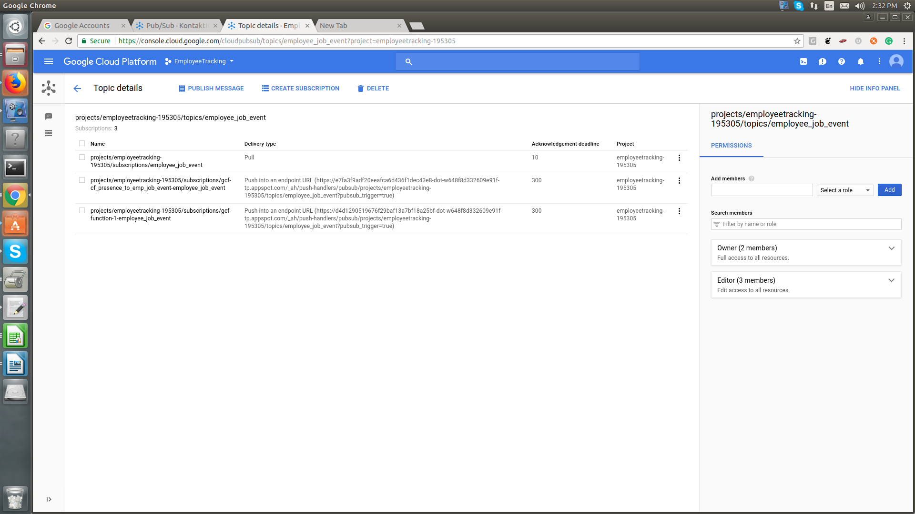

BigQuery (How to use and setup)
- We dont have to enable api for the bigquery such switch to the navigation menu and click bigquery
- First we have to create the dataset in the bigquery to crete the dataset click on dropdown left to create data set.
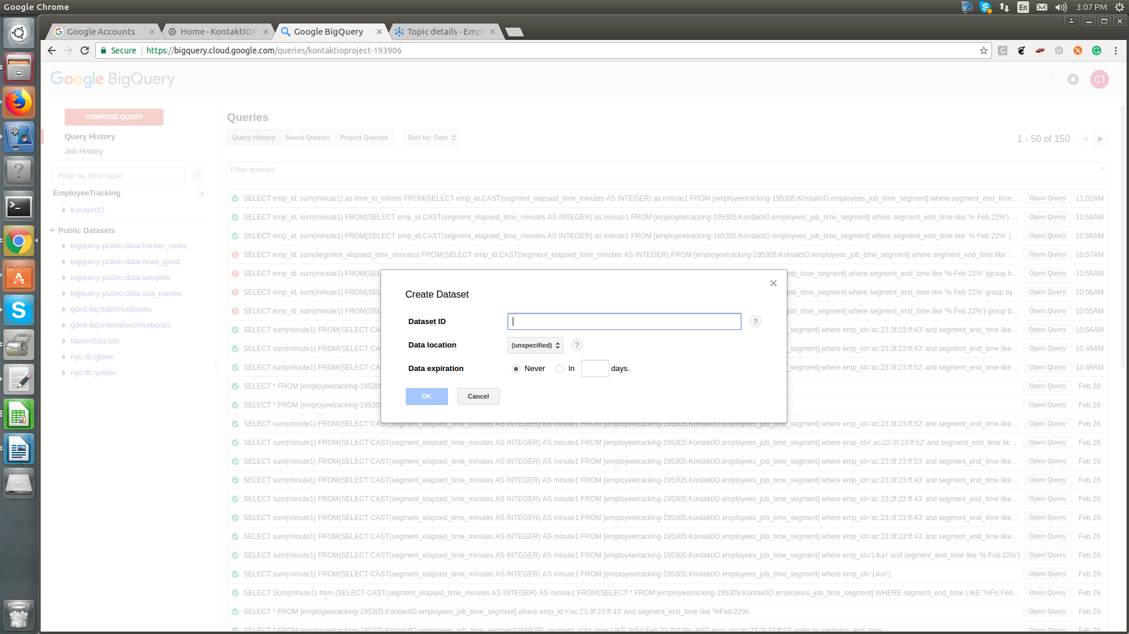
- After creting the data set click on plus icon in your dataset and create it will help you to create table.
- With query editor of BigQuery we can only select data using the select query.Not able to insert and delete from it.
- To Do that we have to use the code and to use the code with cloud function we dont have to provide authentication but with the Pc we have to install cloud sdk and have authentication procedure.

CLOUD FUNCTION

- To use the cloud function we have to create the cloud function we can switch to cloud function through the navigation window.
- We have to create two function for publishing and subscribing both
- For publishing we have to crete an http trigger and for subscribing we have to create the pubsub trigger .
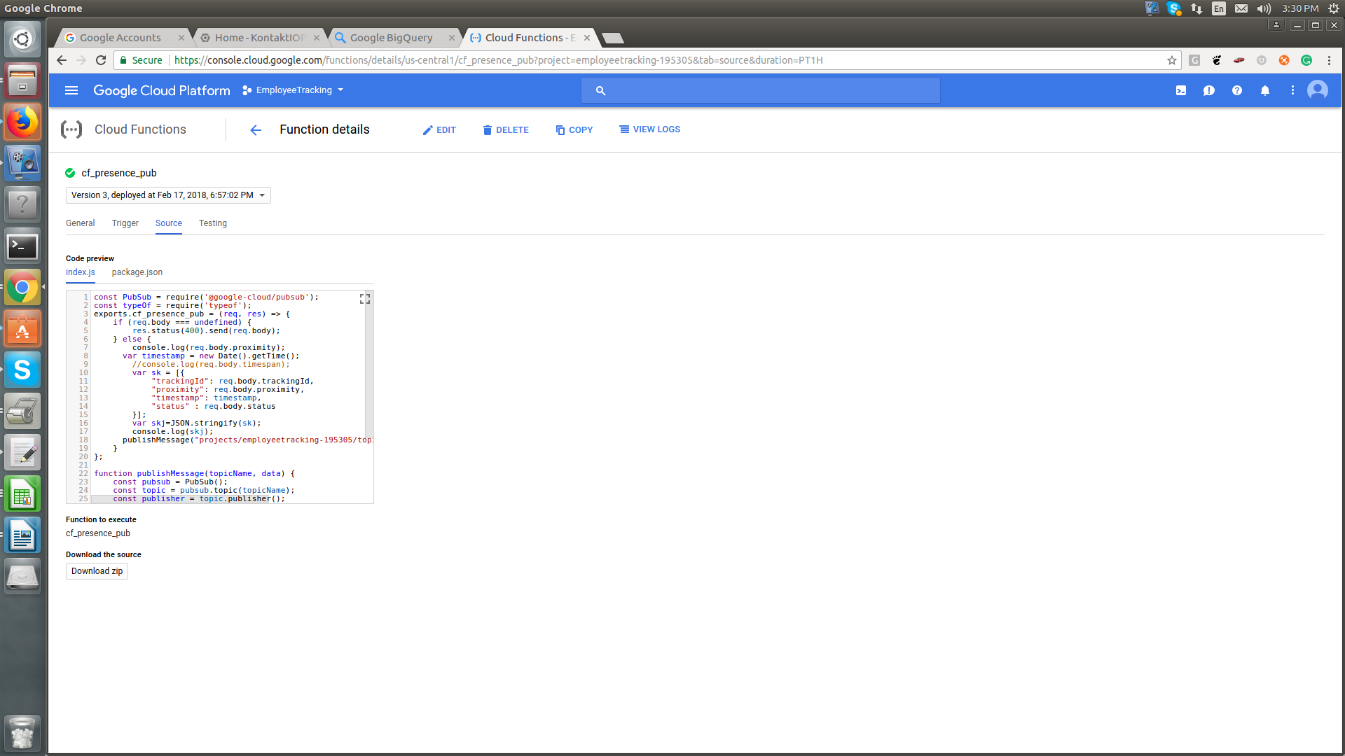
- We have to paste the code in the source and its dependencies in the JSON format

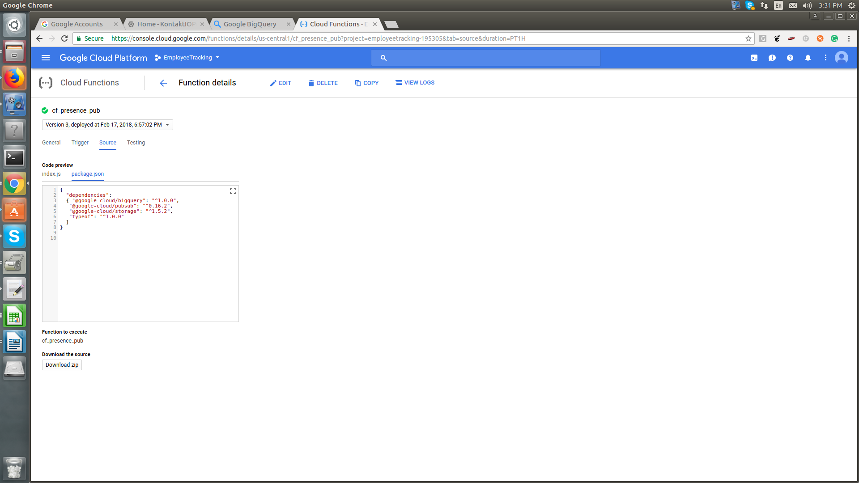
- we can also check the logs with the cloud function logs
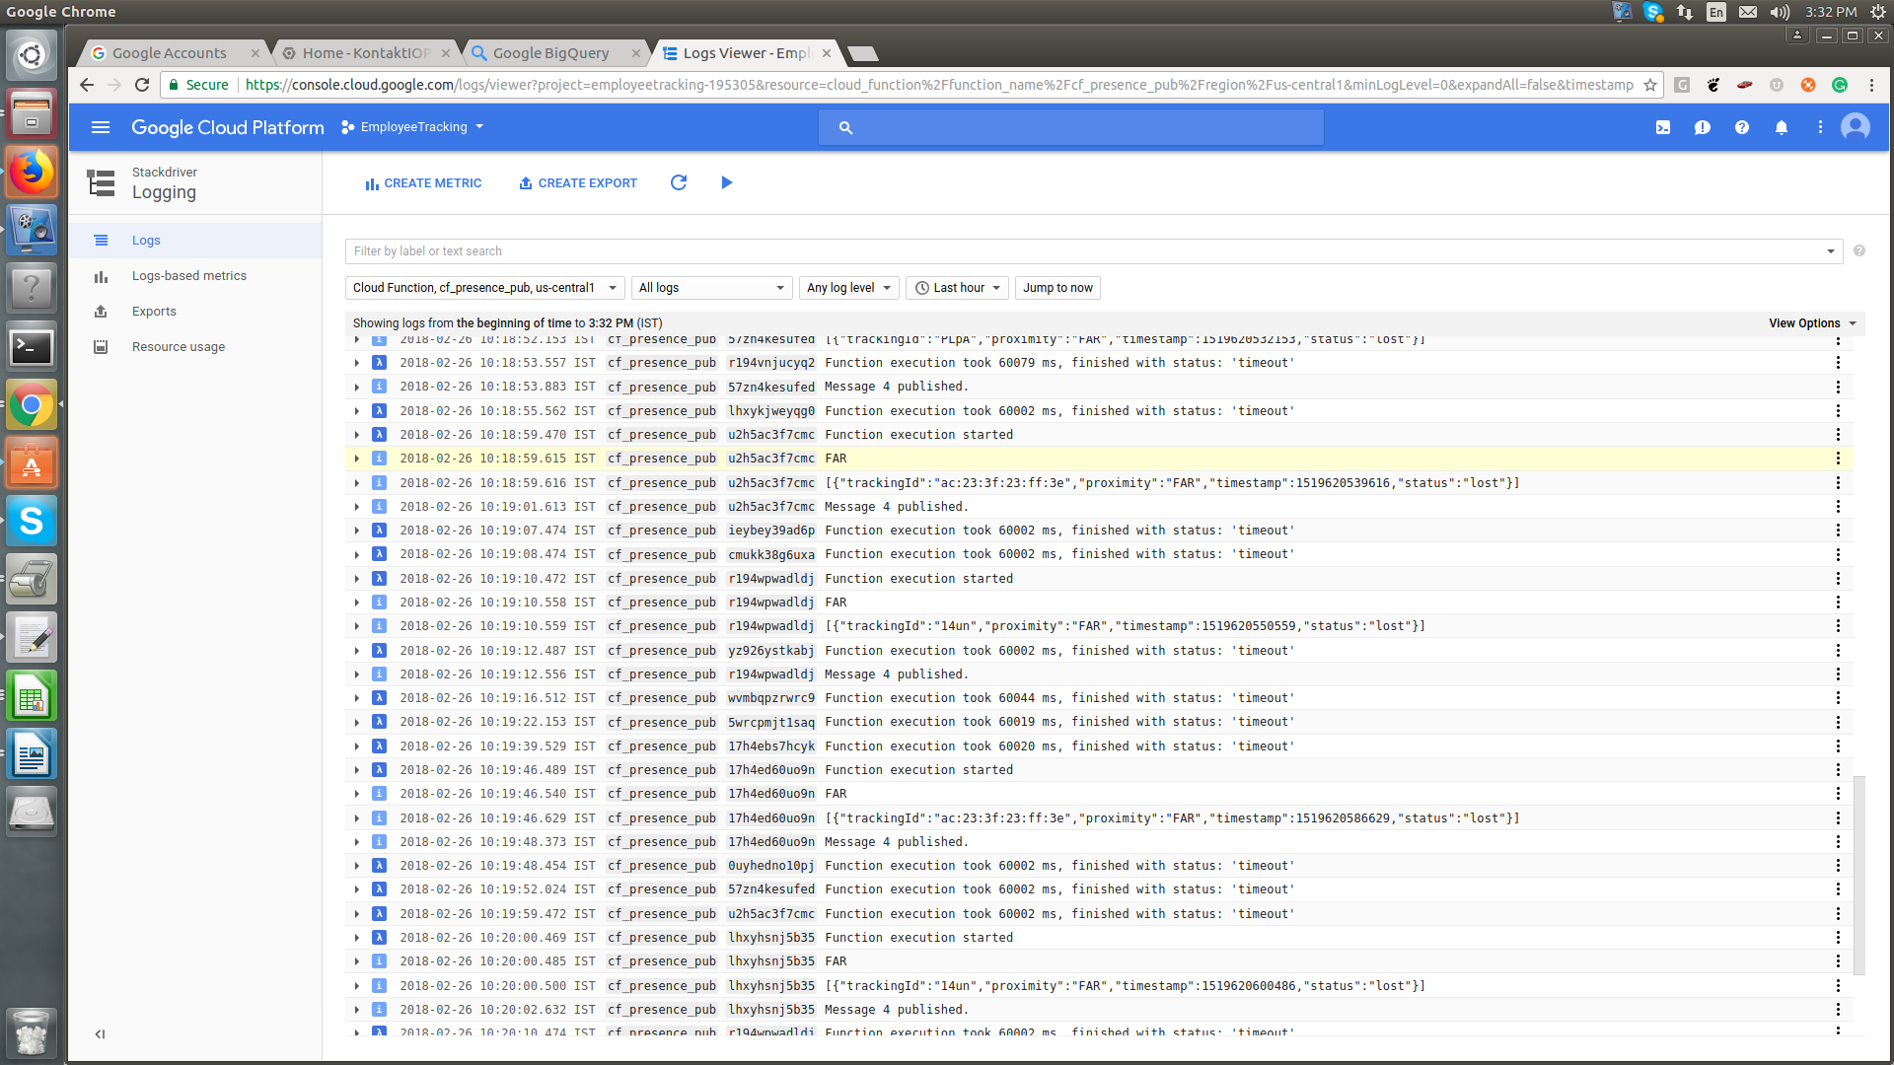

Creation of the Instance on the Spanner.
- To create the instance on the spanner after enabling the api we have navigate to spannner through side bar navigation.
- For instance creation Link:https://cloud.google.com/spanner/docs/create-manage-instances
- After that we havet to create the Databse in the spanner cloud and then we can define the schema in the spanner cloud LINK: https://cloud.google.com/spanner/docs/modify-data

Creation of the Trigger with the KONTAKT CLOUD
- We have to create Trigger with the Kontakt cloud to send data to cloud function on every event.
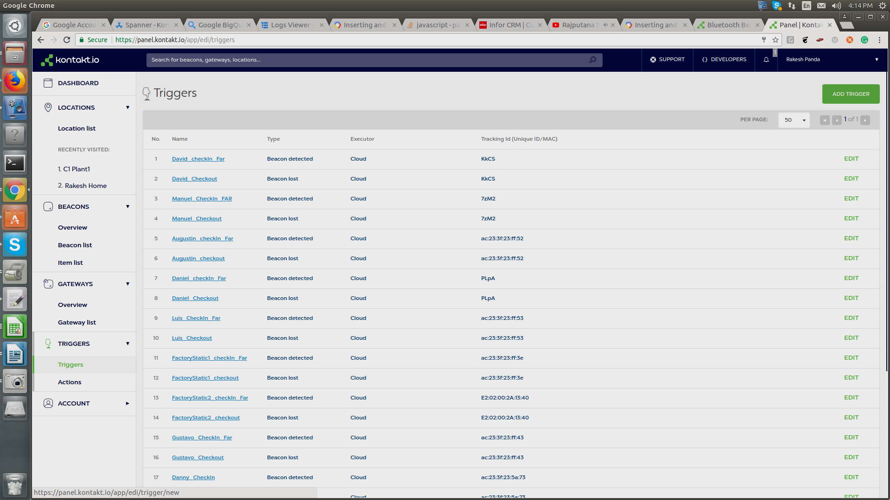
- We can create trigger on Kontakt cloud we have to navigate to the side menu and then on cr add trigger option we have to assign actions after that.
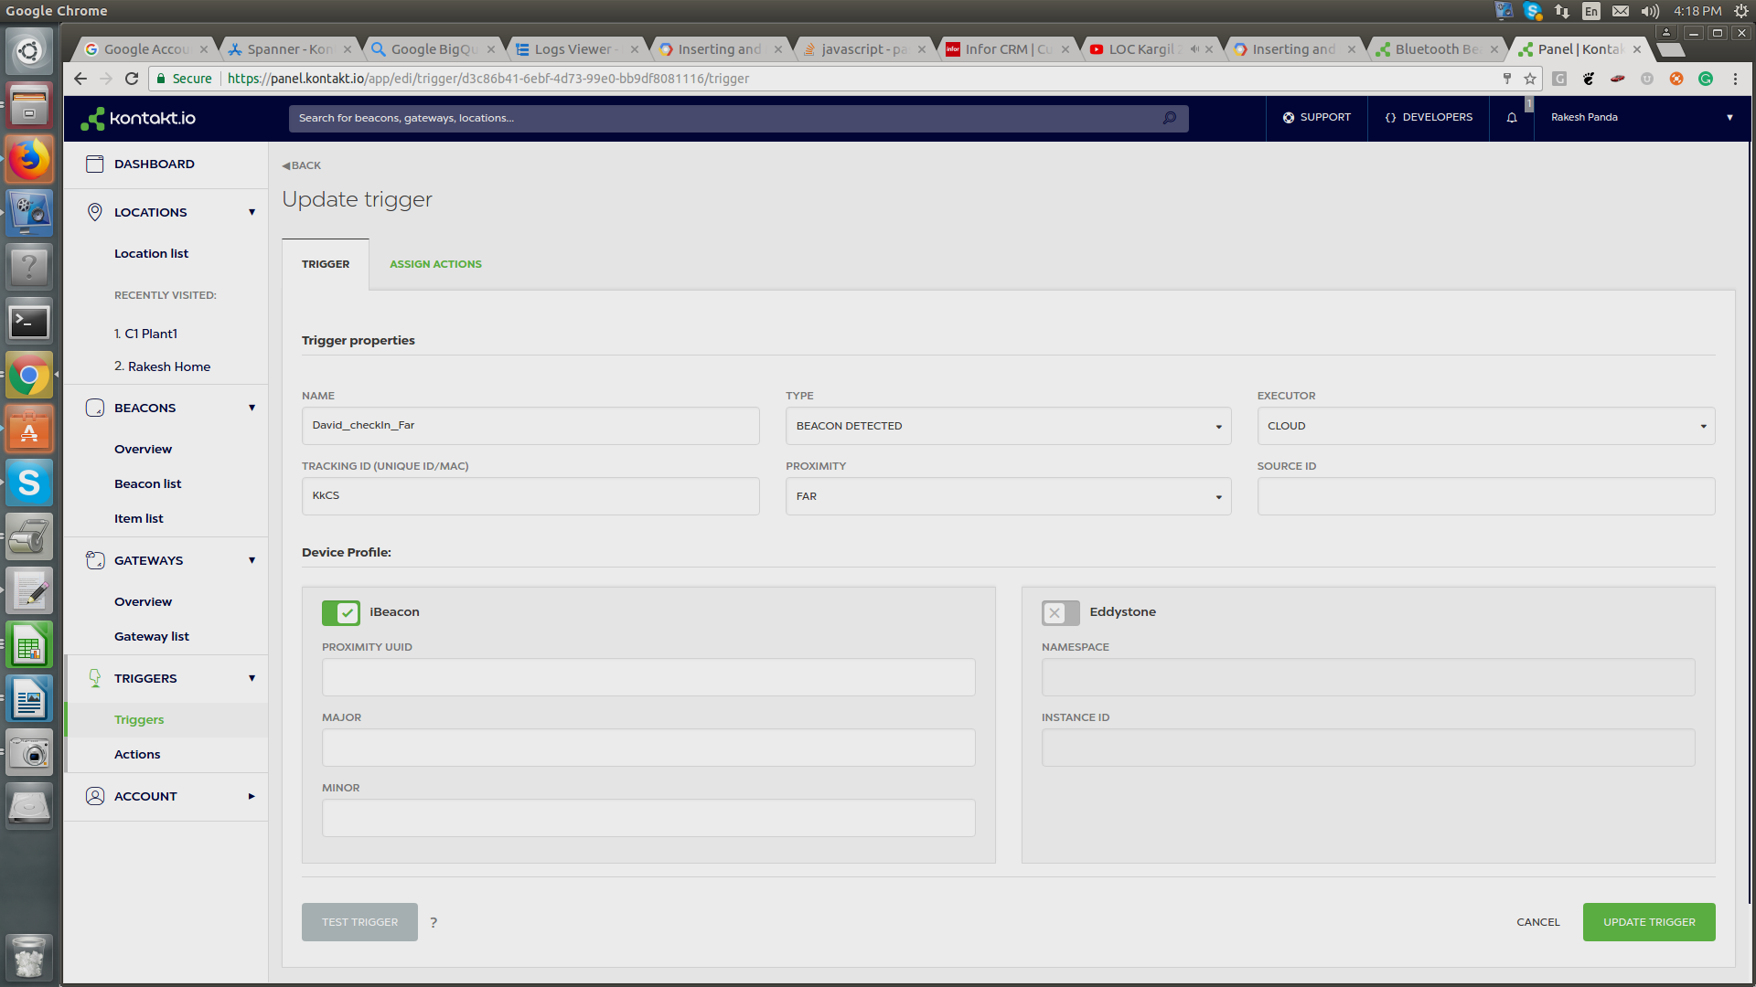
- In the Trigger section we can have to specify the checkin and checkout event For the Checkin event we have Taken TYPE :BEACON DETECTED, PROXIMITY:FAR
- After it we can Assign on assigning action we call our cloud function Http Trigger and POST methood.
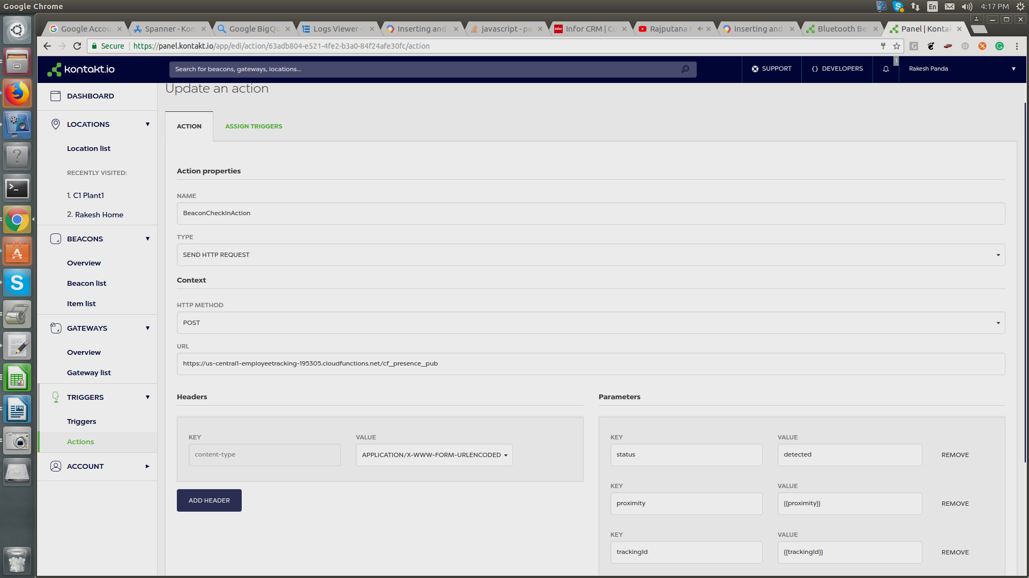
5.In the URL Specify cloud function url and in HTTP methood give post

