**CS3223 Assignment 3**

Tran Manh (A0112058)

Nguyen Viet Dung (A0112068N)

**I. Experiments**

**1. Effect of Selectivity Factor**

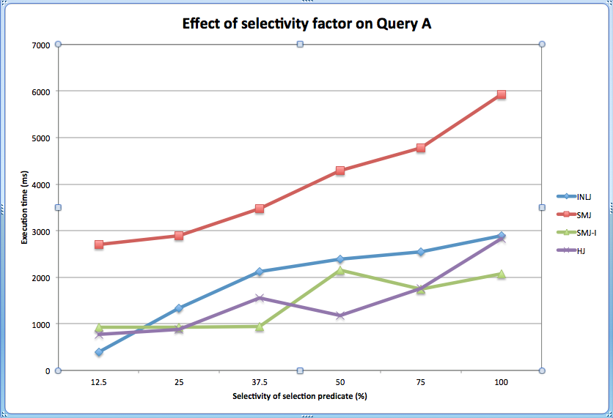

*Figure 1.1 Effect of Selectivity factor on Query A*

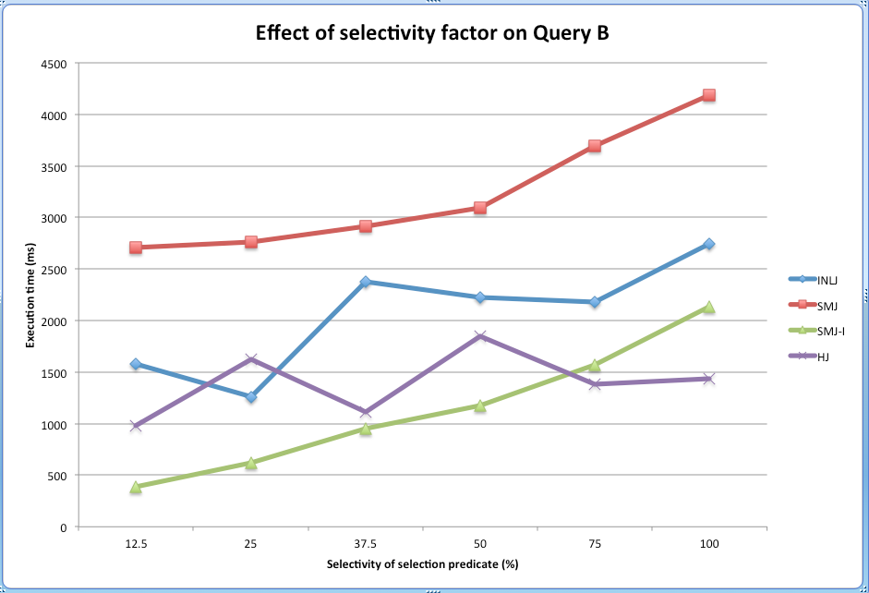

*Figure 1.2 Effect of Selectivity factor on Query B*

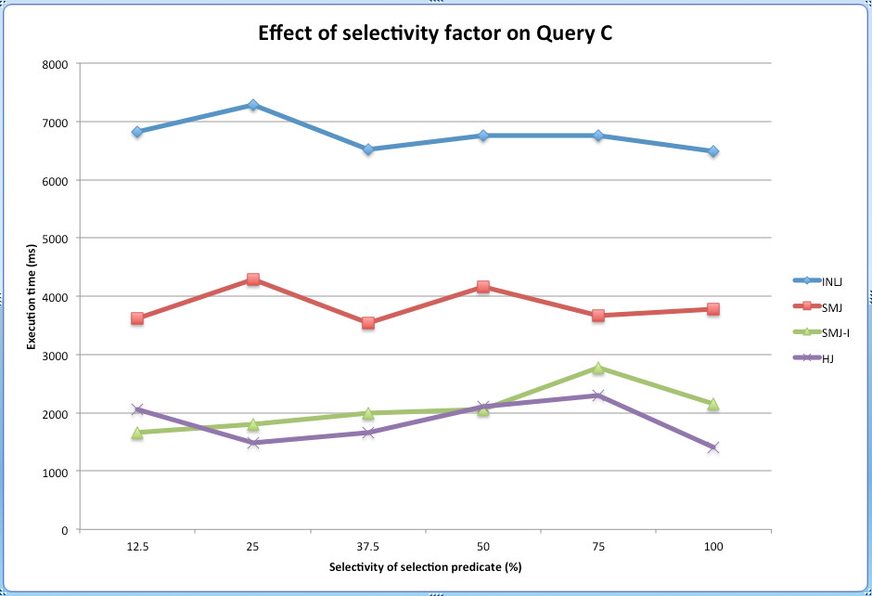

*Figure 1.3 Effect of Selectivity factor on Query C*

**2. Effect of Join Factor**

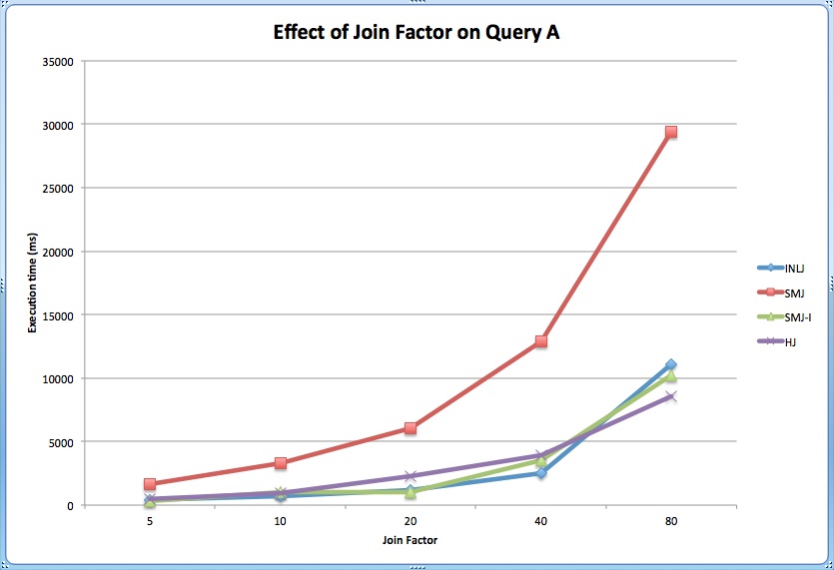

*Figure 2.1 Effect of Join Factor on Query A*

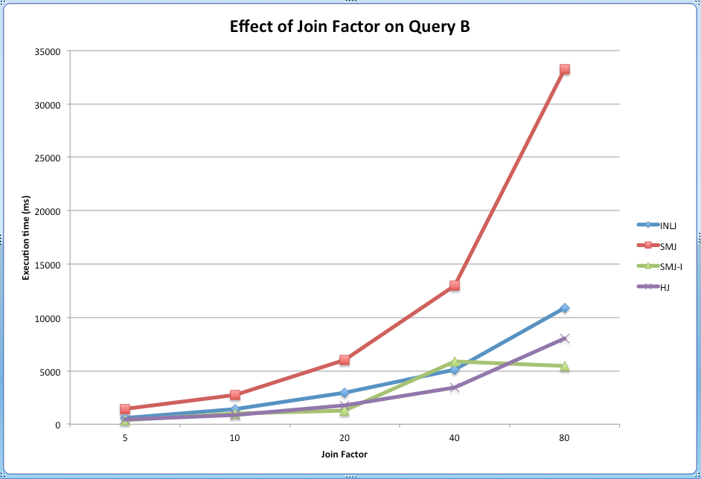

*Figure 2.2 Effect of Join Factor on Query B*

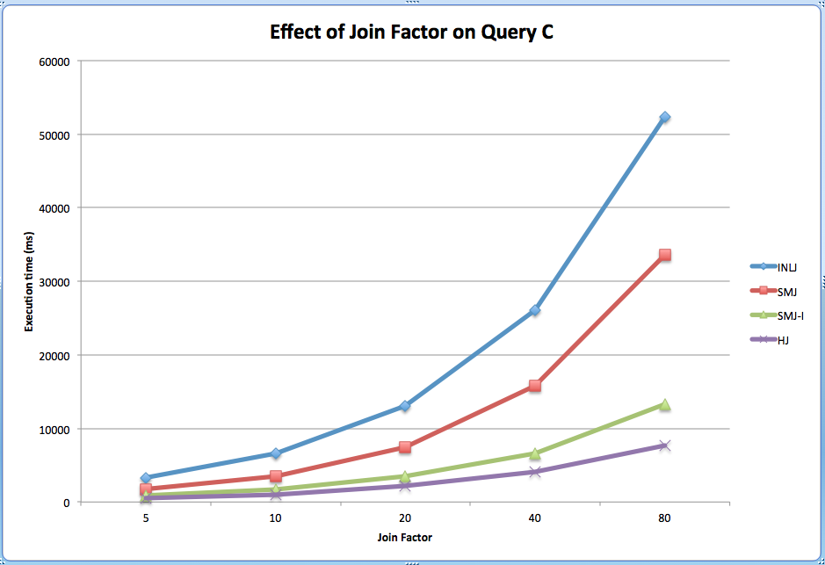

*Figure 2.3 Effect of Join Factor on Query C*

**3. Effect of ‘work_mem’ parameter**

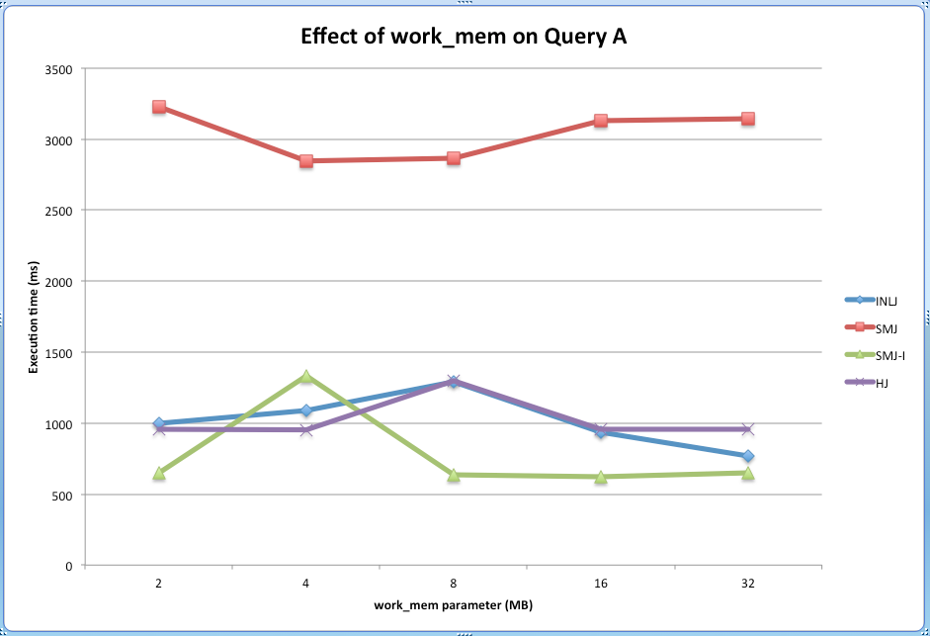

*Figure 3.1 Effect of work_mem on Query A*

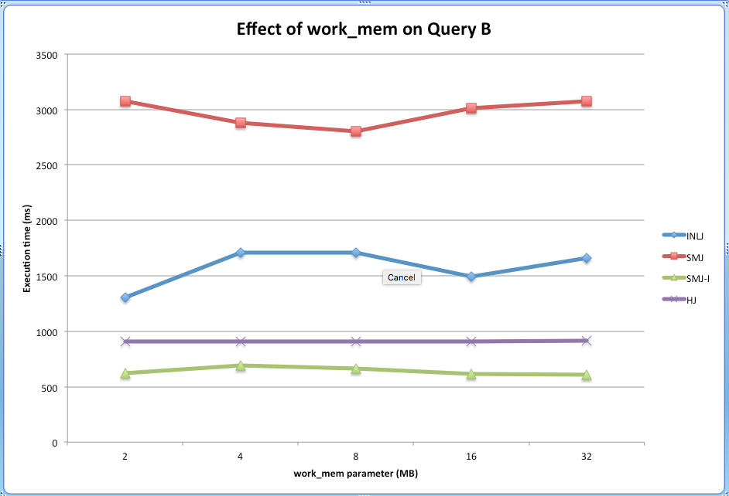

*Figure 3.2 Effect of work_mem on Query B*

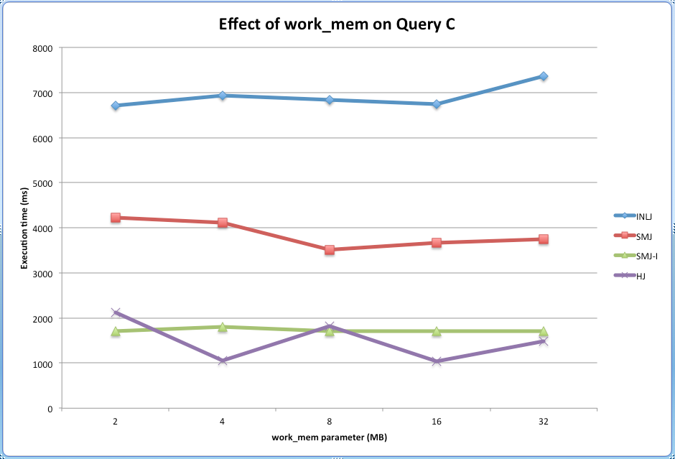

*Figure 3.3 Effect of work_mem on Query C*

**II. Observations & Discussions**

Observation on all graphs: The lines in graphs rarely cross each other. This implies the order (in term of efficiency of algorithms) is regardless of selectivity factor, join factor, work_mem; it mostly regards to the query and proportion of the result. Specifically, for query A and B, we can see that SMJ is significantly slower than the rest; INLJ, SMJ-I and HJ are quite comparable as their lines are close to each other and have some crosses. However, SMJ-I is still a bit faster. For query C, we can see the order clearly as the lines are separated. INLJ made the worst performance here, followed by SMJ. SMJ-I and HJ are comparable but HJ is still a bit faster.

Observation on graphs of Selectivity Factor: For query A and B, we can see that the lines are slightly going up with selectivity factor from small to large. For query C, the slopes of lines are mostly zero. Hence we conclude that Selectivity Factor slightly affects the performances of algorithms. The algorithms are a bit faster with smaller selectivity factor. However, this still depend a lot on the query and proportion of the result

Observation on graphs of Join Factor: For all queries A, B and C, we can see lines with large slopes. They go up with Join Factor from small to large. Hence Join Factor makes a significantly change on performances of algorithms. The larger the Join Factor is, the slower the algorithm performs (regardless to what algorithm).

Observation of work_mem: For all queries A, B, C, the slopes are mostly zero. The performances of algorithms are very stable, regardless to the value of work_mem. Maybe it is due to the queries, which do not need a lot of memory to be done. So we can say work_mem does not affect the performances of algorithms in these specific queries.