More SQL Questions
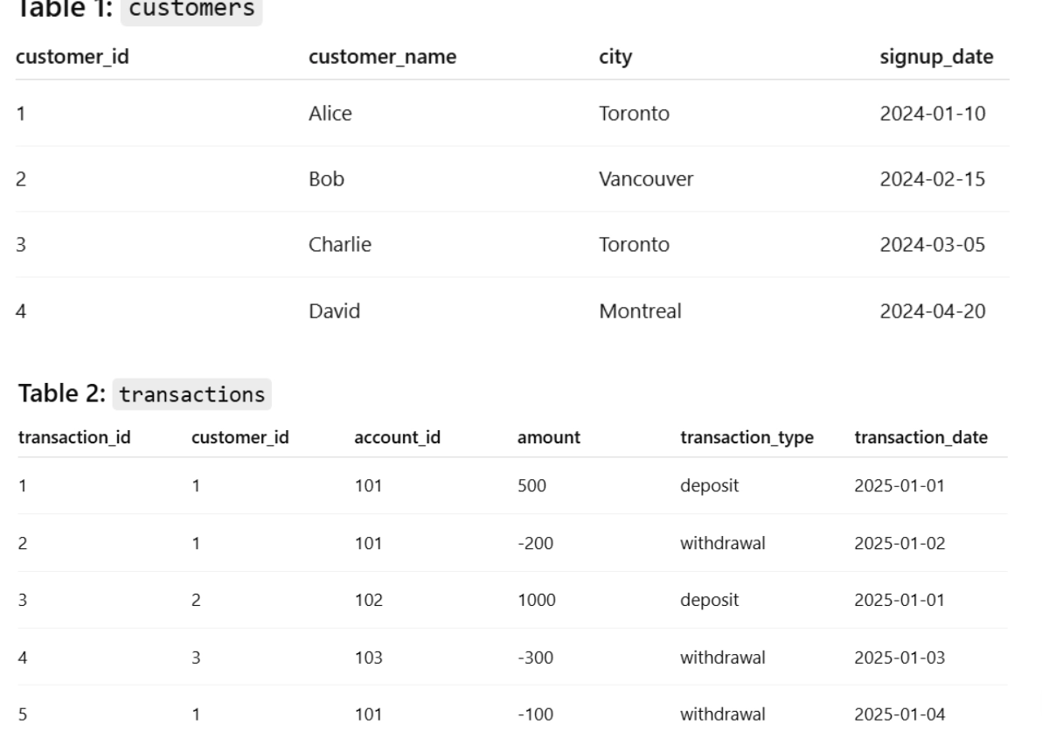

1. Customer Activity Report
Management wants to see all transactions along with the customer's name and city to understand where activity is happening.
SELECT c.customer_id, c.name, c.city, t.transaction_id, t.amount, t.transaction_type, t.transaction_date
FROM customers c
JOIN transactions t
ON c.customer_id = t.customer_id;
2. Customer Value Analysis
The finance team wants to know how much money each customer has transacted in total.
SELECT c.customer_id, c.name, SUM(t.amount) AS total_txn
FROM customers c
JOIN transactions t
ON c.customer_id = t.customer_id
GROUP BY c.customer_id, c.name;
3. Customer Engagement
The marketing team wants to know how many transactions each customer has made so they can identify highly engaged users.
SELECT c.customer_id, c.name,
COUNT(t.transaction_id) AS total_txn_count
FROM customers c
LEFT JOIN transactions t
ON c.customer_id = t.customer_id
GROUP BY c.customer_id, c.name;
4. Dormant Customers
The retention team wants to identify customers who signed up but have never made a transaction.
SELECT c.customer_id, c.name
FROM customers c
LEFT JOIN transactions t
ON c.customer_id = t.customer_id
WHERE t.transaction_id IS NULL;

SELECT c.customer_id, c.customer_name
FROM customers c
LEFT JOIN transactions t
ON c.customer_id = t.customer_id
GROUP BY c.customer_id, c.customer_name
HAVING COUNT(t.transaction_id) = 0;
5. Withdrawal Behavior
Risk management wants to know which customers have made withdrawals, since withdrawals may indicate liquidity needs or account usage.
SELECT DISTINCT c.customer_id, c.name
FROM customers c
JOIN transactions t
ON c.customer_id = t.customer_id
WHERE t.transaction_type = 'withdrawal';
6. Deposit Contribution
The treasury team wants to understand how much money each customer has deposited in total.
SELECT c.customer_id, c.name, SUM(t.amount) AS total_dep
FROM customers c
JOIN transactions t
ON c.customer_id = t.customer_id
WHERE t.transaction_type = 'deposit'
GROUP BY c.customer_id, c.name;
7. High-Risk Spending Customers
Fraud monitoring wants to identify customers who have withdrawn the largest total amount of money.
SELECT c.customer_id, c.name, SUM(t.amount) AS total_withdraw
FROM customers c
JOIN transactions t
ON c.customer_id = t.customer_id
WHERE t.transaction_type = 'withdrawal'
GROUP BY c.customer_id, c.name
ORDER BY total_withdraw DESC;
8. Regional Revenue Analysis
Leadership wants to know how much total transaction value is generated from each city.
SELECT c.city, SUM(t.amount) AS total_txn
FROM customers c
JOIN transactions t
ON c.customer_id = t.customer_id
GROUP BY c.city;
9. Customer Transaction Patterns
The analytics team wants to calculate the average transaction amount for each customer.
SELECT c.customer_id, c.name, AVG(t.amount) AS avg_txn_amount
FROM customers c
JOIN transactions t
ON c.customer_id = t.customer_id
GROUP BY c.customer_id;
10. Customer Onboarding Effectiveness
Product managers want to know when each customer made their first transaction after signing up.
SELECT c.customer_id, c.name, c.signup_date, MIN(t.transaction_date) AS first_txn_date
FROM customers c
JOIN transactions t
ON c.customer_id = t.customer_id
GROUP BY c.customer_id;
11. Large Transaction Monitoring
Compliance wants a report showing customers who have made transactions larger than $500.
SELECT c.customer_id, c.name, t.amount, t.transaction_date
FROM customers c
JOIN transactions t
ON c.customer_id = t.customer_id
WHERE t.amount > 500;
12. Market Penetration by City
The growth team wants to know how many customers in each city are actively transacting.
SELECT c.city, COUNT(DISTINCT c.customer_id) AS active_customers
FROM customers c
JOIN transactions t
ON c.customer_id = t.customer_id
GROUP BY c.city;
13. Recent Customer Activity
Customer success wants to see the most recent transaction for each customer to understand who is still active.
SELECT c.customer_id, c.name, MAX(t.transaction_date) AS recent_txn
FROM customers c
JOIN transactions t
ON c.customer_id = t.customer_id
GROUP BY c.customer_id;
14. High Deposit Customers
Finance wants to identify customers whose total deposits exceed $1000, as these customers may qualify for premium services.
SELECT c.customer_id, c.name, SUM(t.amount) AS total_deposit
FROM customers c
JOIN transactions t
ON c.customer_id = t.customer_id
WHERE t.transaction_type = 'deposit'
GROUP BY c.customer_id, c.name
HAVING SUM(t.amount) > 1000;
15. Daily Regional Activity
Operations wants to see daily transaction totals broken down by city to monitor business activity trends.
SELECT t.transaction_date, c.city, SUM(t.amount) AS daily_total
FROM customers c
JOIN transactions t
ON c.customer_id = t.customer_id
GROUP BY t.transaction_date, c.city
ORDER BY t.transaction_date;

