**AWS**

AWS stands for **Amazon Web Services**.

A cloud computing platform to allow the different organizations to take advantage of reliable IT infrastructure.

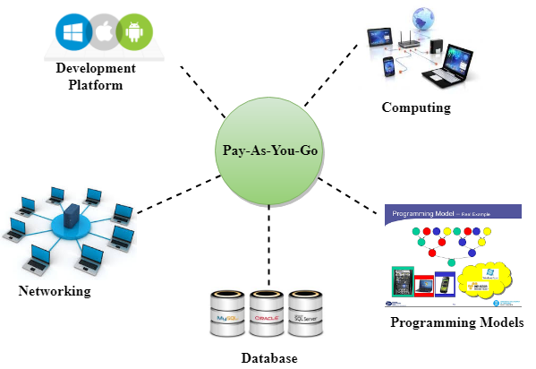

Features of AWS

The following are the features of a Computer Network:

* Flexibility
* Cost-effective
* Scalable and elastic
* Secure
* Experienced

### **Advantages of Amazon S3**

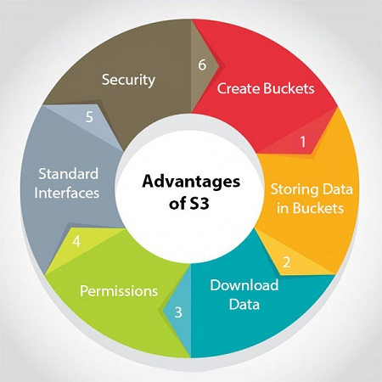

### **S3 is a simple key-value store**

**S3 is object-based. Objects consist of the following:**

* **Key:** It is simply the name of the object. For example, hello.txt, spreadsheet.xlsx, etc. You can use the key to retrieve the object.
* **Value:** It is simply the data which is made up of a sequence of bytes. It is actually a data inside the file.
* **Version ID:** Version ID uniquely identifies the object. It is a string generated by S3 when you add an object to the S3 bucket.
* **Metadata:** It is the data about data that you are storing. A set of a name-value pair with which you can store the information regarding an object. Metadata can be assigned to the objects in Amazon S3 bucket.
* **Subresources:** Subresource mechanism is used to store object-specific information.
* **Access control information:** You can put the permissions individually on your files.