CE 295

Project Declaration

Team 5

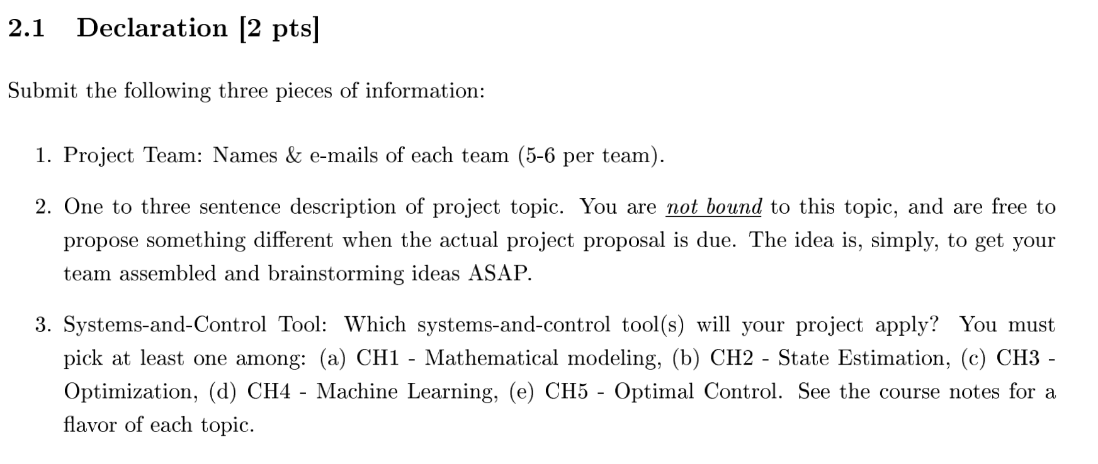

## Team

| **Name** | **Email** |
| --- | --- |
| Tianhao Wu | thwu@berkeley.edu |
| Joe Koszut | joe_koszut@berkeley.edu |
| Aoyu Zou | aoyuzou@berkeley.edu |
| Shih-Hung Chiu | shchiu@berkeley.edu |
| Jarvis Yuan | jarviskroos7@berkeley.edu |
| Marge D’Auria | margaret_dauria@berkeley.edu |
| Arwa AlAnqary | arwa@berkeley.edu |

## Description:

V2X traffic platoon optimization that minimizes overall energy consumption cost while satisfying travel time constraints.

A very interesting topic that we wish to explore for the term project is the energy modeling and optimization of CAV/CACC truck platooning with traffic timing conscious control, ideally in a distributed network context for a study scenario. Platooning is a novel freeway control operation enabled by the fast developing CAV and CCAV technology, where groups of vehicles travel together and allow for closer headway by essentially eliminating reacting distance needed for human reaction. As an essential part of the design of an automated highway system, long-haul truck platooning has the immediate benefit of reduced GHG emissions, and travel time savings in addition to the potential effect of addressing truck driver shortage thus reducing operation cost. We are interested in taking a deeper dive in developing the modeling and optimization of vehicle controls on a transportation network while making comparisons among a range of vehicle powertrains (BEV, FCEV, ICE, PHEV, etc.).

Here are two research papers that inspired this topic:

* [An Optimal Longitudinal Control Strategy of Platoons Using Improved Particle Swarm Optimization](https://downloads.hindawi.com/journals/jat/2020/8822117.pdf)
* [Optimizing Coordinated Vehicle Platooning: An Analytical Approach Based on Stochastic Dynamic Programming Improved Particle Swarm Optimization](https://arxiv.org/pdf/2003.13067.pdf)

## Systems-and-control tools we will apply:

1. Optimization
2. Optimal control
3. Mathematical modeling