**Two-Vehicle Platoon:**

* First Vehicle: Same as what it typically is, 1.0
* Second Vehicle: roughly 87% of drag compared to a vehicle on its own

**Three-Vehicle Platoon:**

* First Vehicle: 100% of normal value
* Second vehicle: 85% of normal value
* Third vehicle: Roughly 78% of normal value

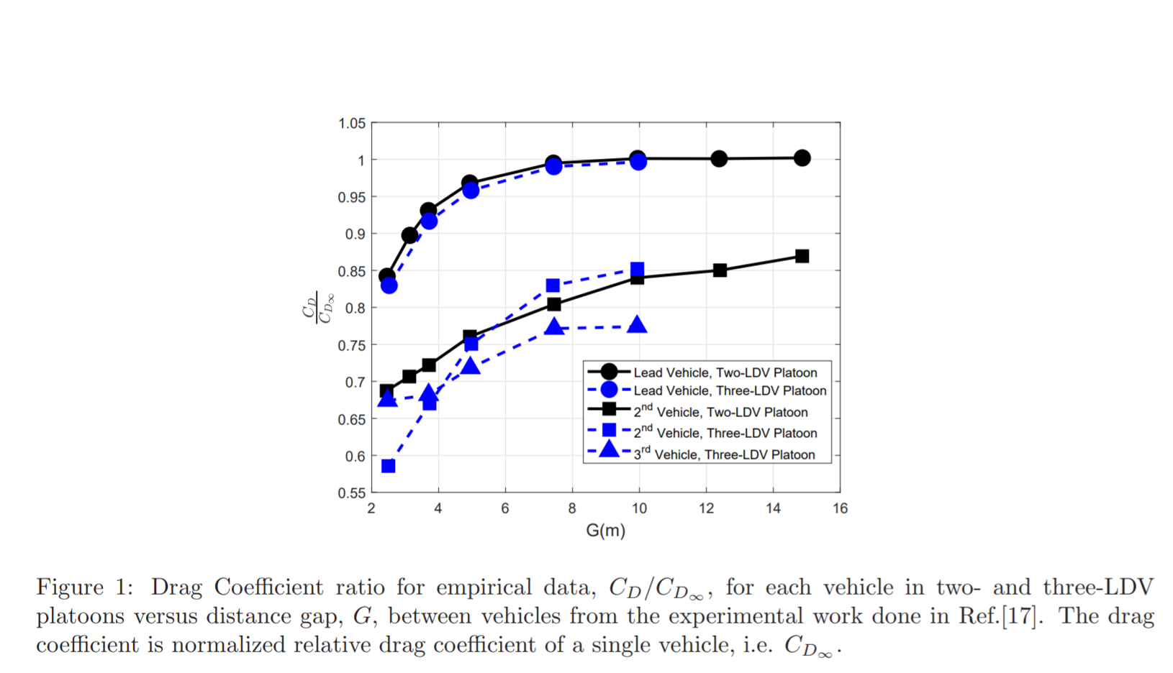

Vehicle used: Chevy Lumina - typical sedan

Pretty good approximation - changes over time, but it is good