Assignment III Pharm 610 Fall 2026 Name: ________________

1. Aggregation number from SLS (6 marks)
Principle. For dilute solutions, static light scattering obeys the Zimm/Debye equation. At zero scattering angle (θ → 0) the angular term disappears, leaving:
Kc / R₀ = 1 / M_{w} + 2A₂c
A plot of Kc/R₀ against c (Debye plot) is a straight line. The intercept gives 1/M_{w} and the slope gives 2A₂ (A₂ = second virial coefficient).

Step 1: Debye plot of the data
Concentration, c (g/L) | Kc/R₀ (mol/g)
0.5 | 2.4 × 10⁻⁶
1.0 | 2.8 × 10⁻⁶
1.5 | 3.2 × 10⁻⁶
2.0 | 3.6 × 10⁻⁶
2.5 | 4.0 × 10⁻⁶
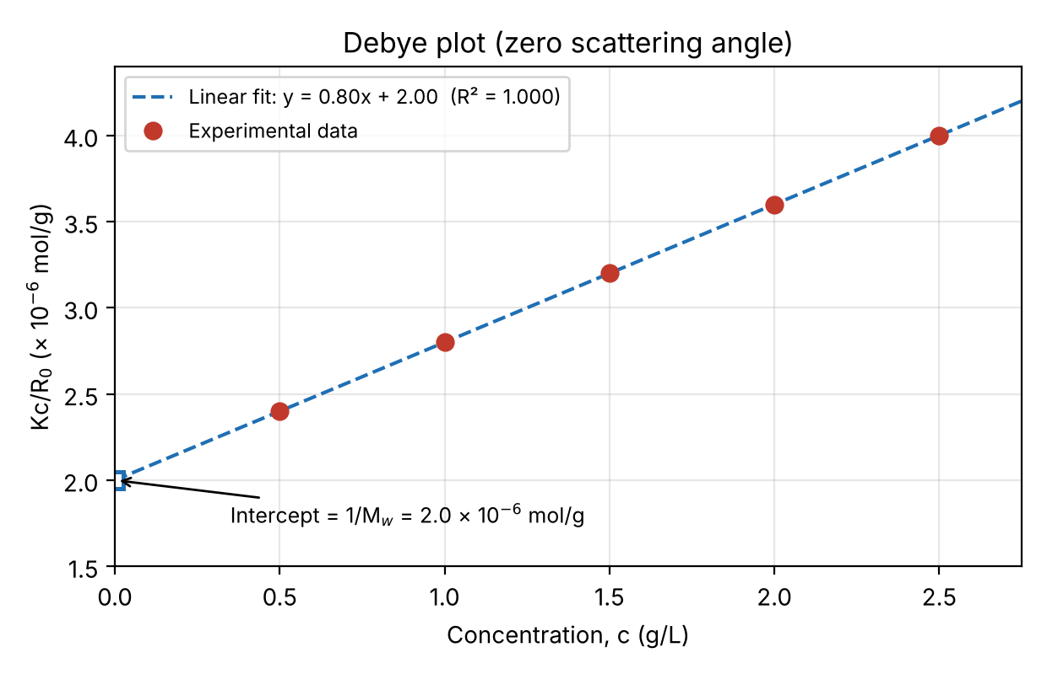
Figure 1. Debye plot of Kc/R₀ vs. c. Linear regression (Excel): y = 8.0 × 10⁻⁷ c + 2.0 × 10⁻⁶, R² = 1.000.

Step 2: Slope
slope = Δ(Kc/R₀) / Δc = (4.0 − 2.4) × 10⁻⁶ / (2.5 − 0.5) = 1.6 × 10⁻⁶ / 2.0 = 8.0 × 10⁻⁷ mol·L/g²

Step 3: Intercept (extrapolate to c = 0)
intercept = 2.4 × 10⁻⁶ − (8.0 × 10⁻⁷)(0.5) = 2.0 × 10⁻⁶ mol/g = 1/M_{w}

Step 4: Weight-average molecular weight of the micelle
M_{w} = 1 / (2.0 × 10⁻⁶ mol/g) = 5.0 × 10⁵ g/mol

Step 5: Aggregation number
N_{agg} = M_{w, micelle} / M_{unimer} = (5.0 × 10⁵ g/mol) / (5.0 × 10⁴ g/mol) = 10
Answer: M_{w} (micelle) = 5.0 × 10⁵ g/mol and N_{agg} = 10, so each micelle contains about 10 polymer chains.
Additional information from the slope: A₂ = slope/2 = 4.0 × 10⁻⁷ mol·L/g² (= 4.0 × 10⁻⁴ mol·mL/g²). A₂ is positive, so micelle–solvent interactions are favourable and micelles repel each other: the dispersion is in a good solvent and colloidally stable. (The Excel calculation and chart are in Q1_Debye_plot.xlsx.)

2. Interpreting DLS correlation functions (4 marks)
Green, Orange, Red, Blue
Blue Good measurement
Green Multiple scattering
Orange Fluorescence
Red Number fluctuations

3. Selecting the appropriate microscopy technique (6 marks)

a. Surface morphology and shape of a dried sample → SEM
- SEM scans a focused electron beam over the surface and detects secondary electrons, giving a high-depth-of-field, 3D-like image of surface topography and shape.
- It works under high vacuum, so the sample must be dry anyway. Non-conductive polymer particles are usually sputter-coated (Au/Pd). A large field of view shows many particles at once.

b. Size, shape and internal structure of individual particles → TEM
- In TEM, electrons are transmitted through the thin specimen, giving a 2D projection at nm or sub-nm resolution. This resolves the size and shape of individual particles and their internal structure: core–shell organisation, vesicle membrane vs. aqueous lumen, encapsulated drug crystals, and multilayers.
- SEM only sees the surface and cannot reveal the interior. Polymer particles have low contrast, so negative staining (e.g. uranyl acetate or phosphotungstic acid) is normally used. Cryo-TEM also gives internal structure if the hydrated state is needed.

c. Morphology and aggregation state in a near-native hydrated state → Cryo-TEM
- The dispersion is blotted into a thin film and plunge-frozen in liquid ethane, so the water vitrifies (amorphous ice). Particles are imaged as they exist in the aqueous dispersion, with no drying, staining or fixation.
- This preserves the swollen, hydrated corona and the true aggregation state. Real aggregates in solution can then be told apart from artefactual clustering caused by drying on the grid.

d. Do particles keep their spherical morphology after drying? → SEM and/or TEM of a dried sample, compared with Cryo-TEM
- Cryo-TEM is the reference for the native, hydrated shape and size. SEM (and conventional TEM) show the same particles after drying.
- If the dried particles are still round and similar in size, the morphology is preserved. Flattening ("pancaking"), buckling, collapse, shrinkage, coalescence or film formation show that drying changes the morphology. SEM is especially useful here because its 3D-like topographic contrast (and stage tilting) reveals flattening or collapse.

Why particle dimensions differ between microscopy techniques
- Sample state. SEM and TEM image dried particles under vacuum. The hydrated polymer shell (e.g. a PEG corona) collapses, so particles shrink. Soft particles can also spread and flatten on the grid, which enlarges the projected lateral diameter. Cryo-TEM keeps the particle hydrated and swollen.
- Contrast. Low-density, highly hydrated polymer shells scatter electrons weakly, so TEM and cryo-TEM often show only the dense core and underestimate the full diameter. Staining can add a halo that blurs the edge.
- Coating. In SEM, the conductive metal coating (a few nm) adds to the measured size, and edge brightness makes boundaries less sharp.
- Imaging geometry. TEM gives a 2D projection, while SEM shows the surface. Orientation and overlap of particles change the apparent size.
- Beam damage. Polymers can shrink, melt or degrade under the electron beam.
- Statistics and analysis. Microscopy counts a limited number of particles (number-weighted, with possible sampling bias such as large particles being excluded from thin cryo ice). Results also depend on the resolution and on the threshold used in image analysis. Ensemble methods such as DLS give intensity-weighted averages over millions of particles.

4. Comparing DLS, TEM and AFM dimensions (4 marks)
Answer: (c) DLS can report a larger hydrodynamic diameter due to the solvated layer; TEM measures projected dimensions of prepared particles, and AFM height can be affected by particle deformation or substrate interactions.
Justification of the order DLS (180 nm) > TEM (130 nm) > AFM height (95 nm):
- DLS, 180 nm. DLS measures the hydrodynamic diameter from the diffusion coefficient (Stokes–Einstein equation). This includes the solvation layer, the swollen polymer corona and the bound ions. DLS is also intensity-weighted (I ∝ d⁶), so a few larger particles or aggregates push the mean up. It therefore gives the largest value.
- TEM, 130 nm. TEM measures the 2D projected diameter of dried (or stained) particles under vacuum. The hydrated shell has collapsed or is not visible, and TEM is number-weighted, so the value is smaller than DLS.
- AFM height, 95 nm. Particles adsorbed on the substrate are dried, and soft polymer particles deform or flatten because of adhesion to the substrate and the force of the tip. The height (z) is therefore lower than the true diameter. (AFM lateral dimensions are overestimated by tip convolution, which is why height is reported.)
Why the other options are wrong: (a) DLS gives a hydrodynamic diameter, not the true core diameter, and no method is "the" correct one. (b) It is reversed: DLS measures the hydrodynamic size in dispersion, and TEM measures dry-state dimensions. (d) The methods use different physical principles, sample states (hydrated vs. dried/adsorbed) and weightings (intensity vs. number), so different values are expected.

