## Full Stack Engineering

Project Report

Semester-VI (Batch-2022)

**LMS Application**

**Supervised By: Submitted By:**

Rahul Singh Rajput Nutan: 2210992005

Palak: 2210992011

Parul: 2210992033

Payal: 2210992037

Prabhjeet: 2210992051

**Department of Computer Science and Engineering**

## Chitkara University Institute of Engineering & Technology,

## Chitkara University, Punjab

**Abstract:**

With the increasing demand for digital learning solutions, this project introduces a Full Stack Learning Management System (LMS) to bridge the gap between students and educators. The LMS is built using the MERN stack (MongoDB, Express.js, React.js, Node.js) and incorporates advanced features such as user authentication, course management, secure payments, and real-time tracking. Unlike traditional education systems that face accessibility and administrative challenges, this LMS offers automation, scalability, and an enhanced learning experience through seamless course interaction and efficient progress monitoring.

The primary objective of this project is to provide an intuitive and scalable platform that addresses the challenges faced in traditional learning environments. By integrating state-of-the-art technologies, the system ensures secure transactions, user-friendly course management, and real-time performance monitoring. Additionally, features like automated progress tracking and cloud-based storage improve the overall efficiency of the platform.

This project is significant in the education sector as it promotes accessibility to quality learning resources, facilitates seamless instructor-student interaction, and supports flexible learning methodologies. The LMS can be utilized by educational institutions, training centers, and individual educators seeking a robust digital learning platform. Through this initiative, we aim to contribute to the ongoing transformation in education by making online learning more efficient, engaging, and accessible to a global audience.

**Index**

|  |  |  |
| --- | --- | --- |
| **Sr. no** | **Topics** | **Page No** |

1. Introduction 4-5

**2.**  Problem Definition and 5-6

Requirements

**3**. Proposed Design / Methodology 6

4. Results 6-8

5. References 9

**1. Introduction**

**1.1 Background:**

In today's rapidly evolving digital landscape, the demand for accessible and efficient online education has significantly increased. Traditional education systems often struggle with challenges such as accessibility, manual course management, and inefficient student progress tracking. To bridge this gap, Learning Management Systems (LMS) have emerged as a powerful solution that enables students and instructors to interact seamlessly, manage courses, and track progress effectively.

The Full Stack LMS Application developed in this project aims to address these issues by leveraging modern web technologies to create a scalable, user-friendly, and automated learning platform. Built using the MERN stack (MongoDB, Express.js, React.js, Node.js), this system ensures a seamless experience for students and educators. Unlike conventional learning platforms, this LMS integrates advanced technologies such as Stripe for secure payments, Cloudinary for media storage, and Redux for state management. With an emphasis on automation and real-time updates, this LMS offers a comprehensive solution for educational institutions, independent instructors, and learners worldwide.

**1.2 Objectives:**

1. **Enhance Accessibility** - Provide a centralized online platform that allows students to access high-quality learning resources from anywhere, ensuring flexibility and convenience in education.
2. **Automate Course Management** - Develop an intuitive system that enables instructors to efficiently create, update, and manage courses without manual intervention.
3. **Improve Student Progress Tracking** - Implement analytics and tracking features to help educators monitor student performance, engagement, and progress in real time.
4. **Secure and Streamline Payments** - Integrate a reliable and secure payment gateway (Stripe) to facilitate hassle-free course enrollment and transactions.
5. **Optimize User Experience** - Utilize modern web development frameworks such as React.js and Tailwind CSS to ensure a responsive and user-friendly interface for both students and instructors.
6. **Ensure Scalability and Performance** - Design the system architecture to handle increasing users and course content efficiently, making it a robust and future-proof solution for e-learning.

**1.3 Significance:**

This LMS is designed to benefit various stakeholders in the education sector, including students, educators, and institutions. It ensures seamless digital learning experiences through automated processes and data-driven decision-making. By providing a structured and intuitive platform, the system enhances knowledge dissemination and simplifies the complexities of online education.

**2. Problem Definition and Requirements**

**2.1 Problem Statement:**

Traditional education systems face multiple challenges, including:

* **Lack of accessibility:** Students may not have equal access to quality learning resources.
* **Manual course management:** Managing courses, progress, and payments manually is time-consuming.
* **Inefficient student tracking:** Educators lack insights into student progress and engagement.
* **Complex payment processes:** Students often face difficulties in seamless course purchases.

**2.2 Software and Hardware Requirements:**

* **Frontend:** React.js, Redux Toolkit, Tailwind CSS
* **Backend:** Node.js, Express.js, MongoDB, JWT Authentication
* **Additional Services:** Stripe (payments), Cloudinary (image storage)
* **Hardware Requirements:**
  + Server with a minimum of 8GB RAM and 250GB SSD storage
  + Recommended hosting on cloud platforms such as AWS or DigitalOcean

**2.3 Data Sets:**

The LMS will store:

* User data (students, instructors)
* Course content (videos, text materials)
* Payment and transaction records

**3. Proposed Design / Methodology**

The proposed system follows a MERN stack architecture to ensure efficiency, scalability, and security. The methodology involves:

1. Schematic Diagram: Visual representation of system flow.
2. File Structure: Organized modular system development.
3. Algorithms Used: Secure authentication, optimized data retrieval, and performance tuning techniques.

**4. Result**

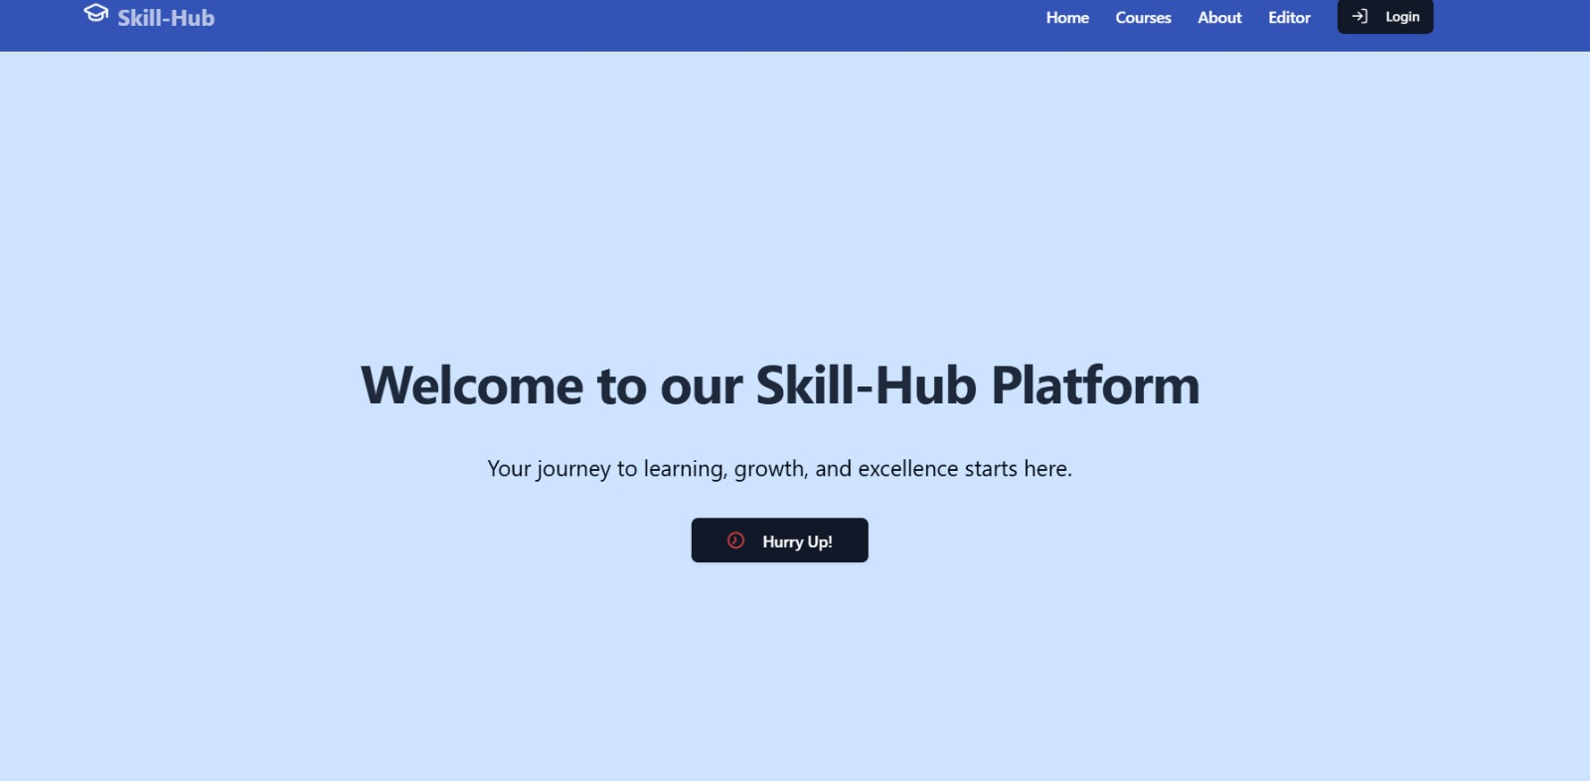

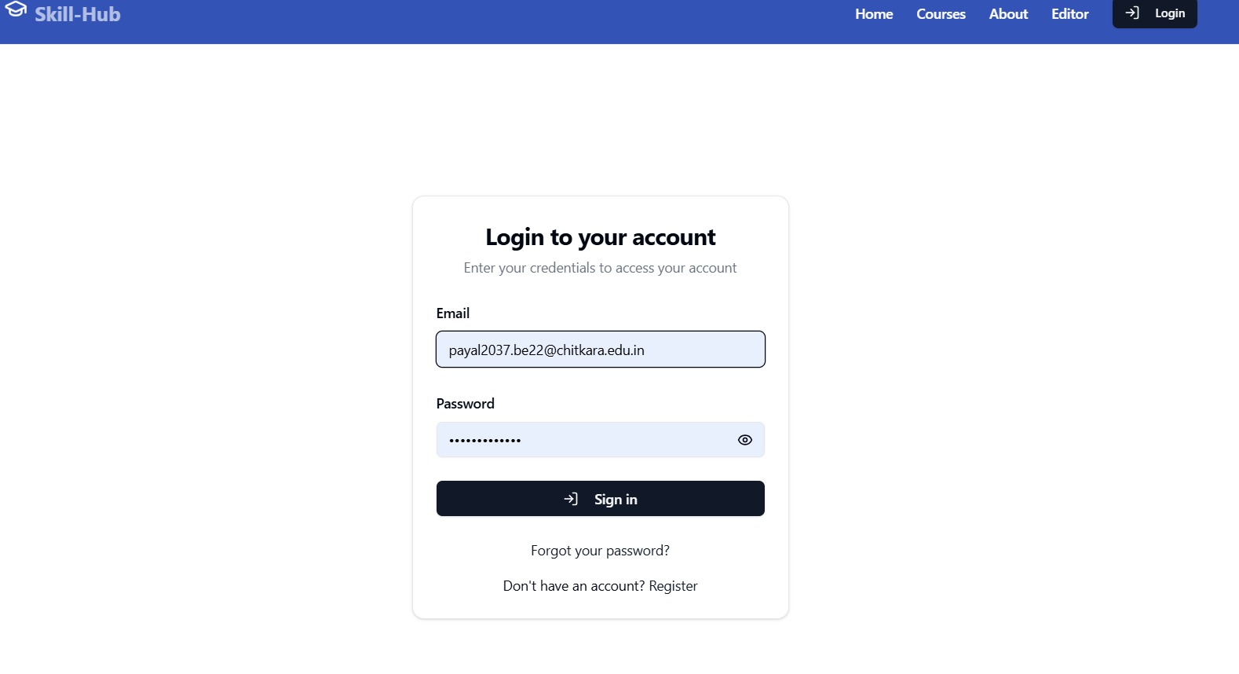

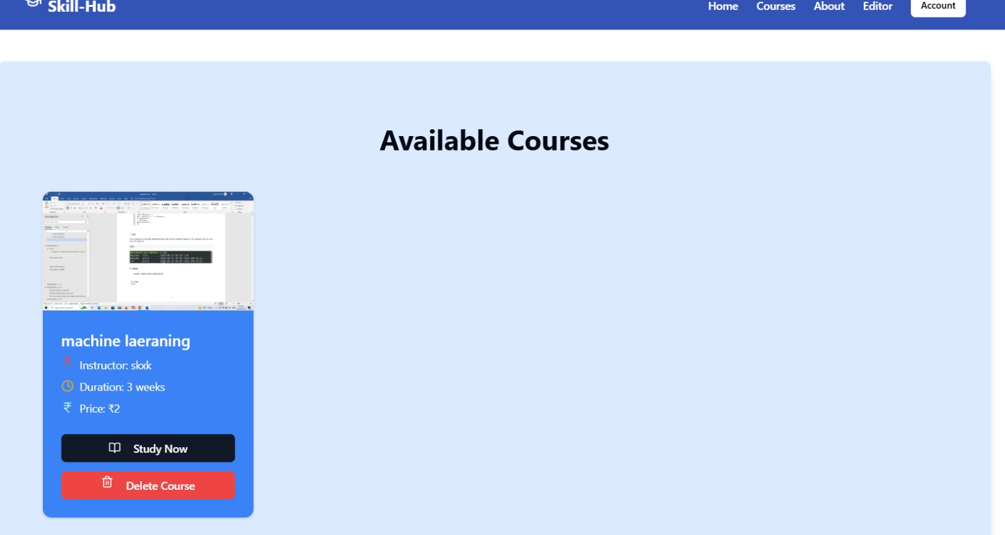

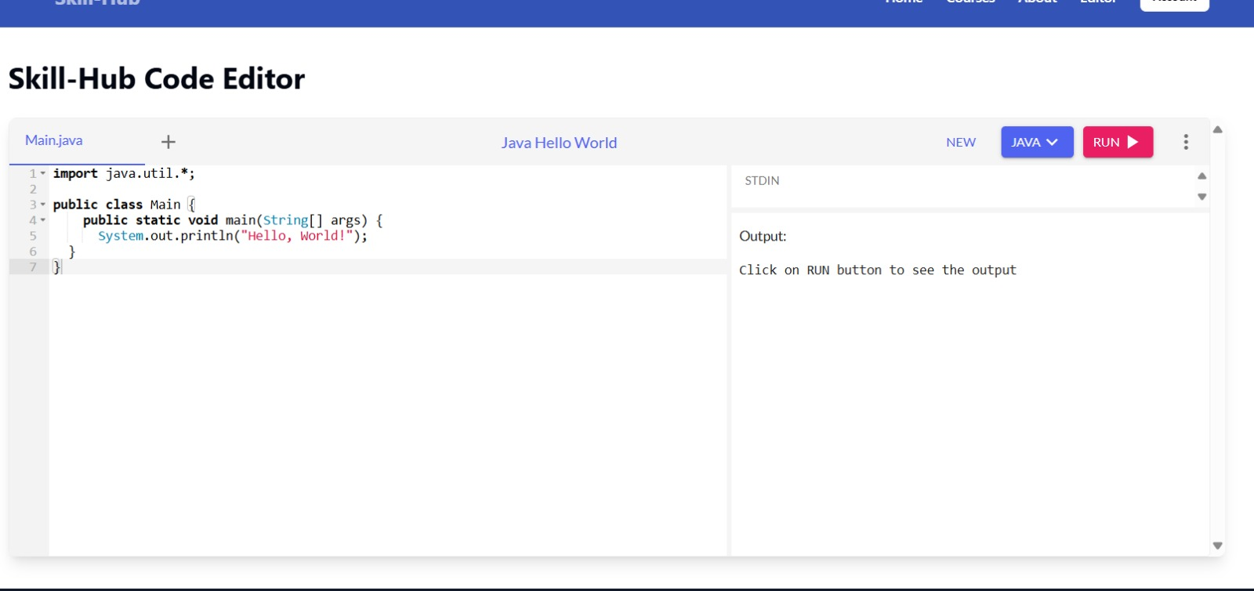

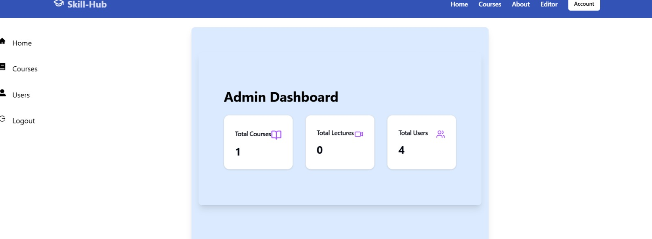

**5. References**

1. Official Documentation:

* React.js: <https://react.dev/>
* Tailwind CSS: <https://tailwindcss.com/docs>
* Framer Motion: <https://www.framer.com/motion/>
* Node.js: <https://nodejs.org/en/docs>
* MongoDB: <https://www.mongodb.com/docs/>

2. You Tube Tutorials:

* <https://youtu.be/JMvWrx_rLw4?si=vMe8Pm-UBMQssdH9>