**PROJECT REPORT**

**On**

# Hospital Management System

Submitted in partial fulfillment of the requirement for the

Course BEE (22CS026) of

**COMPUTER SCIENCE AND ENGINEERING**

**B.E. Batch-2022.**

**In**

**Dec -2024**



**Submitted By**

**Under the Guidance of**

**Ms. Aditi Sharma Palak**

**Mentor Roll. No.2210992011**

**Payal**

**Roll. No.2210992037**

**Parul**

**Roll. No.2210992033**

**Prabhjeet Kaur**

**Roll. No.2210992051**

**DEPARTMENT OF COMPUTER SCIENCE AND ENGINEERING**

# CHITKARA UNIVERSITY

**PUNJAB**

## CERTIFICATE

This is to certify that the project entitled "Hospital Management System" has been submitted for the Bachelor of Computer Science Engineering at Chitkara University, Punjab during the academic semester of May 2024-December 2024 is a bonafide piece of project work carried out by Palak (2210992011), Payal (2210992037), Parul (2210992033), Prabhjeet Kaur (2210992051), towards the partial fulfillment for the award of the course Integrated Project (CS 203) under the guidance of Ms. Aditi Sharma and supervision.

**Sign. Of Project Guide:**

Ms. Aditi Sharma

(Mentor)

### CANDIDATE'S DECLARATION

We, **Palak (2210992011), Parul (2210992033), Payal (2210992037), Prabhjeet Kaur (2210992051)** B.E.-2022 of the Chitkara University, Punjab hereby declare that the Integrated Project Report entitled **"Hospital Management System"** is an original work and data provided in the study is authentic to the best of our knowledge. This report has not been submitted to any other Institute for the award of any other course.

**Sign. of Student 1** Palak 2210992011

**Sign. of Student 2** Parul 2210992033

**Sign. of Student 3** Payal 2210992037

**Sign. of Student 4** Prabhjeet Kaur 2210992051

**Place:**

Chitkara University

**Date:** 9-02-2024

## ACKNOWLEDGEMENT

It is our pleasure to be indebted to various people, who directly or indirectly contributed in the development of this work and who influenced our thinking, behavior and acts during the course of study.

We express our sincere gratitude to all for providing me an opportunity to undergo Integrated Project as the part of the curriculum.

We are thankful to **Ms. Aditi Sharma**for her support, cooperation, and motivation provided to us during the training for constant inspiration, presence and blessings.

We also extend our sincere appreciation to herwho provided very valuable suggestions and precious time in accomplishing our integrated project report.

Lastly, we would like to thank the almighty and our parents for their moral support and friends with whom we shared our day-to day experience and received lots of suggestions that improve our quality of work.

**Palak Parul Payal Prabhjeet Kaur**

2210992011 2210992033 2210992037 2210992051

### Abstract

### The Hospital Management System (HMS) is an advanced software solution designed to streamline and automate key hospital operations, enhancing the overall patient experience and administrative efficiency. The system offers user-friendly features such as login/sign-up, allowing secure access for different user roles including patients, doctors, and hospital staff. Patients can book appointments, book an ambulance and communicate directly with healthcare providers via a messaging system. The user dashboard provides an overview of essential information, including upcoming appointments, medical history. Additionally, users can manage their personal information through a profile section. By integrating these features into a cohesive platform, HMS ensures seamless communication, improved service delivery, and enhanced patient care while maintaining high standards of data security and privacy.

### Keywords

Hospital Management System (HMS)

Login/Sign-up

Patient Communication

Send Message

Book Appointment

User Dashboard

User Profile Management

Book Ambulance

Patient Experience

Hospital Operations

## INDEX

|  |  |  |
| --- | --- | --- |
| **Serial No.** | **Topics** | **Page No.** |
| **1.** | Introduction | **7-9** |
| **2.** | Problem Statement | **10** |
| **3.** | Future Scope | **11** |
| **4.** | Technical Details | **12-14** |
| **5.** | Key Features | **15** |
| **6.** | Snapshots | **16-19** |
| **7.** | Project Advantages | **20** |
| **8.** | Conclusion Of the Project | **21** |
| **9.** | References | **22** |

### 1. INTRODUCTION

A Hospital Management System (HMS) is a comprehensive backend software solution designed to streamline and manage the complex operations of a healthcare facility. It addresses the challenges of patient care, medical records, appointment scheduling, booking an ambulance and administrative processes by offering an integrated platform that automates and organizes essential hospital functions. The platform is designed to be inclusive, user-friendly, and secure, ensuring that users from all walks of life can easily access the help they need.

#### 1.1 Background

The healthcare industry faces a myriad of operational challenges, particularly in large-scale hospitals where the efficient management of patient information, resources, and workflows is crucial. Traditionally, hospitals relied heavily on manual record-keeping and paper-based processes, which often led to inefficiencies, inaccuracies, and delays in critical decision-making. With the increasing demand for quality healthcare services and the necessity to streamline hospital operations, technology has emerged as a key enabler for modern healthcare systems.

The advent of Hospital Management Systems (HMS) represents a pivotal shift in how healthcare facilities are managed. An HMS is designed to automate routine tasks such as patient registration, record maintenance, ambulance booking, and appointment scheduling, while simultaneously ensuring the privacy and security of patient data. These systems enable healthcare providers to focus more on patient care and less on administrative burdens, resulting in improved operational efficiency and enhanced patient outcomes.

**1.2 Objectives:**

1. Data Management and Storage:

Design a well-structured and secure database that stores and organizes patient information, staff records, ambulance booking, appointment schedules, medical histories, and other essential hospital data. Ensure data integrity, allowing only authorized access to sensitive patient and hospital records.

1. Security and Compliance:

Implement security protocols to protect patient data and hospital records from unauthorized access, data breaches, or cyber-attacks. Ensure the system complies with industry regulations and standards, such as HIPAA, ensuring the confidentiality, availability, and integrity of patient information.

1. Automation of Hospital Operations:

Automate critical hospital processes such as patient registration, appointment scheduling, ambulance booking, inventory management, and staff management to reduce manual intervention, improve efficiency, and minimize errors.

1. Scalability and Performance:

Design the system to be scalable, ensuring that it can accommodate an increasing number of patients, staff, and hospital departments as the healthcare facility grows. Ensure that the backend can handle high loads without compromising performance, especially during peak hospital hours or critical situations.

1. API Development:

Develop a set of secure APIs that facilitate communication between the backend and the frontend, allowing seamless interaction for users such as doctors, nurses, administrative staff, and patients through various interfaces. Ensure APIs are flexible enough to allow integration with other external systems, such as insurance companies, pharmacies, and laboratories.

1. Reporting and Analytics:

Enable the system to generate real-time reports for various stakeholders, including hospital administrators, financial officers, and medical staff, to provide insights into patient care, resource usage, and hospital performance. Incorporate analytics capabilities to help in decision-making, such as optimizing staffing levels, reducing wait times, and improving patient outcomes.

1. Reliability and Availability:

Design the backend to ensure high availability and reliability, minimizing downtime and ensuring that hospital operations run smoothly at all times.

#### 1.3 Significance

1. Enhanced Operational Efficiency:

The automation of core hospital operations, such as patient registration, appointment scheduling, leads to a significant reduction in manual workloads. This increases operational efficiency by minimizing the likelihood of human errors, reducing redundant paperwork, and speeding up routine processes. Staff can then focus more on patient care rather than administrative tasks.

2. Improved Patient Care and Experience:

By streamlining processes like booking an ambulance and ensuring that medical staff have access to accurate, up-to-date patient information, the system enhances the overall patient experience. Doctors can make better-informed decisions with quick access to comprehensive patient records, leading to more effective treatments and faster response times. Efficient scheduling systems reduce patient wait times, improving satisfaction levels and ensuring timely care delivery.

3. Data Security and Privacy:

Protecting patient data is of paramount importance, as healthcare institutions handle sensitive medical information. The backend system will be designed with robust security measures to safeguard against unauthorized access, breaches, and data theft.

### 2. PROBLEM STATEMENT

Develop a comprehensive hospital management website with secure user authentication, real-time search and booking for patient records, appointments, ambulance, and other administrative tasks within the hospital. Ensure seamless user experience with fast load times, and scalable architecture. Include an admin panel for managing listings and user accounts, and provide customer support features. Implement compliance with data protection regulations and ensure high availability and security.

* Inefficient Patient Data Management:

Patient information is often scattered across different departments and systems, leading to inconsistent and inaccurate records. This fragmentation hampers the ability of healthcare professionals to access real-time, comprehensive patient data, impacting diagnosis and treatment.

* Manual and Error-Prone Processes:

Administrative tasks such as patient registration, appointment scheduling, and ambulance booking are frequently handled manually, leading to errors, lost paperwork, and time delays. This reduces overall operational efficiency and increases the burden on hospital staff.

* Scalability Issues:

Existing systems often lack the scalability required to handle growing patient populations, larger staff bases, and expanding hospital networks. This can lead to

performance degradation and system downtime, especially during periods of high

demand.

### 3. FUTURE SCOPE

The future scope of a Hospital Management System (HMS) with the integration of a map-based location selection is promising. These enhancements will significantly improve patient convenience and streamline emergency response.

* The map-based location selection in the contact section will make it easier for patients to share their exact location with hospital staff, leading to more accurate services, whether for ambulance dispatch or home-based healthcare services.
* Integrating real-time traffic updates with the map-based location selection can help hospital staff optimize routes, ensuring faster ambulance response times and more efficient delivery of home-based healthcare services.

### 4. TECHNICAL DETAILS

* **Planning and Design**

Needs Assessment: Identify the target audience, key features (e.g., resources, support forums, educational content), and functionality.

1. Wireframing: Create wireframes and mockups to visualize the website layout and user experience.
2. Content Strategy: Develop a content plan, including text, images, videos, and interactive elements.

* **Development Approach**

1. Agile Methodology: Use iterative development with regular feedback to ensure the website meets user needs.
2. Responsive Design: Ensure the website is accessible on various devices (desktops, tablets, smartphones).

* **Testing**

1. Usability Testing: Conduct tests with real users to identify and fix usability issues.
2. Performance Testing: Ensure the website loads quickly and performs well under various conditions.
3. Accessibility Testing: Make sure the website is accessible to users with disabilities (e.g., using screen readers).

* **Programming Environment**

**Frameworks/Libraries:** MERN stack.

* **Requirements to Run the Application**

Hardware Requirements

1. Server:

CPU: Modern multi-core processor (e.g., Intel Xeon or AMD Ryzen).

1. RAM:

Minimum 4GB for small sites; 8GB or more for high traffic.

1. Storage: SSD with sufficient space for the application files, database, and log

(starting from 20GB).

1. Client:

Desktop: Modern computer with at least 2GB of RAM and a recent web browser.

Mobile: Smartphones or tablets with recent operating systems and browsers.

Software Requirements

1. Operating Systems:

Servers: Windows Server, Linux-based OS (e.g., Ubuntu Server, CentOS).

Client Systems: Windows, macOS, or Linux.

1. Database Management System (DBMS):

SQL-based databases like MySQL, PostgreSQL to store records.

1. HMS Software:

A reliable HMS package that supports modules.

1. Web Browser (for Web-Based HMS):

Modern web browsers like Chrome, Firefox for accessing web-based systems.

1. Security Software:

Antivirus/Antimalware: To protect systems from threats.

Encryption Tools: For securing patient data.

6. Backup and Recovery Software:

Tools like Acronis, Veeam, or Windows Server Backup for regular data backups

Network Requirements

1. Internet Connection: Reliable and high-speed connection for development and deployment.
2. SSL Certificate: For securing data transmission and ensuring user privacy (can be obtained from Let’s Encrypt or other providers).

### 

### 5. KEY FEATURES

1. Backend Development: API Design and Management: Learn to design and implement RESTful APIs for efficient communication between the front-end and back-end.
2. Authentication and Authorization: Understand how to implement secure authentication methods (e.g., JWT, OAuth) and role-based access control.
3. Frontend Development: User Interface (UI) Design: Develop skills in creating responsive, attractive, and user-friendly interfaces using modern front-end frameworks.

User Experience Optimization: Focus on providing a seamless user experience.

1. Scalability and Performance: Load Balancing and Caching: Understand techniques to ensure the website can handle increasing numbers of users and transactions efficiently.

Performance Optimization: Optimize server responses and database queries.

1. Deployment and Maintenance: Continuous Integration/Continuous Deployment (CI/CD): Gain knowledge in setting up CI/CD pipelines for automated testing and deployment, ensuring smooth updates.

### SNAPSHOTS

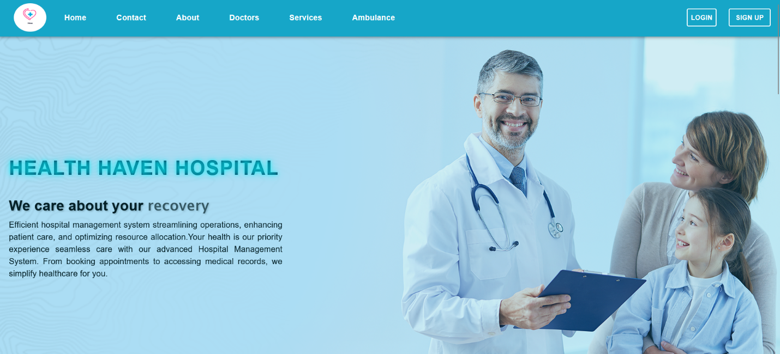

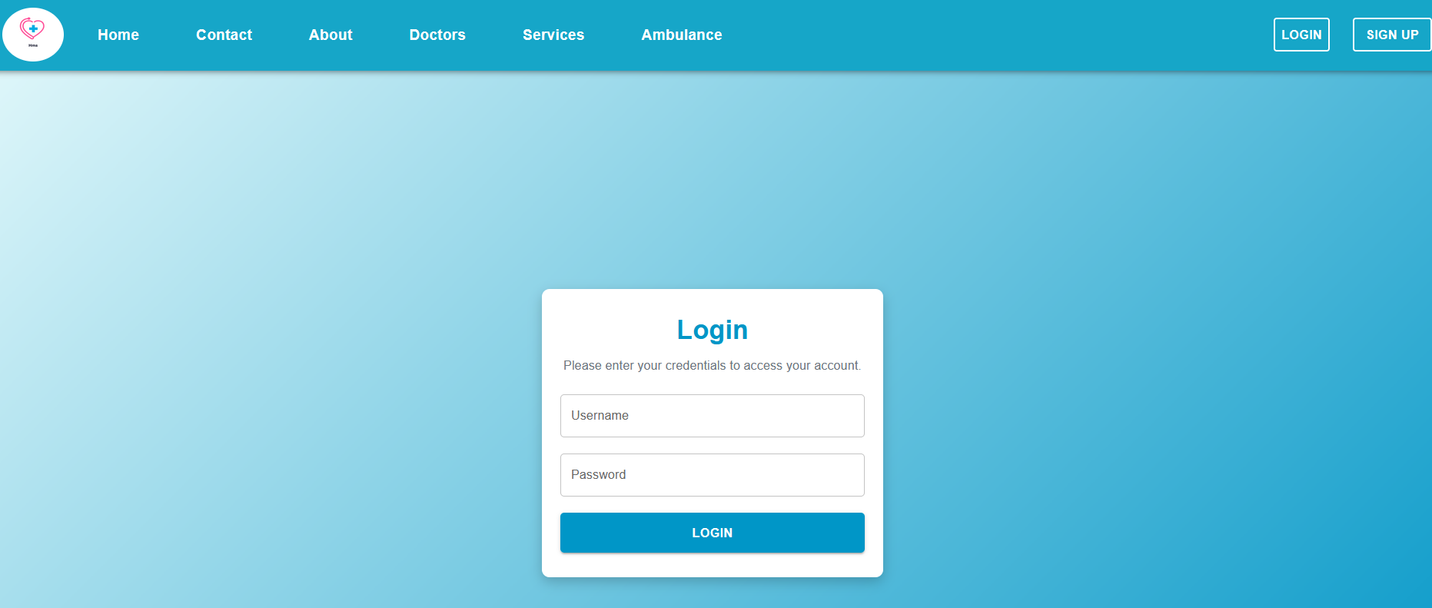

### 



### 

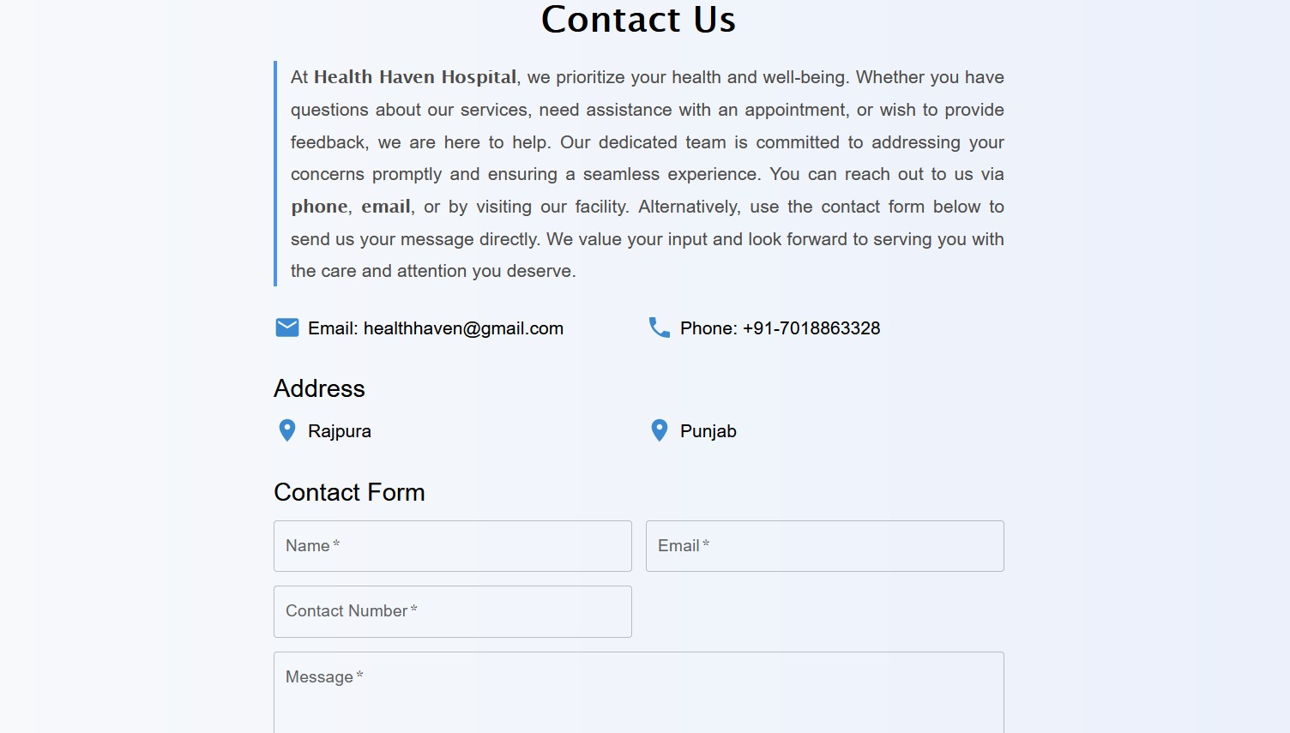

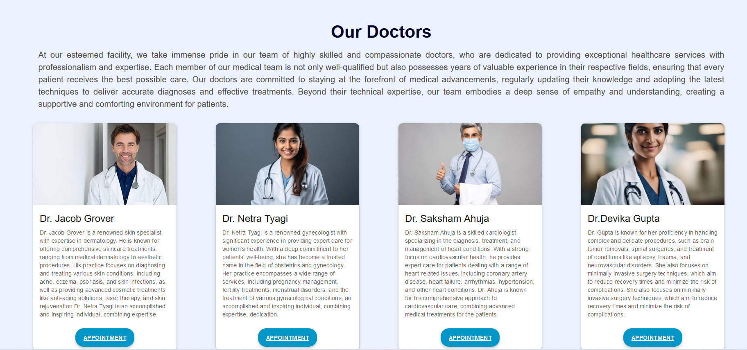

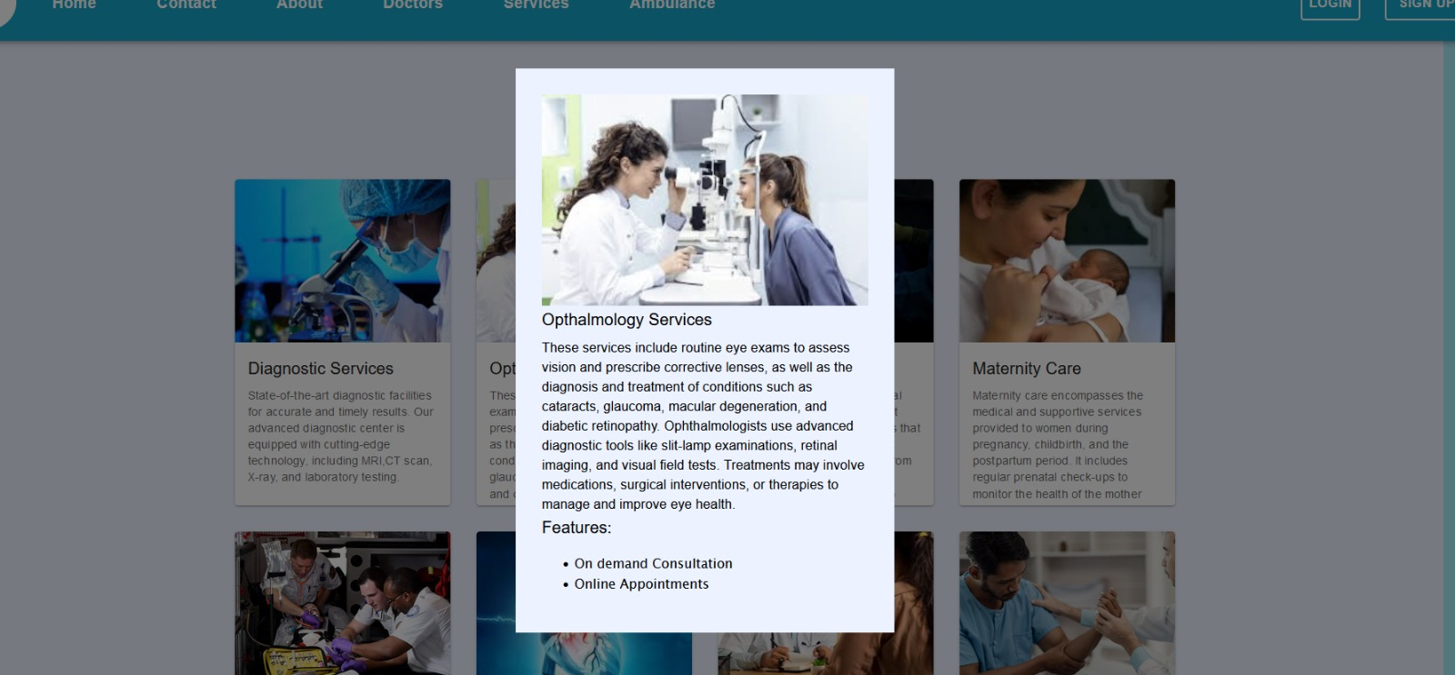

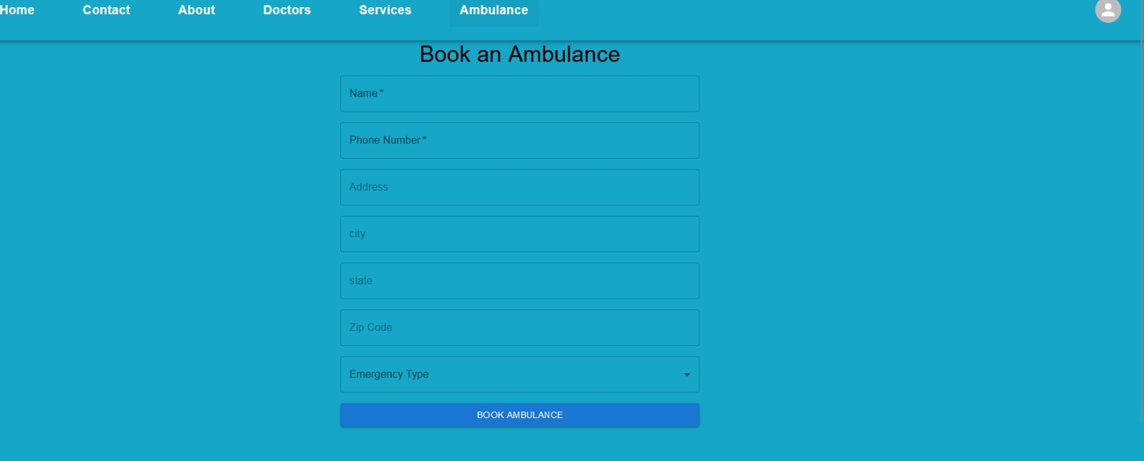

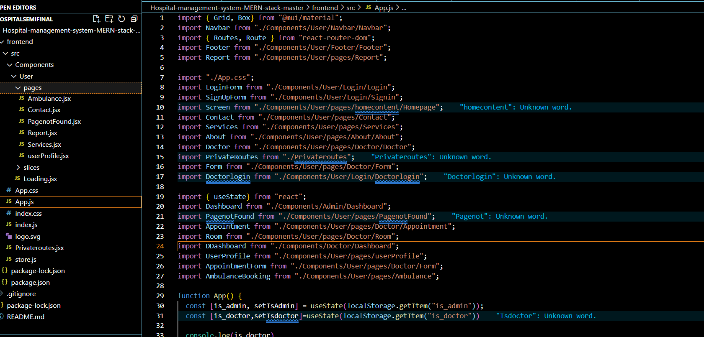

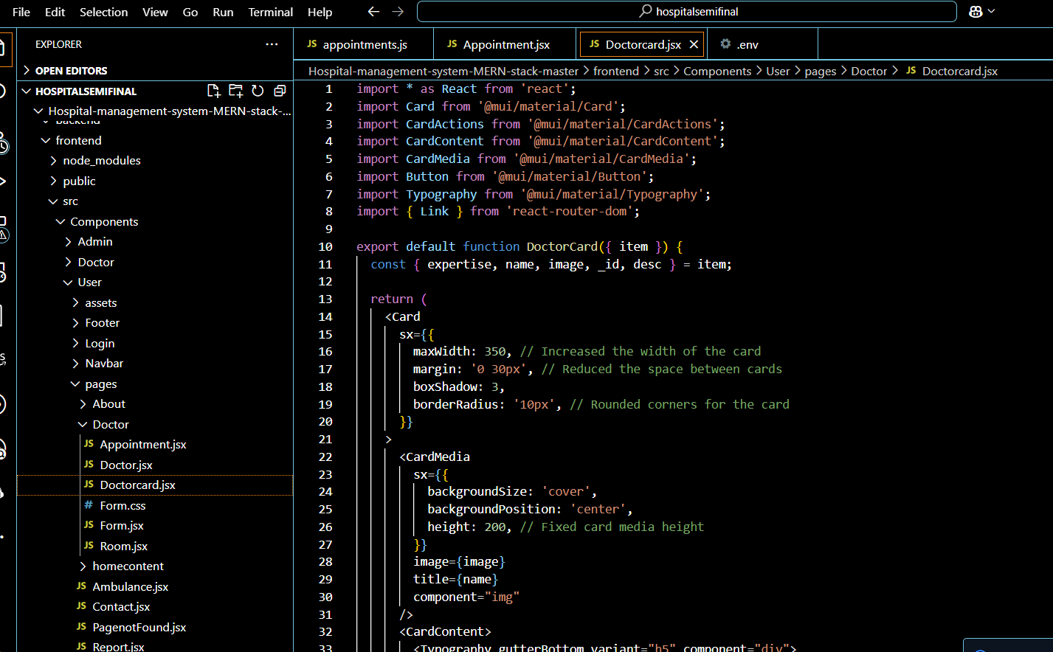

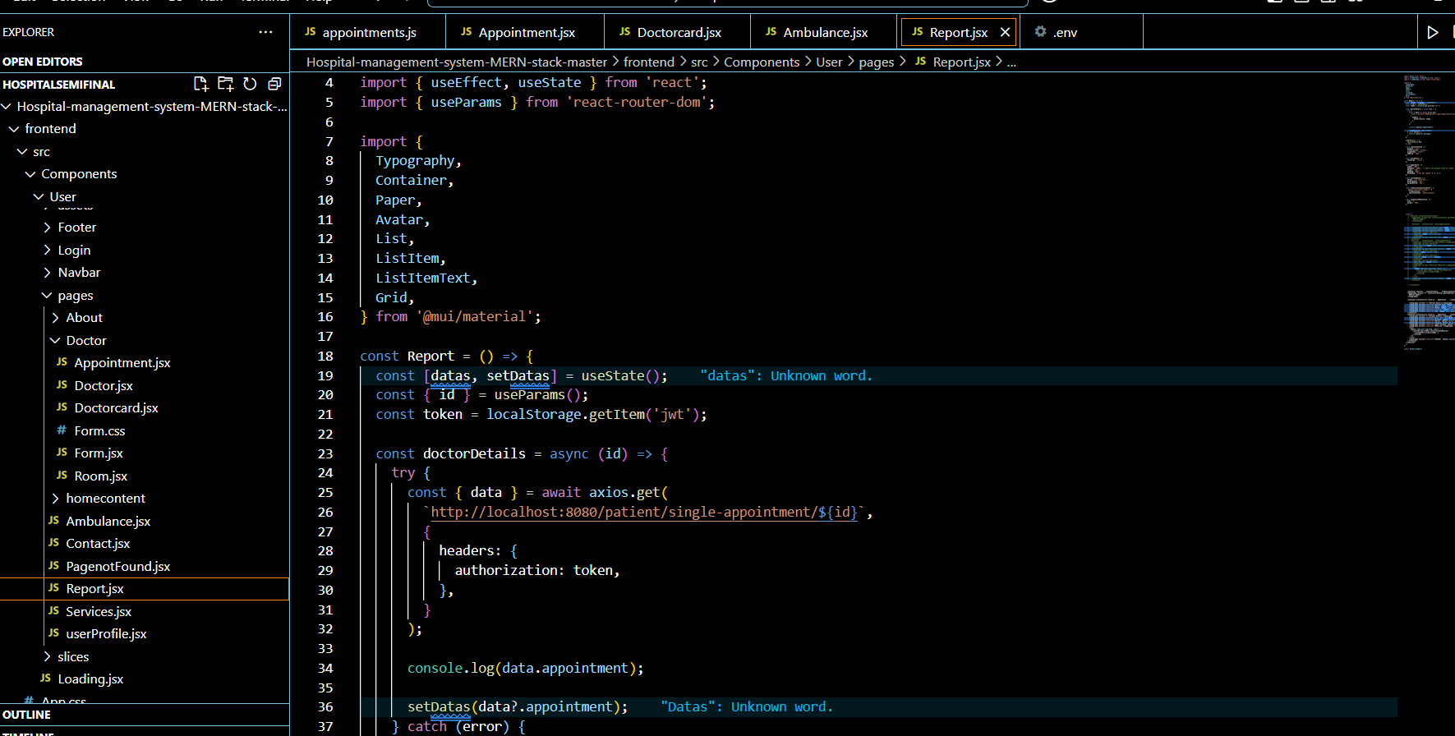

### 7. PROJECT ADVANTAGES

1. **Convenience for Users:**Patients and staff can access and manage appointments ambulance bookings, patient records, and administrative tasks anytime and from anywhere, improving accessibility and efficiency.
2. Patients and staff can access and manage appointments, patient records, and administrative tasks anytime and from anywhere, improving accessibility and efficiency.
3. Enables access to a wider patient base, incorporating diverse demographics and accommodating patients from various geographical locations.
4. Facilitates effective dissemination of hospital services and facilities to a broader audience through digital marketing and outreach initiatives.
5. Offers personalized care plans and treatment recommendations based on patient medical history and specific healthcare needs.
6. Enhances patient experience by providing tailored health and wellness information, appointment reminders, and follow-up care instructions.
7. Provides real-time updates on appointment scheduling, and treatment plan modifications, ensuring accurate and timely information for healthcare providers and patients.
8. Allows patients to provide feedback on their hospital experiences, aiding prospective patients in making informed decisions.
9. Builds trust and credibility for the hospital through authentic patient reviews and testimonials, showcasing the quality of care and services provided.

### 8. CONCLUSION

In conclusion, the **Hospital Management System (HMS)** is an essential tool for streamlining hospital streamlining hospital operations, improving patient care, and enhancing overall efficiency. By automating various processes such as patient registration, appointment scheduling, and inventory management, the system reduces manual errors and ensures timely access to critical data.

The implementation of the HMS leads to significant time savings for both hospital staff and patients, fosters better coordination between departments, and helps in maintaining a comprehensive, easily accessible patient database. Furthermore, the system enhances data security and regulatory compliance, reducing the risk of errors in medical records and financial processes.

### 9. REFERENCES

1. Documentation:

* React
* Node.js
* Express
* MongoDB

1. Online courses and tutorials:

* Udemy, Coursera, FreeCodeCamp: Comprehensive courses on full-stack development
* YouTube: Free tutorials and walkthroughs.

1. Books:

* "Learning React" by Alex Banks and Eve Porcello: For React.js.
* "Node.js Design Patterns" by Mario Casciaro: For Node.js and Express