Signal Harbour
Systematic multi-asset funds, a sector news-sentiment index, and a Streamlit research app
FINS3645 Project B
Kaiyuan Lan (z5444541)
Sample through December 2023
1. Customer, data, and backtest design
Signal Harbour is a research product for a small wealth-advisory firm. The day-to-day user is a portfolio analyst who needs comparable walk-forward evidence before an investment-committee discussion. Equity, Crypto, and Combined sleeves make up the menu, each run with equal weight, minimum variance, maximum Sharpe, and risk parity (Markowitz, 1952). Hutto and Gilbert (2014) supply the VADER baseline the course builds on.
Prices are adjusted-close simple returns within ticker. Equity and Combined sleeves use a 252-session estimation window and 252-day annualisation, whereas crypto sleeves sit on a 365-day native window. For Combined funds, crypto returns are computed on that native calendar first, then left-aligned onto equity dates, so weekend compounding is neither invented nor deleted in the merge.
On monthly decision date T, target weights use returns strictly before T, become effective on the next session, and leave the close-to-close return on T with the prior holdings. Between rebalances the book drifts with relative performance. Optimisation is long-only, a 25% name cap applies in the broad sleeves, and covariance is annualised inside the solver. A candidate solution is kept only when it improves on equal weight.
Backtest conventions
The risk-free rate is zero in the Maximum Sharpe objective and in every reported Sharpe ratio. Headline fund results assume zero trading costs, with Table 5 later applying the same turnover-cost stresses to the MinVar base and the sentiment-fusion sleeve. The Streamlit application reads precomputed CSV files and does not re-run VADER, rebuild the sentiment series, or execute backtests at runtime.
First-live timing
The decision date and the first earning date are not the same under this convention. After the 252-session warm-up, the first Equity and Combined decision date is 4 January 2021 and those targets first earn a return on 5 January 2021, while on the native crypto calendar the first decision date is 1 January 2021 and the first live return is 2 January 2021. Figure A1 starts at those live dates, not at the beginning of the raw price histories.
Why timing and drift are specified this way
A desk that forms weights after the close cannot book the full close-to-close return on T as if the new book had already been traded at the previous close. Assigning T to the old holdings and switching on the next session is the conservative sequence. It is also reproducible.
Drift is a separate issue. Resetting to target weights every day is not monthly rebalancing, even if the optimiser only runs once a month. Letting prices move the holdings, then measuring turnover against those drifted weights, keeps the wealth path and the cost exercise aligned. Annualising covariance inside the optimiser, and rejecting solutions that fail to beat equal weight, also answers a brief-level problem: SLSQP can report success without leaving its starting vector when daily variances are small. In the retained Equity sample, Minimum Variance differs from Equal Weight at every monthly decision, and the mean half-L1 distance is about 0.72, which is enough to show the solver actually moved the weights.
2. Out-of-sample fund results
Table 1 and Figure A1 report the full fund menu. Among mixed-asset portfolios, Combined Risk Parity has the highest zero-risk-free-rate Sharpe ratio, 0.91. CAGR is 14.3%, volatility is 16.2%, and maximum drawdown is -19.3% (Figures A2 and A4). Combined Maximum Sharpe finishes with slightly more wealth, 1.55x and a 15.7% CAGR, but its drawdown reaches -26.2%. Both paths are research paths under the stated assumptions.
How to read the mixed-asset ranking
The mixed result is mainly about diversification under a calendar a desk can actually trade. Combined funds are different. A stand-alone crypto portfolio compounds through weekends because it is evaluated on 365 native days, whereas Combined funds align crypto returns to equity sessions so the mixed desk earns that leg only when the equity book can also be traded. Under that constraint, Risk Parity repeatedly cuts exposure to the most volatile names in the trailing covariance estimate, without forecasting expected returns.
Maximum Sharpe has a heavier estimation burden. It has to estimate means as well as covariance, and over a three-year live window noisy means encourage larger bets, which shows up in the deeper drawdown and in the December 2023 snapshot in Table 3. For a small advisory firm the distinction is practical, with Combined Risk Parity the stronger default comparison and Combined Maximum Sharpe belonging in a satellite discussion with clients who accept concentration and drawdown risk.
Equity and crypto sleeves
On equities, Equal Weight leads with a Sharpe ratio of 0.86. Risk Parity reaches 0.76, ahead of Minimum Variance at 0.47, but it still does not displace the transparent baseline. That does not make optimisation pointless. Once the walk-forward rule is imposed, this sample simply did not pay enough for the extra estimation to beat Equal Weight, and Minimum Variance, which does not forecast expected returns, has a weaker realised Sharpe more plausibly linked to unstable covariance estimates and binding caps than to mean estimation.
Crypto Minimum Variance is the strongest crypto sleeve, with a 1.04 Sharpe ratio and a 62.1% CAGR. Crypto Maximum Sharpe is the reason CAGR and Sharpe are kept separate in this report. CAGR is -2.7%. The annualised arithmetic mean-to-volatility ratio remains positive at 0.35.
Table 1. Out-of-sample performance. CAGR is the annualised return from the growth-of-one path. Sharpe is annualised arithmetic mean divided by annualised volatility, risk-free rate zero. Equity-calendar funds use 252 days; native crypto funds use 365. Source: performance_metrics.csv. See Figures A1 and A4.
Fund | CAGR | Vol. | Sharpe | MaxDD | Terminal
Eq EW | 13.3% | 16.1% | 0.86 | -20.2% | 1.45x
Eq MinVar | 5.4% | 12.7% | 0.47 | -14.9% | 1.17x
Eq MaxSharpe | 7.0% | 17.5% | 0.48 | -22.8% | 1.22x
Eq RP | 10.4% | 14.5% | 0.76 | -18.4% | 1.34x
Cry EW | 37.1% | 81.7% | 0.80 | -81.7% | 2.58x
Cry MinVar | 62.1% | 71.2% | 1.04 | -71.5% | 4.25x
Cry MaxSharpe | -2.7% | 76.2% | 0.35 | -85.6% | 0.92x
Cry RP | 41.0% | 79.7% | 0.83 | -80.1% | 2.80x
Comb EW | 15.5% | 21.5% | 0.78 | -27.7% | 1.54x
Comb MinVar | 5.4% | 12.8% | 0.48 | -15.1% | 1.17x
Comb MaxSharpe | 15.7% | 23.3% | 0.74 | -26.2% | 1.55x
Comb RP | 14.3% | 16.2% | 0.91 | -19.3% | 1.49x
Eq MinVar+Sent | 5.3% | 12.7% | 0.47 | -14.9% | 1.17x

Concentration and the Combined sleeve
Figure A3 follows the decision weights of Combined Minimum Variance and Risk Parity, with an Other residual so that each stacked area sums to one. Risk Parity stays more dispersed. That matches the shallower drawdown in Figure A2. Minimum Variance is willing to cluster in names that look low-volatility in the trailing covariance matrix. The clustering is coherent with its objective. It still becomes a problem when the selected cluster later weakens.
Across families, the Combined sleeve tempers crypto-native volatility while keeping exposure to both asset classes. Crypto Equal Weight and Crypto Risk Parity reach high terminal growth, but their drawdowns remain extreme. The -2.7% CAGR and positive 0.35 Sharpe for Crypto Maximum Sharpe also warn against reading one metric in isolation. Once the mixed fund is evaluated on the equity calendar, Combined Risk Parity is the more usable default for a mixed-client conversation. The best pure-crypto result is not.
Table 2. Latest Combined Risk Parity decision weights, top five. Source: latest_holdings_snapshot.csv.
Ticker | Weight
MRK | 3.81%
ABBV | 3.74%
WMT | 3.37%
KO | 3.19%
TMUS | 3.17%

Table 3. Latest Combined Maximum Sharpe decision weights, top five. Source: latest_holdings_snapshot.csv.
Ticker | Weight
GE | 25.00%
NVDA | 20.09%
SO | 16.86%
ADBE | 10.32%
BTC-USD | 10.29%

These tables are end-of-sample snapshots. They describe concentration at the final decision date, not the full path from 2021 to 2023. A large December 2023 weight cannot explain performance earlier in the sample.
3. Sentiment model, sector index, and fusion
Part B keeps the headline-processing rules from Part A. Ticker-date-title duplicates are removed, and each headline is mapped to the same or next equity session before Base VADER and the Week 9 finVADER analyser are re-scored without alteration for comparison. The Week 9 benchmark combines NLTK VADER, SentiBigNomics scaled by 0.1, and the Henry lexicon, matching the course helper and Korab’s FinVADER resources. Loughran and McDonald (2011) give the wider rationale for finance-specific dictionaries.
Signal Harbour starts from that Week 9 base and adds documented masks, finance terms, and negation-aware phrases. The resulting score is multiplied by coverage confidence and by the elevated Attention Pulse confidence developed in Part A. Abnormally low headline volume never raises confidence. Missing ticker-days are inserted as neutral on a complete equity ticker-day grid before sector aggregation, so Figure A5 and the tradable signal share the same no-news convention. Any score used in a portfolio is lagged by one equity session.
The sector index as an economic series
Figure A5 is a delayed description of the news climate. Treating it as a stand-alone timing rule would over-read the series. Context-weighted sector means are mildly positive over 2020 to 2023, but their ordering moves with the macro cycle. During the February to April 2020 COVID stress window, Energy is the weakest sector at about 0.005, whereas Technology and Real Estate sit closer to 0.05. That pattern fits an energy-demand shock and comparatively resilient digital and property-related language in the supplied corpus. It says nothing about realised sector returns.
The ranking changes in 2022. Energy becomes the strongest sector on the index at roughly 0.061, while Materials and Communications sit near the bottom around 0.023 to 0.030. A year dominated by inflation, energy cash flows, and supply concerns makes that ordering economically plausible. Healthcare rises from about 0.036 in 2021 to 0.053 in 2023, and Technology recovers from 0.033 in 2022 to 0.051 in 2023.
Coverage is not uniform. Technology and Consumer average more than five headlines on news-bearing ticker-days, whereas Materials and Real Estate are nearer two and have larger exact-zero raw-score shares (Figure A11). Context weighting discounts sparse observations so that a thinly covered sector is not treated as equally well measured. Communications stays in a relatively narrow 0.027 to 0.038 range across 2020 to 2023. Energy moves from 0.017 in 2020 to 0.061 in 2022 before easing to 0.041 in 2023, and Consumer remains roughly between 0.037 and 0.045. Neutral filling compresses the index level, so the useful information is mainly in relative movement across sectors and years. Figure A11 is the coverage check for whether a move reflects dense headline flow or a thin signal.
Continuity with Part A
Two design choices keep continuity with Part A. First, Attention Pulse remains a volume-confidence feature. It was descriptive in Part A and is not converted here into a contemporaneous trading trigger. Using only its elevated-volume confidence keeps the construction past-looking, without reversing the earlier claim that the pulse itself was not backtested alpha.
Second, the phrase and lexicon layer is recorded in the audit material, not hidden inside a package label. The Week 9 FinVADER lexicons are vendored with Apache-2.0 notices, and Signal Harbour’s own terms, phrases, and masks are identified separately. Without that record, calling the model “augmented finVADER” would say very little about what actually changed.
Distributional model comparison
Table 4 and Figure A8 compare polarity shares across a 4,000-headline sample. A lower neutral share is only a distributional observation, not evidence of better prediction. The 120-headline worksheet can support later labelling, but its review column is blank on purpose and the pseudo-label field is not treated as ground truth. Figure A9 looks at component effects through ablation on the Week 9 analyser and does not report labelled precision or recall. On the 800-headline ablation sample, removing neutral overrides has no effect. no_neutral_overrides matches full_signal_harbour because the retained masks rarely fire. The components that visibly move the neutral share are custom terms and phrases. Figure A10 reports active ticker counts. Figure A11 is the separate coverage-intensity exhibit.
Table 4. Model polarity shares on 4,000 headlines. The comparison is distributional only. Source: sentiment_model_comparison.csv; Figure A8.
Model | Mean | Positive | Neutral | Negative
Base VADER | 0.106 | 37.5% | 49.6% | 12.9%
Week 9 finVADER | 0.069 | 26.6% | 62.1% | 11.3%
Signal Harbour | 0.081 | 29.8% | 58.7% | 11.6%

Fusion result
The main fusion test applies the lagged context-weighted score to Equity Minimum Variance. Figure A6 shows that the two wealth paths are almost indistinguishable. The overlay is slightly worse. The zero-risk-free-rate Sharpe ratio falls from 0.4740 to 0.4711 and CAGR from 5.36% to 5.32%. Figure A7 and Table 6 extend the stress across tilt strengths and base portfolios. None of the tested specifications overtakes Equity Equal Weight. Table 5 then applies the same turnover-cost assumptions to the MinVar base and the fusion sleeve. Even modest costs preserve, and slightly widen, the disadvantage of the overlay. What remains usable is a continuous, look-ahead-safe monitoring pipeline, not a marketed alpha claim.
Table 5. Base versus fusion under equal turnover costs. TO is average annual turnover. Source: fusion_cost_sensitivity.csv.
Sleeve | Cost | Sharpe | CAGR | TO | Terminal
Base | 0 bp | 0.474 | 5.36% | 1.90 | 1.169x
Fusion | 0 bp | 0.471 | 5.32% | 1.91 | 1.167x
Base | 5 bp | 0.467 | 5.26% | 1.90 | 1.165x
Fusion | 5 bp | 0.464 | 5.22% | 1.91 | 1.164x
Base | 10 bp | 0.459 | 5.16% | 1.90 | 1.162x
Fusion | 10 bp | 0.456 | 5.12% | 1.91 | 1.161x
Base | 25 bp | 0.437 | 4.86% | 1.90 | 1.152x
Fusion | 25 bp | 0.434 | 4.82% | 1.91 | 1.151x

Table 6. Fusion robustness across equity bases and tilt strengths at zero cost. Source: fusion_sensitivity.csv; Figure A7.
Base | Tilt | CAGR | Sharpe | MaxDD
EW | 0.15 | 13.24% | 0.853 | -20.2%
EW | 0.35 | 13.17% | 0.849 | -20.2%
EW | 0.60 | 13.08% | 0.845 | -20.3%
RP | 0.15 | 10.39% | 0.753 | -18.4%
RP | 0.35 | 10.34% | 0.751 | -18.4%
RP | 0.60 | 10.29% | 0.748 | -18.5%
MinVar | 0.15 | 5.34% | 0.473 | -14.9%
MinVar | 0.35 | 5.32% | 0.471 | -14.9%
MinVar | 0.60 | 5.29% | 0.469 | -14.9%

The negative fusion result does not mean finance-aware sentiment has no research value. Table 4 and Figures A8 and A9 show that Week 9 finVADER and Signal Harbour redistribute polarity mass relative to social-media VADER, and the Explain view can still identify the terms and confidence weights behind a lagged score. In this 2021 to 2023 equity sample, a multiplicative portfolio tilt was not rewarded after the one-session lag, which sits with headline tone being partly contemporaneous with price information already present in the estimation window, and with the lag removing the most mechanical portion of any apparent edge. Repeating the test on Equal Weight and Risk Parity bases also shows the result is not an artefact of a damaged MinVar path. Thus, Recommendation 3 keeps sentiment as a monitoring and explanation layer, not as an independent return engine.
4. The Signal Harbour application
The application follows the analyst’s pre-committee workflow. Each tab answers a different question using precomputed research files, which keeps the free-tier deployment light and makes the displayed evidence reproducible.
Compare. Rank sleeves by zero-risk-free-rate Sharpe and terminal growth, then plot a shortlist of wealth paths from the research sample through December 2023.
Fact sheet. Inspect one fund at a time: CAGR, volatility, Sharpe, drawdown, and the latest decision weights. A residual is stated whenever only the top holdings are displayed.
Allocate. Combine completed fund return streams without re-optimising names, using intersecting equity sessions for equity-only blends and the native union calendar for blends containing crypto.
Sentiment and Explain. Review the sector news climate, model comparisons, coverage diagnostics, and the prior-session fields that produced the lagged tradable score. Headlines are not re-scored live.
Calendar treatment in Allocate
Allocate uses a different calendar rule from the Combined-fund backtest because it mixes already-built return streams without re-optimising the underlying names. Any selection containing a Crypto fund uses the native union calendar, annualises at 365 days, and records zero for a closed equity leg. Equity-only blends stay on intersecting equity sessions and use 252-day annualisation. Due to that split, a 60/40 equity-crypto research allocation can retain crypto weekend returns without silently dropping Saturdays.
A few product choices are worth stating because they affect what a user actually sees. The light theme is pinned so a dark-mode browser cannot place white headings on a pale custom background, Allocate does not imply that a crypto sleeve exists only on equity-open dates, and Explain displays the signal-date fields that entered the one-session lag so same-day headlines are not paired with yesterday’s tradable score. The fact sheet states the residual weight whenever the top-20 table is not the complete portfolio.
For the advisory firm described in Part A, the interface maps onto a short meeting sequence. Begin with Combined Risk Parity and its drawdown profile (Recommendation 1; Sharpe 0.91). Combined Maximum Sharpe enters only when a client asks for more growth and accepts a deeper loss profile (Recommendation 2). Explain is for news-context colour, with Recommendation 3 already setting the boundary that sentiment is a monitoring layer, not a trading engine. If Energy’s stronger 2022 news-climate reading is questioned, the answer is in Section 3. Every series is labelled as an out-of-sample research path through December 2023, not as a live production feed.
5. Recommendations
The three recommendations below are taken from the verified tables and exhibits.
1. Default mixed sleeve. Use Combined Risk Parity as the primary balanced multi-asset comparison within this sample, with a zero-risk-free-rate Sharpe ratio of 0.91 and a maximum drawdown of -19.3% (Table 1; Figures A1, A2 and A4).
2. Satellite growth sleeve. Keep Combined Maximum Sharpe as an optional higher-growth alternative rather than the default. Terminal wealth reaches 1.55x, but maximum drawdown deepens to -26.2% and the latest holdings are more concentrated (Tables 1 and 3; Figure A3).
3. Sentiment as monitoring, not alpha. Retain the lagged context-weighted layer in the explainability workflow, but do not market it as a return engine. Relative to Equity MinVar, Sharpe moves from 0.4740 to 0.4711 and deteriorates further under equal cost assumptions (Figure A6; Tables 5 and 6).
6. Critical reflection and limits
Several choices make the study internally consistent, and they also narrow what can be claimed from it.
Short live window. Equity and Combined returns run from 5 January 2021 to December 2023, so the rankings are exposed to the COVID recovery, the 2022 inflation and rate shock, and the 2023 equity rebound. A longer sample could reorder Equal Weight and Risk Parity.
Headline results exclude costs. Table 1 is a zero-cost laboratory, and Table 5 shows that even 5 to 25 basis points per unit of turnover reduce the fusion result. Applying the same grid to every fund would probably narrow the gap between higher-turnover Maximum Sharpe paths and lower-turnover Risk Parity.
Uneven news coverage. Materials and Real Estate have thinner headline intensity and larger exact-zero raw-score shares than Technology or Consumer (Figure A11), so their sector readings require greater caution.
Distributional, not labelled, sentiment evidence. The model comparison rests on polarity shares and the Week 9 ablation. Because the 120-headline review column remains blank, this report does not claim labelled precision or recall.
End-point holdings are not path explanations. The December 2023 snapshots in Tables 2 and 3 describe concentration at the last decision date and cannot explain the complete 2021 to 2023 wealth path.
Product-level reflection
Building Signal Harbour on the actual Week 9 analyser was a stronger continuity choice than attaching a few finance terms to plain VADER. The report records the provenance of both the course lexicons and the project-specific additions. The application is explicit that it reads precomputed files and does not re-score headlines at runtime. Under those conditions, credibility comes from design quality, auditability, and restrained claims, not from the appearance of a live model.
If I extended the project, I would make three changes. First, I would complete the review column and report labelled validation statistics. Second, I would apply the turnover-cost grid from Table 5 to every fund family so that Recommendation 1 is tested under the same frictions. Third, I would publish the public GitHub repository and Streamlit deployment, then resolve any remaining theme issues before submission. Those steps would improve validation and delivery without altering the central result that the sentiment overlay is economically flat to negative in this sample.
What out-of-sample means here
The fund weights are walk-forward and use only past returns, and the tradable sentiment input is delayed by one equity session. The research choices around lexicon retention, tilt strength, and the base sleeve receiving the overlay were nevertheless made with knowledge of the full study period, which is a normal limitation in a fixed-sample coursework project. The negative fusion result should be read as a stress test of one pre-specified overlay design, not as proof that every possible news rule failed under a sealed holdout. The development-holdout split in the headline worksheet offers partial discipline for labelling work, but it is not a complete untouched test set.
Signal Harbour gives a small advisory desk a coherent menu of systematic funds, a lagged sector news-climate monitor linked to Part A, and an auditable explanation for why a name was tilted. It should not claim that the tilt paid in this sample, nor hide the calendar, cost, or coverage frictions that an investment committee would reasonably raise. Remaining packaging work is operational: keep the light theme pinned and verify that the live URL matches the version described here.

Appendix A. Exhibits
Each exhibit is discussed in Sections 2 to 4. Captions restate the sample, source, and the claim the figure is meant to support.
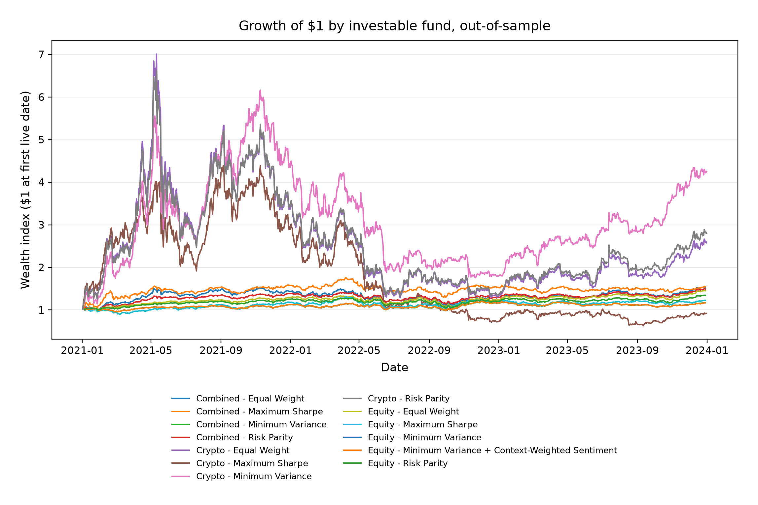
Figure A1. Growth of $1 across funds, out-of-sample through December 2023. Combined Risk Parity is steadier than Combined Maximum Sharpe; Crypto Minimum Variance leads terminal wealth among the crypto sleeves. Source: fund_returns.csv.

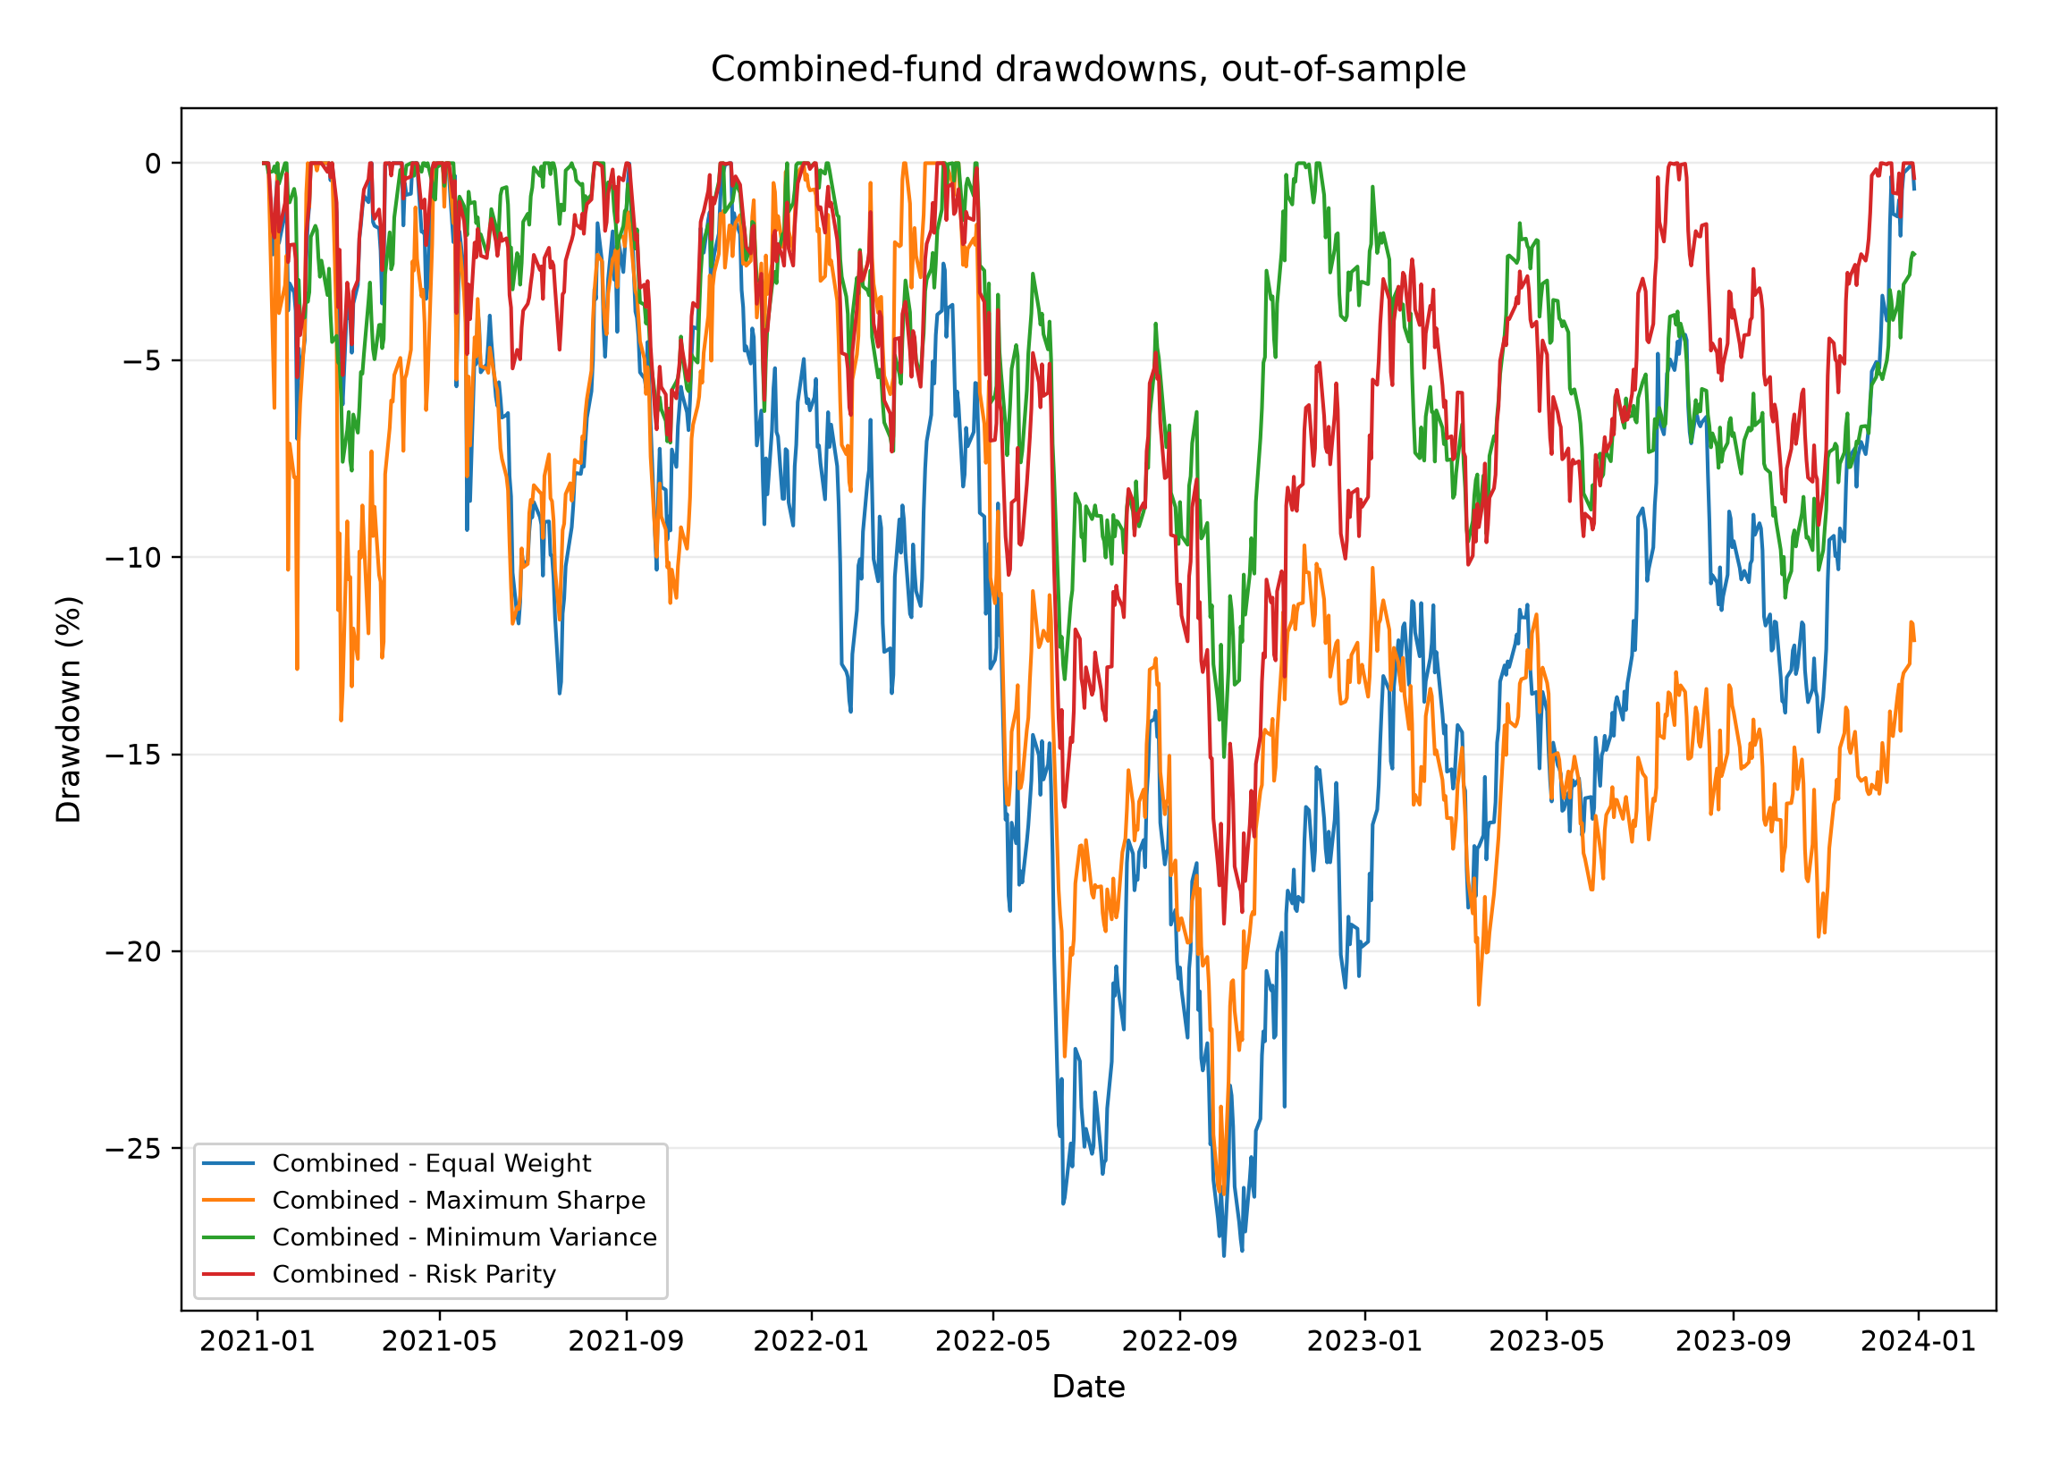
Figure A2. Combined-fund drawdowns. Risk Parity has the shallower path, supporting Recommendation 1; Maximum Sharpe reaches the deeper trough expected of the higher-growth satellite. Wealth paths prepend 1.0 so that the first loss is visible.

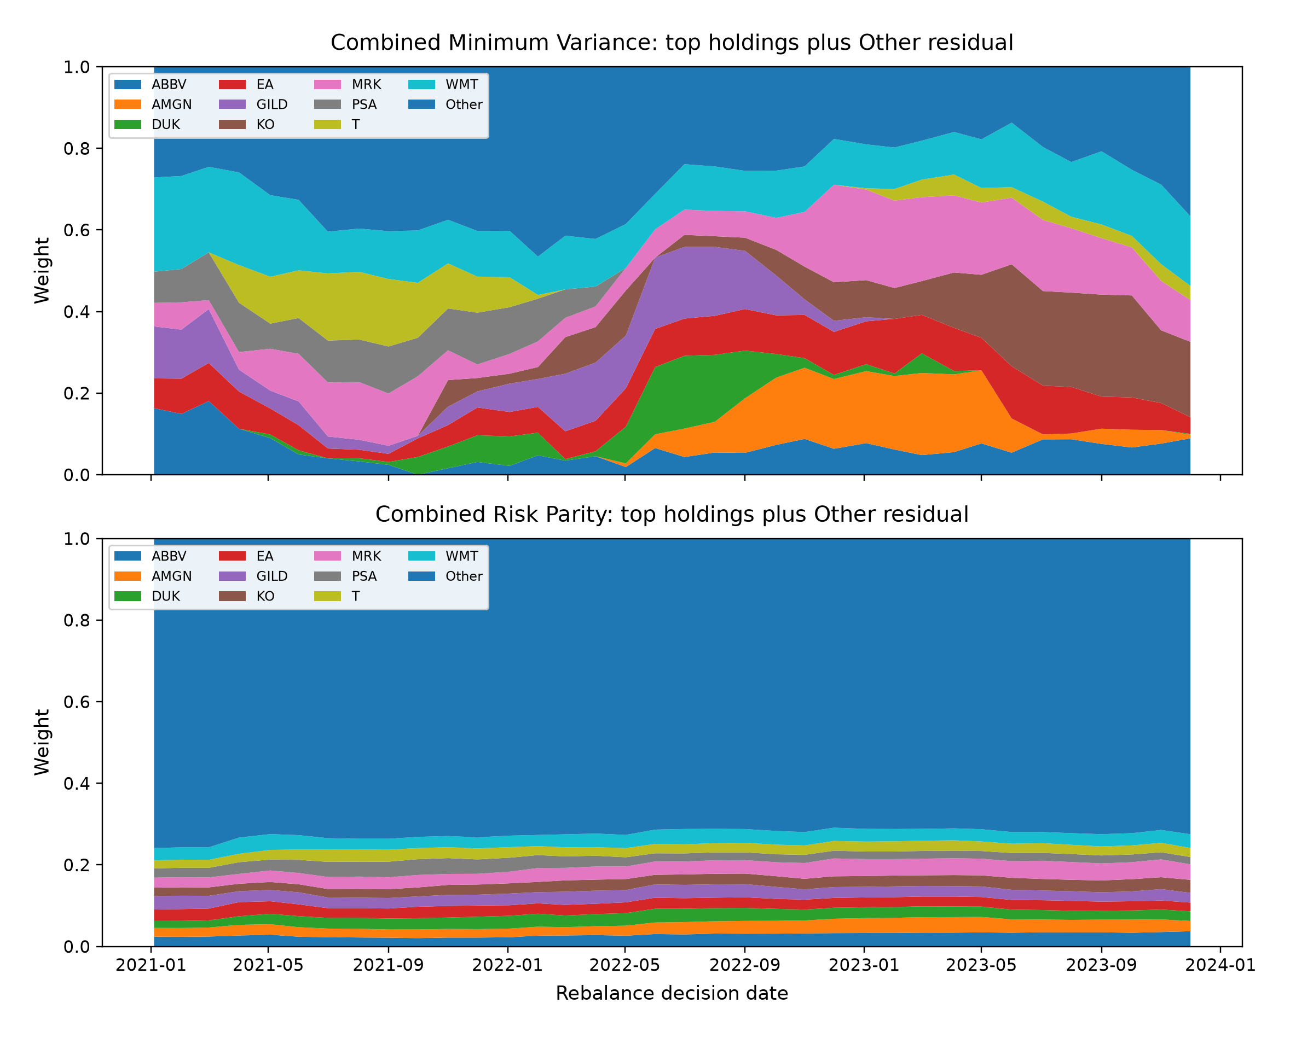
Figure A3. Combined Minimum Variance and Risk Parity decision weights, with an Other residual so the stacked areas sum to one. Maximum Sharpe concentration is summarised in Table 3 rather than in this panel.

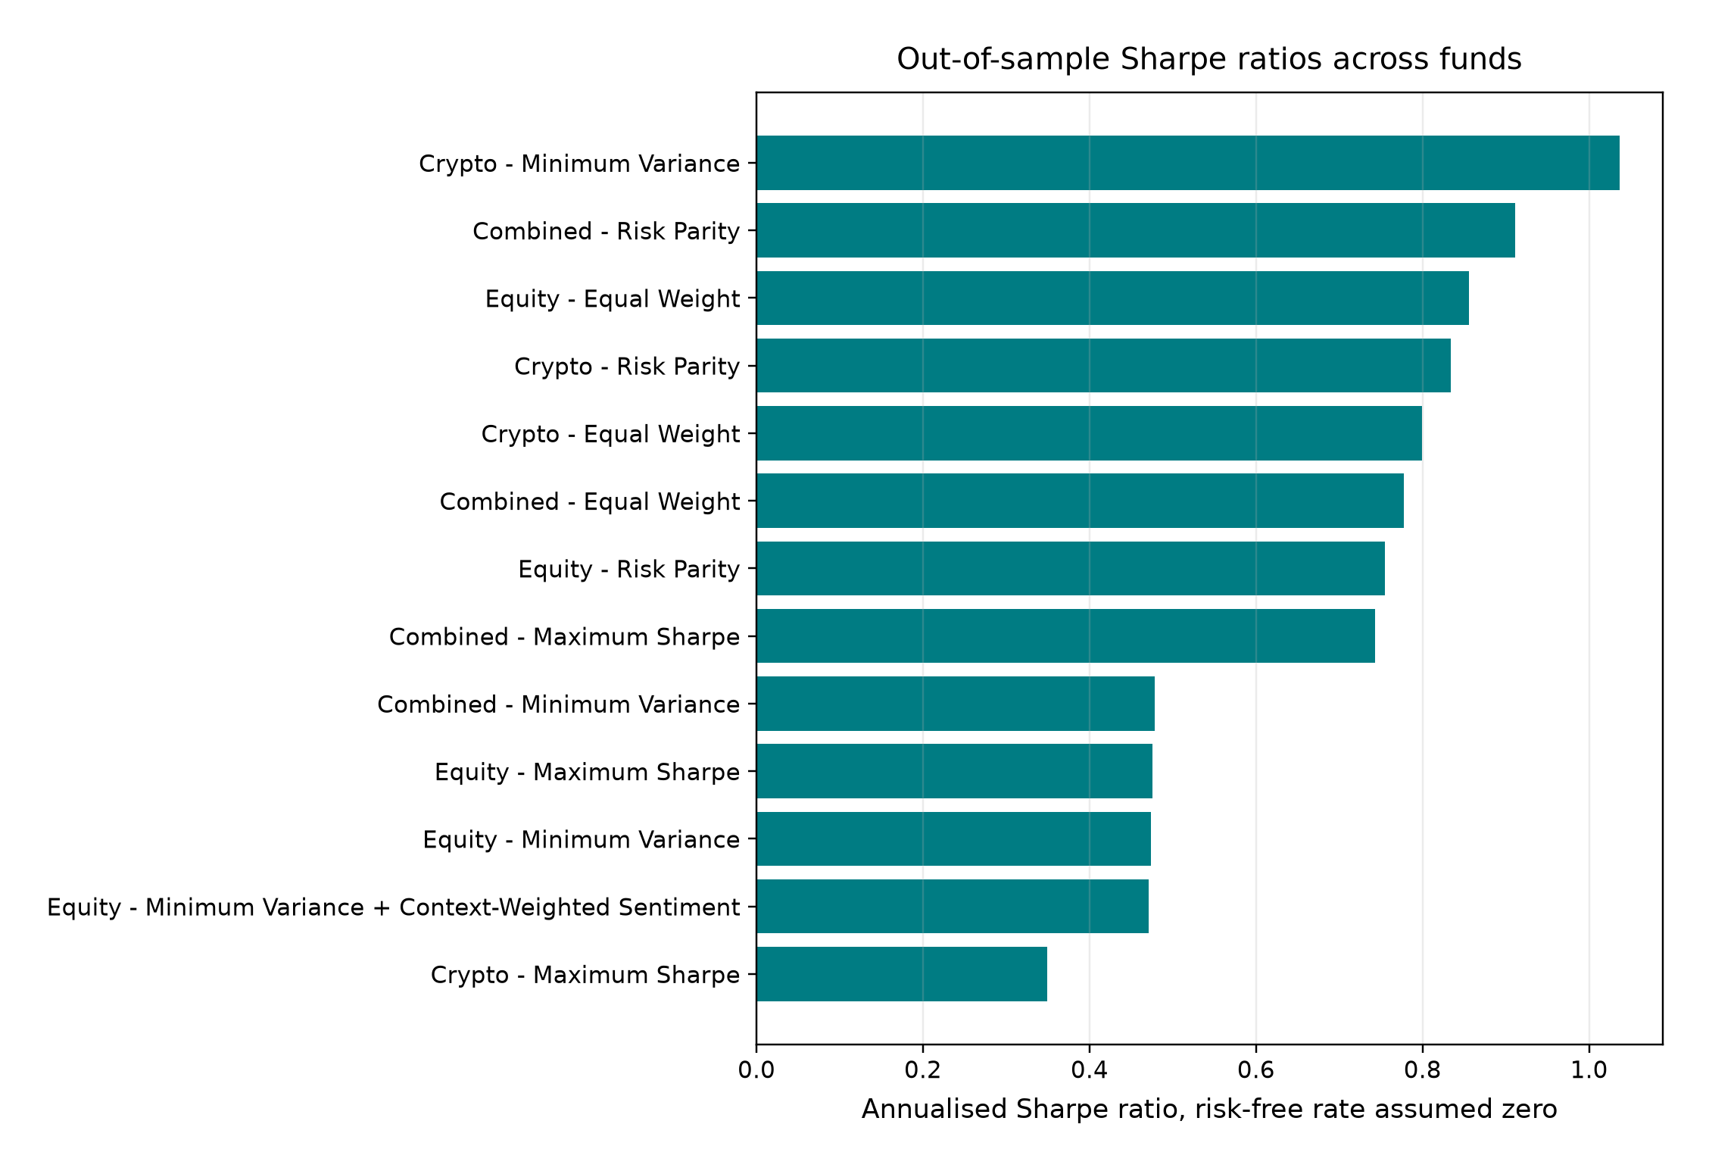
Figure A4. Zero-risk-free-rate Sharpe rankings. Combined Risk Parity leads the mixed sleeves; Equity Equal Weight leads equities; Crypto Minimum Variance leads crypto. Annualisation is 252 or 365 days by sleeve.

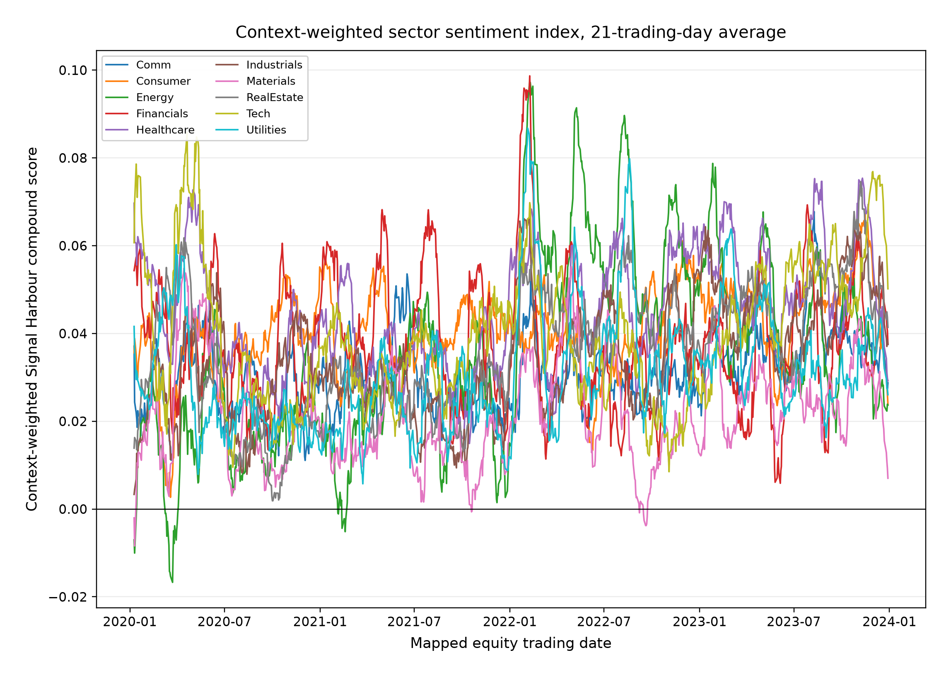
Figure A5. Context-weighted sector sentiment, shown as a 21-session average. The series uses the complete ticker-day grid, sets no-news observations to neutral, and is lagged before any trading use.

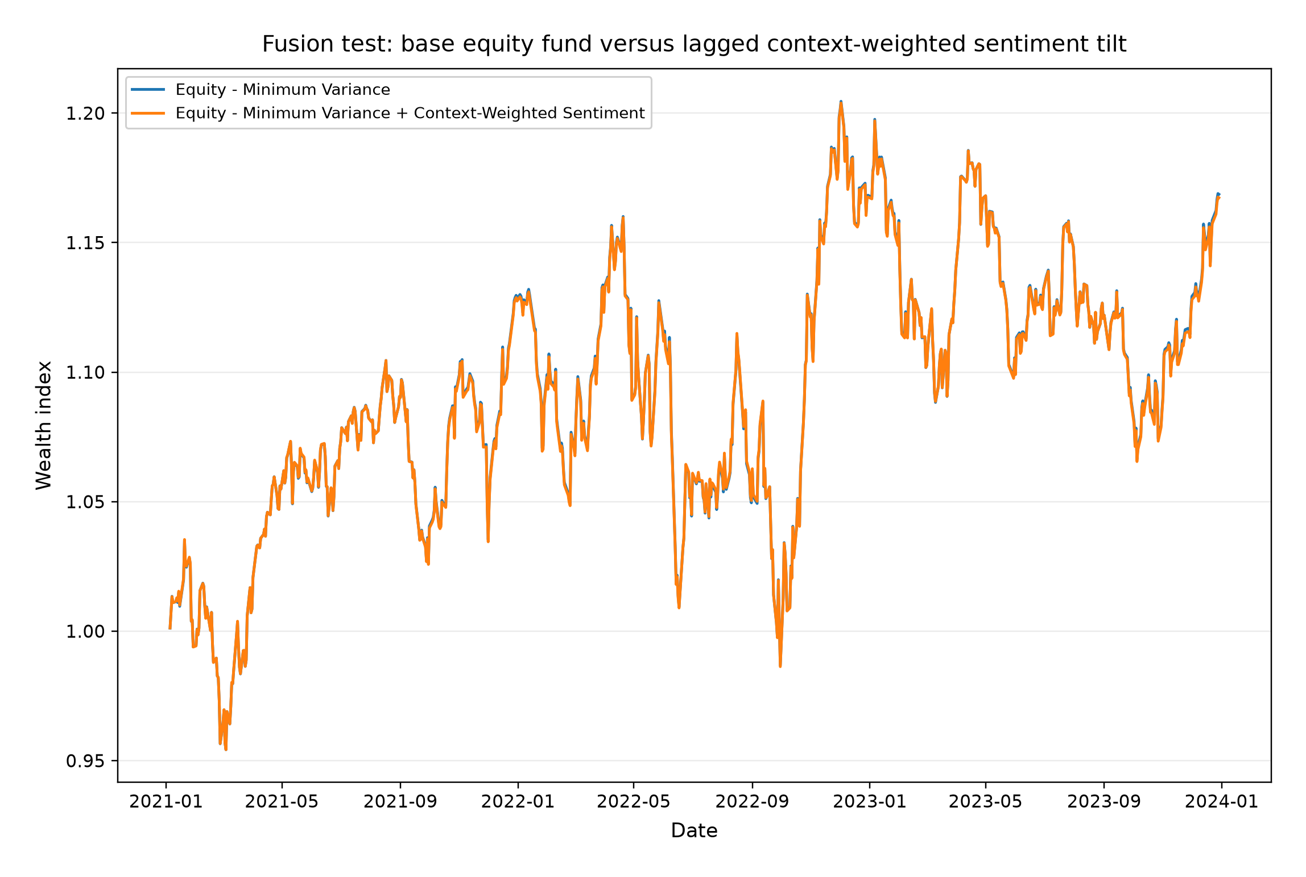
Figure A6. Equity Minimum Variance against the lagged context-weighted sentiment tilt. The overlay does not improve the corrected baseline, which supports Recommendation 3.

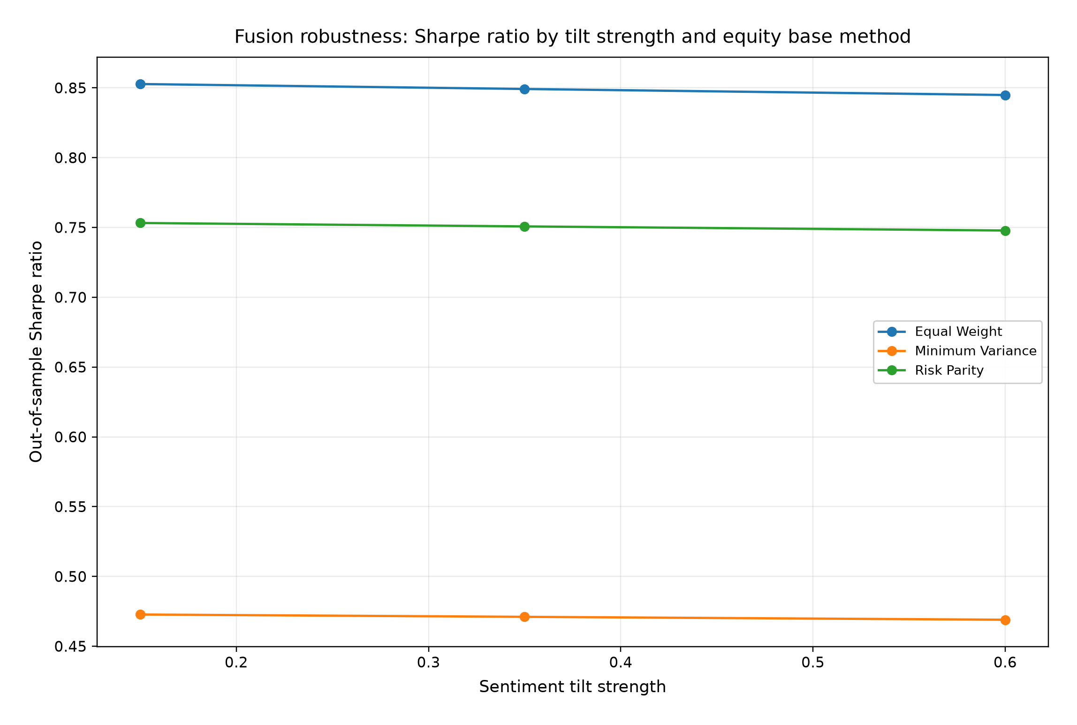
Figure A7. Fusion sensitivity by tilt strength and equity base at zero cost. None of the tested specifications overtakes Equity Equal Weight (Table 6).

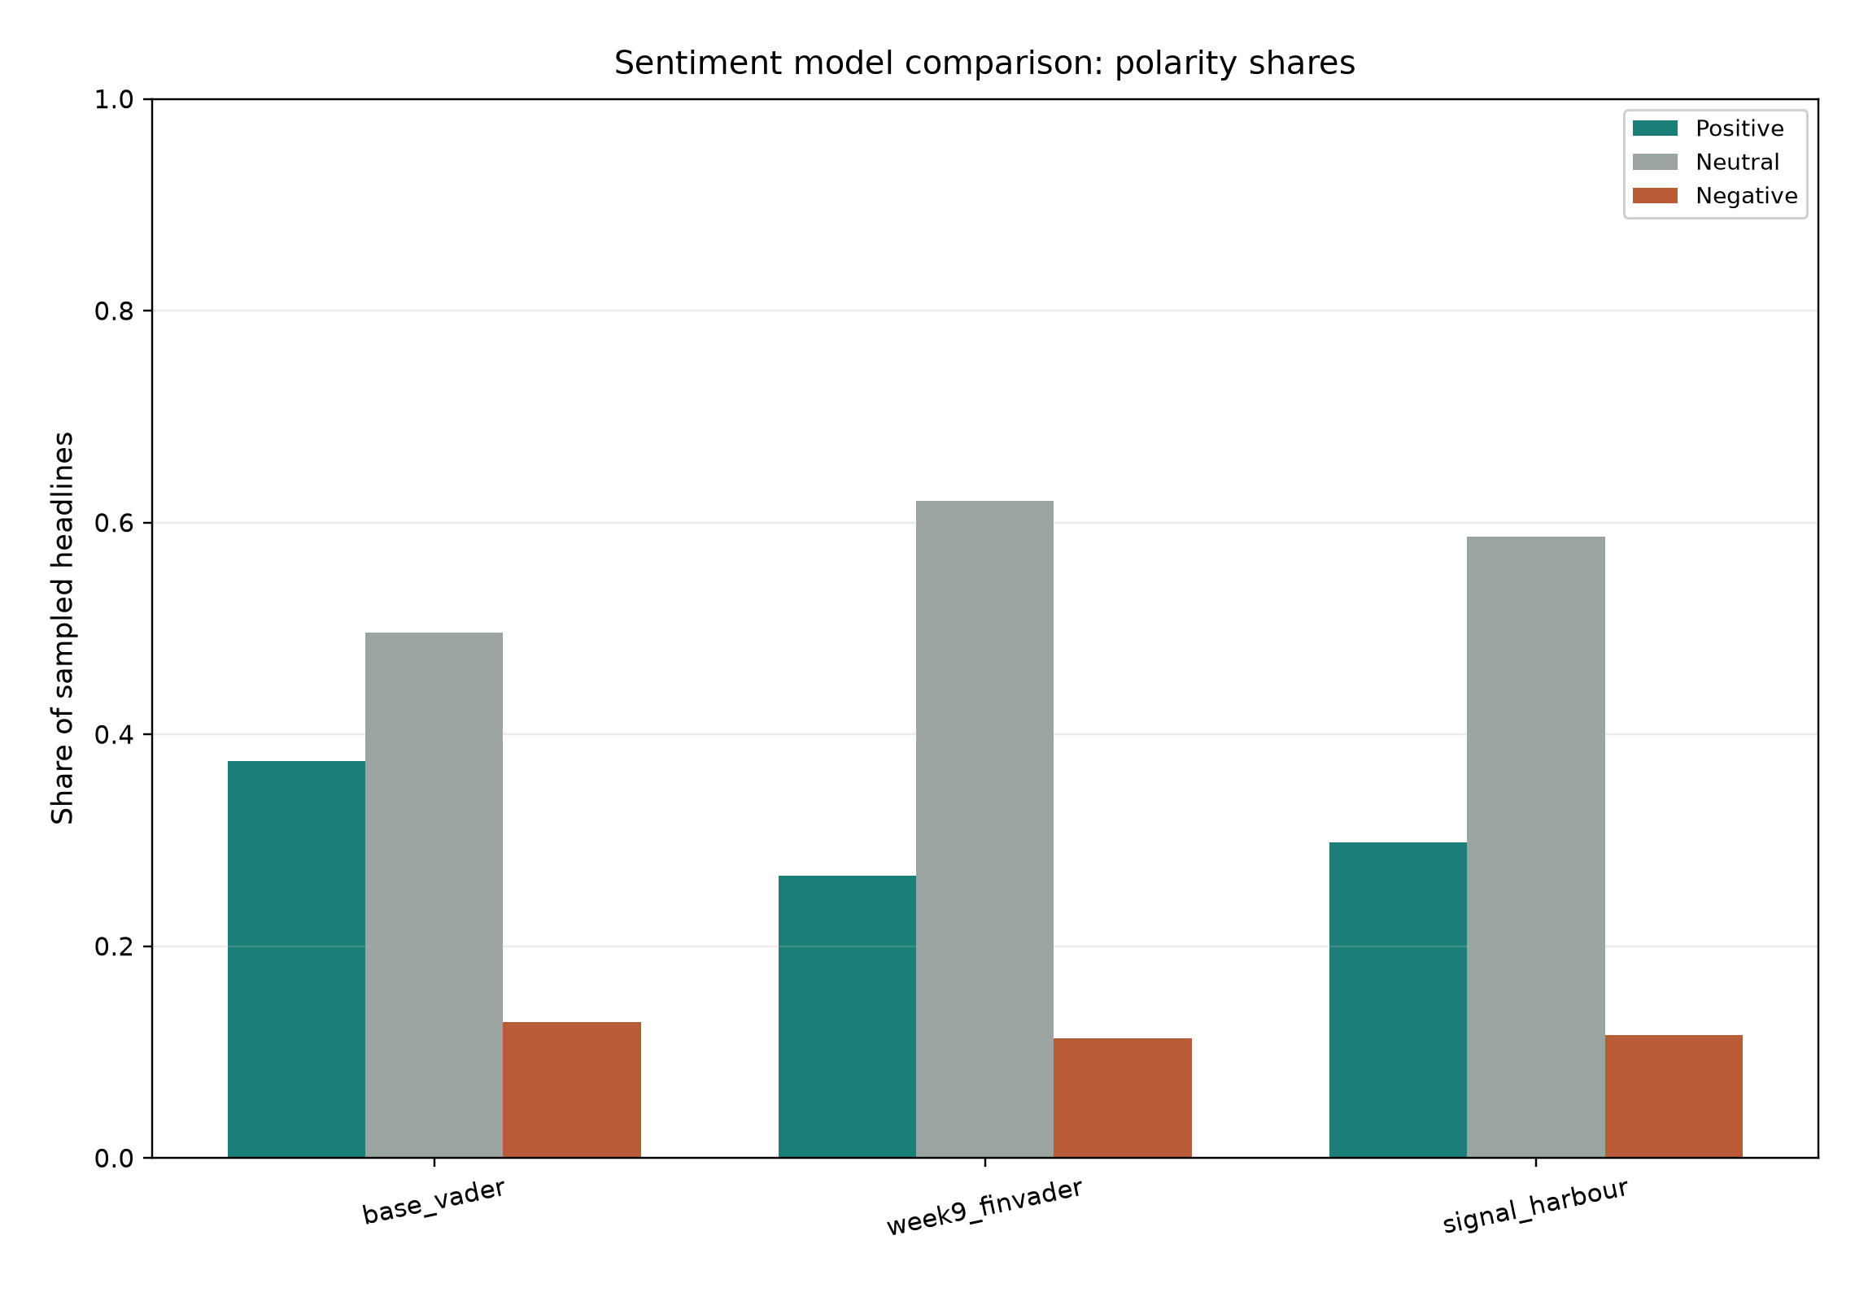
Figure A8. Polarity shares for Base VADER, Week 9 finVADER, and Signal Harbour on 4,000 headlines (Table 4). The comparison is distributional only.

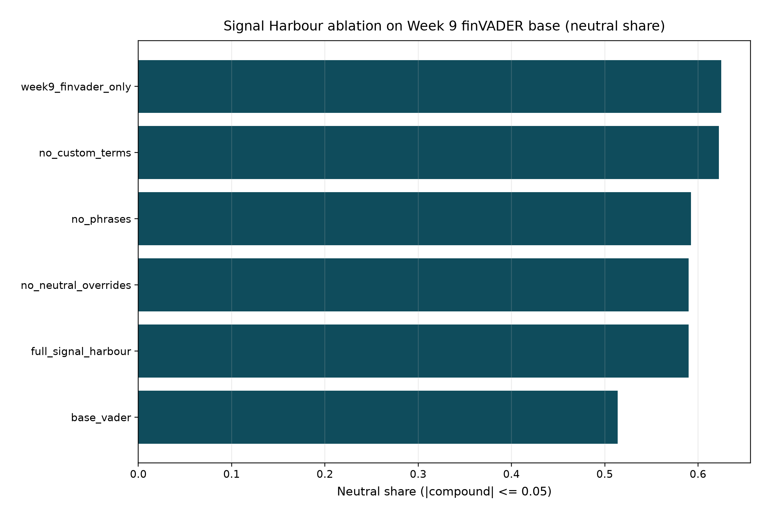
Figure A9. Ablation of Signal Harbour components on the Week 9 finVADER base analyser, with Week 9-only and plain-VADER references.

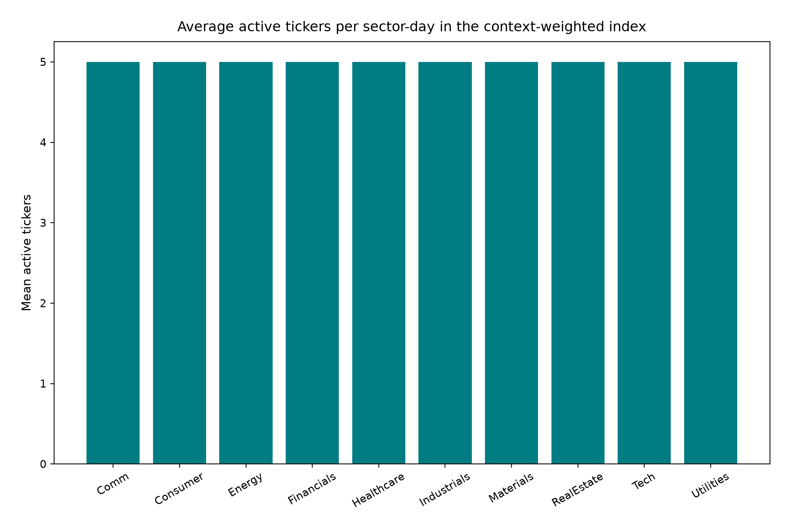
Figure A10. Average active tickers per sector-day under the complete-grid context-weighted index. This is the coverage companion to Figure A5.

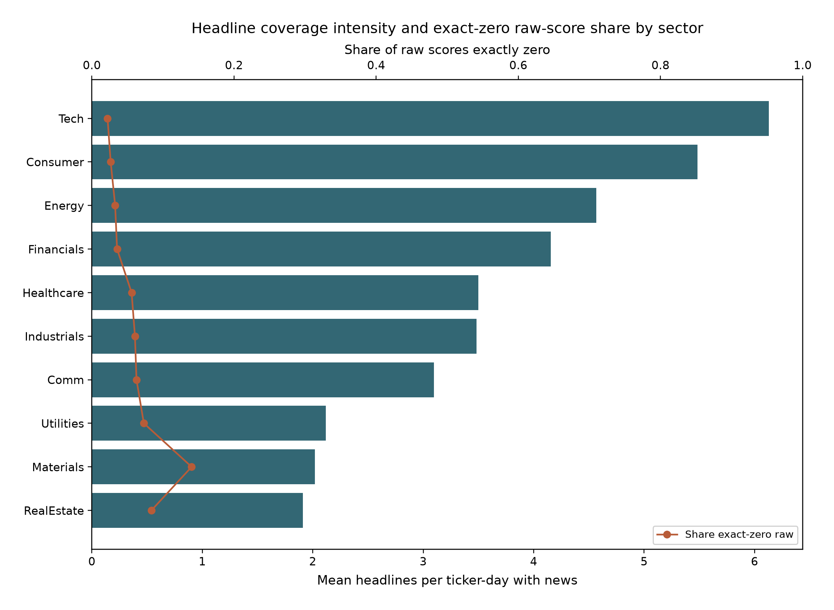
Figure A11. Sector coverage intensity: mean headlines on news-bearing ticker-days (bars) and the share of exact-zero raw scores (line). This exhibit is distinct from the polarity comparison in Figure A8.

Appendix B. Core equations and references
Minimum variance
minimise w^T SigmaAnn w subject to 1^T w = 1 and 0 <= w(i) <= wMax
SigmaAnn = ppy * Cov(R), where ppy is 252 on the equity calendar or 365 on the native crypto calendar.
Maximum Sharpe
maximise (w^T muAnn) / sqrt(w^T SigmaAnn w)
The risk-free rate is zero; the long-only and name-cap constraints are unchanged.
Reported performance
Sharpe = (mean(r) * ppy) / (std(r) * sqrt(ppy))
CAGR = WT raised to the power (ppy/T), minus 1
Context-weighted score
sCw(i, t) = s(i, t) * coverageConf(i, t) * attentionConf(i, t)
Tradable score = sCw(i, t minus 1).
Sentiment tilt
wTilt is proportional to w * exp(lambda * (score minus mean(score))). The tilted vector is then projected back onto the capped simplex.
References
Hutto, C. J., and Gilbert, E. (2014). VADER: A parsimonious rule-based model for sentiment analysis of social media text. ICWSM.
Korab, P. FinVADER lexicons (SentiBigNomics / Henry path used in FINS3645 Week 9). Apache 2.0; vendored under src/vendor/course_finvader.
Loughran, T., and McDonald, B. (2011). When is a liability not a liability? The Journal of Finance, 66(1), 35 to 65.
Markowitz, H. (1952). Portfolio selection. The Journal of Finance, 7(1), 77 to 91.
FINS3645 Project 2026 brief and data access helper; Kaiyuan Lan, Project A Signal Harbour / Attention Pulse (2026).

