TITLE & AUTHORS

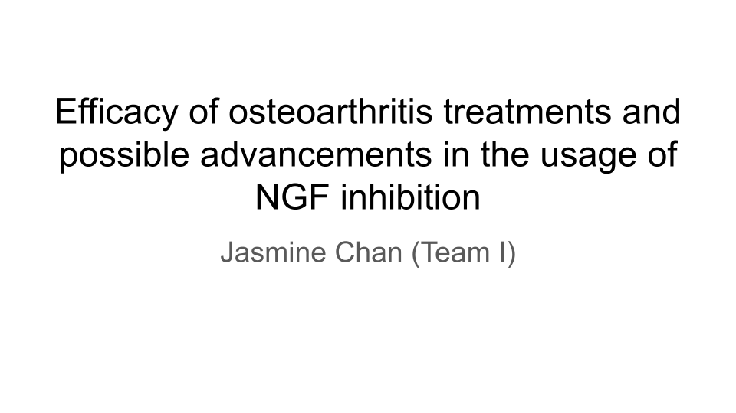
Title: Efficacy of osteoarthritis treatments and possible advancements in NGF inhibition

Authors: Jasmine Chan

O. ABSTRACT (100-200-300words)
Background: Current OA treatments are limited and most only relieve pain, improve range of motion, and promote partial regeneration, thus meaning that the need for advancements for OA cure is needed. Researched methods include NGF inhibition and modulation of other neurotrophins.

Hypothesis / Problem Statement: Compared to more common treatments such as PT, NGF inhibition will work more strongly in relieving pain. LEVI-04 inhibits neurotrophin-3, tanezumab is an NGF inhibitor but with harmful side effects, hypothesis is that LEVI-04 will be preferable over PT and placebo.

Aims: Compare various treatments, existing and experimental, of OA and determine efficacy of pain reduction and severity of effects.

Study Design: (Statistical analysis): Four groups, treated with placebo, PT, tanezumab, and LEVI-04. Measures on Bristol Rabbit Pain Scale (0-18) over time of 16 weeks. 2-way ANOVA to compare treatment as well as treatments over time.

Results: LEVI-04 preferable due to less deleterious side effects compared to tanezumab, although the inhibitors show more pain relief in comparison to PT and placebo.

Significance: Advancements in OA treatment and discovery of NGF inhibitors that do not cause progressively worsening OA.

I. BACKGROUND

I.1. Replace this with the main take-home point of this Background slide.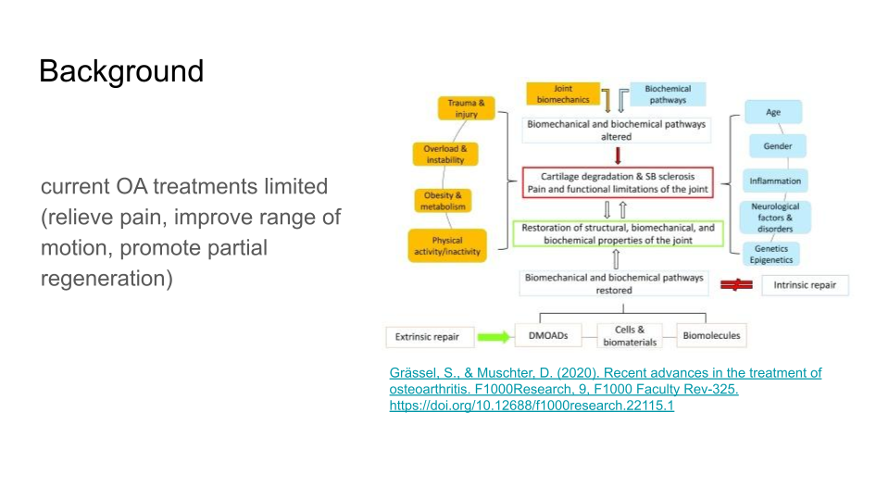
B1. current OA treatments are limited, and most only relieve pain, improve range of motion, and promote partial regeneration, thus meaning that the need for advancements for OA cure is needed.
.A. OA is driven by both mechanical and biological factors, as you can see in the schematic, which alter typical joint functions that lead to damage. extrinsic treatments are needed to prevent further degradation as intrinsic healing is insufficient to restore joint function and possible repair
.B. several common types: physical therapy, pharmacologic treatment, surgery, arthroscopic management, transplantation, osteotomy, arthroplasty, radiofrequency
.C. treatments are either good for short-term pain relief, or are better long-term but reduce movement
.D. many methods are currently being researched, including NGF blockade and other neurotrophin level modulation

I.2. Replace this with the main take-home point of this Background slide.
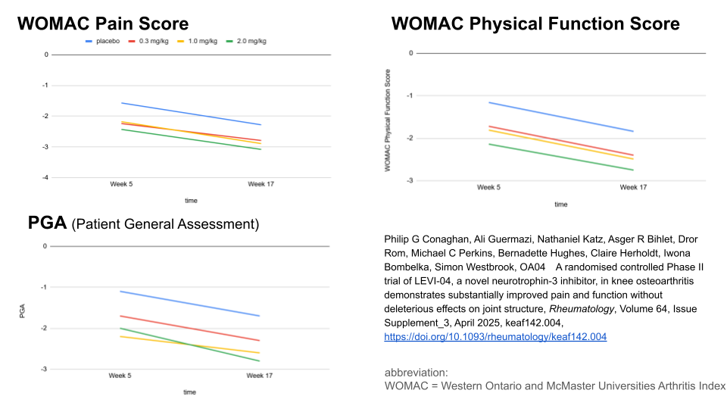
B2. original study showing the use of LEVI-04 protein in IV infusions in groups of people with OA, neurotrophin modulation, proves more amount of LEVI-04 means more effective results in reduction of pain and increase in mobility
.A. in general, higher amounts of LEVI-04 can be seen at improvement in pain, function, and patient general assesment (2.0 mg/kg is often the lowest values, showing more change/improvement)
.B.
.C. abbreviation:
WOMAC = Western Ontario and McMaster Universities Arthritis Index
.D. Supporting statement 4

I.3. Replace this with the main take-home point of this Background slide.
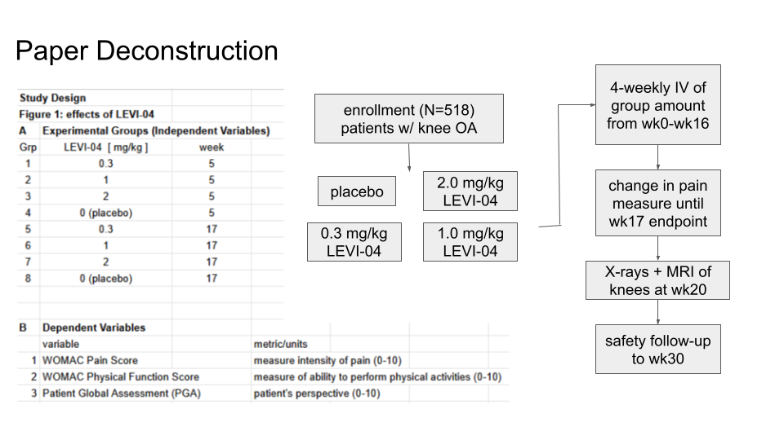
I.B3. (Repeat here the) Main take-home point of this Background slide
.A. (flow chart) started with enrollment of 518 patients with knee OA, randomized into four groups: placebo, 0.3, 1.0, 2.0. led to 4-weekly IVs of LEVI-04 of amount specified per group from wk0-wk16, change in pain measured from wk5-wk17. x-rays + mri at wk20 and safety follow-up to wk30.
.B. groups shown in results table: amount of LEVI-04 and which week factors were measured at to show change.
.C. dependent variables: WOMAC Pain Score, which is measure of pain intensity from 0-10. WOMAC Physical Function Score, measure of physical function from 0-10 based on mobility activities. PGA, patient perspective from 0-10
.D. statistical analysis as seen in the previous slide showed reduction correlating with increase of LEVI-04, as well as in general over time. two-way ANOVA can be used to evaluate results.
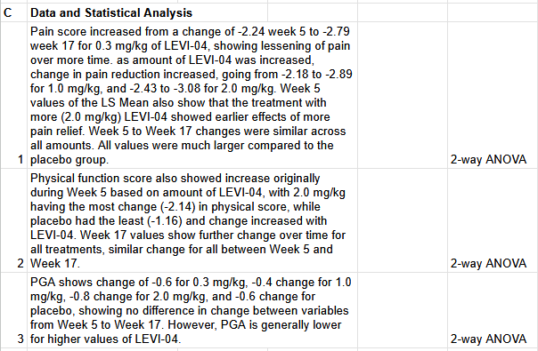

II. HYPOTHESIS & AIMS
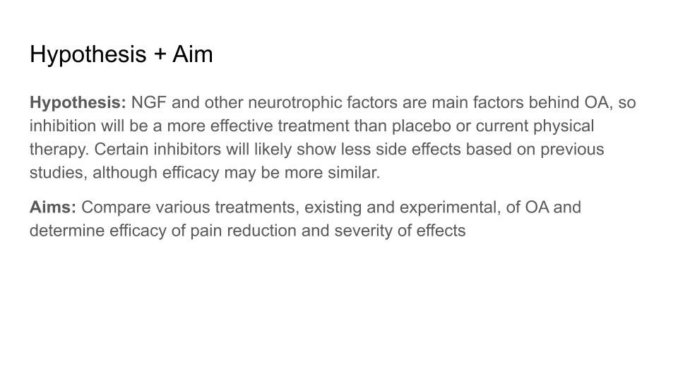
Schematic illustrating
Overall Hypothesis or Problem, and
Aim(s) to test Hypothesis or solve Problem

Hypothesis or Problem : NGF and other neurotrophic factors are main factors behind OA, so inhibition will be a more effective treatment than placebo or current physical therapy. Certain inhibitors will likely show less side effects based on previous studies, although efficacy may be more similar.

Aims: Compare various treatments, existing and experimental, of OA and determine efficacy of pain reduction and severity of effects

III. STUDY DESIGN
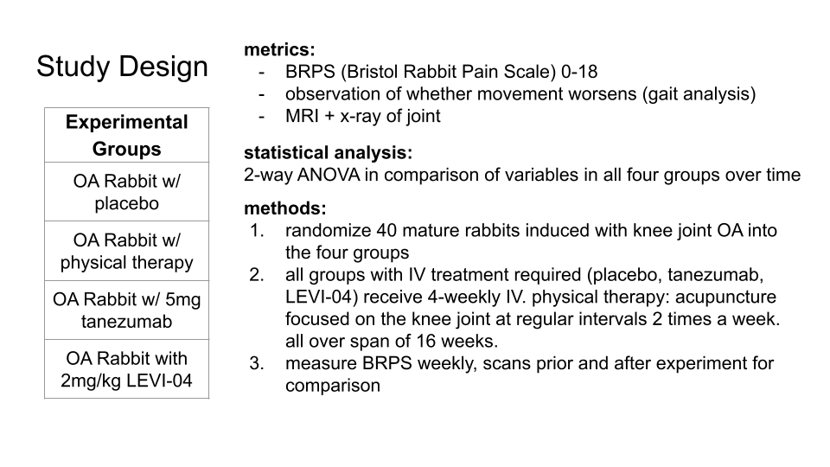

.A. Experimental Groups
OA placebo, OA treated with physical therapy, OA treated with tanezumab (5mg/kg), OA treated with LEVI-04 (2.0mg/kg)
tanezumab is one of the more common NGF inhibitors, but known to cause possible worsening OA. LEVI-04 inhibits neurotrophin-3 and seems to cause no deleterious side effects

.B. Metrics
BRPS (Bristol Rabbit Pain Scale) 0-18, observation of possible deleterious effects, MRI + x-ray

.C. Statistical Plan: Student T-Test
2-way ANOVA to compare BRPS of four groups across weeks (so variables are BRPS and time)

.D. Calculations & Planning

.E. Timeline / Flowchart
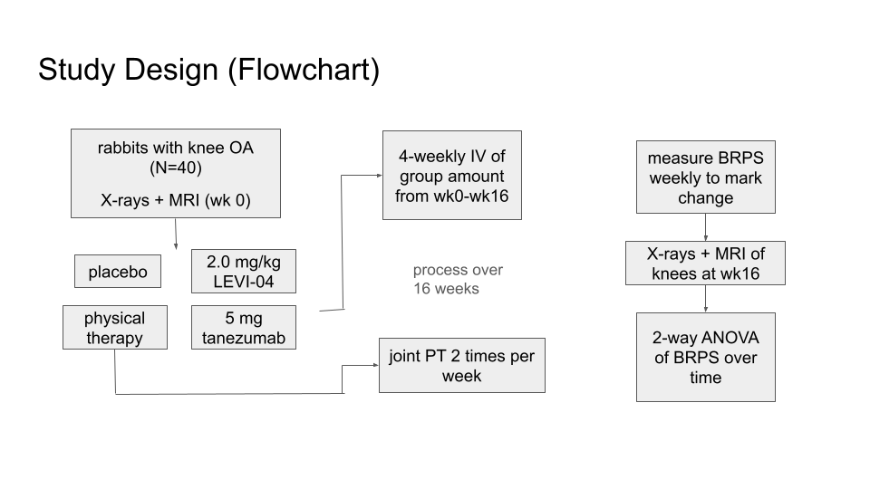
Add paper/presentation text here.

IV. SAFETY
Use gloves, lab coats, and goggles to prevent contact with chemicals. Wash hands thoroughly and cleanse eyes if substances come into contact with face. Use care when handling rabbits.

V. EQUIPMENT

VI. SUPPLIES
Separate housing areas in order to make clear which rabbits are in which group and to sustain them over a period of 16 weeks. IV containing placebo (saline), tanezumab, and LEVI-04. Acupuncture needles for PT. X-ray and MRI equipment for imaging purposes

VII. PROTOCOL
in methods area in study design slide

VIII. RESULTS

.A. Results-1: Add TakeHome Result Point Here
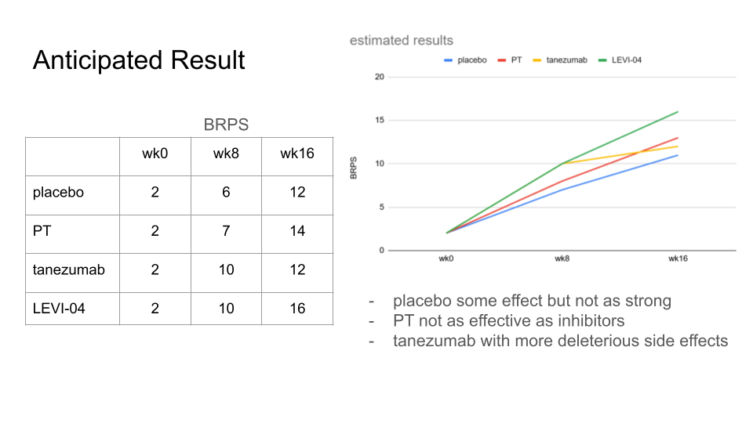
- BRPS on scale of 0-18.
- based on other studies, PT will likely be less effective than the inhibitors, while placebo will be the least effect but will still cause some pain relief.
- tanezumab and LEVI-04, both being inhibitors, will have similar effects originally in pain relief, but due to tanezumab’s recorded side effects, it will likely not match LEVI-04 in the long-term.

IX. DISCUSSION

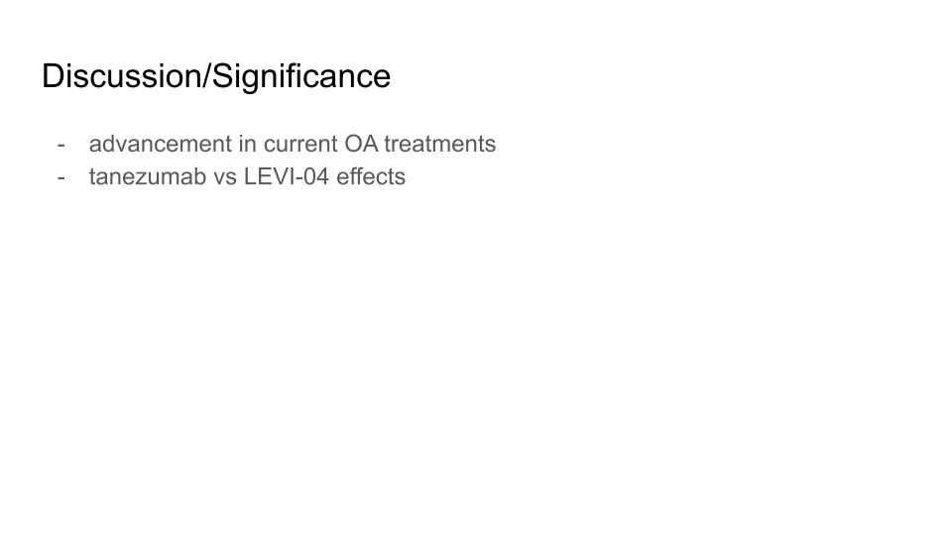
advancement in current OA treatments
tanezumab as one of the more common NGF inhibitors but could cause worsening OA–now a possible alternative (LEVI-04) with no deleterious effects

X. ACKNOWLEDGMENTS
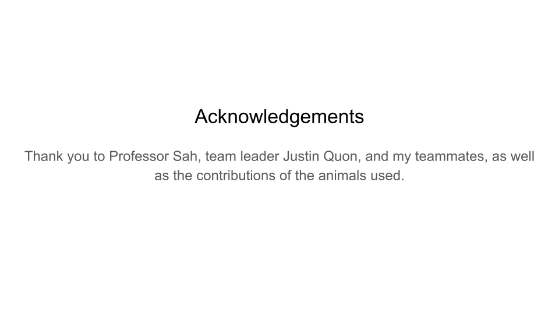
Add paper/presentation text here.

XI. BIBLIOGRAPHY
[1] Author FM, Author2 FM, AuthorL FM. The text-slide combo approach to planning and reporting research eliminates repetition and saves 60% time. J Amaz Bioeng. 8:88-103, 2024. doi…
* Rvw or Rsrch : Add a note after reference indicating why you think it is a good one for your project.

Add entries here
Use a concise format, as is typical in scientific communications - not very long (eg APA) ones. Here are some principles for that.
* withOUT extra commas and periods for author names, without "and" before the last author.
* with official abbreviation of journal name instead of full journal name
* withOUT issue number (often in parenthesis), since volume number and page or article number completely specifies the article (the issue number only indicates the issued collection / hardcopy within the volume)
* withOUT PMID or PMCID
* with doi, since this links to "official" journal publisher site and electronic location of the article (where it is often available for free, or else for purchase, as a PDF)

Grässel, S., & Muschter, D. (2020). Recent advances in the treatment of osteoarthritis. F1000Research, 9, F1000 Faculty Rev-325. https://doi.org/10.12688/f1000research.22115.1
Ge, Zigang & Hu, Yang & Heng, Boon & Yang, Zheng & Ouyang, Hongwei & Lee, Eng & Cao, Tong. (2006). Osteoarthritis and therapy. Arthritis and rheumatism. 55. 493-500. 10.1002/art.21994.
Philip G Conaghan, Ali Guermazi, Nathaniel Katz, Asger R Bihlet, Dror Rom, Michael C Perkins, Bernadette Hughes, Claire Herholdt, Iwona Bombelka, Simon Westbrook, OA04 A randomised controlled Phase II trial of LEVI-04, a novel neurotrophin-3 inhibitor, in knee osteoarthritis demonstrates substantially improved pain and function without deleterious effects on joint structure, Rheumatology, Volume 64, Issue Supplement_3, April 2025, keaf142.004, https://doi.org/10.1093/rheumatology/keaf142.004
Gandek, B. (2015), Measurement Properties of the Western Ontario and McMaster Universities Osteoarthritis Index: A Systematic Review. Arthritis Care & Research, 67: 216-229. https://doi.org/10.1002/acr.22415
Nikiphorou, E., Radner, H., Chatzidionysiou, K. et al. Patient global assessment in measuring disease activity in rheumatoid arthritis: a review of the literature. Arthritis Res Ther 18, 251 (2016). https://doi.org/10.1186/s13075-016-1151-6
Miller, R. E., Block, J. A., & Malfait, A. M. (2017). Nerve growth factor blockade for the management of osteoarthritis pain: what can we learn from clinical trials and preclinical models?. Current opinion in rheumatology, 29(1), 110–118. https://doi.org/10.1097/BOR.0000000000000354
Benato, L., Murrell, J. & Rooney, N. Bristol Rabbit Pain Scale (BRPS): clinical utility, validity and reliability. BMC Vet Res 18, 341 (2022). https://doi.org/10.1186/s12917-022-03434-x
Schnitzer TJ, Easton R, Pang S, et al. Effect of Tanezumab on Joint Pain, Physical Function, and Patient Global Assessment of Osteoarthritis Among Patients With Osteoarthritis of the Hip or Knee: A Randomized Clinical Trial. JAMA. 2019;322(1):37–48. doi:10.1001/jama.2019.8044
Fazeli MS, McIntyre L, Huang Y, Chevalier X. Intra-articular placebo effect in the treatment of knee osteoarthritis: a survey of the current clinical evidence. Therapeutic Advances in Musculoskeletal Disease. 2022;14. doi:10.1177/1759720X211066689
Ni, Xinxin MSa; Hu, Lianxin PhDa; Zhang, Xun PhDa,b; Wang, Zefeng PhDa,*; Yan, Cong PhDc; Peyrodie, Laurent PhDd; Lin, Minghai MSa; Wu, Xinyue MMc; Wang, Huajun MSa; Hu, Shijia MSa. Physical therapy options for knee osteoarthritis: A review. Medicine 103(30):p e38415, July 26, 2024. | DOI: 10.1097/MD.0000000000038415
P.G. Conaghan, A. Guermazi, N. Katz, A.R. Bihlet, D. Rom, C.M. Perkins, B. Hughes, C. Herholdt, I. Bombelka, S.L. Westbrook, LEVI-04, A NOVEL NEUROTROPHIN-3 INHIBITOR, DEMONSTRATED SIGNIFICANT IMPROVEMENTS IN PAIN AND FUNCTION AND WAS NOT ASSOCIATED WITH DELETERIOUS EFFECTS ON JOINT STRUCTURE IN PEOPLE WITH KNEE OA IN A PHASE II RCT, Osteoarthritis Imaging, Volume 5, Supplement 1, 2025, 100352, ISSN 2772-6541, https://doi.org/10.1016/j.ostima.2025.100352.

XII. NOTES
LINK EXTRA SLIDEs HERE

Questions & Answers (predicted from what the audience might ask)

