TITLE & AUTHORS

Joint Pain : Innervation at the Bone-Cartilage Interface

Authors: Justin Quon, Danielle Paredes, Jasmine Chan, Tien Nghiem, Tai Nghiem

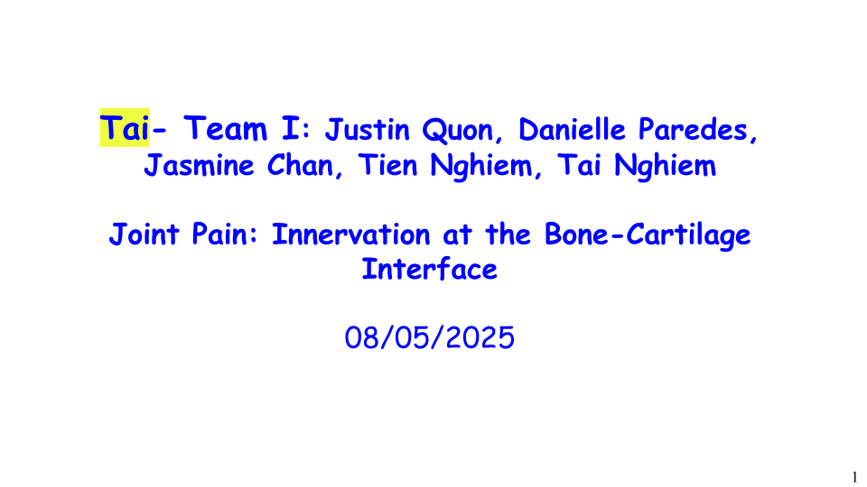

Team SLIDES:TeamI_Slides_20250730vXX_TN_TN_DP_JC

O. ABSTRACT (100-200 words)

Osteoarthritis is a degenerative disease in the osteochondral joint that causes a lot of pain. It causes changes at the osteochondral junction, specifically the nerve density, structure, and amount changes which lead to increased pain, which can be mediated by reducing such changes. We want to determine the changes between the normal and after state of osteoarthritis of nerves in the osteochondral junction and see if they can be associated with pain in a rabbit model. We also want to investigate the role of inflammation-induced structural and molecular changes at the osteochondral junction in mediating joint pain. We then want to compare cytokines Visfatin and IL-1Beta, and determine which is more potent in raising NGF production by chondrocyte cells. Lastly, we will compare the efficacy of pain reduction and whether it outweighs side effects between placebo, existing acupuncture PT, and two neurotrophin inhibitors tanezumab and LEVI-04. Our study design will include rabbit cell samples with various independent and dependent variables. Our predicted findings are that OA pain can be linked to nerve growth, growth factors such as VEGF contribute to joint pain and inflammation, IL-1Beta made chondrocytes produce more NGF, and possible advances in treatment include NGF inhibition and LEVI-04.

Background:
Info about OA
Present study

Hypothesis:
Osteoarthritis causes changes at the osteochondral junction, specifically the nerve density, structure, and amount changes which lead to increased pain, which can be mediated by reducing such changes.

Aims:
1)Determine the changes between normal and after state of osteoarthritis on nerves in the junction at the osteochondral junction and if they can be associated with pain in a rabbit model.
2) Investigating the role of inflammation-induced structural and molecular changes at the osteochondral junction in mediating joint pain.
3) Compare Visfatin and IL-1Beta, and determine which is more potent in raising NGF production by chondrocyte cells.
4) Compare the efficacy of pain reduction and whether it outweighs side effects between placebo, existing acupuncture PT, and two neurotrophin inhibitors tanezumab and LEVI-04.

Study Design: (Statistical analysis):
Experimental groups:
- Healthy Rabbit Samples
- OA Rabbit Samples
Dependent variables:
- Nerve Density (n/mm)
- NGF (pg/mL)
- Bristol Rabbit Pain Scale (0-18)

Results:
OA pain can be linked to nerve growth (as pain went away when NGF decreased).
Growth factors such as VEGF contribute to joint pain and inflammation
Identifying which proinflammatory factors are most indirectly responsible for NGF synthesis helps prioritize therapeutic targets
Results show NGF inhibition can aid pain relief, and that LEVI-04 has none of the deleterious side effects tanezumab can bring, thus possible advances in treatment

I. BACKGROUND

I.1. Replace this with the main take-home point of this Background slide.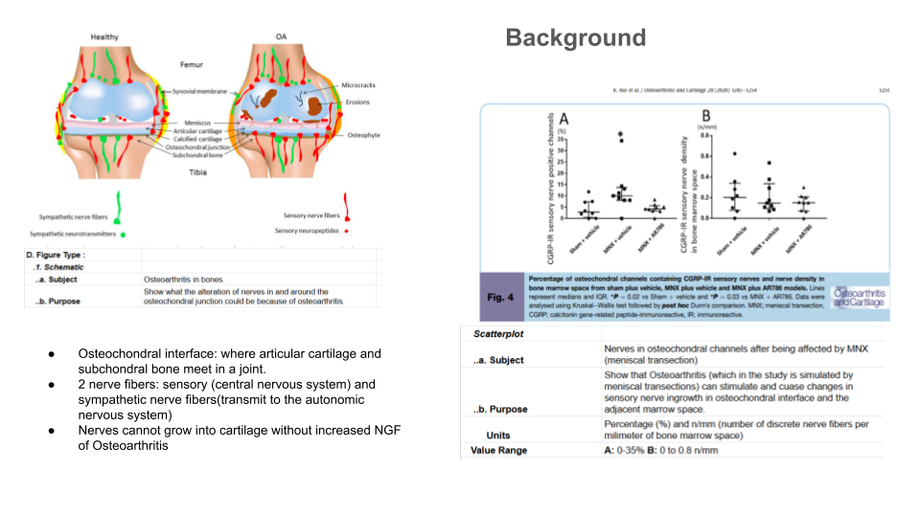

Osteochondral interface: where articular cartilage and subchondral bone meet in a joint.

2 nerve fibers: sensory (central nervous system) and sympathetic nerve fibers(transmit to the autonomic nervous system)

Nerves cannot grow into cartilage without increased NGF of Osteoarthritis

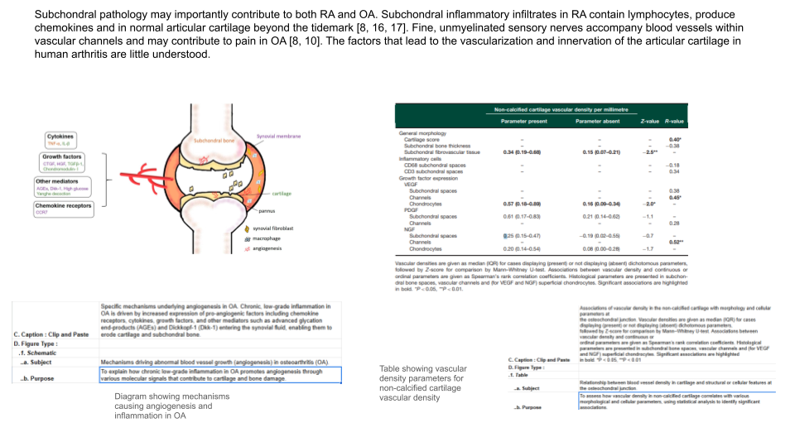
Current research shows that the osteochondral interface is complex when it comes to nerves. While this region was previously considered relatively inactive, new findings reveal that it contains nerve fibers, particularly in areas affected by diseases like osteoarthritis and rheumatoid arthritis. These nerves are often found near blood vessels and are more common in damaged or inflamed tissue. They may play a role in joint pain, as their growth seems to be influenced by inflammation and changes in bone and cartilage structure. Scientists are now paying closer attention to this interface to better understand how nerves contribute to chronic joint pain and how targeting them might lead to new treatments.

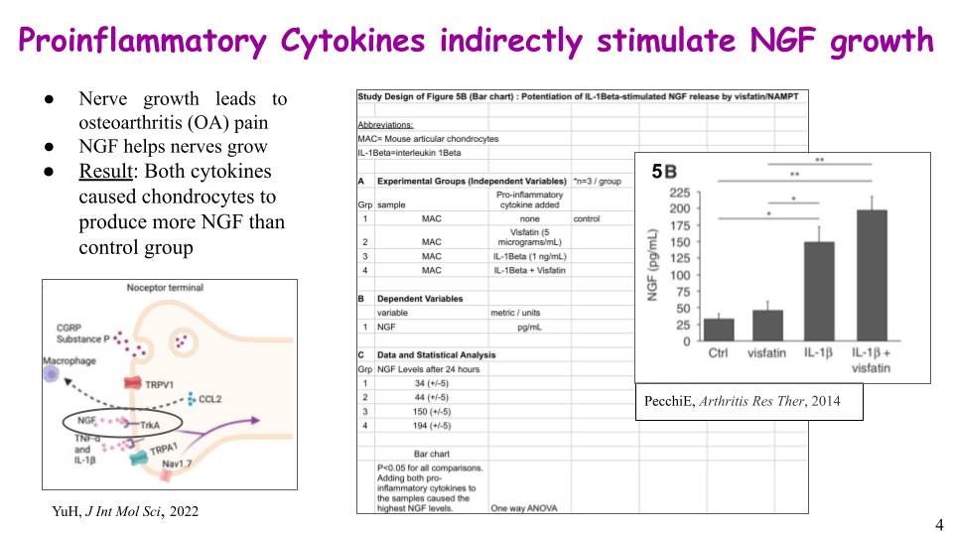
- Hi, I am Danielle and I am focusing on the point that proinflammatory cytokines indirectly stimulate NGF growth.
- One aspect of osteoarthritis (OA) is that more pain is experienced as a result of nerves growing in the knee joint. The protein NGF, which stands for nerve growth factor, is what causes the nerves to grow.
- A study was done to determine if proinflammatory cytokines stimulated chondrocytes to produce NGF. Figure 5B specifically addressed the cytokines visfatin and interleukin-1Beta. Using a one-way ANOVA test, it can be seen that in a span of 24 hours, mouse chondrocyte cells with one or both of the cytokines present produced more NGF than the control cells that had none injected.

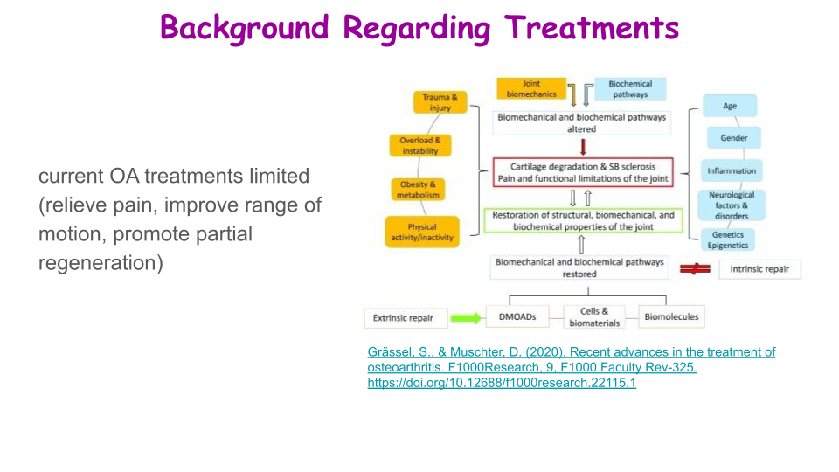

Current OA treatments are limited, and most only relieve pain, improve range of motion, and promote partial regeneration, thus meaning that the need for advancements for OA cure is needed.
.A. OA is driven by both mechanical and biological factors, as you can see in the schematic, which alter typical joint functions that lead to damage. extrinsic treatments are needed to prevent further degradation as intrinsic healing is insufficient to restore joint function and possible repair
.B. several common types: physical therapy, pharmacologic treatment, surgery, arthroscopic management, transplantation, osteotomy, arthroplasty, radiofrequency

II. HYPOTHESIS & AIMS
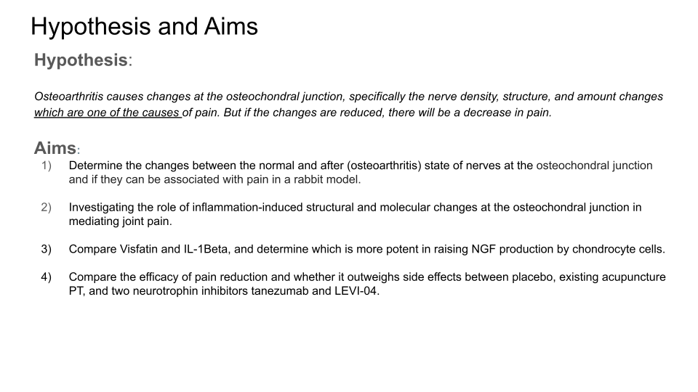

III. STUDY DESIGN
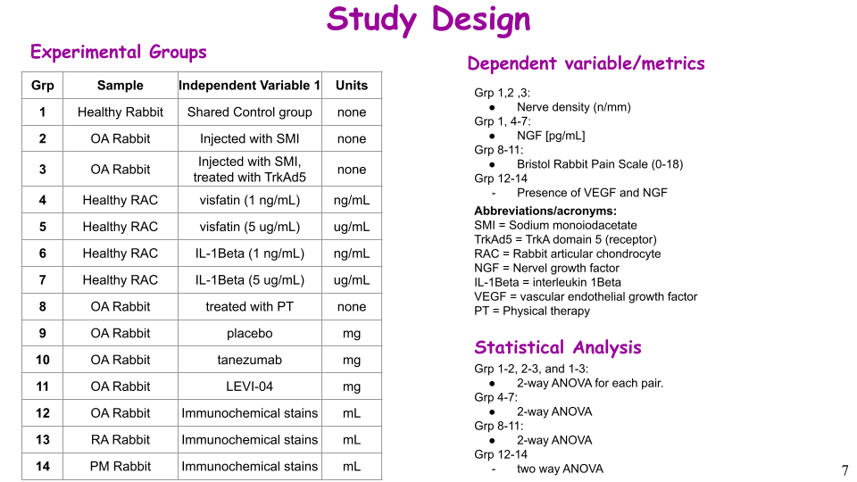
Tien’s independent variables in groups 1-3 are normal rabbits, rabbits with SMI, and rabbits with SMI treated with trkAd5. The plan is to inject them with inhibitors to try and reduce nerve growth. Tien will then analyze the data to see if it correlates with high or little pain.

Tai’s study design variables in groups 12-14 are patients with OA, RA and post-mortem healthy samples. He will slice them into super thin sections and analyze them for the presence of growth factors and histological features.

In groups 4-7, I will treat healthy rabbit chondrocytes with two different dosages of each cytokine- one is visfatin and the other is interleukin-1Beta. The dependent variable is NGF.

For the last experiment, Grps 8-11 are all rabbits with OA treated with either PT, a placebo, tanezumab, or LEVI-04 to test treatment efficacy. The dependent variable Jas will determine is a value on the Bristol rabbit pain scale.

Tien-
This is our team study design. As listed in groups 1-3, I will use the normal rabbits, rabbits with SMI, and rabbits with SMI treated with trkAd5. I will inject them with inhibitors to try and reduce nerve growth. I will then analyze the data to see if they correlate with high or little pain.

Tai-
My variables in groups 12-14 are patients with OA, RA and post-mortem healthy samples. I will slice them into super thin sections and analyze them for the presence of growth factors and histological features.

Danielle-
In groups 4-7, I will treat healthy rabbit chondrocytes with two different dosages of each cytokine- one is visfatin and the other is interleukin-1Beta. The dependent variable is NGF.

Jas-
For the last experiment, groups 8-11 are all rabbits with OA treated with either PT, a placebo, tanezumab, or LEVI-04 to test treatment efficacy. The dependent variable I will determine is a value on the Bristol rabbit pain scale.

BRAINSTORM/NOTES:

.A. Experimental Groups
Healthy rabbits injected with saline every day, rabbits injected with sodium mono-iodoacetate, rabbits injected with sodium mono-iodoacetate (SMI) and TrkAd5 (binds to the nerve growth factor (NGF) protein), rabbits injected with SMI and tanezumab (another NGF inhibitor), rabbits injected with SMI and fulranumab. All rabbits injected with multiple substance (SMI and another will get the NGF inhibitor injected every twelve hours until the end of the study from the moment OA sets in).

.B. Metrics
Density of nerves in the space of the subchondral bone (# of nerves per mm of space length) and density of nerves in the space of the osteochondral junction, (Whether nerves penetrated the cartilage in the osteochondral junction), Healthy rabbits and rabbits injected with sodium mono-iodoacetate (to onset osteoarthritis), percentage of osteochondral channels with sensory (pain) nerve.
Nerve length [mm] or [micrometers]

Vascular density (vessels/mm²): Quantified in non-calcified cartilage and correlated with disease state and molecular markers.

Presence of growth factors: VEGF and NGF expression levels in chondrocytes, vascular channels, and subchondral bone.

Cell proliferation: Detected by PCNA-positive nuclei in vascular channels, indicating active vessel growth.

Histological features: Presence of fibrovascular tissue, tidemark-crossing vessels, and cartilage degradation (e.g., fissuring, proteoglycan loss).

.C. Statistical Plan: Student T-Test
1) 5 way ANOVA test to compare data of the 5 groups and judge effectiveness based on the the smallest difference to the control group at the end of the thirty days.

2) One-way ANOVA for comparing vascular density across RA, OA, and PM groups (3+ groups, continuous data). And Spearman’s Rank Correlation for measuring associations between vascular density and continuous/ordinal variables like subchondral bone thickness or NGF levels. Mann–Whitney U Test to compare vascular densities between two categorical groups (e.g., VEGF-positive vs. VEGF-negative).

3) Use ELISA to compile data of NGF synthesis. Then, a two-way ANOVA to compare all four groups that have two independent variables (type of cytokine and dosage concentration)
.

.D. Calculations & Planning

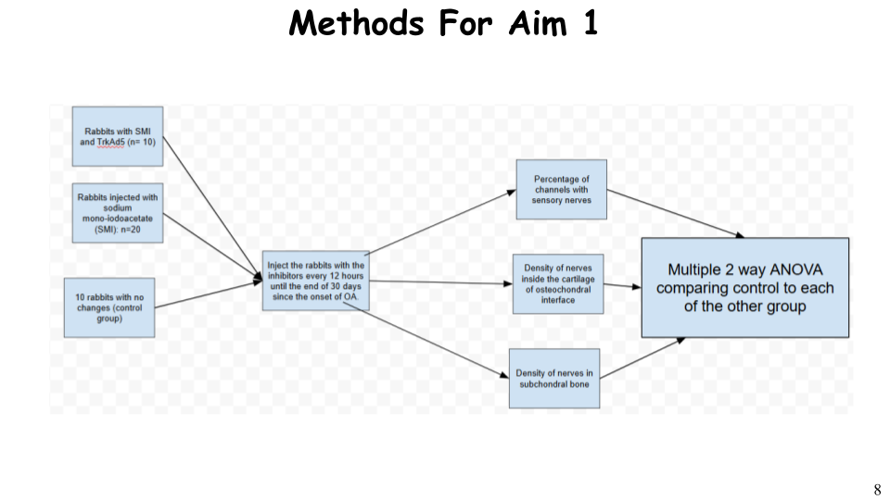
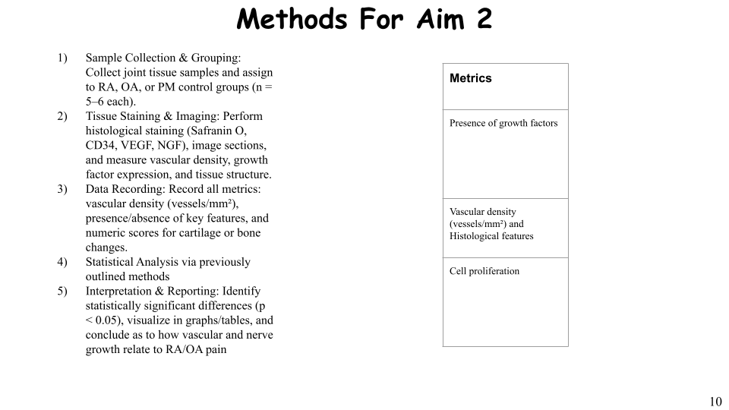

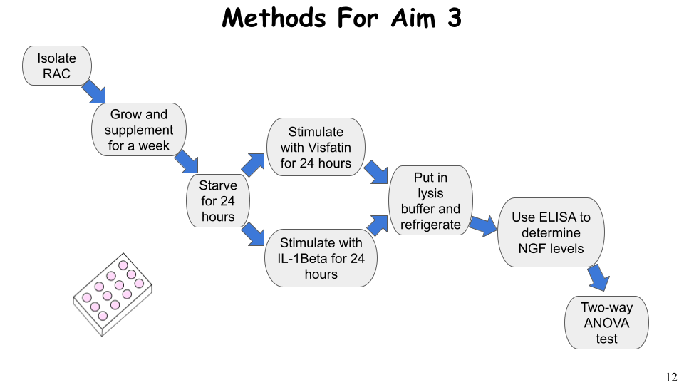

- First off, I will isolate the chondrocytes from the rabbit’s articular cartilage
- I will then grow the cells in well plates and supplement them with fetal calf serum, penicillin, streptomycin, and glutamine for 7 days.
- Then, I will starve the cells in a medium with bovine serum albumin for 24 hours.
- With the cells ready, I can then stimulate them with either visfatin or interleukin 1beta, and either 1 nanogram/mL or 5 micrograms/mL of said cytokine, for 24 hours.
- Once the time is up, I will put the samples in a lysis buffer and refrigerate them.
- I will use the Enzyme-Linked Immunosorbent Assay, known as ELISA, to determine NGF levels for all twelve samples, and compare the groups using the 2 way ANOVA test.

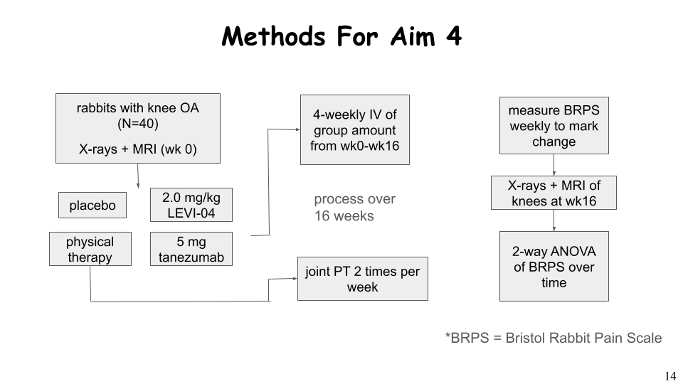

IV. RESULTS

.A. Results-1: TrkAd5 decreased pain behavior the most, and almost fully normalized the effects of OA (minimal nerve changes). The means of the independent variables are in the bar graphs below. Very little changes as in the control group.

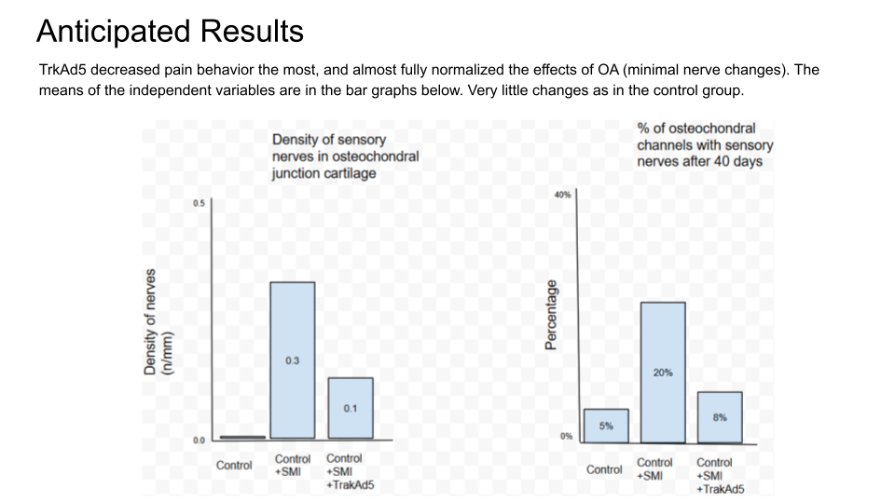

.B. Results-2: We discovered that vascular density was higher in the RA group, which also tended to have more positive VEGF values.
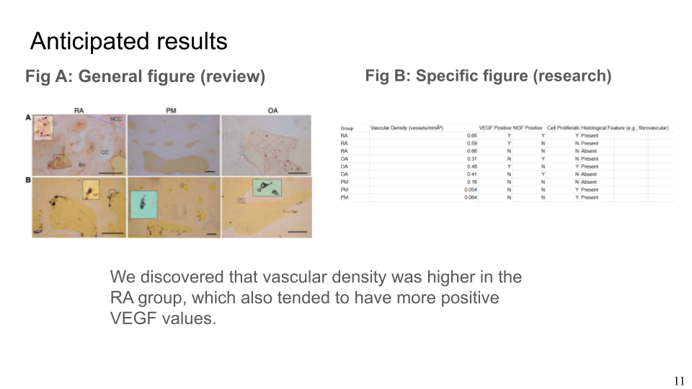

.C. Results-3: The chondrocytes with the IL-1Beta will have more NGF than the control and IL-1Beta cells after 24 hours for both the 1 ng/mL dosage and the 5 ug/mL dosage.
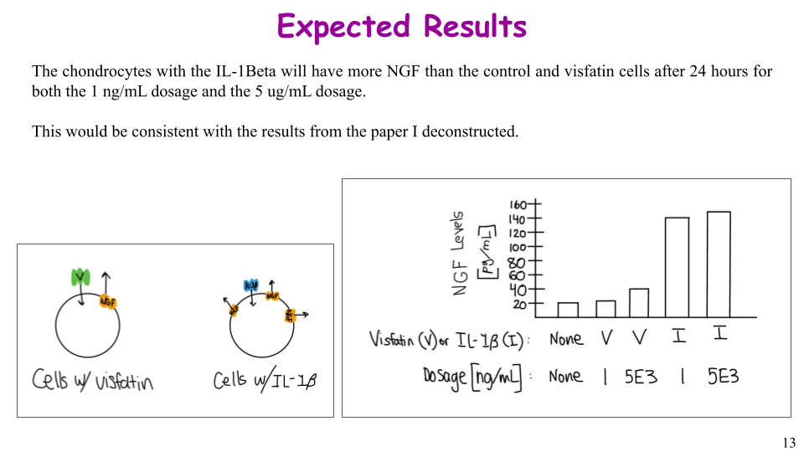
After averaging the NGF levels of three samples in each group, I will use these average values to represent the groups in a bar chart. The values on the y-axis are a rough estimate of NGF levels. I predict that the control group will have the least amount of NGF and that both dosages of visfatin will be higher than the control. I also predict that the chondrocytes with interleukin-1Beta, specifically with the higher dosage, will have the most NGF present. Thus, it confirms the hypothesis that Interleukin-1Beta causes chondrocytes to synthesize more NGF than visfatin does.

.D. Results-4: TakeHome Result Point below
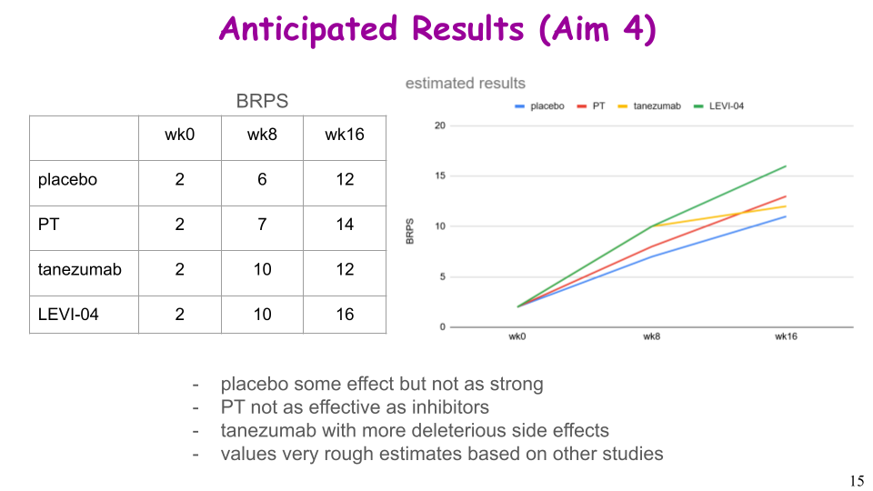
- placebo some effect but not as strong
- PT not as effective as inhibitors
- tanezumab with more deleterious side effects
- values very rough estimates based on other studies

V. DISCUSSION

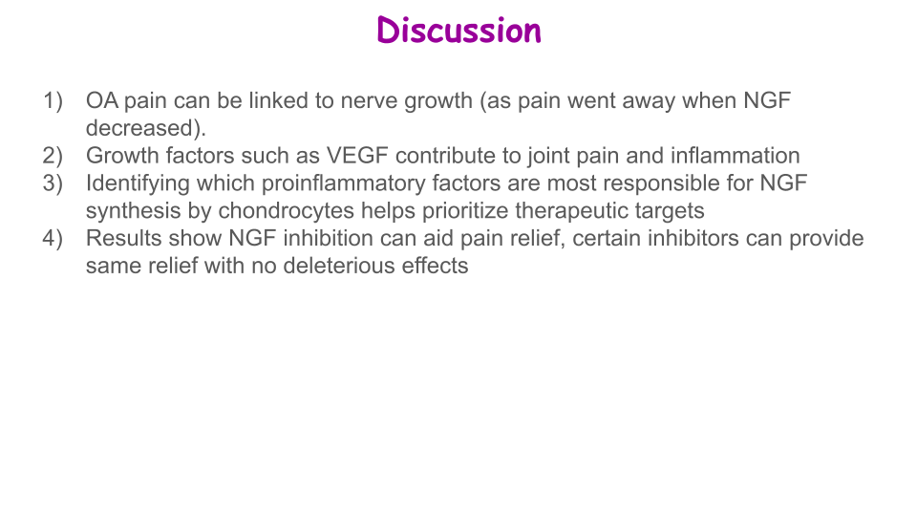

VI. ACKNOWLEDGMENTS


VII. BIBLIOGRAPHY

[1]Aso K, Shahtaheri SM, Hill R, Wilson D, McWilliams DF, Nwosu LN, Chapman V, Walsh DA. Contribution of nerves within osteochondral channels to osteoarthritis knee pain in human and rats. Osteoarthritis and Cartilage.28:1245-1254, 2020, doi.org/10.1016/j.joca.2020.05.010

[2]Cledes G, Felizardo R, Foucart JM, Carpentier P. Validation of a chemical osteoarthritis model in rabbit temporomandibular joint: a compliment to biomechanical models. Int J Oral Maxillofac Surg.11:1026-33, 2006, doi: 10.1016/j.ijom.2006.05.003

[3]Jaffal S, Khalil R. Targeting nerve growth factor for pain relief: pros and cons. Korean J Pain 37:288-298, 2024, https://doi.org/10.3344/kjp.24235

[4] Grässel, S.; Muschter, D. Peripheral Nerve Fibers and Their Neurotransmitters in Osteoarthritis Pathology. Int. J. Mol. Sci. 2017, 18, 931. https://doi.org/10.3390/ijms18050931

Add entries here
Use a concise format, as is typical in scientific communications - not very long (eg APA) ones. Here are some principles for that.
* withOUT extra commas and periods for author names, without "and" before the last author.
* with official abbreviation of journal name instead of full journal name
* withOUT issue number (often in parenthesis), since volume number and page or article number completely specifies the article (the issue number only indicates the issued collection / hardcopy within the volume)
* withOUT PMID or PMCID
* with doi, since this links to "official" journal publisher site and electronic location of the article (where it is often available for free, or else for purchase, as a PDF)

VIII. NOTES

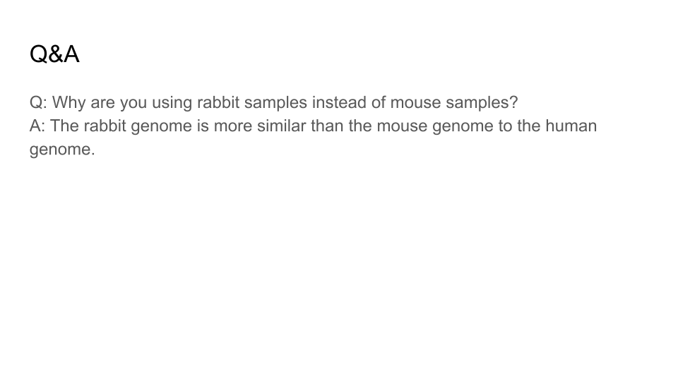

Questions & Answers (predicted from what the audience might ask)

Q: Is a rabbit sample better than a mouse sample?
A: The rabbit genome is more similar to the human genome, so it is likely more accurate.

