AI Equity Research Terminal
Dashboard Project Documentation

Project Summary
This project focuses on building an AI‑powered Equity Research Dashboard capable of collecting financial news, summarizing articles using Artificial Intelligence, analyzing market sentiment, and generating research insights automatically. The dashboard is designed to simulate a simplified financial research terminal similar to tools used by analysts in investment firms.
Problem Statement
Financial analysts spend significant time collecting news, analyzing information, and producing reports. Manual analysis is time‑consuming and often inefficient. This project attempts to automate this process using Artificial Intelligence and data visualization.
Project Objectives
• Automate financial news collection.
• Summarize large amounts of news using AI.
• Perform sentiment analysis to understand market mood.
• Identify companies frequently mentioned in news articles.
• Provide visual insights through an interactive dashboard.
Technologies and Tools Used
• Python Programming Language
• Streamlit – Dashboard development
• NewsAPI – Real‑time financial news data
• Groq LLM API – AI summarization and insights generation
• TextBlob – Sentiment analysis
• Plotly – Interactive data visualization
• Pandas – Data manipulation and processing
System Architecture and Workflow
The system begins with user input where the user enters a company or sector name. The application fetches relevant financial news articles using NewsAPI. Each article is processed using a Large Language Model via the Groq API to generate concise summaries. The summarized content is analyzed using TextBlob to determine sentiment. The system also extracts company names from the summaries and counts their frequency. Finally, all insights are displayed through an interactive Streamlit dashboard.
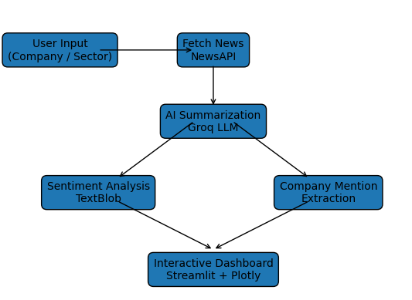
Dashboard Features
• AI Generated Equity Research Report
• Real‑time News Feed
• Market Sentiment Visualization
• Company Mention Analysis
• AI Market Insight Generation

Challenges Faced During the Project
1. Model deprecation errors when Groq discontinued certain LLM models.
2. Indentation and syntax issues while converting notebook code to Python scripts.
3. Managing API keys securely during deployment.
4. Handling missing or incomplete news data returned by APIs.
5. Ensuring the dashboard runs efficiently without long delays.
Solutions Implemented
1. Updated the application to use the latest Groq supported models.
2. Refactored the entire codebase to fix indentation and structure issues.
3. Stored API keys securely using Streamlit Secrets.
4. Added safe checks for missing news fields.
5. Optimized the workflow to reduce API calls and improve performance.
Future Enhancements
• Integration of live stock price data.
• AI‑based buy/sell recommendation engine.
• Export research reports in PDF format.
• Addition of financial ratio analysis.
• Integration with real‑time financial market APIs.
Conclusion
The AI Equity Research Terminal demonstrates how Artificial Intelligence and data visualization can simplify financial research. By automating news analysis, sentiment detection, and report generation, the system reduces manual workload and provides quick insights for decision‑making.

