ISAForge Midterm Progress Report
AI for Engineering ECE 4803 | October 27, 2026
Prepared for Professor Farahmand

Executive summary
ISAForge is a machine-learning-guided RISC-V custom-instruction selection project. We automatically identify legal instruction patterns in real RV32 workloads, evaluate candidates on a PicoRV32-based processor, and test whether learned ranking and a bounded AI selector can find a faster feasible design with fewer hardware evaluations. The end-to-end CRC32 and aha-mont64 experiments are working, and the measured dataset now spans 14 workload groups.
The strongest result so far is a 1.094120× whole-program speedup on aha-mont64: 62,311,489 to 56,951,233 cycles, +42 LUT4, 64.88 MHz minimum routed Fmax, with correctness passing. This is a measured candidate result, not evidence that ML selected it better than a heuristic. Across the broader retrospective screen, the XGBoost ranker has small, uncertain gains at one and two evaluations, while merit leads at three. No ML or agent superiority is established.
Current chat model pilot
I used the LLM in this Codex conversation as the policy in the existing four-tool selector. It selected an EDN candidate matching that pool’s oracle at one valid measurement, but one malformed ID consumed a second attempt. Frequency, merit, pairwise XGBoost, and GP controls reach the same result at the same two-attempt budget. This is an exploratory replay, not a new hardware job or a clean LLM win.

Research question
Can learned predictions and a bounded LLM selection agent reach better verified whole-program performance under explicit area and timing limits with fewer expensive evaluations than frequency, merit, random search, and non-agent active learning? We count a success only when the modified workload is correct and the integrated design meets the area and timing constraints.

Scope and claim boundary
We build on established custom-instruction identification and microarchitecture-aware selection research. ISAForge’s testable contribution is measurement-efficient selection using learned ranking and uncertainty, followed by real PicoRV32 validation. The project does not generate or rewrite RTL. Current support is a restricted RV32 integer pattern set and a single-instruction selector; the final one-to-three-instruction combination stage is still open.

Method and use of AI
The current pipeline begins with a real C workload and a baseline RISC-V execution. Trace-based dataflow analysis extracts repeated, legal RV32 instruction trees under the PCPI custom-instruction limits. Candidates are lowered into the existing compiler/simulator/processor path, checked against the original program’s outputs, then measured for complete-program cycles, integrated LUT4 area, and routed timing. Failed attempts remain recorded and consume evaluation budget.

AI and selection methods
Method | Role in the experiment | Status
XGBoost regression | Predict candidate whole-program speedup from structural and profile features. | Evaluated on workload-held-out data; labels currently match calibrated latency exactly.
XGBoost pairwise ranking | Order candidates within a workload context. | Current ML challenger; not superior to merit across all budgets.
Feasibility / hardware models | Estimate area and timing feasibility; support constrained acquisition. | Used as decision inputs; area predictions are secondary to measured feasibility.
Gaussian-process active learning | Update candidate priorities after paid results. | Implemented and compared as a non-agent control.
Bounded LLM selector | Inspect candidates/predictions, request measurements, choose a verified feasible instruction. | Four host-enforced tools; one exploratory current-chat replay completed.
The selection loop is an agentic measure-update cycle: predict → choose → measure → update → finalize. The LLM cannot submit its own speedup or area labels. The host charges each requested measurement, checks correctness/area/timing, and only accepts a paid feasible improvement. The current API provider requires an explicit model ID; the Codex chat bridge does not invoke an API. Dynamic routing across models or cost tiers has not been tested.

Dataset and evaluation protocol
The frozen scorecard contains 122 successful candidate measurements and four charged failures across 14 workload groups and 15 contexts. Embench contributes 39 labels across six workloads, BEEBS 48 across five, and TACLeBench 35 across three. Twelve pools have complete measured oracles; two are censored. The 2,925 policy-budget endpoints come from 13 selectors × 5 seeds × 3 budgets × 15 contexts; they are dependent retrospective replays and add no hardware measurements.
Evaluation holds out entire workloads and removes related operation-tree families from fitting. The primary endpoint is the best paid, correct, area/timing-feasible whole-program result after the same evaluation budget. We report regret against a measured-pool oracle where complete, charge failures, and distinguish historical data-collection time from replay and model-scoring time. This is a consumed development cohort, not a confirmatory test on unseen workloads.

Verified workload results
The current processor infrastructure produces whole-program cycle counts, integrated area and routing results for the following selected candidates. All listed candidates passed correctness. Speedup is baseline cycles divided by candidate cycles. The full candidate-level records, including non-winning candidates and failures, are in the attached CSV dataset.
Workload | Baseline → candidate cycles | Speedup | Added LUT4 | Min Fmax | Correct
CRC32 | 32,387,382 → 30,820,662 | 1.050833× | +31 | 71.49 MHz | Pass
aha-mont64 | 62,311,489 → 56,951,233 | 1.094120× | +42 | 64.88 MHz | Pass
TACLe bitcount | 51,689 → 51,599 | 1.001744× | +39 | 67.78 MHz | Pass
G.723 transfer | 3,783,237 → 3,623,462 | 1.044095× | +30 | 67.55 MHz | Pass
Lift | 2,218,414 → 2,148,344 | 1.032616× | +8 | 64.53 MHz | Pass
These are best selected candidates from their measured pools, not improvements attributed to the ML agent. The CRC32 pipeline discovered 37 formulas and narrowed to eight executable candidates before the six-candidate experiment. The six-candidate CRC32 and aha-mont64 experiments remain preserved. In CRC32 merit found the best candidate in one query; in aha-mont64 merit also found the best candidate in one query. The bitcount result is an explicit negative comparison: the strong latency/cost heuristic found the feasible optimum while the live GP spent three attempts on over-budget candidates and retained baseline.

What the measurements say
- The pipeline can go from a real program through extraction, lowering, execution, correctness checks, and integrated hardware measurement.
- A frequent or high-merit candidate is not automatically a worthwhile implementation. We compare measured cycle reduction against added area and routed timing.
- We retain small gains and negative results; 1.001744× bitcount is not presented as a large practical speedup.
- The dataset covers more workloads than the original proposal, but complete candidate pools and truly independent confirmatory families remain limited.

Learned selection results
The current pairwise ranker is retained as the single ML challenger for a fresh frozen test. Merit remains the operational fallback. Mean regret is measured against the best verified feasible candidate in each complete pool. The intervals are workload-bootstrap summaries over consumed development data.
Budget | Merit regret | Pairwise XGBoost regret | Paired difference favoring XGB (95% CI) | Workload W/T/L
1 evaluation | 1.132% | 0.842% | +0.290 pp [−0.065, +0.849] | 2 / 9 / 1
2 evaluations | 0.465% | 0.439% | +0.027 pp [−0.097, +0.177] | 1 / 10 / 1
3 evaluations | 0.015% | 0.070% | −0.056 pp [−0.167, 0.000] | 0 / 11 / 1
The point estimate favors the ranker at budgets one and two, but both paired intervals cross zero. Merit has lower regret at budget three. The budget-specific leader changes, and we have not shown a consistent ML advantage. At the +64-LUT4 cap, the selected feasible designs average roughly 34–40 LUT4 area and 67–68 MHz minimum routed Fmax; the 12 MHz timing floor is not a difficult constraint in this cohort.
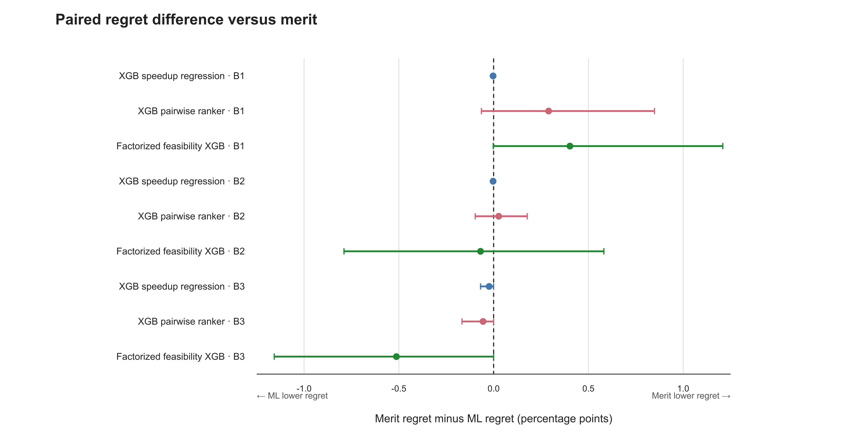
Figure 1. Workload-paired difference in mean regret; positive values favor XGBoost. The intervals cross zero at budgets 1 and 2.
The 122 speedup labels exactly equal independent calibrated-latency estimates. As a result, these experiments do not demonstrate that XGBoost learned residual program-level performance beyond the analytic estimate. The selection study primarily tests ranking and hardware-feasibility decisions. No additional speedup model is justified until fresh measurements reveal systematic prediction error.

Explainability and selector agent

What the ranker uses
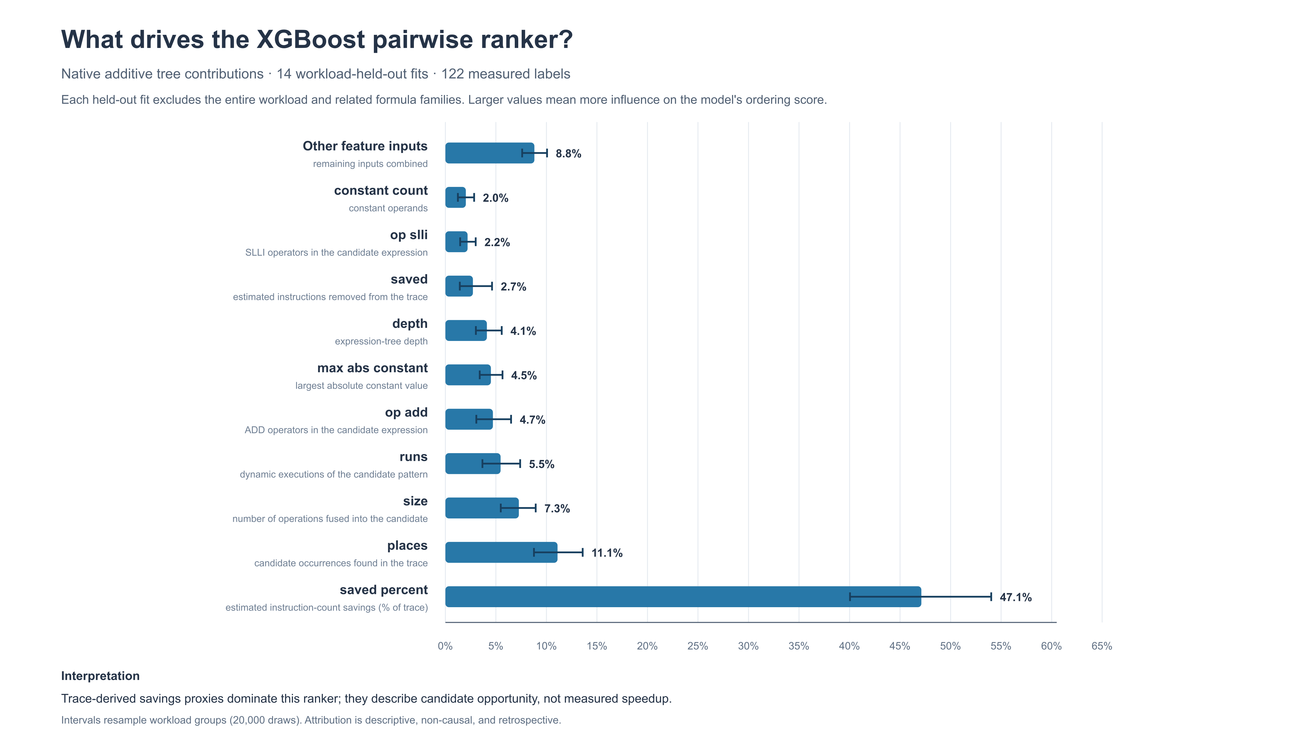
Figure 2. Global absolute XGBoost contribution averaged over whole-workload-held-out folds.
Profile-derived opportunity features account for 66.39% of normalized global attribution; `saved_percent` alone contributes 47.10%. The attribution is descriptive, not causal. It shows that the ranker relies heavily on estimated trace instruction savings and occurrence counts. It does not establish that these features explain measured whole-program speedup. A local bitcount example ranks first of 12, with raw rank score 0.473 and measured speedup 1.008782×, but costs +65 LUT4, one LUT above the +64 cap. This illustrates why candidate opportunity and measured hardware feasibility must stay separate.

Current chat-model selector pilot
The current Codex chat model received public features and predictions for six EDN candidates, then requested a measurement of `srai(slli(add(in0,in1),16),16)`. The host returned 386,561,849 baseline cycles and 386,394,809 candidate cycles: 1.0004323× speedup, +32 LUT4, 71.1187 MHz minimum routed Fmax, with correctness and feasibility passing. This matched the measured-pool oracle with zero regret.
One shortened candidate ID was rejected and charged. The run therefore used two charged attempts for one valid measurement, and ended after four tool/model turns. At the same two-attempt endpoint, frequency, merit, raw XGBoost regression, pairwise ranking, and the GP control also match the oracle; random remains at baseline and the timing/cost heuristic reaches 1.0003566×. The LLM does not beat these controls here. No API call or new native hardware job occurred. The chat deployment ID, token use, and model-only latency are unavailable, and the active conversation had broader context than the serialized four-tool boundary.
Future agent work: multiple frozen seeds, a fresh workload, identical visible information and charged budgets across LLM and non-agent controls, time-cost accounting, and joint measurement of selected instruction combinations. Dynamic LLM routing and cost-tiered model switching are possible later extensions, not completed capabilities.

Timeline, contributions, and next steps
Date | Milestone | Evidence
Oct 19–21 | Automatic CRC32 and aha-mont64 | Six-candidate real processor experiments; best aha result 1.094120× at +42 LUT4.
Oct 22 | Heuristic challenge | Bitcount transfer; cost-aware heuristic reaches measured feasible optimum.
Oct 25 | Bounded selection interface | Four-tool host/API provider and matched controls completed.
Oct 26 | Lift campaign | Twelve candidates measured; 17 policies replayed under frozen data.
Oct 27 | Scorecard and chat agent | 122 labels, explainability figures, current-chat EDN replay pilot.

Contribution matrix
This matrix separates recent Git evidence from proposal role assignments. Git history does not capture meetings, external work, or uncommitted contributions. Names, author aliases, exact work attribution, and shares must be confirmed by the team before Canvas submission.
Member / evidence | Recent Git evidence | Proposal role to verify | Share
Name to confirm; Git author “jason rivera” | Model training and evaluation, active selection, bounded agent, experiment results and reports. | Predictor, active learning, selection agent. | To confirm
Name to confirm; Git author “Matsuki, Yuuto Tyler” / YM5563 | Frequency/oracle baselines, selection engine, hardware probes and result-data documentation. | Synthesis and hardware. | To confirm
Name to confirm; no distinct recent Git author located | Repository history does not isolate contribution under a distinct author; this does not establish absence of work. | Toolchain, tracing, extraction, instruction integration and measurement tools. | To confirm

Next engineering milestones
- Qualify a fresh independent RV32 workload with at least a manageable legal candidate pool; keep failed workload qualification evidence.
- Freeze merit, frequency, random, pairwise XGBoost, non-agent active learning, and the LLM agent before labels; compare identical budgets and actual evaluation time.
- Expand measured whole-program speedup, area, timing, and correctness labels; evaluate zero-shot workload generalization and limited-budget adaptation.
- Add uncertainty checks, then select one to three compatible instructions as a set and measure the combined modified program on the processor.

Current limitations
The broad scorecard is retrospective; two pools are censored, and 12 complete oracles do not satisfy the project’s intended independent-source confirmatory cohort. Combined instruction sets are not yet part of the current selector. The active chat pilot is a single operator-relayed replay, not a reproducible API benchmark. Timing constraints are not yet challenging. No claim of generalization, calibrated uncertainty, or ML/LLM superiority is supported.

Sources and evidence
Original project proposal; docs/automatic-workloads.md; docs/bounded-selection.md; docs/codex-chat-selector-pilot.md; docs/bitcount-transfer.md; docs/g723-transfer.md; docs/lift-selection-campaign.md; docs/research-foundation.md; results/2026-10-27-final-selection-scorecard/README.md; results/2026-10-27-ranker-explainability/README.md. The attached dataset README lists each exported CSV and its interpretation.
Research foundation: Atasu, Pozzi and Ienne (DAC 2003); Sun et al. (IEEE TCAD 2004); Rezunov et al. (ICCAD 2025); Gardner et al. (ICML 2014); Zheng et al. (LACE preprint, 2026). These works motivate constrained candidate identification, timing-aware selection and tool-checked LLM workflows. ISAForge does not claim to reproduce each method or outperform prior research. See docs/research-foundation.md for exact references, method details and access limitations.

