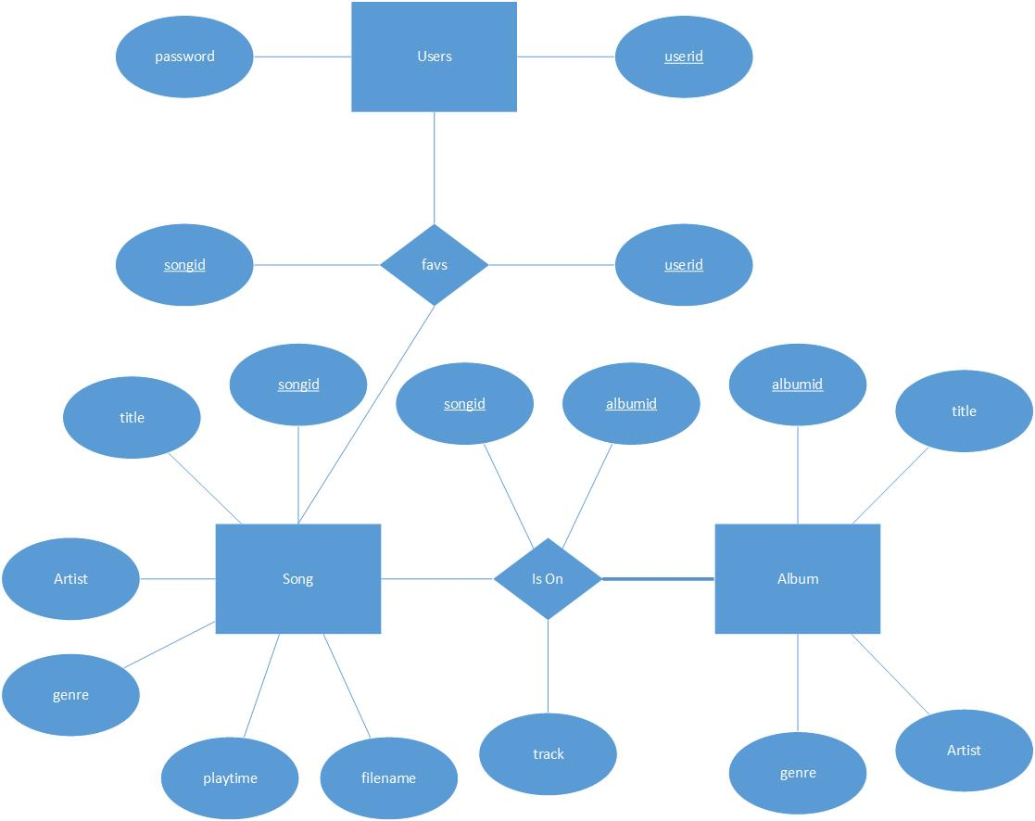

The purpose of my project was to build a web site to help organize a hard drive filled with .mp3 files on a local machine. The site uses XAMPP, PHP, and HTML to scan the music directory and read in the file names and then stores the ID3 tag information in a MySQL database. The tags are retrieved using getID3(), a PHP script that extract useful information from .mp3’s and other media formats. The database is set up with a table for users and passwords, for login, and the song data. The song data is split into different tables, one for the song, which contains a songid, title, artist, genre, playtime, and the file name.
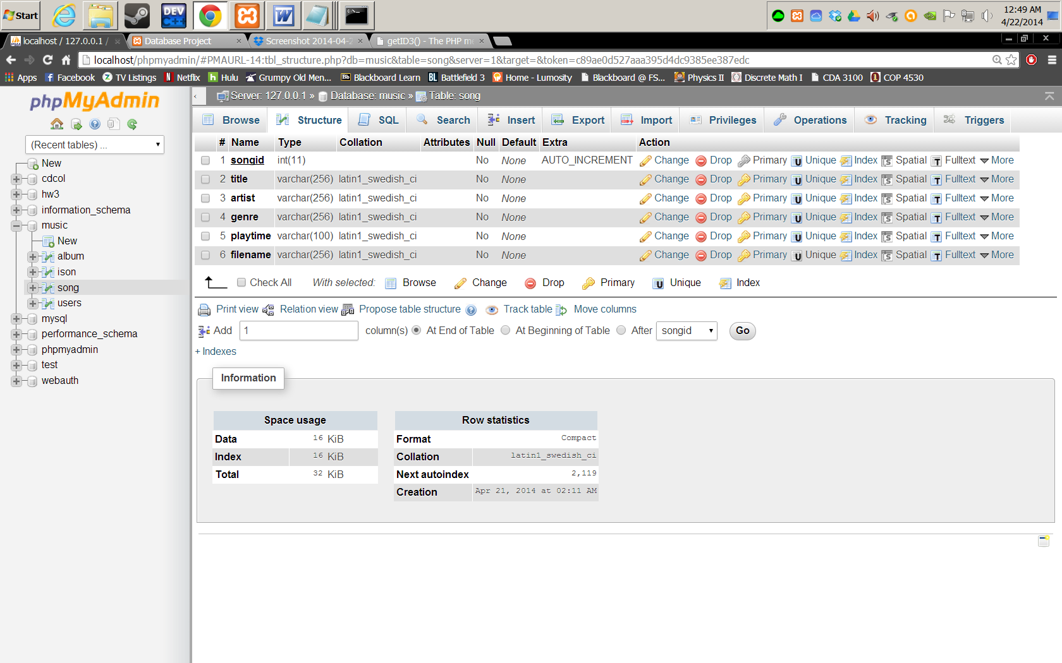

Another for the album, storing an albumid, title, artist, and genre.

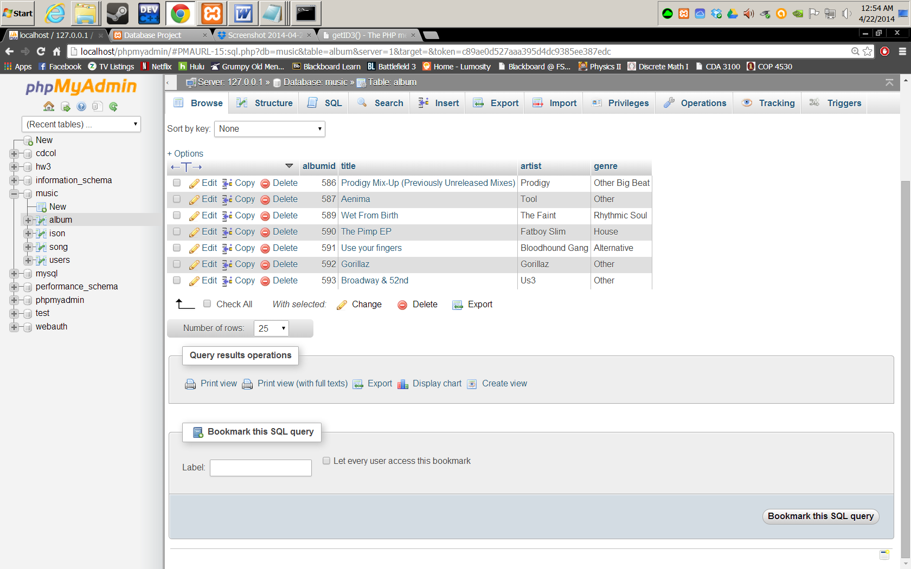

And, an IsOn table to identify which songs are on what albums, by using the songid and albumis, and track number.

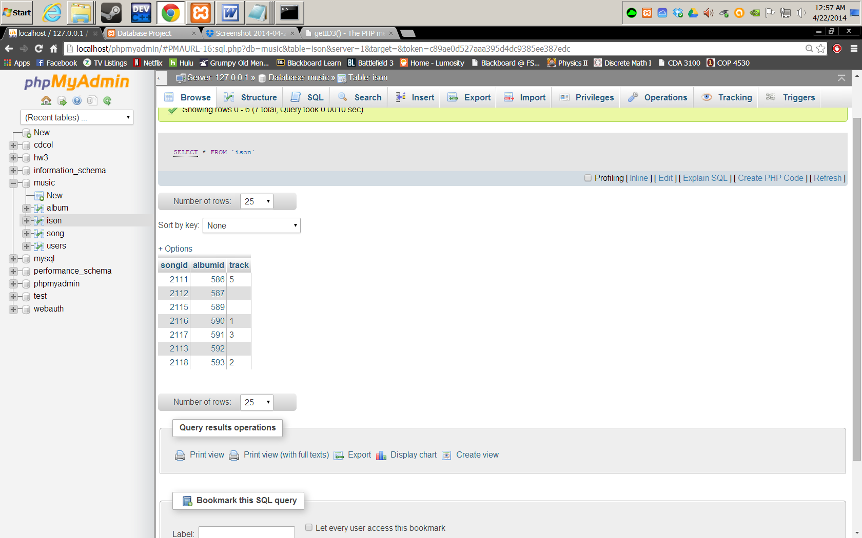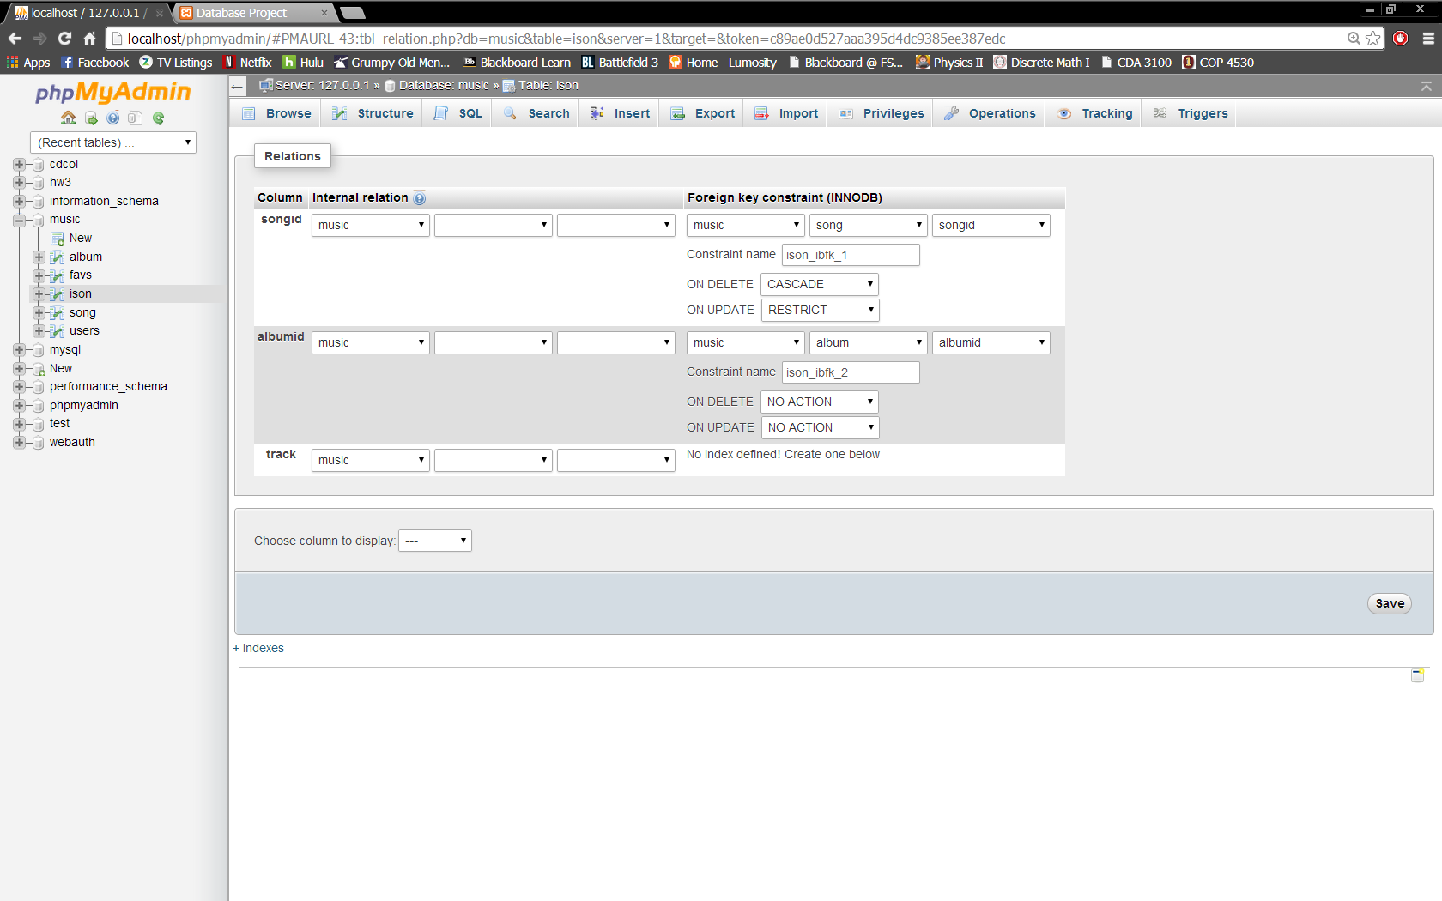

Once the songs are entered into the database, the user can perform queries such as “what songs are not on an album” or “how many songs have ‘Blues’ genre” and manipulate the database information as well as the file’s ID3 tags using the getid3() script. The domain opens to a login screen

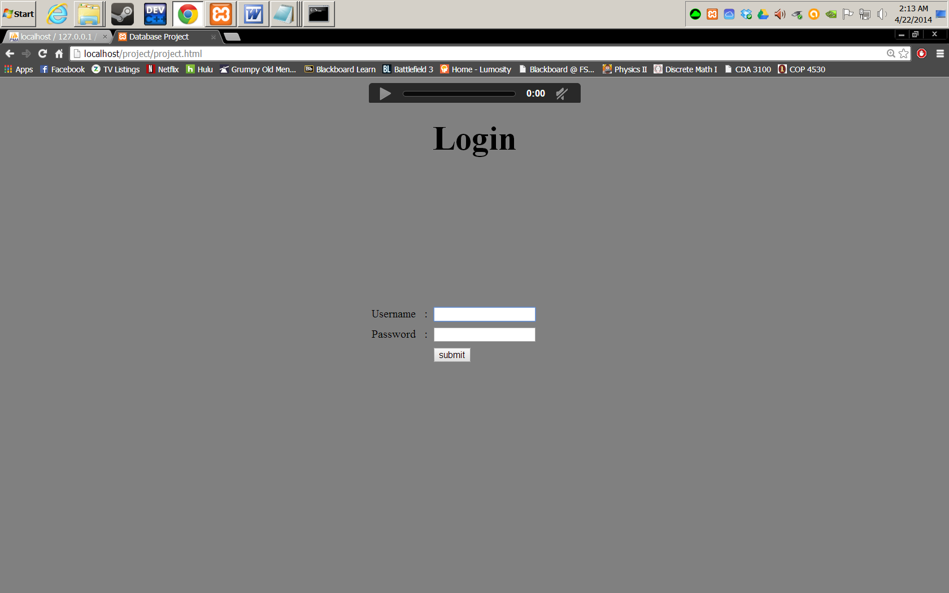

And a main menu

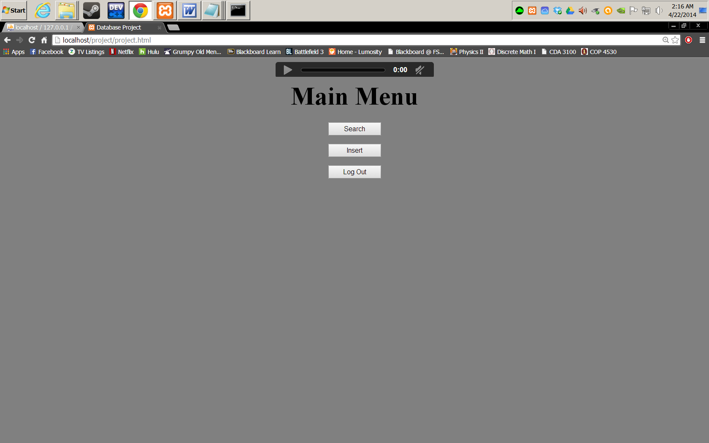

Where you can search the database, insert new songs from the music drive, or logout.
In the Insert section the drive is scanned for files and then the files are displayed for the user to choose which files to add.
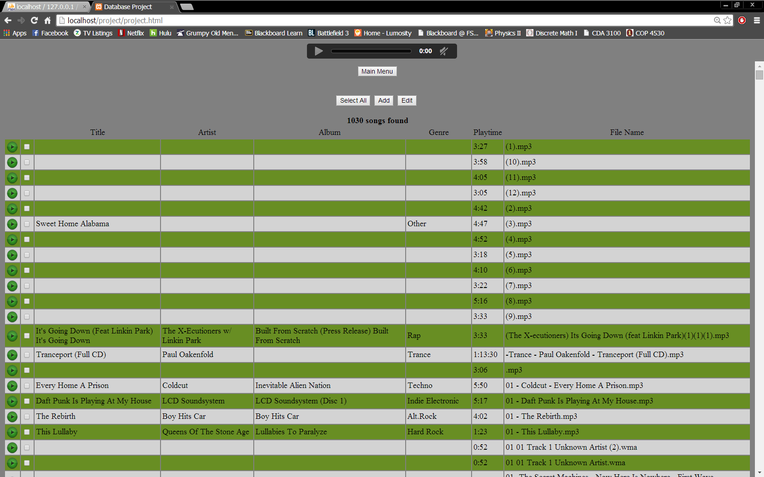

The user can add songs and also manipulate the ID3 tags here with the Edit section and Add option. The user can listen to the song here as well.

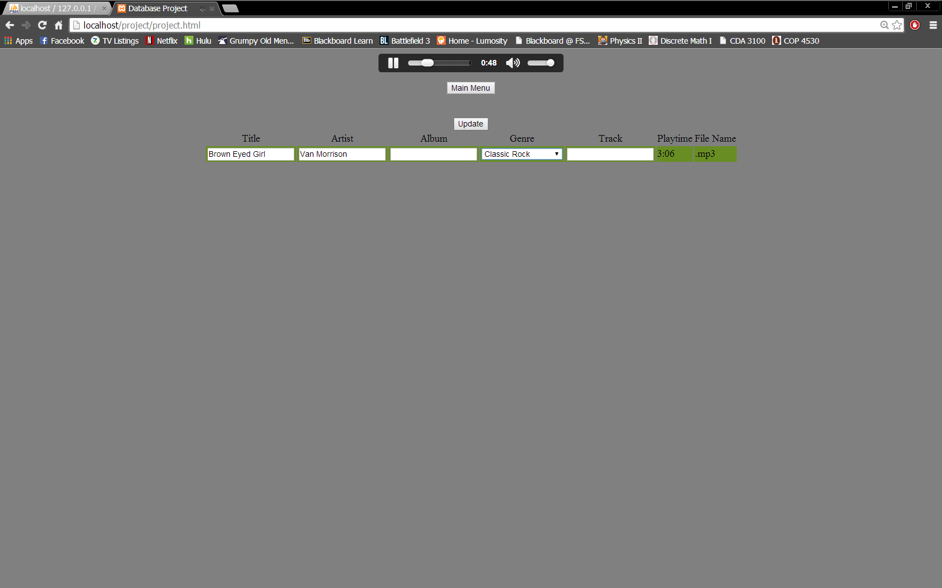

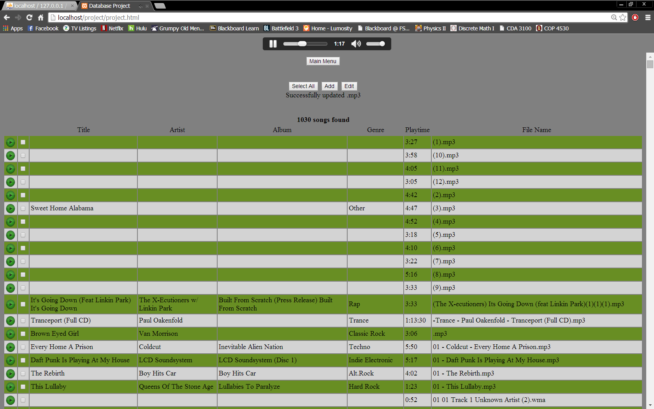

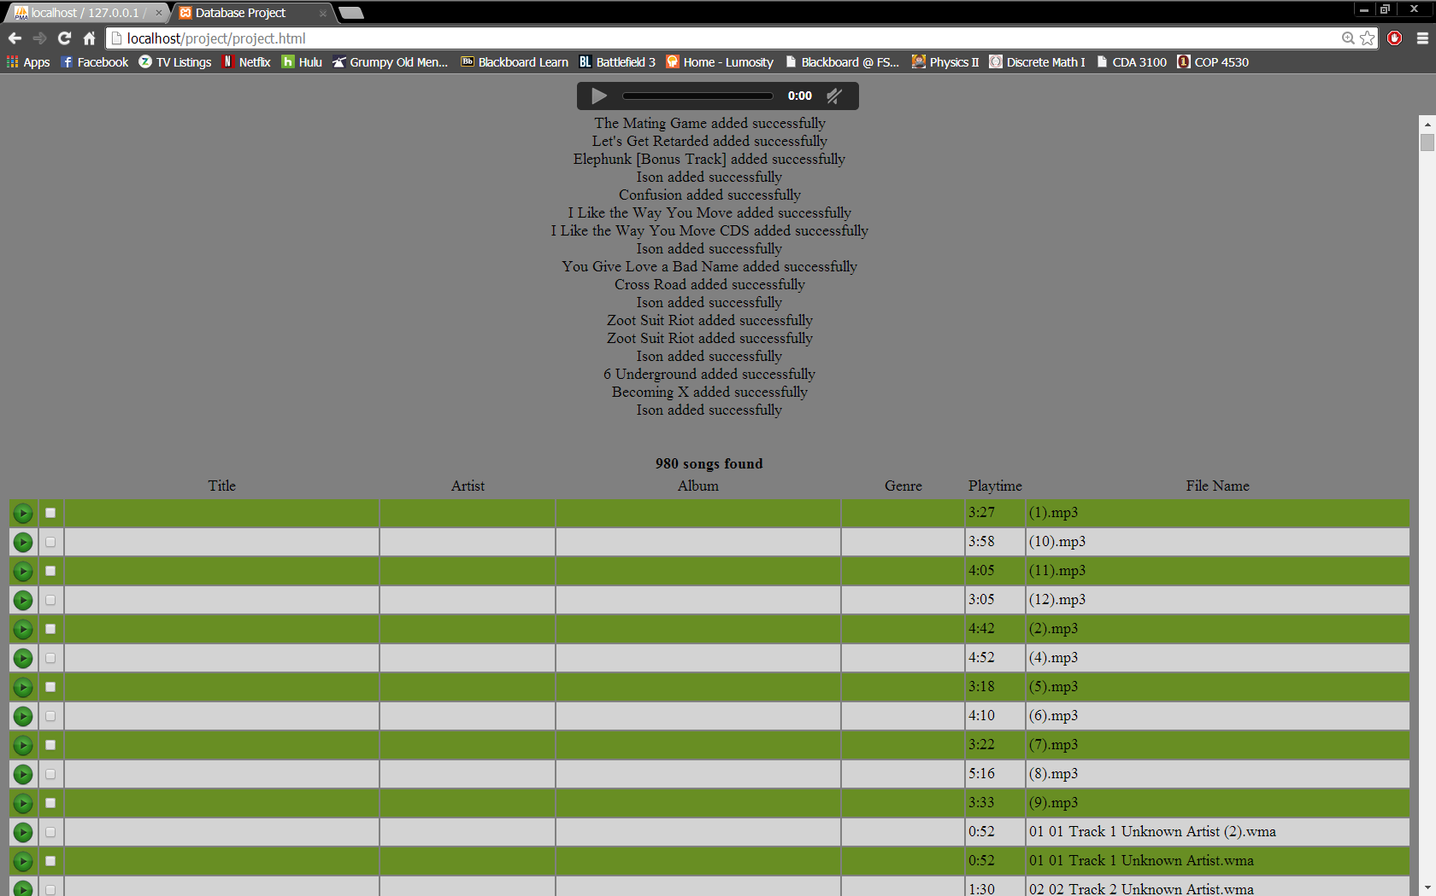

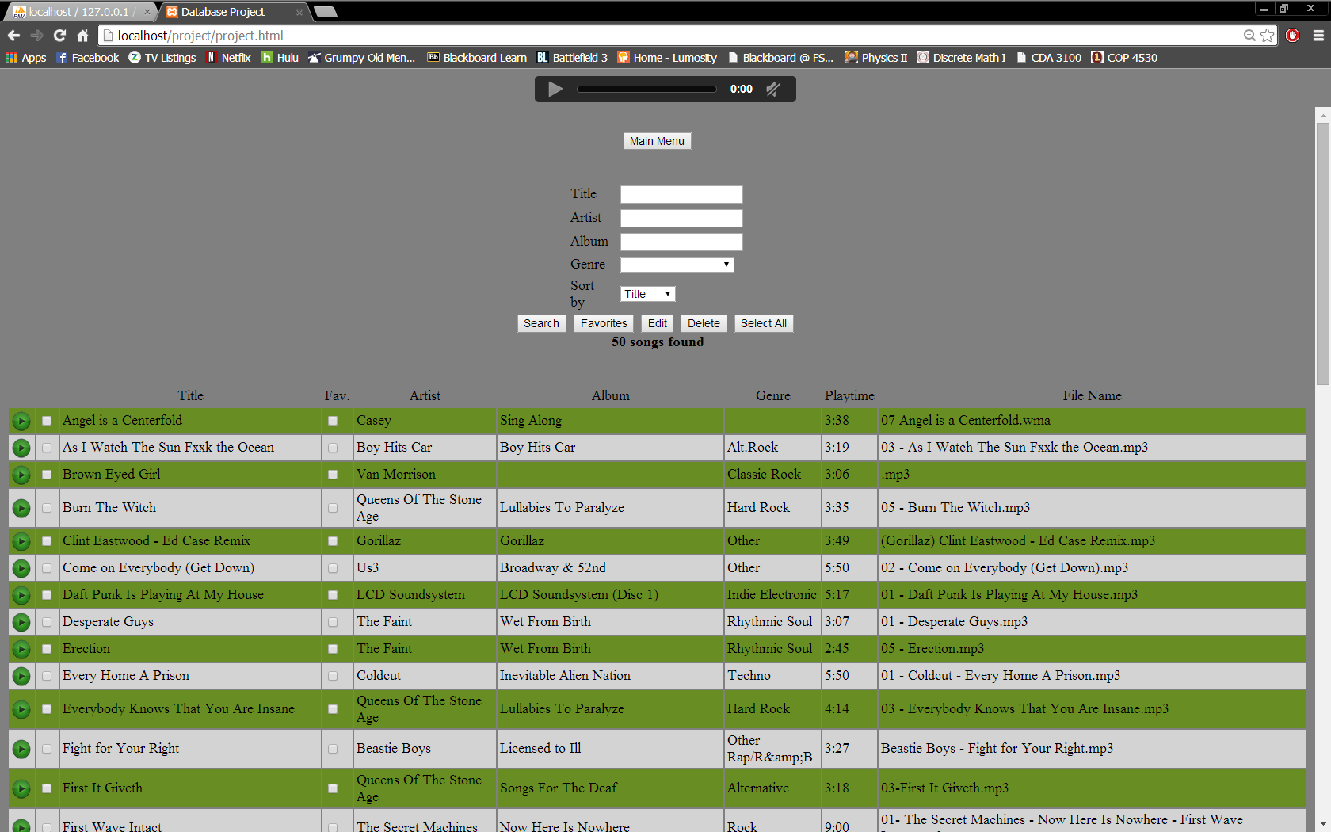

In the search area, the user can query base on song title, artist name, album title, or genre, and sort the results by any of these fields. The user can also add songs to their favorites list, edit ID3 tag info, or delete songs from the database.
