PaddyGuard-TN: Project Guide
Oct 17, 2026 · @Sidharth

Project at a glance
PaddyGuard-TN turns a smartphone photo of a paddy (rice) leaf into a safe, traceable spray decision for Tamil Nadu farmers. It names the disease, measures how much of the leaf is damaged, decides whether it is confident enough to answer, and then gives the action recommended by Tamil Nadu Agricultural University (TNAU), in English.
The one research question: can a paddy disease model, trained on Tamil Nadu photos and tested on other datasets, measure leaf damage accurately enough to trigger TNAU's spray rules correctly, and say "I am not sure" when it cannot? The whole project uses public data only, so you do not need to photograph or label anything yourself.
What you will build, in order:
- A disease classifier trained on Paddy Doctor and tested on two other rice datasets (Sethy from Odisha, Dhan-Shomadhan from Bangladesh) to measure how much accuracy drops.
- A lesion-severity estimator trained on public pixel masks, then stress-tested by pasting leaves onto field backgrounds where the true severity is still known.
- An answer-or-abstain layer, calibrated on a small labelled slice of each target dataset.
- A rule-based English advisory for three diseases, with every chemical and dose checked against TNAU and CIBRC (the government pesticide registry).
- A small web demo, plus evaluation by "did the system reach the correct spray decision?" rather than top-1 accuracy alone.

Problem statement
Paddy disease models look solved on paper but are not safe to act on: they are tested only on photos like the ones they were trained on, they name a disease without saying how bad it is, and they never say "I am not sure".
Background
- Farmers in Tamil Nadu mostly identify paddy diseases by eye, which is slow, depends on experts, and varies between regions.
- The Paddy Doctor benchmark reports F1 97.5% (ResNet34), but on a test split from the same dataset it was trained on.
- A 2026 study on two Bangladeshi rice datasets found zero-shot transfer fell below the 0.25 chance level for all five backbones tested. A second 2026 study on three Bangladeshi datasets reported cross-dataset macro-F1 of 0.44 against 0.72 in-domain.
- TNAU's treatment advice is triggered by severity, not just disease name. For rice blast it recommends spraying at about 5% leaf area damage (figure taken from the TNAU expert-system page; confirm it there yourself).
- Pesticide advice is safety-critical. TNAU and the CIBRC registry (different editions) can list different doses for the same chemical, so an advisory must say which source each number comes from.
Exact problem. Given a smartphone photo of a paddy leaf, output:
- the disease class;
- lesion severity (percent of leaf area) and the matching TNAU action band;
- an answer-or-abstain decision that can be trusted;
- an English action that traces back to TNAU or CIBRC;
and do this reliably when the photo comes from a different camera, place or background than the training photos.
Root causes
- Models learn dataset-specific backgrounds and lighting, not only lesions.
- Severity models are trained and tested on the same image source, so cross-domain error is never measured.
- Confidence scores calibrated on the source data become unreliable under shift.
- Advisory modules are generic, or generated text that nobody checked against the registry.

Existing work
Each piece of PaddyGuard-TN has been done somewhere, but never together and never for Tamil Nadu paddy. Entries marked † were opened and checked while preparing this guide; open the rest before you cite them.
Work | What it did | What it misses
Paddy Doctor † (Petchiammal et al., CODS-COMAD 2023) | 16,225 photos, 13 classes; ResNet34 F1 97.5% | Tested only on its own split; no severity, no advice
Amato et al. † (Smart Agricultural Technology, 2026) | Five backbones tested across two Bangladeshi datasets; zero-shot falls below chance | Bangladeshi data only; classification only
Paul † (arXiv 2609.31709, 2026) | Three Bangladeshi datasets; strong augmentation helps (about +0.07 macro-F1), adaptive batch-norm and Grad-CAM do not | No severity, no abstention, no advice
Two-stream Swin + ConvNeXt (MDPI Computers, 2026) | Cross-dataset rice classifier with an LLM advisory step | Advice not checked against dose registries
BLB severity, multitask | Segmentation plus classification, 5 severity stages | One disease; tested on its own images
Copy-paste segmentation severity (Plants, 2022) | Lesion-percent severity from segmentation, 450 images | Small, in-domain only
Reliability gap in cross-domain plant disease (Frontiers in Plant Science, 2026) | Calibration and selective prediction on PlantVillage to PlantDoc | Not rice; calibration on source data fails under shift
Multilingual LLaMA + RAG (Tamil Nadu farmer queries) | Retrieval-based text advisory | Text only; scored with BLEU/ROUGE, not dose correctness
DG-Eval and Pezego-HITL | Fact-level checks and registry checks for agri advice (Bihar, Ghana) | No image diagnosis or severity
Khaliq et al. (IEEE Access, 2025, your first deck) | Soil, irrigation, crop and fertilizer models at about 99% | Generic Kaggle data; no disease component; no regional validation
Two cautions from the checks. "SOFS-Rice" from your second deck could not be found anywhere, so remove it unless you hold the PDF. And plain "cross-dataset test plus MixStyle plus Grad-CAM" is no longer new, so the project must lean on the severity and decision parts.

Research gaps and what this project addresses
The gap is the combination: to the best of our search, no one has put the four pieces below together on Tamil Nadu paddy. The search was broad but not exhaustive, so use that wording in your review and recheck Google Scholar for "Paddy Doctor" with "Sethy" before Review 1.
Gap | What PaddyGuard-TN does about it
Cross-dataset studies use Bangladeshi data only | Trains on Tamil Nadu Paddy Doctor and tests on the Indian Sethy set (four shared classes) and on Dhan-Shomadhan
Severity is measured only on the images it was trained on | Trains on public lesion masks, then measures severity error under a controlled shift: leaves with known masks are pasted onto field backgrounds and degraded with blur, lighting changes and JPEG compression. The shift is simulated, not real field photos
Abstention calibrated on source data fails under shift | Calibrates the answer-or-abstain rule on a small labelled slice (25 to 150 images) of each target dataset and compares it with source-only calibration
Advice is scored as text quality, not as a decision | Scores whether the system reaches the correct TNAU spray decision and whether every dose matches the registry
Three contributions to claim
- The first Indian-to-Indian cross-dataset benchmark from Paddy Doctor to Sethy, with per-variety analysis from Paddy Doctor's metadata.
- Severity error under a controlled, simulated domain shift with exact ground truth, reported as "decision flips": how often a severity error changes the TNAU action.
- Target-calibrated abstention scored by spray-decision agreement, with a registry-checked English advisory.
Be upfront about one limit. Contribution 2 uses a simulated shift because no public dataset has severity masks for a second source. Say "simulated" every time you report it, and show a few example composites in the report.

Objectives and success measures
- Measure the generalization gap. Train lightweight classifiers on Paddy Doctor and test them on Sethy (4 shared classes) and Dhan-Shomadhan (3 shared classes), broken down by class and by rice variety.
- Estimate severity. Train a lesion-segmentation model on the RiceSeg-5932 masks and convert it to percent of leaf damaged. Measure the error on held-out Sethy images and again under a simulated shift (leaves pasted onto field backgrounds, plus blur, lighting and JPEG changes).
- Know when to abstain. Add conformal prediction (a method that outputs a set of plausible classes with a coverage guarantee) and compare source-only calibration with calibration on 25 to 150 labelled images from the target dataset.
- Give checked advice. Build a versioned knowledge base from TNAU and CIBRC for blast, brown spot and bacterial leaf blight, and generate English advice from it. Every chemical and dose must come from the knowledge base, which an automated test checks.
- Judge it end to end. Score the whole pipeline on spray-decision agreement using Sethy test images, whose masks give the true severity, and ship a small web demo.
Measure | Metric | Why it matters
Classification | Macro-F1 (main), balanced accuracy, per-class recall, 3 seeds | Shows the in-domain versus cross-dataset gap
Severity | Dice and IoU on masks, MAE of percent damaged, accuracy of severity band, and how much MAE rises under each simulated shift | Tells you whether the 5% style thresholds are reachable and how fragile they are
Reliability | Expected calibration error, coverage against the 90% target, average set size, selective risk at 80% coverage | Tells you whether "I am not sure" can be trusted
Decision | Spray-decision agreement, decision-flip rate, abstention rate | The headline result
Advice safety | Dose-compliance rate (target 100%), source attribution present | The safety guarantee
Minimum viable result: the cross-dataset table, severity error on clean and simulated-shift images, conformal abstention, the decision table, and a rule-based English advisory with 100% dose compliance. Stretch goals: a second backbone, few-shot adaptation curves, a per-variety write-up, soil and weather notes, verified Tamil text, and a 30 to 40 photo real-world check.

Approach in brief
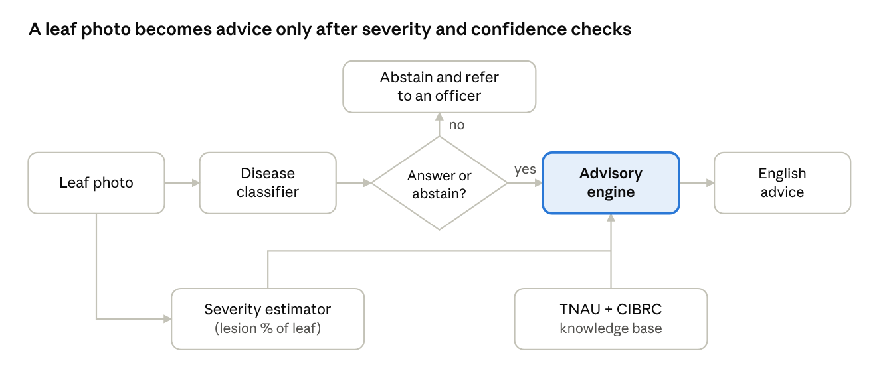
PaddyGuard-TN pipeline · photo to advice
The photo goes to two models in parallel. The advisory engine combines their output with the registry knowledge base, and any uncertain case is referred to an officer instead of answered.
- Prepare the data. Remove near-duplicate photos, split by group so the same leaf never appears on both sides, and map class names across datasets.
- Classify. Fine-tune EfficientNet-B0 on Paddy Doctor, with and without strong augmentation, and test on the other datasets. MobileNetV3 is an optional second backbone.
- Measure severity. Train a small U-Net on the RiceSeg masks, then compute lesion pixels divided by leaf pixels. Stress-test it by pasting the masked leaves onto Paddy Doctor field backgrounds and adding blur, lighting and JPEG changes, so the true severity stays known.
- Decide whether to answer. Use conformal prediction; abstain when more than one class is plausible or severity sits close to a TNAU threshold.
- Advise. Look up the action, registered product and dose in a JSON knowledge base you build from TNAU and CIBRC for three diseases, and write it in English from templates. No free-text AI generation in the core.
- Demo and evaluate. A Streamlit app, plus the decision-level evaluation.

Datasets and where to download them
Every dataset below is public, so you do not need to collect or label any photos. Start with the Kaggle copy of Paddy Doctor: the full IEEE DataPort version needs a paid DataPort subscription, while the Kaggle one is free and can be attached directly inside a Kaggle notebook. All four shared classes (blast, brown spot, bacterial leaf blight, tungro) should be in it; confirm in its train.csv. Licences were not stated on the pages I could read, so check each page before reuse.
Dataset | Role | Size and labels | Download | Notes
Paddy Doctor, Kaggle competition version | Training, in-domain test, and the field backgrounds for the simulated-shift test | 10,407 labelled photos, 10 classes (bacterial leaf blight, bacterial leaf streak, bacterial panicle blight, blast, brown spot, dead heart, downy mildew, hispa, tungro, normal), plus variety and age per image | kaggle.com/c/paddy-disease-classification | Join the competition and accept the rules. The 3,469 test images are unlabelled; do not use them. Confirm the class list in train.csv
Paddy Doctor, Hugging Face mirror | Backup for the Kaggle copy | About 10.4k images in Parquet, with label, variety and age columns, 480 to 640 px wide | anthony2261/paddy-disease-classification | Unofficial mirror; licence not stated
Paddy Doctor, full version | Optional upgrade | 16,225 photos, 13 classes, 1080x1440 original (about 4.7 GB), 480x640 (about 1.2 GB), 256x256 (about 320 MB) | IEEE DataPort | Page says it needs login and an IEEE DataPort subscription; ask if your college has one
Rice Leaf Disease Image Samples (Sethy et al.) | Cross-dataset target, severity training images, and the source of the leaves for the shift test | 5,932 photos, 4 classes: bacterial blight, blast, brown spot, tungro | Mendeley, DOI 10.17632/fwcj7stb8r.1 | Check for near-duplicate images yourself before splitting (see the architecture file)
RiceSeg-5932 | Pixel masks that make severity measurable | 5,932 JPG masks, one per Sethy image, made in Label Studio | Mendeley, DOI 10.17632/92jc6w6mcy.1 | Pair masks with images by exact filename (Sethy version 1 or 2). Licence field was blank on the page text; one source reports CC BY 4.0, so confirm
Dhan-Shomadhan | Second cross-dataset target (Bangladesh) | 1,106 photos, 5 classes, field and white backgrounds | Mendeley, DOI 10.17632/znsxdctwtt.1 | Shares 3 classes with Paddy Doctor: blast, brown spot, tungro. Use the field-background images for the main test
Skip IP102. It shows insects, whereas Paddy Doctor's pest classes show leaf damage, so the "shift" would be a different task, not a different domain. Optional extras for reproducing the Amato et al. setup: Hasan et al. 2023 (Mendeley hx6f852hw4), RiceLeafBD (kx9rx8p2mz) and BRRI (vwv3nry3wr); all are Bangladeshi and not needed for the core project.

Other resources you will need
The treatment rules are not downloadable datasets; you read them from official sources and type them into your own knowledge base. Several of these sites blocked my automated fetch, so open them in your browser and confirm what they say.
Resource | Used for | Link
TNAU Agritech expert system, paddy | Disease descriptions, severity thresholds and TNAU recommended actions | Disease index, blast page
CIBRC "Major Uses of Pesticides" | Registered products and doses; the check that every advised chemical is legal for paddy | ppqs.gov.in, CIB&RC; use the 31.03.2024 edition and download the PDFs manually
TNAU copy of the older CIBRC fungicide table | Only to spot disagreements between editions | PDF
Software: Python, PyTorch, timm (pretrained models), segmentation_models_pytorch, Albumentations and OpenCV (for the background-paste test), imagehash, a hand-written split-conformal routine, and Streamlit for the demo. Compute: Kaggle notebooks or Colab free GPUs are enough because everything is fine-tuning of small pretrained models.

Scope and risks
The project uses public data only and needs no photo collection; it does not cover hardware, field imagery, Tamil text or free-form chatbots.
Included | Excluded
Leaf photos of blast, brown spot, bacterial leaf blight and tungro for cross-dataset tests; other Paddy Doctor classes in-domain only | Panicle or neck blast severity, drone or whole-field imagery
Lesion-percent severity from public masks, plus a simulated-shift stress test | Real field severity ground truth; collecting or annotating your own photos
Rule-based, registry-checked English advice for blast, brown spot and bacterial leaf blight; tungro as classification plus a management note | Tamil text, soil-health and weather modifiers, automatic spraying, LLM chat
A small web demo | Production app release

Risk | Fallback
IEEE DataPort needs a subscription | Use the Kaggle or Hugging Face copy
Near-duplicates in Sethy inflate scores | Remove them with perceptual hashing and split by group before any experiment
RiceSeg masks do not mean what the page implies | Look at the overlays in week 1; if they cannot give lesion percent, estimate lesions by colour thresholding on Sethy's plain-background images and say so
The simulated shift looks unrealistic to a reviewer | Paste onto real Paddy Doctor field backgrounds, show example composites, and optionally add a 30 to 40 photo real-world check
Kaggle competition rules limit reuse | Use the Hugging Face mirror, or ask your guide about the IEEE DataPort copy
TNAU and CIBRC doses disagree | Store both with source and edition, show the TNAU value and flag the conflict
The knowledge base has no expert review | Label it "not expert-verified" in the report and demo; ask a TNAU student or officer to glance at it if you can
Reviewer says cross-dataset work is already done | Cite Amato and Paul up front and position the work as Indian-source, severity-aware and decision-level
GPU quota runs out | Cache resized images, use mixed precision, keep to one small backbone

Timeline for one person
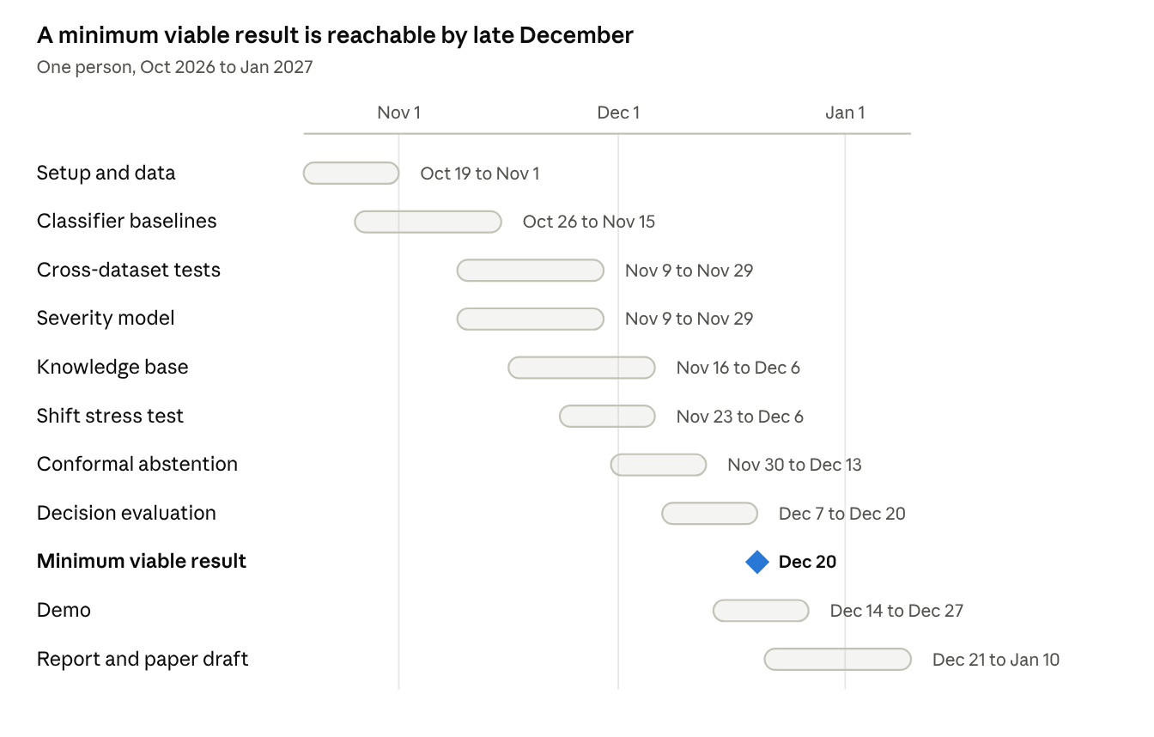
plan by phase · Oct 2026 to Jan 2027
The plan assumes about 12 steady weeks, with Claude Code writing the code and Kaggle doing the training, and it leaves the rest of your 4 to 5 month window as buffer. The dates are an estimate; slide them if a step takes longer. Phases overlap on purpose:
- Oct 19 to Nov 1: downloads, private Kaggle datasets, duplicate check, and a look at the mask overlays.
- Nov 2 to Nov 29: classifier baselines, the cross-dataset table (the headline result) and the severity model.
- Nov 16 to Dec 13: knowledge base for three diseases, the simulated-shift stress test, and conformal abstention.
- Dec 7 to Dec 27: decision evaluation (minimum viable result around Dec 20) and the demo.
- Dec 21 to Jan 10: report and paper draft.

Before you start: checklist
These are the points I could not confirm myself, plus the first setup steps.
- ☐ Create a Kaggle account, join the Paddy Doctor competition and accept its rules.
- ☐ Download Sethy, RiceSeg-5932 and Dhan-Shomadhan from Mendeley, upload each as a private Kaggle dataset, and read the licence on each page.
- ☐ Check that RiceSeg mask filenames match the Sethy image filenames exactly, and look at a few mask overlays to see what the masks mark (lesions only, or leaf and lesion).
- ☐ Open the TNAU paddy pages for blast, brown spot, bacterial leaf blight and tungro and write down each threshold and recommended action; my automated fetch of the TNAU blast page was blocked, so the 5% blast figure is unconfirmed by me.
- ☐ Download the CIBRC "Major Uses of Pesticides" PDFs (31.03.2024 edition) by hand.
- ☐ Check the volume and article number of the Amato et al. paper on the Elsevier page; I confirmed it only through the authors' code repository.
- ☐ Remove "SOFS-Rice" from your literature table unless you hold the PDF.
- ☐ Search Google Scholar for "Paddy Doctor" with "Sethy" cross-dataset work before Review 1.
- ☐ If you can, ask a TNAU student or agriculture officer to glance at the knowledge base. Only the 5% blast threshold is published; the other severity band edges are design choices. Otherwise label it "not expert-verified".
- ☐ Ask your guide whether your college has an IEEE DataPort subscription (optional).

References
Pages I opened myself: Paddy Doctor (DataPort), Sethy, RiceSeg-5932, Dhan-Shomadhan, Paul (arXiv), the Amato repository and the Hugging Face dataset card. The others come from the research run, so open each before citing it.
- Petchiammal A. et al., "Paddy Doctor: A Visual Image Dataset for Automated Paddy Disease Classification and Benchmarking," CODS-COMAD 2023. IEEE DataPort; earlier version arXiv 2205.11108 (smaller; cite the 16,225-image version).
- Paddy Doctor on Kaggle: paddy-disease-classification.
- Amato F., Ghosh R.C., Mondal S., Moccardi A., "Cross-Dataset Generalisation of Rice Leaf Disease Classifiers," Smart Agricultural Technology, 2026. Code and citation.
- Paul A., "Cross-Dataset Generalization of Bangladeshi Rice Leaf Disease Classifiers," arXiv 2609.31709, 2026.
- Sethy P.K. et al., "Rice Leaf Disease Image Samples," Mendeley Data, 2020.
- "RiceSeg-5932: Complete Pixel-Level Segmentation Masks for Rice Leaf Disease Images Samples," Mendeley Data, 2025.
- Hossain M.F. et al., "Dhan-Shomadhan," Mendeley Data, 2021; arXiv 2309.07515.
- Khaliq A. et al., "AI-Driven Smart Agriculture," IEEE Access 13:141124-141138, 2025. DOI.
- "Global-Local Feature-Based Rice Leaf Disease Classification Using Two-Stream Deep Neural Network Feature Fusion," Computers 15(8):528, 2026. MDPI.
- "Quantifying the reliability gap in cross-domain plant disease classification," Frontiers in Plant Science, 2026. Link.
- "Interpretable multitask deep learning model for detecting and analyzing severity of rice bacterial leaf blight." PMC12301484.
- "A Copy Paste and Semantic Segmentation-Based Approach for the Classification and Assessment of Significant Rice Diseases," Plants 11:3174, 2022. DOI.
- "Fine-Tuning and Evaluating Conversational AI for Agricultural Advisory" (DG-Eval), arXiv 2603.03294.
- "Pezego-HITL: A policy-grounded LLM architecture for agricultural extension in Ghana," arXiv 2607.13934.
- "Enhancing Agricultural Advisory Services with Multilingual LLaMA and RAG." ResearchGate.
- Official sources: TNAU Agritech paddy and CIBRC major uses of pesticides.

