HA MQTT Store
Architecture, database schema, lineage, SQL examples, and MCP access
CURRENT IMPLEMENTATION REFERENCE • 10 OCTOBER 2026
PostgreSQL 17 | SQLAlchemy 2.x | Alembic | pgvector
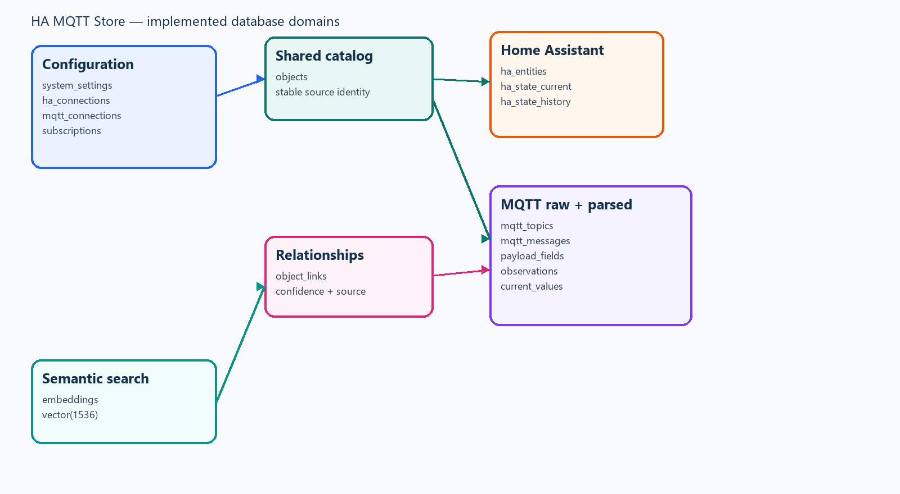

Implemented database ER diagram
The diagram below reflects the tables and relationships implemented by the current SQLAlchemy models and Alembic migrations.
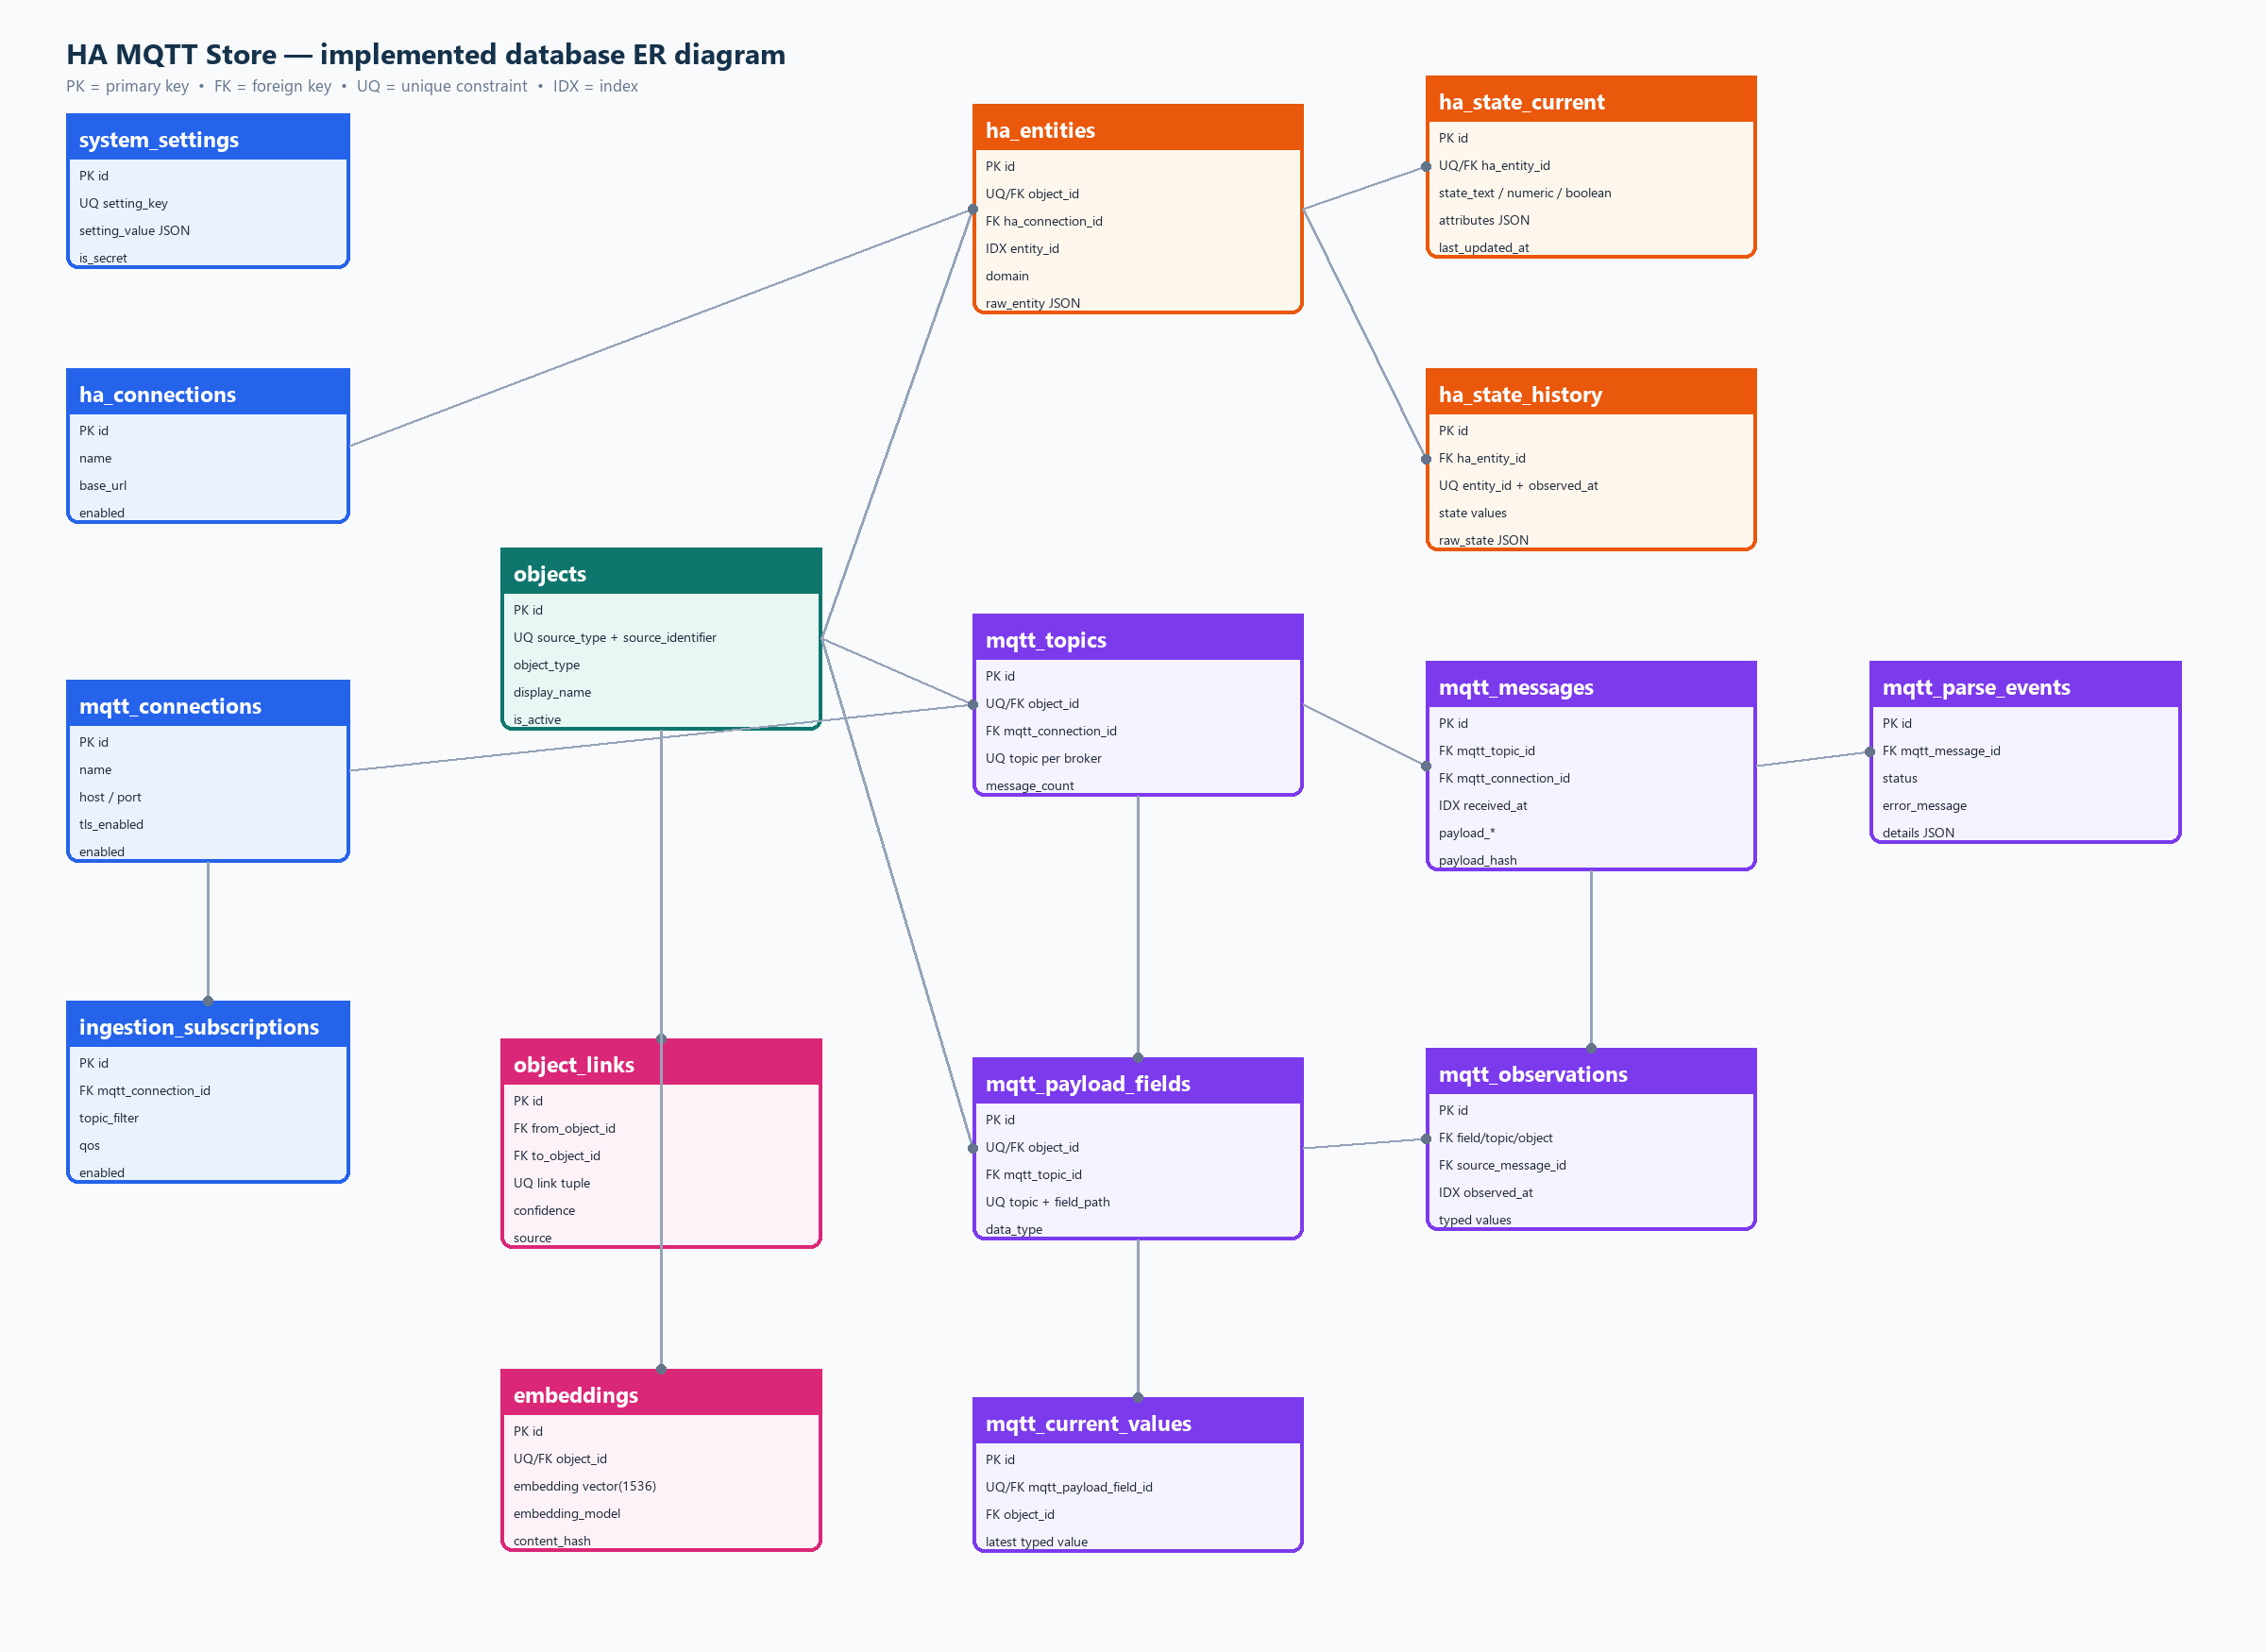

HA MQTT Store — Architecture and Database Design
**Document status:** Current implementation reference
**Last reviewed:** 2026-10-12
**Database:** PostgreSQL 17 with `pgvector`
**ORM:** SQLAlchemy 2.x
**Migrations:** Alembic
`%INSTALL_PATH%` denotes the local directory where the repository is installed.
This document describes the database implemented in the repository. Planned tables are explicitly marked as planned.

1. Executive summary
HA MQTT Store collects Home Assistant and MQTT data into PostgreSQL. It preserves source data and derives query-friendly records:
- Connection and ingestion settings are stored relationally.
- Home Assistant entities and MQTT topics/fields share the `objects` catalog.
- Raw MQTT messages are retained in `mqtt_messages`.
- Parsed MQTT values are stored in `mqtt_observations` and accelerated by `mqtt_current_values`.
- Home Assistant current state and history are stored separately.
- `object_links` provides generic relationships between catalog objects.
- The read-only MCP service queries this schema and redacts sensitive payload keys.
Preserve the raw source message or state, then create normalized records for every meaningful value extracted from it.

2. Logical architecture
Home Assistant ──WebSocket──► HA ingestor ─┐
│
MQTT broker ─────MQTT────────► MQTT ingestor ─┼──► PostgreSQL 17 + pgvector
│
├──► Redis dashboard cache ──► Flask JSON API ──► Browser live tiles
Browser ─────────HTTP────────► Flask web ───┘
ChatGPT/Codex ◄── read-only MCP ── MCP service ──► same PostgreSQL database
Container | Responsibility | Port
`hamqtt-postgres` | PostgreSQL and pgvector | `5432`
`hamqtt-migrate` | Alembic migrations | —
`hamqtt-web` | Flask/Gunicorn UI | `8000`
`hamqtt-mqtt-ingestor` | MQTT ingestion and parsing | —
`hamqtt-ha-ingestor` | Home Assistant synchronization | —
`hamqtt-mcp` | Read-only MCP server | host `8001` → container `8000`
The local MCP endpoint is `http://localhost:8001/mcp`. ChatGPT requires HTTPS, so the temporary bridge is:
ngrok http 8001
The ChatGPT URL is the current ngrok HTTPS address followed by `/mcp`.

3. Database design principles
- **Relational first:** foreign keys, unique constraints, and typed columns protect the core model.
- **JSON for source fidelity:** source attributes, raw states, JSON payloads, and parser metadata retain original shape.
- **Typed value slots:** normalized values use text, numeric, boolean, and JSON columns; the matching slot is normally populated.
- **UTC timestamps:** application timestamps are timezone-aware UTC values.
- **Current plus history:** current tables make UI/MCP reads fast; history tables preserve time-series detail.
- **Raw-to-derived lineage:** every MQTT observation points to its original `mqtt_messages` row through `source_message_id`.
- **Cascade awareness:** source-specific rows use `ON DELETE CASCADE`; deleting a connection can delete its ingested data.
- **Schema authority:** `src/hamqtt_store/db.py` is the model authority; Alembic revisions create/evolve the database.
The dashboard live path is intentionally separate from durable history. After a successful source write, the MQTT worker writes a compact six-message list to Redis key `dashboard:mqtt:latest`, and the HA worker writes compact current entities to Redis hash `dashboard:ha:states`. Flask exposes these caches through `/api/dashboard/latest-mqtt` and `/api/dashboard/random-ha`. `static/app.js` polls the MQTT endpoint every two seconds and the HA endpoint every ten seconds, skips requests while the tab is hidden, and renders the returned rows in place. Redis writes and reads are best-effort: failures are logged and return an empty cache or an offline badge, while PostgreSQL ingestion remains the source of truth.

4. Implemented schema at a glance
Group | Tables | Purpose
Configuration | `system_settings`, `ha_connections`, `mqtt_connections`, `ingestion_subscriptions` | Runtime settings and source connections
Shared catalog | `objects` | Stable cross-source identity and display metadata
Home Assistant | `ha_entities`, `ha_state_current`, `ha_state_history` | Entity registry and state data
MQTT | `mqtt_topics`, `mqtt_messages`, `mqtt_payload_fields`, `mqtt_observations`, `mqtt_current_values`, `mqtt_parse_events` | Raw MQTT storage and parsed values
Relationships/search | `object_links`, `embeddings` | Cross-source links and optional semantic search

Relationship map
ha_connections ──< ha_entities ──1── ha_state_current
│ └──────<── ha_state_history
mqtt_connections ──< ingestion_subscriptions
└───────────< mqtt_topics ──< mqtt_messages ──< mqtt_parse_events
│
└──< mqtt_payload_fields ──1── mqtt_current_values
└────────────<── mqtt_observations ──> mqtt_messages
objects ◄── referenced by HA entities, MQTT topics, MQTT fields, observations,
current values, object_links, and embeddings
objects ──< object_links >── objects
Each HA entity, MQTT topic, and MQTT payload field has a one-to-one `objects` row, providing a common identity model for UI, links, and MCP.

5. Detailed database schema
`PK` = primary key, `FK` = foreign key, `UQ` = unique, `IDX` = explicit index.

5.1 `system_settings`
Stores structured application settings such as the MCP configuration.
Column | Type | Key/default | Meaning
`id` | integer | PK | Row identifier
`setting_key` | varchar(150) | UQ | Stable setting name, e.g. `mcp`
`setting_value` | JSON | `{}` | Structured configuration
`is_secret` | boolean | `false` | Secret classification flag
`created_at`, `updated_at` | timestamptz | required | Audit timestamps

5.2 `ha_connections`
Column | Type | Key/default | Meaning
`id` | integer | PK | Connection identifier
`name` | varchar(150) | required | Friendly name
`base_url` | varchar(500) | required | Home Assistant URL
`access_token` | text | nullable | Access token; protect operationally
`enabled` | boolean | `true` | Worker enable flag
`verify_tls` | boolean | `true` | TLS verification policy
`last_connected_at` | timestamptz | nullable | Last successful connection
`last_error` | text | nullable | Latest connection error
`created_at`, `updated_at` | timestamptz | required | Audit timestamps

5.3 `mqtt_connections`
Column | Type | Key/default | Meaning
`id` | integer | PK | Broker identifier
`name` | varchar(150) | required | Friendly name
`host` | varchar(255) | required | Broker host
`port` | integer | `1883` | Broker port
`username` | varchar(255) | nullable | Broker username
`password` | text | nullable | Broker password; protect operationally
`tls_enabled` | boolean | `false` | TLS flag
`client_id` | varchar(255) | nullable | MQTT client ID
`enabled` | boolean | `true` | Worker enable flag
`last_connected_at`, `last_error` | timestamptz/text | nullable | Runtime status
`created_at`, `updated_at` | timestamptz | required | Audit timestamps

5.4 `ingestion_subscriptions`
Column | Type | Key/default | Meaning
`id` | integer | PK | Subscription ID
`mqtt_connection_id` | integer | FK → `mqtt_connections.id`, cascade | Broker
`topic_filter` | varchar(500) | required | Filter such as `sensors/#`
`qos` | integer | `0` | Requested QoS
`enabled` | boolean | `true` | Active flag

5.5 `objects`
The shared catalog. `(source_type, source_identifier)` is unique.
Column | Type | Key/default | Meaning
`id` | integer | PK | Catalog ID
`object_type` | varchar(50) | required | `ha_entity`, `mqtt_topic`, `mqtt_value`, etc.
`source_type` | varchar(50) | required | `ha`, `mqtt`, or another namespace
`source_identifier` | varchar(1000) | UQ with source type | Stable source identity
`display_name`, `nickname` | varchar(500) | nullable | Display labels
`description` | text | nullable | User description
`is_active` | boolean | `true` | Active flag
`first_seen_at`, `last_seen_at` | timestamptz | nullable | Activity range
`created_at`, `updated_at` | timestamptz | required | Audit timestamps

5.6 Home Assistant tables
#### `ha_entities`
Column | Type | Key/default | Meaning
`id` | integer | PK | Internal ID
`object_id` | integer | FK → `objects.id`, UQ, cascade | Shared object
`ha_connection_id` | integer | FK → `ha_connections.id`, cascade | Source connection
`entity_id` | varchar(255) | IDX | HA ID, e.g. `sensor.room_temperature`
`domain` | varchar(100) | required | HA domain
`platform` | varchar(255) | nullable | Integration/platform
`device_id`, `area_id` | varchar(255) | nullable | Registry references
`unique_id` | varchar(500) | nullable | Integration unique ID
`original_name` | varchar(500) | nullable | Registry name
`raw_entity` | JSON | `{}` | Original entity payload
#### `ha_state_current`
One row per entity; `ha_entity_id` is unique.
Column | Type | Key/default | Meaning
`id` | integer | PK | Current row ID
`ha_entity_id` | integer | FK → `ha_entities.id`, UQ, cascade | Entity
`state_text`, `state_numeric`, `state_boolean` | text/float/boolean | nullable | Typed state slots
`attributes` | JSON | `{}` | Current attributes
`last_changed_at`, `last_updated_at` | timestamptz | nullable | HA timestamps
`raw_state` | JSON | `{}` | Original state payload
#### `ha_state_history`
Append-oriented history. `(ha_entity_id, observed_at)` is unique; `ha_entity_id` and `observed_at` are indexed.
Column | Type | Key/default | Meaning
`id` | integer | PK | History ID
`ha_entity_id` | integer | FK → `ha_entities.id`, IDX, cascade | Entity
`observed_at` | timestamptz | IDX; UQ with entity | Observation time
`state_text`, `state_numeric`, `state_boolean` | text/float/boolean | nullable | Typed state slots
`attributes` | JSON | `{}` | Historical attributes
`raw_state` | JSON | `{}` | Original historical state

5.7 MQTT tables
#### `mqtt_topics`
`(mqtt_connection_id, topic)` is unique. Each topic has one shared object.
Column | Type | Key/default | Meaning
`id` | integer | PK | Topic ID
`object_id` | integer | FK → `objects.id`, UQ, cascade | Shared object
`mqtt_connection_id` | integer | FK → `mqtt_connections.id`, cascade | Broker
`topic` | varchar(1000) | IDX | Full topic
`first_seen_at`, `last_seen_at` | timestamptz | defaults | Activity range
`message_count` | integer | `0` | Message counter
#### `mqtt_messages`
Raw ingestion record. It is inserted before parsed derived data.
Column | Type | Key/default | Meaning
`id` | integer | PK | Message ID
`mqtt_connection_id` | integer | FK → `mqtt_connections.id`, cascade | Broker
`mqtt_topic_id` | integer | FK → `mqtt_topics.id`, IDX, cascade | Topic
`received_at` | timestamptz | IDX/default | Application receive time
`qos`, `payload_size` | integer | `0` | QoS and byte length
`retain`, `duplicate` | boolean | `false` | MQTT flags
`payload_type` | varchar(30) | required | JSON/number/boolean/text/binary/etc.
`payload_text` | text | nullable | Text payload
`payload_json` | JSON | nullable | Parsed JSON payload
`payload_binary` | bytea | nullable | Original binary payload
`payload_hash` | varchar(64) | IDX | Content hash
#### `mqtt_payload_fields`
`(mqtt_topic_id, field_path)` is unique.
Column | Type | Key/default | Meaning
`id` | integer | PK | Field ID
`mqtt_topic_id` | integer | FK → `mqtt_topics.id`, cascade | Parent topic
`object_id` | integer | FK → `objects.id`, UQ, cascade | Shared field object
`field_path` | varchar(1000) | UQ with topic | `environment.temperature`
`field_name` | varchar(500) | required | Leaf name
`data_type` | varchar(30) | required | Parsed type
`unit` | varchar(50) | nullable | Optional unit
`first_seen_at`, `last_seen_at` | timestamptz | defaults | Activity range
`observation_count` | integer | `0` | Parsed count
#### `mqtt_observations`
Time-series facts derived from raw messages. `source_message_id` preserves lineage.
Column | Type | Key/default | Meaning
`id` | integer | PK | Observation ID
`mqtt_topic_id` | integer | FK → `mqtt_topics.id`, IDX, cascade | Topic
`mqtt_payload_field_id` | integer | FK → `mqtt_payload_fields.id`, IDX, cascade | Field
`object_id` | integer | FK → `objects.id`, cascade | Field object
`source_message_id` | integer | FK → `mqtt_messages.id`, cascade | Raw source
`observed_at` | timestamptz | IDX | Source observation time
`received_at` | timestamptz | required | Application time
`value_type` | varchar(30) | required | Parsed type
`value_text`, `value_numeric`, `value_boolean`, `value_json` | text/float/boolean/JSON | nullable | Typed value slots
`unit` | varchar(50) | nullable | Unit
`quality` | varchar(30) | `good` | Quality marker
`raw_field_value` | JSON | nullable | Original extracted field
#### `mqtt_current_values`
One latest value per field; `mqtt_payload_field_id` is unique. It repeats the typed value columns for fast reads.
#### `mqtt_parse_events`
Column | Type | Key/default | Meaning
`id` | integer | PK | Event ID
`mqtt_message_id` | integer | FK → `mqtt_messages.id`, cascade | Raw message
`status` | varchar(40) | required | `success` or `partial_success` currently used
`error_message` | text | nullable | Failure detail
`details` | JSON | `{}` | Diagnostics, including field count
`created_at` | timestamptz | default | Event time

5.8 `object_links`
Generic directed relationships. `(from_object_id, to_object_id, link_type)` is unique.
Column | Type | Key/default | Meaning
`id` | integer | PK | Link ID
`from_object_id`, `to_object_id` | integer | FK → `objects.id`, cascade | Source and target
`link_type` | varchar(50) | UQ tuple | Relationship type
`direction` | varchar(30) | `one_way` | Direction semantics
`confidence` | float | nullable | Match confidence
`source` | varchar(30) | `manual` | Creation source
`is_active` | boolean | `true` | Active flag
`notes` | text | nullable | Explanation
`created_at`, `updated_at` | timestamptz | required | Audit timestamps

5.9 `embeddings`
Optional semantic-search row per object; `object_id` is unique and `embedding` is `vector(1536)`.
Column | Type | Key/default | Meaning
`id` | integer | PK | Embedding ID
`object_id` | integer | FK → `objects.id`, UQ, cascade | Embedded object
`source_text` | text | required | Embedded text
`embedding` | vector(1536) | nullable | pgvector vector
`embedding_model` | varchar(150) | nullable | Model identifier
`content_hash` | varchar(64) | nullable | Rebuild detection
`created_at`, `updated_at` | timestamptz | required | Audit timestamps

6. Ingestion and lineage
For each MQTT message, the worker:
- Resolves/creates the topic `objects` row.
- Resolves/creates `mqtt_topics` for `(mqtt_connection_id, topic)`.
- Parses the payload.
- Inserts `mqtt_messages` with raw data.
- Resolves/creates `mqtt_payload_fields`.
- Inserts `mqtt_observations` with `source_message_id`.
- Inserts/updates `mqtt_current_values`.
- Inserts a `mqtt_parse_events` result.
- Commits the transaction.
mqtt_messages.id = 9001, topic = sensors/living-room
├─ mqtt_payload_fields.id = 7, path = temperature
│ ├─ mqtt_observations.source_message_id = 9001
│ └─ mqtt_current_values.mqtt_payload_field_id = 7
└─ mqtt_payload_fields.id = 8, path = humidity
├─ mqtt_observations.source_message_id = 9001
└─ mqtt_current_values.mqtt_payload_field_id = 8
The HA worker maintains one `ha_entities` row, one `ha_state_current` row, and many `ha_state_history` rows per entity. The history uniqueness rule makes repeated synchronization idempotent for the same entity/timestamp pair.

6.1 Dashboard, graph, and export reads
The main dashboard route uses PostgreSQL for summary counts and Redis for the initial MQTT preview. The browser then refreshes the live MQTT and sampled HA tiles through the JSON endpoints described above. The dashboard cache is bounded and disposable; it is not used for historical analysis.
The `/graph` route reads `ha_state_history` and `mqtt_observations` for one to four selected catalog objects, sorts the results by timestamp, and downsamples numeric rows above 4,000 points before rendering Plotly traces. The `/export` route reads the same historical sources for one to ten selected objects and, with `download=1`, returns `hamqtt-export.csv` with timestamp, series, source, identifier, value, value type, unit, and state columns. Both routes use the shared `objects` catalog and UTC-normalized time ranges.

7. SQL query examples
Examples target PostgreSQL and are read-only unless stated otherwise.

7.1 Extension and database health
SELECT current_database(), version();
SELECT extname, extversion
FROM pg_extension
WHERE extname = 'vector';

7.2 Table row estimates
SELECT relname AS table_name, n_live_tup AS estimated_rows
FROM pg_stat_user_tables
WHERE schemaname = 'public'
ORDER BY n_live_tup DESC;

7.3 Current Home Assistant states
SELECT e.entity_id, e.original_name,
c.state_text, c.state_numeric, c.state_boolean,
c.last_changed_at, c.last_updated_at
FROM ha_entities AS e
JOIN ha_state_current AS c ON c.ha_entity_id = e.id
ORDER BY e.entity_id;

7.4 HA history for one entity
SELECT h.observed_at, h.state_text, h.state_numeric,
h.state_boolean, h.attributes
FROM ha_state_history AS h
JOIN ha_entities AS e ON e.id = h.ha_entity_id
WHERE e.entity_id = 'sensor.living_room_temperature'
AND h.observed_at >= now() - interval '24 hours'
ORDER BY h.observed_at DESC;

7.5 Latest MQTT values with names
SELECT t.topic, f.field_path, f.field_name,
c.value_type, c.value_numeric, c.value_boolean,
c.value_text, c.value_json, c.last_observed_at
FROM mqtt_current_values AS c
JOIN mqtt_payload_fields AS f ON f.id = c.mqtt_payload_field_id
JOIN mqtt_topics AS t ON t.id = f.mqtt_topic_id
ORDER BY t.topic, f.field_path;

7.6 Trace a value to its raw message
SELECT o.observed_at, t.topic, f.field_path, o.value_type,
o.value_numeric, o.value_boolean, o.value_text,
o.raw_field_value, m.id AS source_message_id,
m.received_at, m.payload_type, m.payload_json, m.payload_text
FROM mqtt_observations AS o
JOIN mqtt_payload_fields AS f ON f.id = o.mqtt_payload_field_id
JOIN mqtt_topics AS t ON t.id = o.mqtt_topic_id
JOIN mqtt_messages AS m ON m.id = o.source_message_id
WHERE t.topic = 'sensors/living-room'
AND f.field_path = 'temperature'
ORDER BY o.observed_at DESC
LIMIT 100;

7.7 Parser failures and partial success
SELECT pe.created_at, pe.status, pe.error_message, pe.details,
m.id AS message_id, t.topic, m.payload_type,
m.payload_text, m.payload_json
FROM mqtt_parse_events AS pe
JOIN mqtt_messages AS m ON m.id = pe.mqtt_message_id
JOIN mqtt_topics AS t ON t.id = m.mqtt_topic_id
WHERE pe.status <> 'success'
ORDER BY pe.created_at DESC;

7.8 Cross-source links
SELECT src.source_type AS from_source,
src.source_identifier AS from_identifier,
l.link_type, l.confidence, l.source AS link_source,
dst.source_type AS to_source,
dst.source_identifier AS to_identifier, l.notes
FROM object_links AS l
JOIN objects AS src ON src.id = l.from_object_id
JOIN objects AS dst ON dst.id = l.to_object_id
WHERE l.is_active = true
ORDER BY l.confidence DESC NULLS LAST, src.source_identifier;

7.9 High-volume topics
SELECT topic, message_count, first_seen_at, last_seen_at
FROM mqtt_topics
ORDER BY message_count DESC
LIMIT 25;

7.10 Retention review candidates
Review only; this does not delete data.
SELECT id, mqtt_topic_id, received_at, payload_size, payload_hash
FROM mqtt_messages
WHERE received_at < now() - interval '90 days'
ORDER BY received_at
LIMIT 1000;

7.11 pgvector similarity search
SELECT o.id, o.source_type, o.source_identifier, o.display_name,
1 - (e.embedding <=> '[0.01,0.02,0.03]'::vector) AS similarity
FROM embeddings AS e
JOIN objects AS o ON o.id = e.object_id
WHERE e.embedding IS NOT NULL
ORDER BY e.embedding <=> '[0.01,0.02,0.03]'::vector
LIMIT 10;

8. MCP read-only access
`src/hamqtt_store/mcp_server.py` uses the same SQLAlchemy session/database as the web app.
MCP operation | Primary tables
`get_system_summary` | `objects`, `ha_entities`, `mqtt_topics`, `mqtt_messages`
`search_objects` | `objects`
`list_home_assistant_entities` | `ha_entities`, `ha_state_current`, `objects`
`get_home_assistant_entity` | `ha_entities`, `ha_state_current`
`get_home_assistant_history` | `ha_entities`, `ha_state_history`
`list_mqtt_topics` | `mqtt_topics`, `mqtt_connections`
`list_mqtt_fields` | `mqtt_topics`, `mqtt_payload_fields`
`get_mqtt_current_value` | `mqtt_current_values`
`list_recent_mqtt_messages` | `mqtt_messages`
`get_object` | `objects`
The server requires the `mcp` setting to be enabled with `access_level = 'read_only'`. It clamps list limits and redacts keys such as passwords, tokens, secrets, and API keys from JSON/text responses. It never publishes MQTT, calls HA services, or writes to the database.
ChatGPT/Codex → HTTPS or stdio → MCP server → SQLAlchemy → PostgreSQL
For ChatGPT Personal, the temporary HTTPS boundary is `ngrok http 8001`; configure `https://<current-ngrok-host>/mcp` and stop ngrok after use.

9. Performance and indexing
Explicit indexes cover `ha_entities.entity_id`, HA history entity/time, MQTT topic, raw message topic/time/hash, and MQTT observation topic/field/time. Unique constraints create additional identity/current-value indexes.
If volume grows, review query plans and consider `(mqtt_topic_id, received_at DESC)`, `(mqtt_payload_field_id, observed_at DESC)`, time partitioning for raw/history tables, and an appropriate pgvector index.

10. Security and data lifecycle
- Treat HA tokens, MQTT passwords, and raw payloads as sensitive.
- Do not expose unauthenticated MCP beyond the required ngrok session.
- Keep backups encrypted and test restores.
- Retain catalog/current values while applying explicit policies to high-volume raw/history data.
- Deleting raw messages currently cascades to observations and parse events.
- Add authentication, CSRF protection, authorization, and stronger secret-at-rest protection before production exposure.

11. Implemented versus planned

Implemented now
PostgreSQL/pgvector, Alembic, HA connection/entity/current/history tables, MQTT connection/subscription/topic/raw message/field/observation/current/parse-event tables, shared objects, object links, embeddings, MQTT lineage, and read-only MCP.

Planned or not currently represented
Earlier planning text mentioned aliases, tags, metadata history, HA devices/areas/services/events/actions, MQTT parser rules, link evidence, and retention tables. These are **not** currently defined in `src/hamqtt_store/db.py`; add them only through explicit models and Alembic migrations.

12. Schema change checklist
cd "<path-to-installation>"
python -m pytest -q
python -m compileall -q src
python tools/validate_docs.py
python tools/generate_architecture_docx.py
git diff --check
Before a schema change: update `db.py`, add an Alembic migration, update this document and tests, regenerate the `.docx`, and run the complete checks.

