New Features
- Deployed 12 different models and integrated them with my logic in the browser:
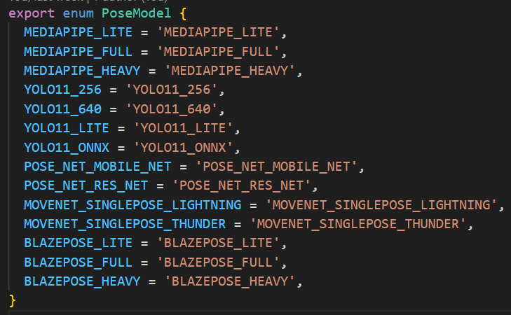
- Need to measure FPS for each of them on different phones – TODO
- Picked accuracy metrics:
  - Total Keypoint Error vs Ground Truth
  - Avg Keypoint Error per image vs Ground Truth
  - MPJPE
  - For each model total Keypoint Error vs Ground Truth for each Keypoint
- Measured accuracy metrics for each model on:
  - DB Biceps Curl Video (cut frames from video)
  - CMJ Video (cut frames from video)
  - Test Dataset
  - … I will add a bunch of other exercises
- Created my own dataset – from images which got taken using the current deployed version. Went through all of them and excluded »weird« ones:
  - Train: 7543 images
  - Val: 942 images
  - Test: 944 images
- Made statistics on the dataset – histogram for unique exercises and users
- Generated »Ground-Truth« labels (keypoint positions) with RTMO-X model on the dataset
- Used the new test dataset for the main model evaluation method (besides the seperate exercises)
- Trained one the models – YOLO11n_256 (easiest to train and had space to improve)
- Evaluated new trained model results – the results were very good

