# Steps to produce annotated report file

* Make sure that the text (.txt) file containing development team comments is named exactly same as the HTML file generate by Beyond compare tool. Note that the file name is case sensitive.



* The comments related to a line number must be in the following format: **<p>{**line:line#:L|R } some text describing the changes related to that line. The text may contain other html formatting **</p>.** The comments which are not related to a line can omit curly buckets.

e.g.:

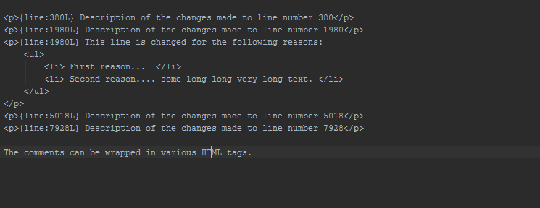

* Note the comments can be wrapped in HTML tags for formatting.
* Copy the html and txt file with development team comments in a directory and execute the CodeReviewReport as following:
  + java -jar <path to code review report jar>/CodeReviewReport-1.0-SNAPSHOT.jar <list of root directories containing code merge reports separated by spaces.>
  + e.g.: java -jar CodeReviewReport-1.0-SNAPSHOT.jar report-dir-1 report-dir-2
* Confirm that annotate reports with suffix
* Open one of the annotated report to see if the annotation are generated correctly as follows:

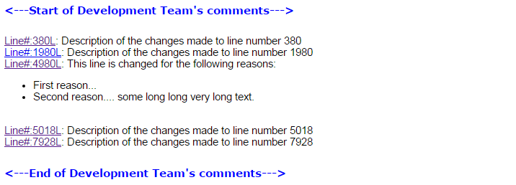

* Clicking on the browser should take you to the line number with the comment and show the developer comments in the HTML mouse over comment as shown below.

