* EventHub’s In Azure

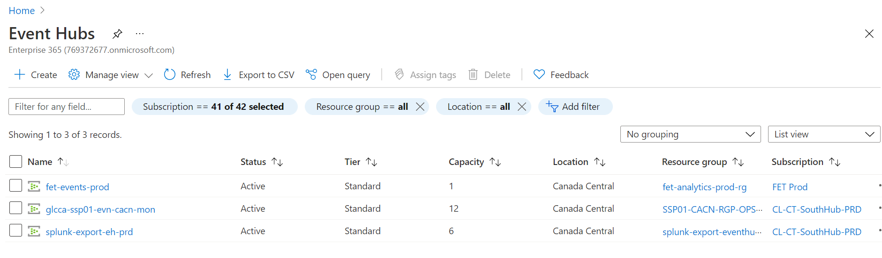

1. Fet-events-prod

This event hub is used to get statistics of requests, messages,throughput

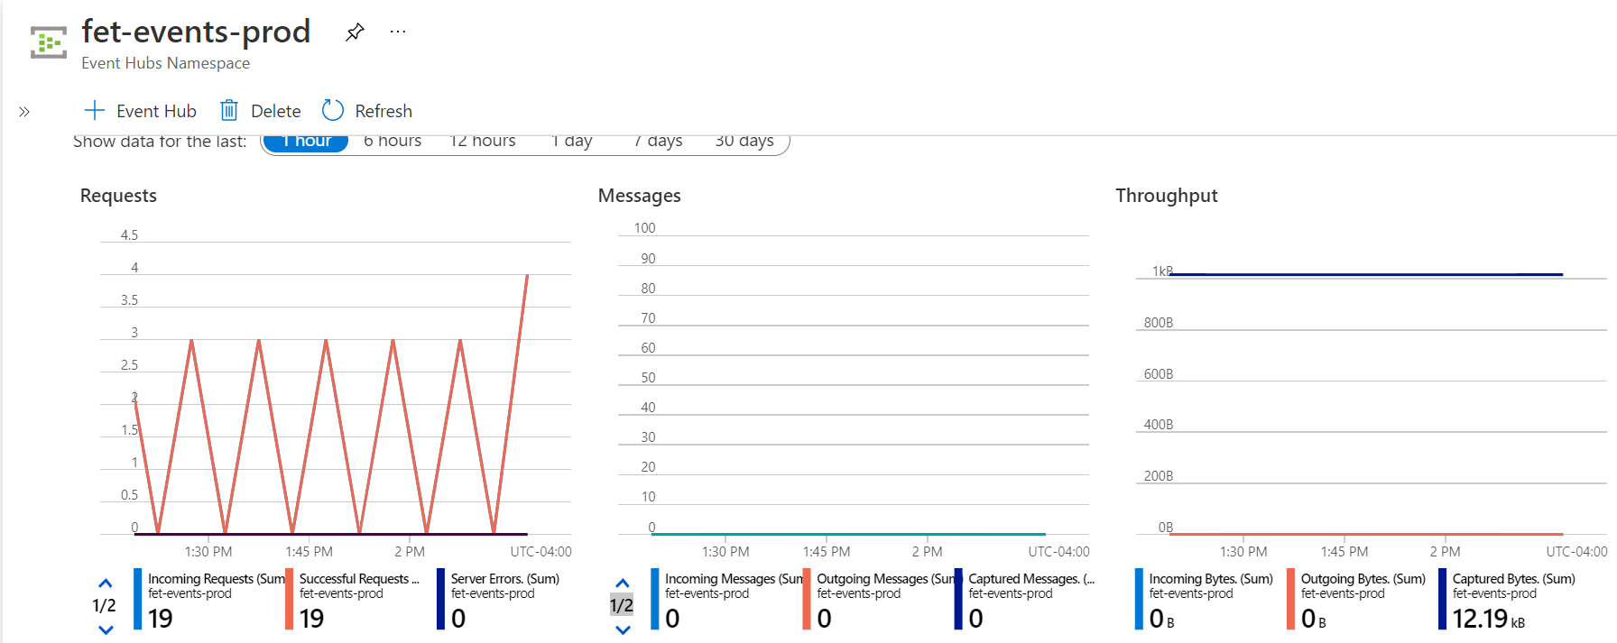

1. glcca-ssp01-evn-cacn-mon

This event hub is used to get statistics of requests, messages, throughput for helix siem logs.

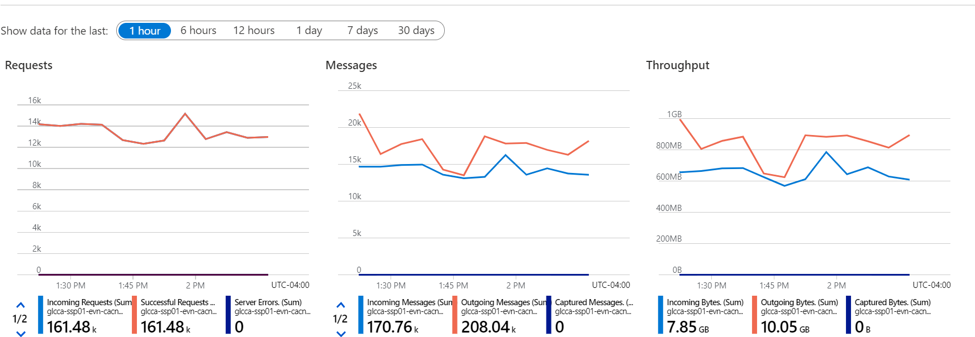

1. splunk-export-eh-prd

This event hub is used to get statistics of requests, messages, throughput to send it to splunk.

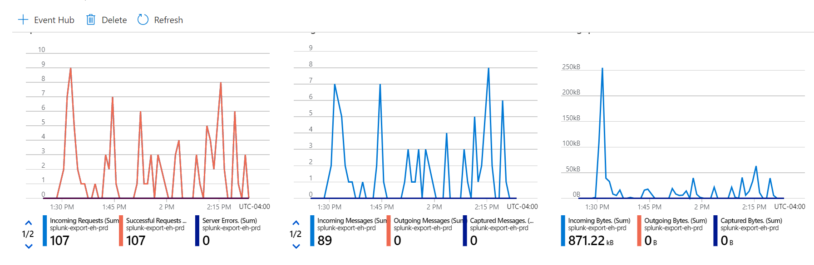

Using Microsoft cloud services addon eventhubs can be configured.

* Security Logs

1. To get security logs from azure used Azure addon for splunk

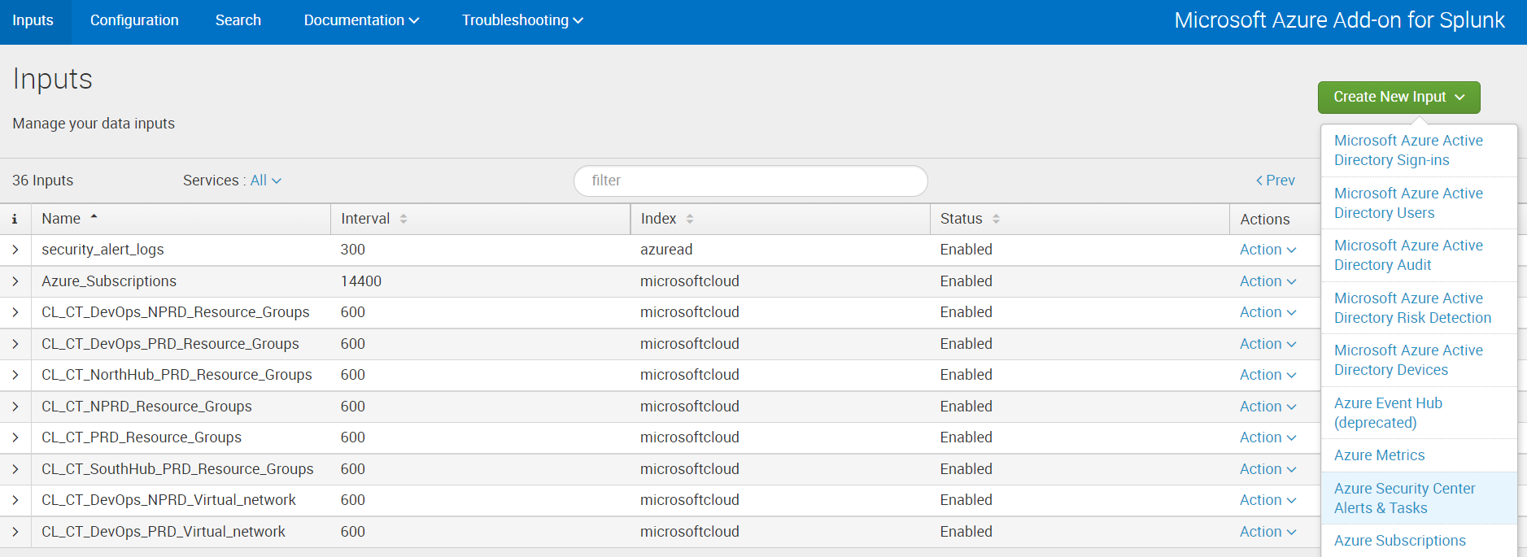

1. Created new input using azure security center Alerts &Tasks

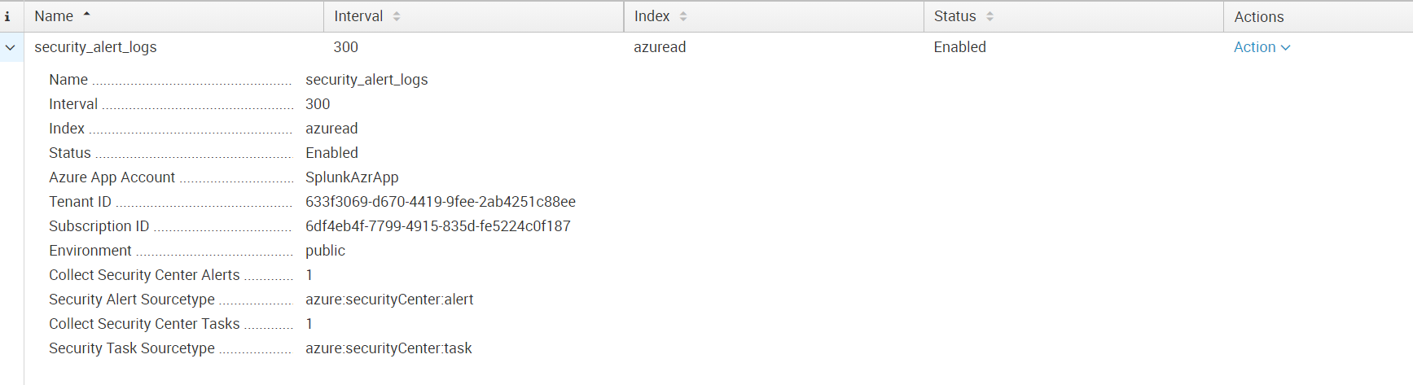

1. This is configured to get azure security center alerts and tasks.

* Resource graph Input

1. To get availability of the VM configured resource graph input.

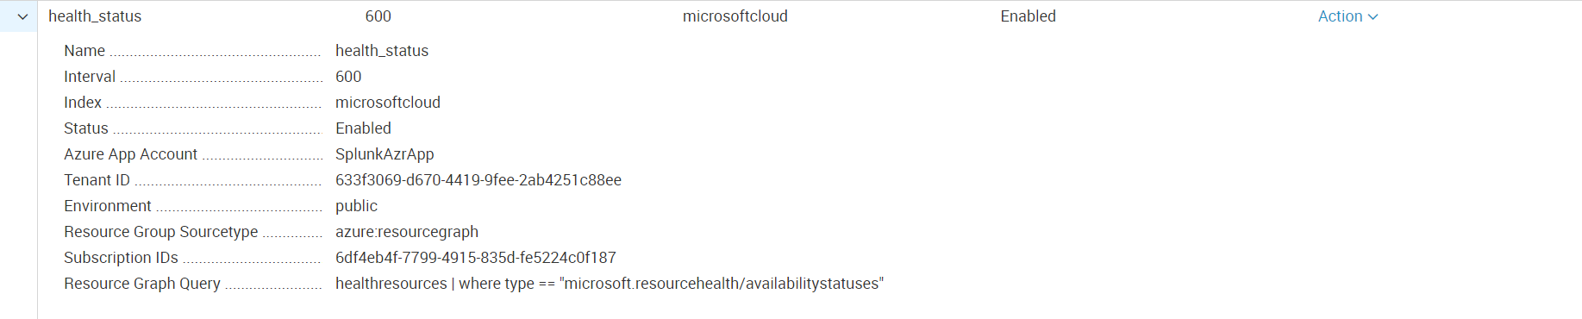

1. To get resourcegraph query as per requirement go to azure resource graph explorer on azure portal.

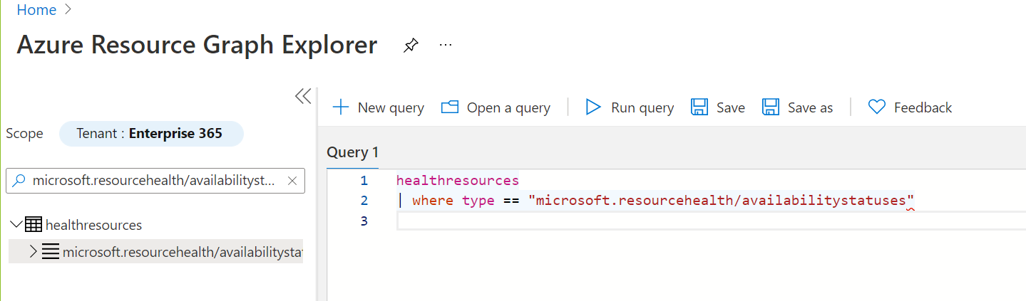

1. Using this query status can be fetched.