#import packages
import numpy as np
import matplotlib.pyplot as plt
import pandas as pd

#create dataset using DataFrame
df=pd.DataFrame({'X':[0.1,0.15,0.08,0.16,0.2,0.25,0.24,0.3],
'y':[0.6,0.71,0.9,0.85,0.3,0.5,0.1,0.2]})
f1 = df['X'].values
f2 = df['y'].values
X = np.array(list(zip(f1, f2)))
print(X)

#centroid points
C_x=np.array([0.1,0.3])
C_y=np.array([0.6,0.2])
centroids=C_x,C_y

#plot the given points
colmap = {1: 'r', 2: 'b'}
plt.scatter(f1, f2, color='k')
plt.show()

#for i in centroids():
plt.scatter(C_x[0],C_y[0], color=colmap[1])
plt.scatter(C_x[1],C_y[1], color=colmap[2])
plt.show()

C = np.array(list((C_x, C_y)), dtype=np.float32)
print (C)

#plot given elements with centroid elements
plt.scatter(f1, f2, c='#050505')
plt.scatter(C_x[0], C_y[0], marker='*', s=200, c='r')
plt.scatter(C_x[1], C_y[1], marker='*', s=200, c='b')
plt.show()

#import KMeans class and create object of it
from sklearn.cluster import KMeans
model=KMeans(n_clusters=2,random_state=0)
model.fit(X)
labels=model.labels_
print(labels)

#using labels find population around centroid
count=0
for i in range(len(labels)):
if (labels[i]==1):
count=count+1

print('No of population around cluster 2:',count-1)

#Find new centroids
new_centroids = model.cluster_centers_

print('Previous value of m1 and m2 is:')
print('M1==',centroids[0])
print('M1==',centroids[1])

print('updated value of m1 and m2 is:')
print('M1==',new_centroids[0])
print('M1==',new_centroids[1])

Output
[[0.1 0.6 ]
[0.15 0.71]
[0.08 0.9 ]
[0.16 0.85]
[0.2 0.3 ]
[0.25 0.5 ]
[0.24 0.1 ]
[0.3 0.2 ]]
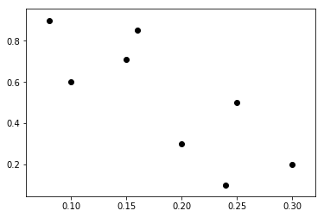
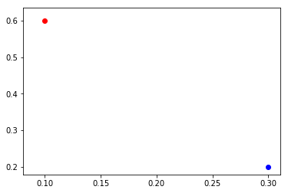

[[0.1 0.3]
[0.6 0.2]]
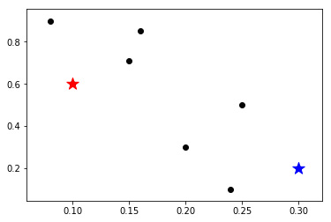

[1 1 1 1 0 0 0 0]
No of population around cluster 2: 3
Previous value of m1 and m2 is:
M1== [0.1 0.3]
M1== [0.6 0.2]
updated value of m1 and m2 is:
M1== [0.2475 0.275 ]
M1== [0.1225 0.765 ]

