**Assignment #2**

**Jascharan singh**

1. Create a directory in the mac232 user home directory called Mac232. In the Mac232 directory, create eight empty files that are named lab1, lab2, lab3, and so on to lab8. Also, come up with a single argument to “**ls” command** that would list just the first four files. Use File Globbing (Wild Card Metacharacter) – 3 commands

----------------------------------------------------------------------

mkdir /home/mac232/Mac232

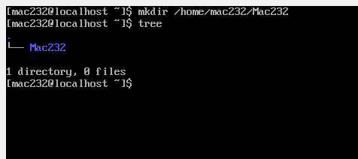

B)

touch /home/mac232/Mac232/lab{1..8}

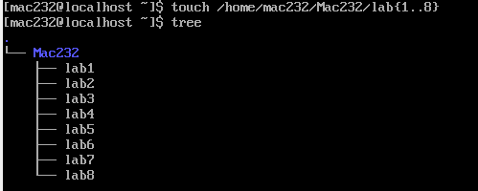

1. Create the following directories:

/root/Mac232/projects/assignments/transcripts

/root/Mac232/projects/labs/

Use one command for each (use the option to create parent directory if it does not exist).

Mkdir /home/mac232/Mac232/projects

Mkdir /home/mac232/Mac232/projects/assignments

Mkdir /home/mac232/Mac232/projects/assignments/transcripts

Mkdir /home/mac232/Mac232/projects/labs

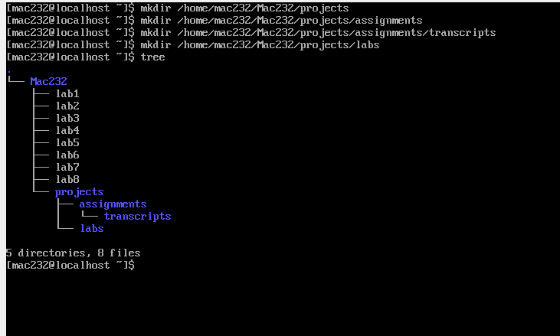

1. Copy the files lab1 to lab6 located in Mac232 directory to the /root/Mac232/projects/labs directory. Use File Globbing (Wild Card Metacharacter)

cp /home/mac232/Mac232/lab{1..6} /home/mac232/Mac232/projects/labs

1. Remove the files lab 1 to lab6 located in Mac232 directory without being prompted. Use File Globbing (Wild Card Metacharacter)

rm /home/mac232/Mac232/lab{1..6}

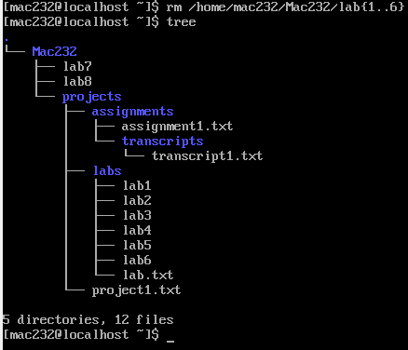

5. Move lab7 and lab8 located in Mac232 directory to the /root/projects/labs directory. Use File Globbing (Wild Card Metacharacter)

mv /home/mac232/Mac232/lab{7,8} /home/mac232/Mac232/projects/labs

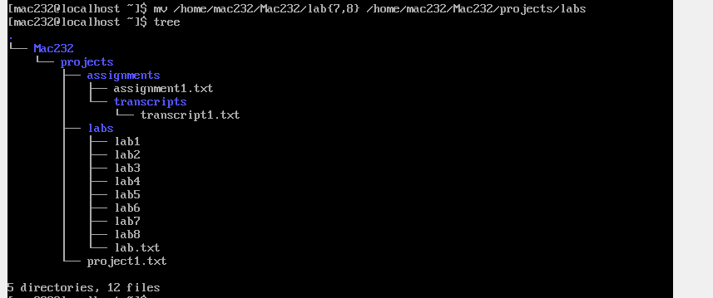

6. Remove the /root/Mac232/projects/assignments directory and its contents without being prompted.

rm -r /home/mac232/Mac232/projects/assignments

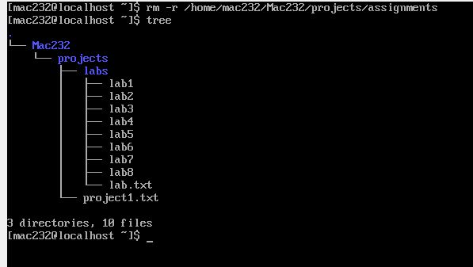

Thankyou