STEP 1
whole_script.jl

First, after running whole_script.jl, you will save 10 jld files: crime_(1,2,3,4,5).jld and crime_(1,2,3,4,5)predict.jld

usage:
For example, for crime type #2
load the data via crime_predict = load("crime_2predict.jld","March_Predictions")
The prediction of next month (28x24) for box number N can be accessed by crime_predict[N][2]

STEP 2
clean_#2_sum

This one clean the data for type 2
output:
a real data matrix 28x24 realdta: in March, the number of crime#2 happened in each box
a predict matrix 28x24 prdct: our prediction about how many crimes will happen in each box in March.

STEP 3
compare_plot.m (matlab)

draw the plot of: crime #2
prediction in each box (sum over a month) (see sum_predic.png)
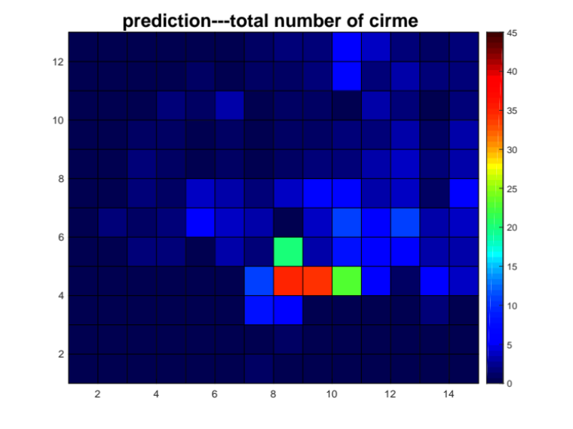
reality in each box (sum over a month) (see sum_reality.png)
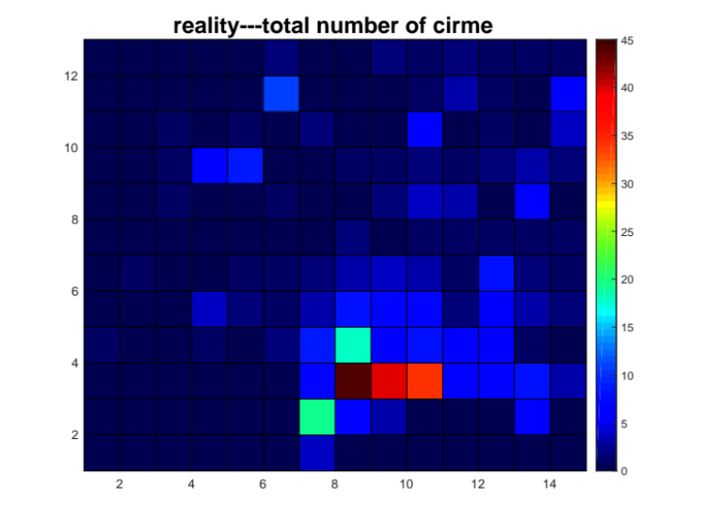
Vancouver crime plot (use all X and Y, that will also give us the outline of vancouver ), red shows the size of one box. (see Vancouver.png)

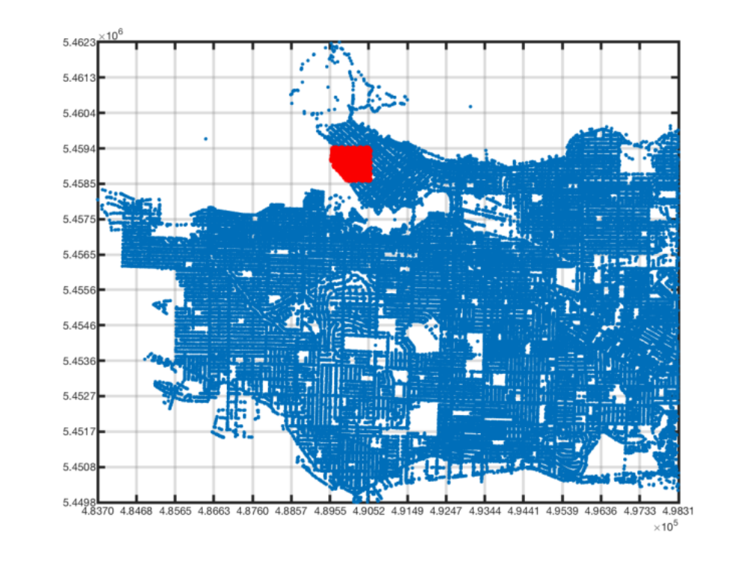

STEP 4
clean_#2_hour

how many crimes happen in midnight 0am in each box (sum over a month)

prediction (hour_predict.png)
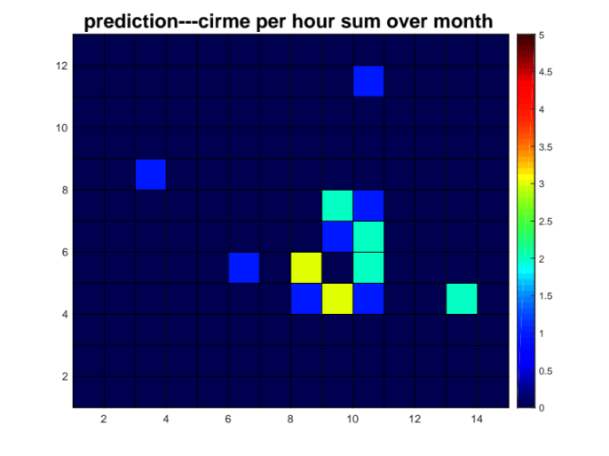

reality (hour_reality.png)
