DATABASE ASSIGNMENT

Problem Statement: There can be multiple customers, who can place multiple orders on the site. Now a sales person can handle these orders will distribute into multiple sales persons (One order will be assign to one salesperson only). So a sales person can have multiple orders of multiple customers

1. Create Database

Ans-- create database <database name>

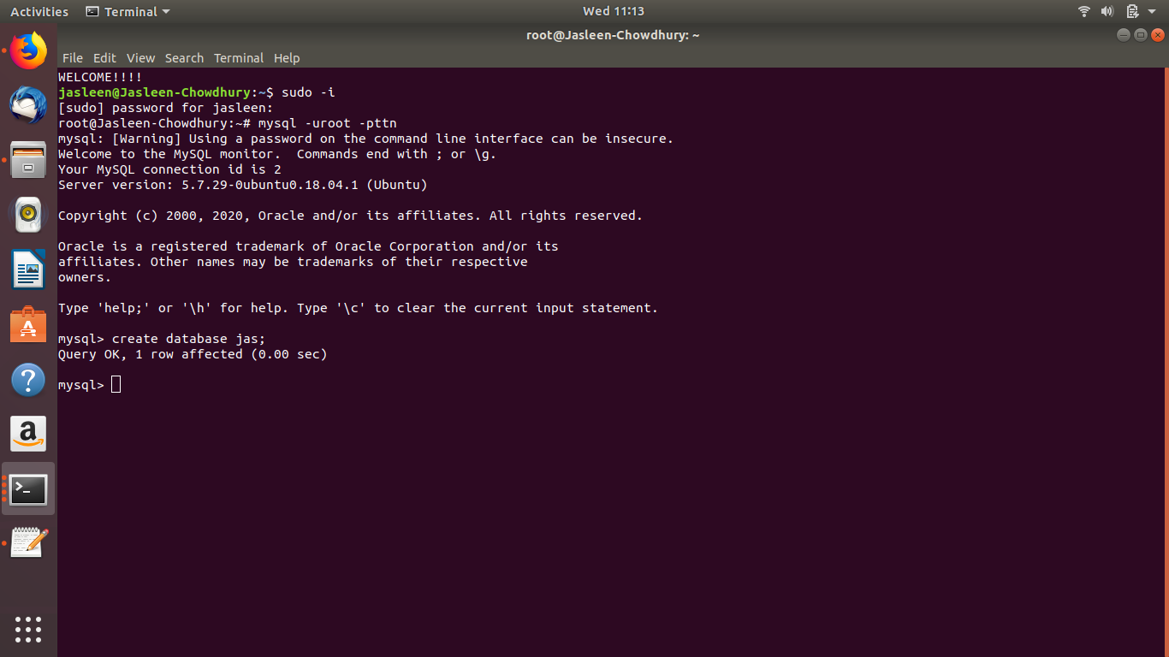

1. Design Schema

Ans-- show tables;

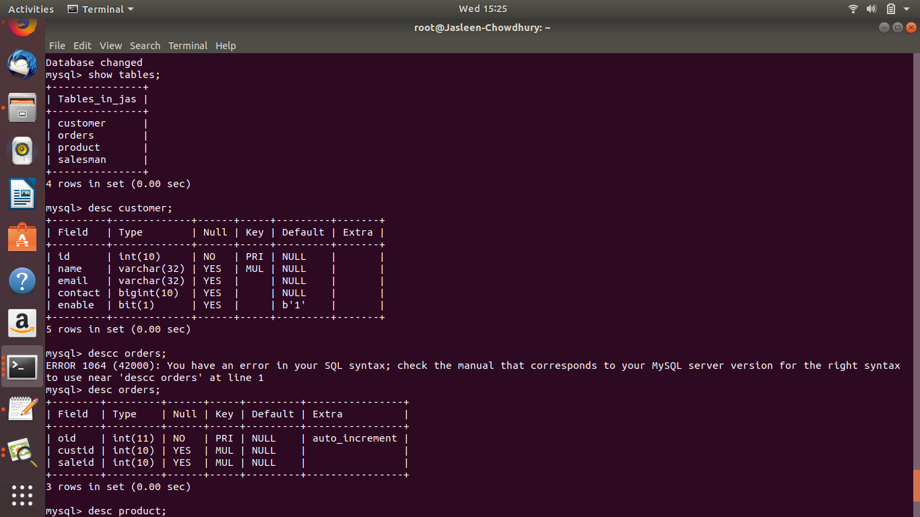

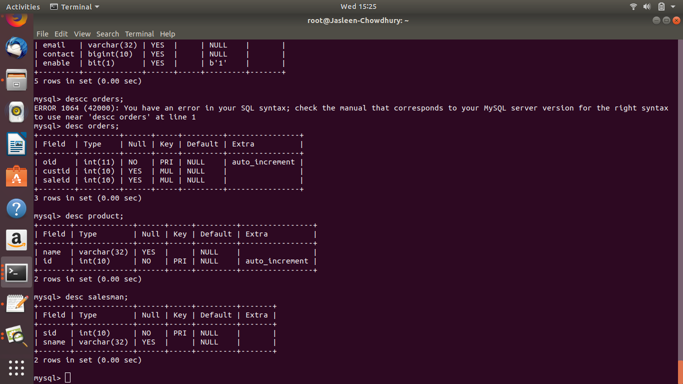

1. Create tables

Ans---mysql> create table customer(id int(10), name varchar(32), email varchar(32), contact int(10));

Query OK, 0 rows affected (0.03 sec)

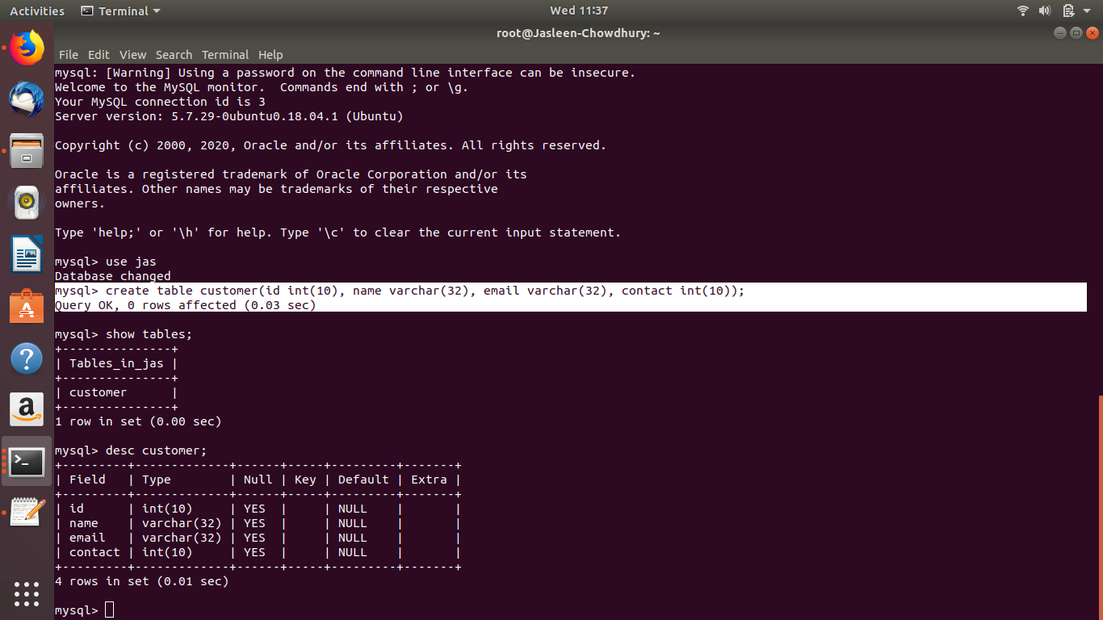

1. Insert sample data

Ans -- mysql> insert into customer values(2343, 'priya', 'priya@gmail.com',9897897,1);

Query OK, 1 row affected (0.01 sec)

mysql> insert into customer values(2353, 'divya',' divya@gmail.com',989789907,1);

Query OK, 1 row affected (0.02 sec)

mysql> select \* from customer;

+------+-------+------------------+-----------+--------+

| id | name | email | contact | enable |

+------+-------+------------------+-----------+--------+

| 2303 | riya | riya@gmail.com | 98977 | |

| 2343 | priya | priya@gmail.com | 9897897 | |

| 2353 | divya | divya@gmail.com | 989789907 | |

+------+-------+------------------+-----------+--------+

3 rows in set (0.00 sec)

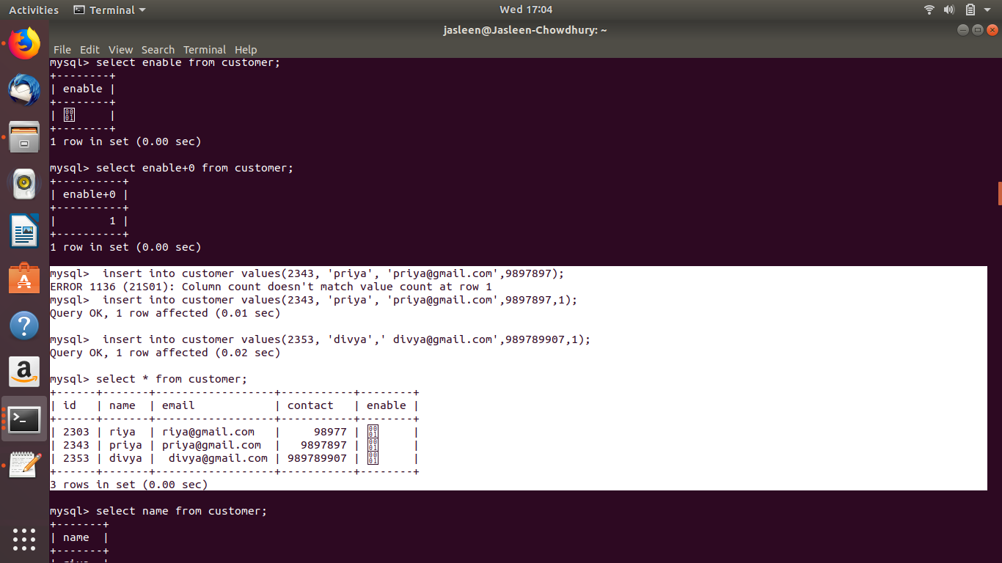

1. Find the sales person have multiple orders.

Ans-- SELECT \* FROM salesman WHERE saleid IN (SELECT DISTINCT saleid FROM customer a WHERE EXISTS (SELECT \* FROM customer b WHERE b.saleid=a.saleid AND b.custname<>a.custname));

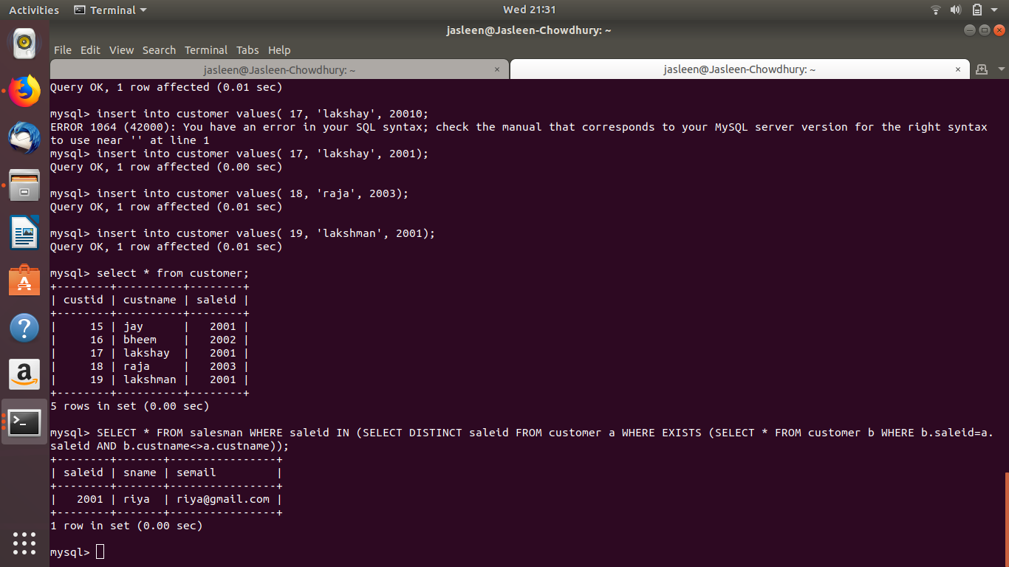

1. Find the all sales person details along with order details

Ans -- select \* from salesman s left join orders o on s.saleid = o.saleid;

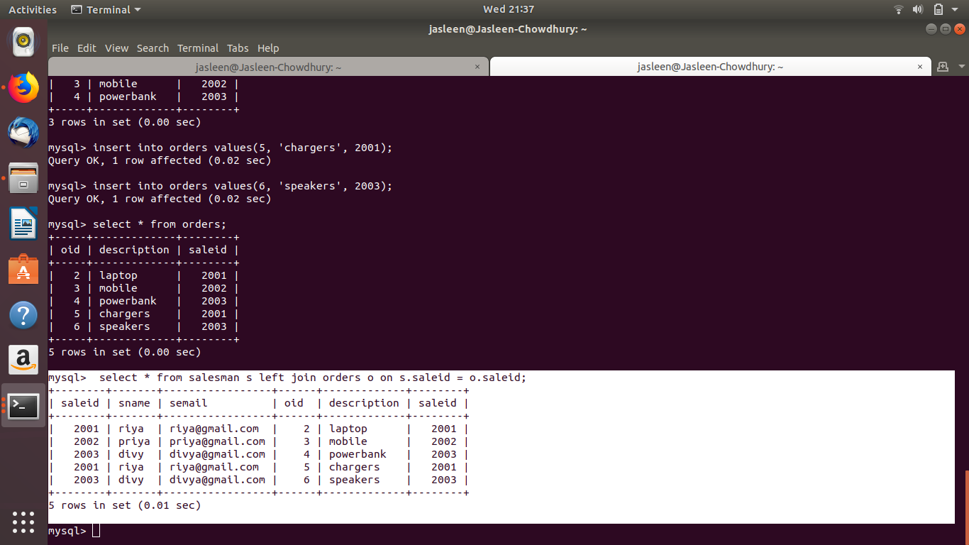

1. Create index

mysql> create index cindex on customer (name);

Query OK, 0 rows affected (0.03 sec)

Records: 0 Duplicates: 0 Warnings: 0

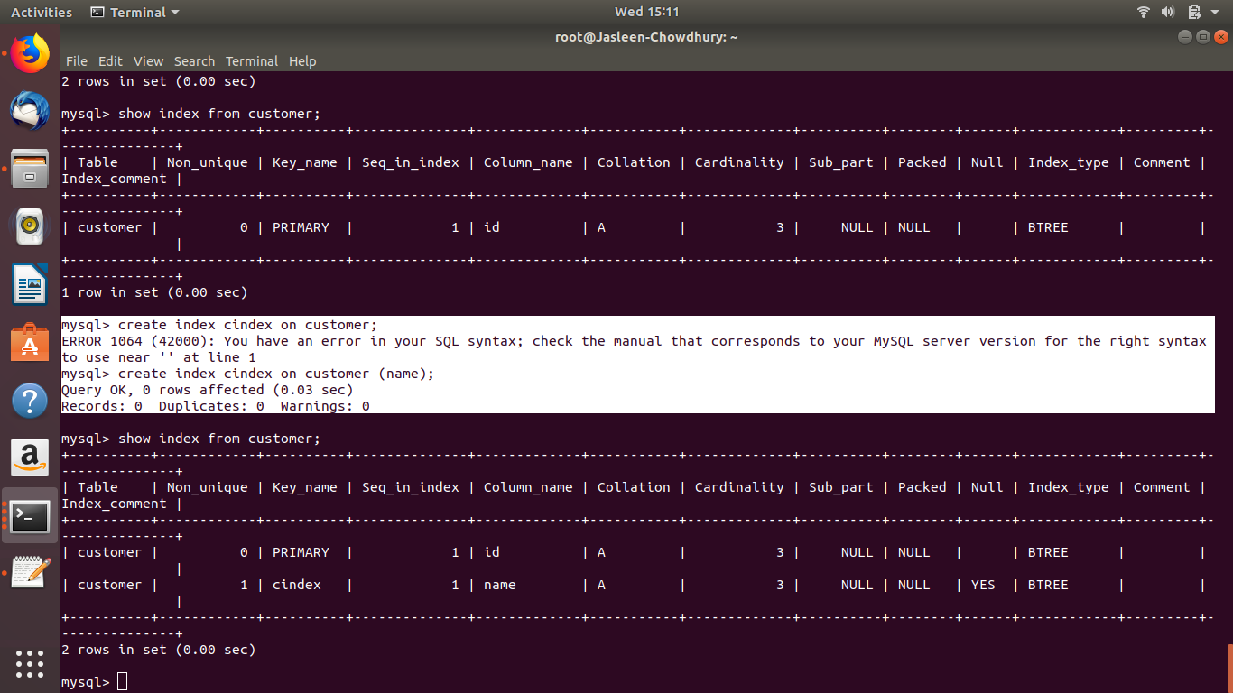

1. How to show index on a table

mysql> show index from customer;

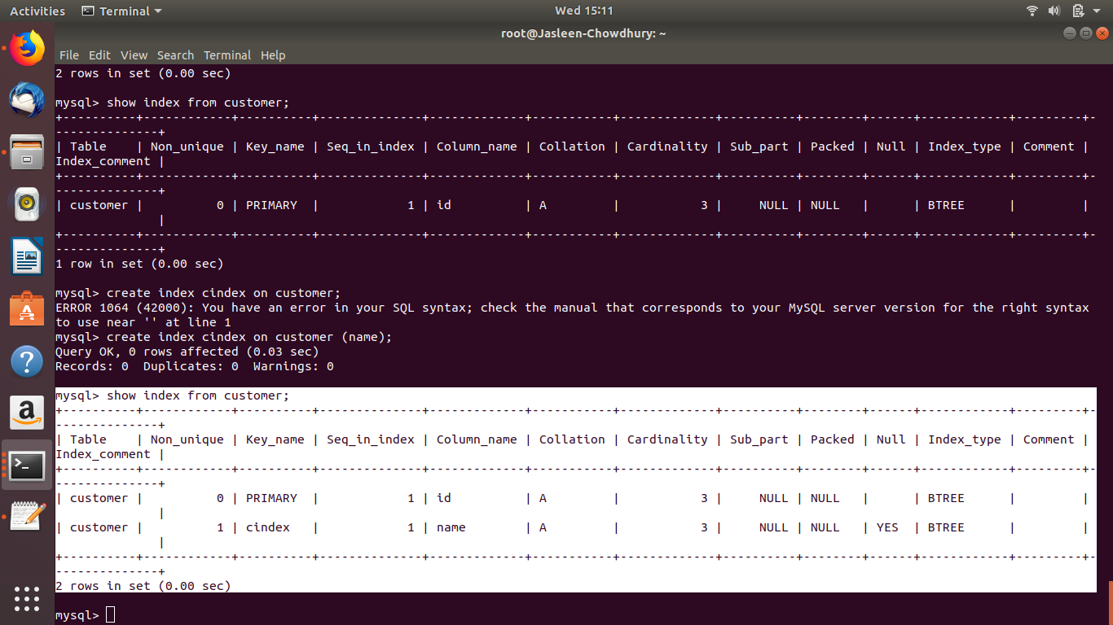

1. Find the order number, sale person name, along with the customer to whom that order belongs to

Ans-- mysql> select oid,sname,custname from orders o inner join salesman s on o.saleid=s.saleid inner join customer c on c.saleid=s.saleid;

