**ME351 Analysis Project  
Influence of Tube Length on Drainage System**

Ahmed Syed (20484061), Jasdeep Dhillon (20468850), Ben Mendis (20456838)

**1.0 Description of Model and Solution Method**

This report analyzes the drainage of a 2L bottle to determine the relationship between the length of the discharge tube and the total drainage time. Figure 1 illustrates the setup of the experiment.

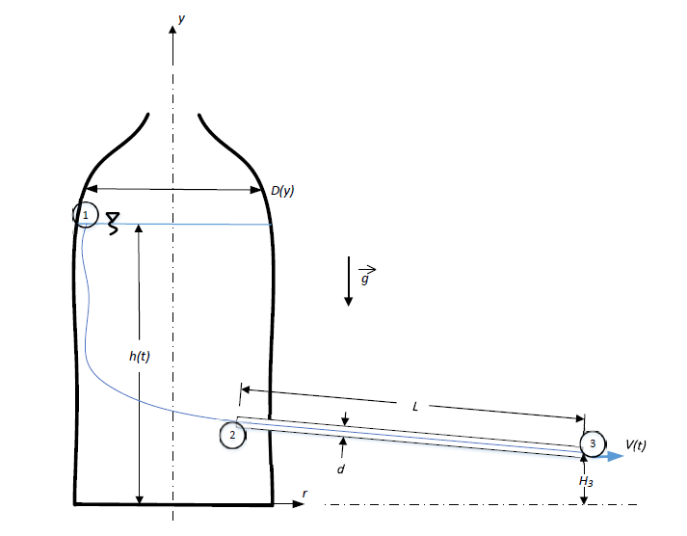

Figure 1: Diagram of the experiment setup.

To model the experiment mathematically, only the constant diameter portion of the bottle was considered. The relation between the change in height with respect to the velocity is then:

$$\frac{dh}{dt}={-\left(\frac{d}{D}\right)}^{2}V(t)$$

In order to determine the mathematical solution, the Bernoulli analysis of the streamline was used to describe the potential energy change of the water:

$g\left(h\left(t\right)-H_{3}\right)=\frac{V^{2}\left(t\right)}{2}\left(\frac{K_{1}}{{Re}_{d}}+ K_{2}\right)+\frac{V^{2}\left(t\right)}{2}\left(\frac{L}{d}\right)\left(f\left({Re}_{d}, \frac{ε}{d}\right)\right)+\frac{V^{2}\left(t\right)}{2}$,

where the first term is the friction on the water entering the tube, the second term is the friction inside the tube, and the last term is the acceleration of the water from rest to its exit speed. The Reynolds Number is also a function of velocity and is given by:

${Re}_{d}=\frac{ρVd}{μ}$

It was initially assumed that the flow is laminar which gives the tube friction factor as:

$$f=\frac{64}{{Re}_{d}}=\frac{64μ}{ρVd}$$

The velocity term was isolated from the first equation and substituted into the potential energy change formula, as well as the Reynold's Number formula. The final equation was then given as:

$$0=\left[\left(K_{2}+1\right){\left(\frac{D}{d}\right)}^{4}\right]{\left(\frac{dh}{dt}\right)}^{2}-\left[\frac{D^{2}}{{ρd}^{4}}\left(K_{1}μd+64μL\right)\right]\left(\frac{dh}{dt}\right)+2g\left(H_{3}-h\right)$$

This equation can be treated as a quadratic equation and solved using the quadratic formula to obtain the rate of change of the height, as shown below. The positive solution to this equation is disregarded, as the height must decrease with time.

$$\frac{dh}{dt}=\frac{\frac{D^{2}}{ρd^{4}}\left(K_{1}μd+64μL\right)±\sqrt{\frac{D^{4}}{ρ^{2}d^{8}}{\left(K_{1}μd+64μL\right)}^{2}-\frac{8gD^{4}}{d^{4}}\left(K_{2}+1\right)\left(H_{3}-h\right)}}{\frac{2D^{4}}{d^{4}}\left(K_{2}+1\right)}$$

The value for $\frac{dh}{dt}$ was then solved using the Runge-Kutta method, and used to find the velocity and the Reynold's number as a function of time. The maximum Reynold's Number calculated using this function was observed to be less than 4000, which confirmed the initial assumption made of the flow being laminar. Therefore, the turbulent case was not required and the entry friction for a turbulent case was not required either.

The table below lists the values used for the simulation that was done in MATLAB.

|  |  |  |  |
| --- | --- | --- | --- |
| **Property** | **Value** | **Property** | **Value** |
| d | 0.004 [m] | h(0) | .015 [m] |
| D | 0.109 [m] | L | 1,5,10.15,20,25 [m] |
| ρ | 998 [kg/m3] (@ T = 20 C Table A.1) | K2 | 1 (re-entrant) |
| µ | 1.003x10-3 [N s/m2] (@T = 20 C Table A.1) | K1 | 164 |
| H3 | 0.044 [m] | g | 9.81 m/s2 |
| ϵ | 1.5x10-6 [m] (plastic, Table 6.1) |  |  |

Table 1: Table of Properties used

**2.0 Analysis**

2.1 Period of Laminar Flow in Drainage Tube

The equation describing the Reynold's number is ${Re}_{d}=-\frac{ρ{\left(\frac{D}{d}\right)}^{2}\frac{dh}{dt}d}{μ}$. By observing the equation, the maximum value of the Reynold's number would occur at the highest magnitude of $\frac{dh}{dt}$ as all the other variables remain constant. This would occur at the start of the experiment, when the water surface is at its highest point as shown in Figure 2.

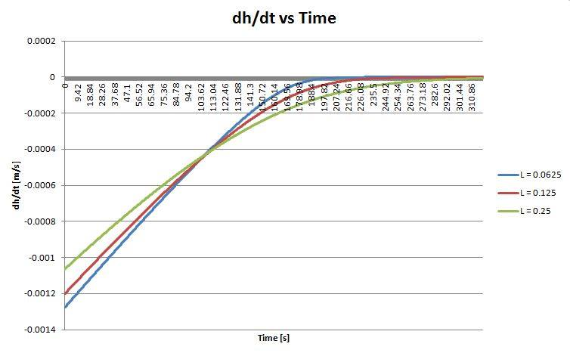

Figure 2: Plot of dh/dt vs Time for Varying Lengths (0.0625, 0.125, 0.25 [m])

As seen in Figure 3, the maximum Reynolds Number, which occurs at t=0, decreases as the tube length increases. It can also be observed that the flow remains laminar during the entire drainage time since the value is always less than 4000.

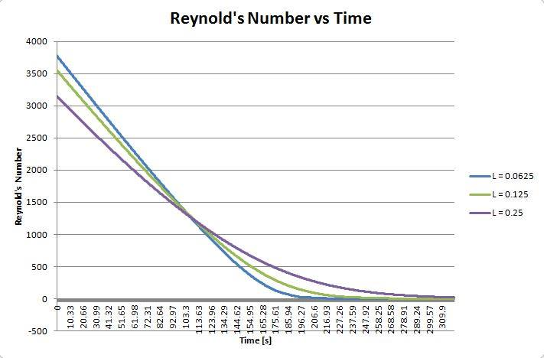

Figure 3: Plot of Reynolds Number vs Time for Varying Lengths (0.0625, 0.125, 0.25 [m])

2.2 Influence of Flow Acceleration on Pressure Changes

In order to determine the influence of flow acceleration on pressure changes, the pressure gradient in the x direction has to be found. The formula for the pressure gradient can be found by taking the pressure difference at the entry of tube, P2= Patm+ ρ g(h(t) – H3), and the exit of the tube, P3=Patm, over the length of the tube,L .

$$\frac{∂P}{∂x}=\frac{ρg\left[H_{3}-h(t)\right]}{L}$$

The entry friction and tube friction can be taken as zero so that a relationship can be observed between the pressure gradient and the acceleration. The acceleration component from Bernoulli potential energy equation is given as V2(t)/2. Multiplying both sides of the equation by $ρ/L$ gives the relation below.

$$-\frac{ρa}{L}= -\frac{ρV^{2}(t)}{2L}$$

Now that these two relationships have been found, using the numerical solutions of h(t) and V(t), the flow accelerations and pressure changes during the duration of drainage can be obtained.

The contribution of the flow acceleration to the pressure gradient value can be found by comparing the two extreme points on Figure 4 and 5, for the respective tube length. So it can be seen that for a length of .0625[m], the flow acceleration contributes to 41.2% of the pressure gradient, 38.3% for a length of .125 [m] and 27.5% for .25 [m]. So as the length of the tube increases, the flow acceleration starts to decrease in the contribution to the pressure gradient.

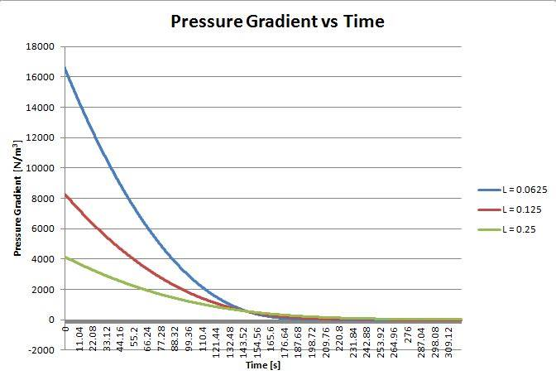

Figure 4: Plot of Pressure Gradient vs Time for Varying Lengths (0.0625, 0.125, 0.25 [m])

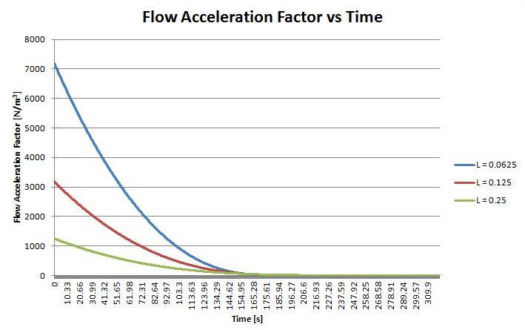

Figure 5: Plot of Flow Acceleration vs Time for Varying Lengths (0.0625, 0.125, 0.25 [m])

Finally, the extent to which the flow acceleration influences the pressure change must be found. This can be done by comparing the discharge times for when the flow acceleration is considered and when it is neglected. For the case when flow acceleration is neglected, the equation for h(t) has to be re-derived and solved for, using MATLAB.

|  |  |  |  |
| --- | --- | --- | --- |
| **Length [m]** | **Drainage Time [s] with Flow Acceleration** | **Drainage Time [s] without Flow Acceleration** | **Error**  **[%]** |
| 0.010 | 163.05 | 118.25 | 27.48 |
| 0.04 | 207.03 | 159.41 | 23.00 |
| 0.07 | 212.38 | 174.12 | 18.02 |
| 0.10 | 240.37 | 199.98 | 16.80 |
| 0.13 | 266.54 | 228.45 | 14.29 |
| 0.16 | 295.76 | 259.37 | 12.30 |
| 0.19 | 326.13 | 290.29 | 10.99 |
| 0.22 | 356.36 | 321.69 | 9.73 |
| 0.250 | 386.83 | 353.40 | 8 |

Table 2: Effect of Flow Acceleration on Drainage time at Various Lengths

From Table 2, it can be seen that the error decreases as the length increases. The longer the tube, the lower the error in the drainage time by neglecting the flow acceleration. So at a length of .25 [m] the flow acceleration can be neglected due to the small error and will have a negligible influence on the pressure change.

2.3 The Effect of Entry Friction on Pressure Change

The relations from the previous section can be used to compare the entry friction and the pressure gradient. The pressure gradient graph has already been plotted in the previous section and can be reused. The graph for pressure gradient can be seen in Figure 4 in section 2.2.

An expression of the entry friction with respect to time can be found using the Bernoulli equation provided in the given flow model. Only the entry friction component is considered and is multiplied by $ρ/L$ on both sides of the equation. This yields: $$F_{entry}=\frac{ρV^{2}\left(t\right)}{2L}\left(\frac{K_{1}}{{Re}_{d}}+K_{2}\right)$$

The relationship of the pressure change and entry friction can be used with the numerical solutions of h(t) and V(t) to obtain a plot of entry friction versus time. Figure 6 shows the entry friction versus time.

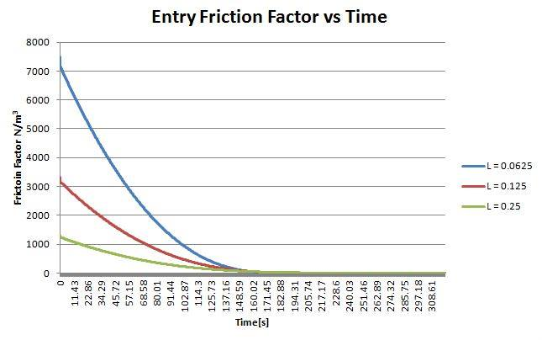

Figure 6: Plot of Entry Friction Factor vs Time for Varying Lengths (0.0625, 0.125, 0.25 [m])

It can be seen that entry friction factor contributes to 43.8% to the pressure gradient for a length of .0625[m], 37.5% for a length of .125 [m] and 25% for .25 [m]. As the length of the tube increases, the influence of the entry friction on the pressure gradient decreases.

Finally, the extent to which the flow acceleration influences the pressure change must be found. This can be done by comparing the drainage times for when the flow acceleration is considered and when it is neglected. For the case when flow acceleration is neglected, the equation for h(t) has to be re-derived and solved for, using MATLAB.

|  |  |  |  |
| --- | --- | --- | --- |
| **Length, L [m]** | **Drainage Time [s] with Entry Friction Taken into Account** | **Drainage Time [s] with Entry Friction Not Taken into Account** | **Error** |
| 0.010 | 163.05 | 116.70 | 28.43 |
| 0.04 | 207.03 | 138.22 | 33.24 |
| 0.07 | 212.38 | 162.40 | 23.53 |
| 0.1 | 240.37 | 190.58 | 20.71 |
| 0.13 | 266.54 | 218.76 | 17.93 |
| 0.16 | 295.76 | 249.30 | 15.71 |
| 0.19 | 326.13 | 279.84 | 14.19 |
| 0.22 | 356.36 | 310.95 | 12.74 |
| 0.250 | 386.83 | 342.44 | 11.48 |

Table 3: Effect of Entry Friction on Drainage time at Various Lengths

From Table 3, it can be seen that the error decreases as the length increases. So longer the tube, lower the error in the drainage time by neglecting the entry friction. So at a length of .25 [m] the entry friction can be neglected due to the small error and will have a negligible influence on the pressure change.

2.4 Relationship between Drainage Time and Tube Length

The drainage time is when h(t) reaches the height of the straw (H3). In order to determine the relation between drainage time and tube length, the drainage time needs to be found for various tube lengths. This can be done by using the numerical solution of h(t), to find the time when h(t) = H3.

|  |  |
| --- | --- |
| **Length [m]** | **Simulated Drainage Time [s]** |
| 0.010 | 163.05 |
| 0.040 | 207.03 |
| 0.070 | 212.38 |
| 0.100 | 240.37 |
| 0.130 | 266.54 |
| 0.160 | 295.76 |
| 0.190 | 326.13 |
| 0.220 | 356.36 |
| 0.250 | 386.83 |

Table 4: Effect of Length on Simulated Drainage Time

Figure 7: Plot of Simulated Drainage Time vs Varying Lengths

Table 4 and the graph in Figure 7 present the effect of tube length on the drainage time. It can be concluded that the drainage time increases linearly as the tube length is increased. The drainage time and tube length have a linear relationship.

**3.0 Experiment**

3.1 Description of Setup and Method

In addition to the numerical solution, an experiment was conducted that models the fluid flow. The setup consists of a 2 litre pop bottle filled with water and a straw with a diameter of 0.007[m]. The hole was made by puncturing the bottle using a knife at approximately 0.044[m] from the base of the bottle. A straw was then inserted 1cm into the bottle so that the setup was re-entrant. This 1 cm is included for the total length of the tube. The straw was secured to the bottle by using duct tape on the outside of the bottle. The bond was further sealed by applying super glue in order to prevent leaks.

The length of the straw was varied in 4 cm decrements from a range of 0.24[m] to 0.04[m]. The bottle was filled to a height of 0.15[m] above the position of the hole and then drained and timed. The drainage time was recorded when the water level reached the position of the hole and the flow stopped.

3.2 Summary of Results

|  |  |
| --- | --- |
| **Length [m]** | **Drainage Time [s]** |
| 0.04 | 48.39 |
| 0.08 | 48.21 |
| 0.12 | 49.84 |
| 0.16 | 52.47 |
| 0.2 | 53.67 |
| 0.24 | 54.21 |

Table 5: Effect of Length on Drainage Time

Figure 8: Plot of Drainage Time vs Length (Experimental)

By comparing the graph in Figure 8 with the graph in Figure 7, it can be seen that the simulated and experiment results vary compared to each other, and this is due to errors during the setup and real world factors the model may have ignored.

One source of error is the parallax error when filling the bottle to the maximum height of 0.15[m] leading to inaccuracies in measurements. The bottle had leaks due to the imperfect bond between the straw and the bottle.

Another error is due to human’s reaction time error with the stopwatch during measurements, since the person might be delayed or press the stopwatch prematurely leading to inaccurate times.

The drainage time at the length 0.04 [m] is observed to be anomalous point since it doesn’t fit the trend. This error can be due to several factors, such as the errors discussed above. A reasonable explanation for the error could be the change in angle of the tube. The difference in the weight of the water in the varying tube lengths contributes to the change of angle, therefore the shorter the tube, the more horizontal the tube is.

Figure 9 below shows the group members (Jasdeep, Ben and Ahmed) with the experimental setup used.

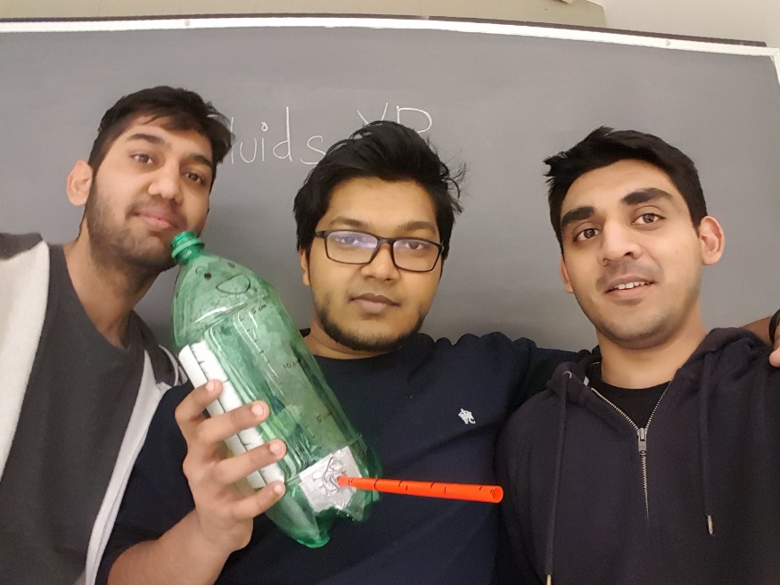

Figure 9: Selfie of the group with the experiment.