Joseph Smith

Module 1.2 Assignment

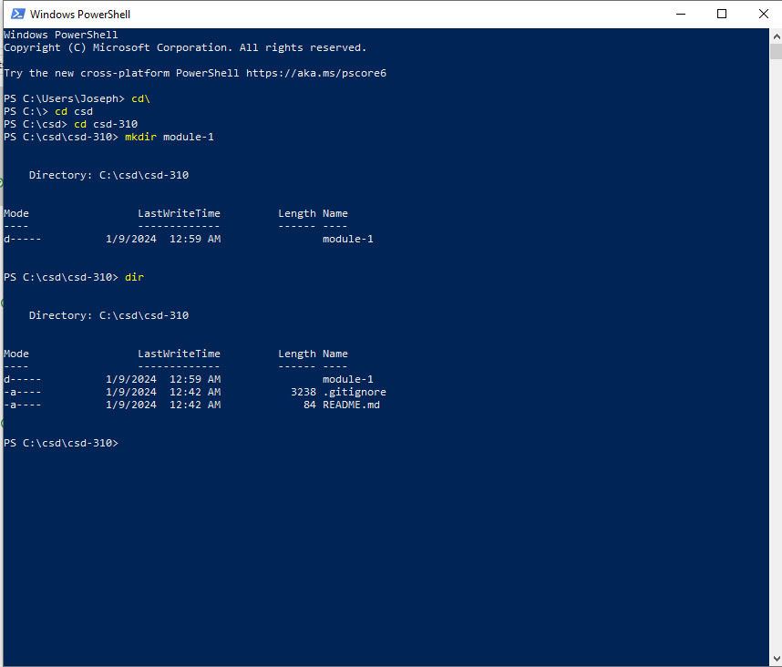

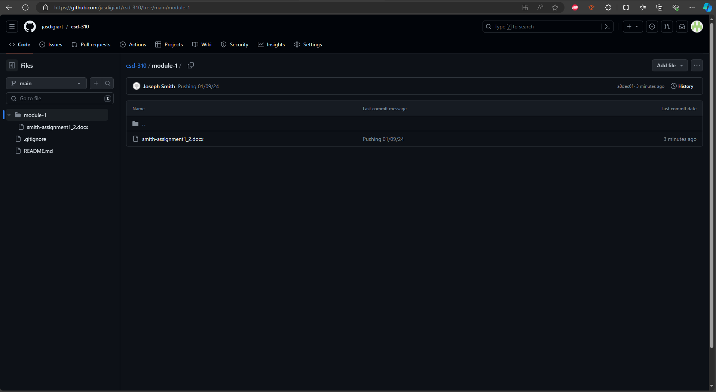

https://github.com/jasdigiart/csd-310.git