Assignment 4
Due Date: Tuesday, March 1st, by midnight (for both in-class and online students)
Total number of points: 40 points
Problem 1 (20 points):
Download the letter recognition data from: http://archive.ics.uci.edu/ml/datasets/Letter+Recognition
The objective is to identify each of a large number of black-and-white rectangular pixel displays as one of the 26 capital letters in the English alphabet. The character images were based on 20 different fonts and each letter within these 20 fonts was randomly distorted to produce a file of 20,000 unique stimuli. Each stimulus was converted into 16 primitive numerical attributes (statistical moments and edge counts) which were then scaled to fit into a range of integer values from 0 through 15. Below is the attribute information, but more information on the data and how it was used for data mining research can be found in the paper:
P. W. Frey and D. J. Slate. "Letter Recognition Using Holland-style Adaptive Classifiers". (Machine Learning Vol 6 #2 March 91)
Create a classification model for letter recognition using decision trees as a classification method with a holdout partitioning technique for splitting the data into training versus testing.
  - Changing the values for the depth, number of cases per parent and number of cases per leaf produces different tree configurations with different accuracies for training and testing. Choose at least five different configurations and report the accuracy for training and testing for each one of them. Which configuration will you choose as the best model? Explain your answer. I was able to try 7 configurations for value changes for depth, parent, and child/leaf cases. The best model I was able to create was a depth of 20, parent minimum cases of 6, and a child/leaf minimum cases of 2. This appears to be the best configuration as the overall training and test percentage correct values were the highest compared to the other groups and minimizing the risk value for training and test. I also tried to go higher and lower with values to ensure I was not over or under fitting the values. The overall accuracy for the best model was ~0.94 for training and ~0.855 for testing.
trial | DEPTH | PARENT | CHILD/LEAF | TRAINING OVERALL PERCENTAGE CORRECT | TESTING OVERALL PERCENTAGE CORRECT
1 | 20 | 10 | 5 | 87.6 | 81.9
2 | 20 | 11 | 6 | 86.5 | 81.5
3 | 20 | 8 | 4 | 89.5 | 83.4
4 | 26 | 8 | 4 | 89.6 | 82.0
5 | 20 | 7 | 3 | 91.5 | 84.4
6 | 20 | 6 | 2 | 94.0 | 85.5
7 | 20 | 5 | 2 | 92.0 | 83.2
Table 1: SUMMARY OF CLASSIFICATION DECISON TREE (HOLDOUT PARTIONING)
  - For the best tree configuration, report the misclassification matrix and interpret it. In your opinion, is accuracy a good way to interpret the performance of the model? If not, suggest other measures. Below is the misclassification matrix for the best tree configuration. The model performed very well and has very high percentages for training and testing data sets. The matrix also shows that there was a good and fair distributions mixture of the difference classes within each of the datasets for training and testing. Accuracy could have its drawback if the amount of classes to classify are small and with there being a majority of 1-class in that example. However for this model (as described in the letter-recognition.names file from the http://archive.ics.uci.edu/ml/datasets/Letter+Recognition ) the classes of each letter are distributed well for us to determine that accuracy for this dataset and model would be good to use for model evaluation (ie ~66% of Class A in train and ~33% of Class A in test).
The research from this dataset says: “The best accuracy obtained was a little over 80%.” With their method. Other methods for evaluating model performance are: precision, recall, and F-measure calculations which all make use out of the notion of True Positive, False Negative, False Positive, True Negative classification when the models are run.
Class Distribution:
789 A 766 B 736 C 805 D 768 E 775 F 773 G
734 H 755 I 747 J 739 K 761 L 792 M 783 N
753 O 803 P 783 Q 758 R 748 S 796 T 813 U
764 V 752 W 787 X 786 Y 734 Z

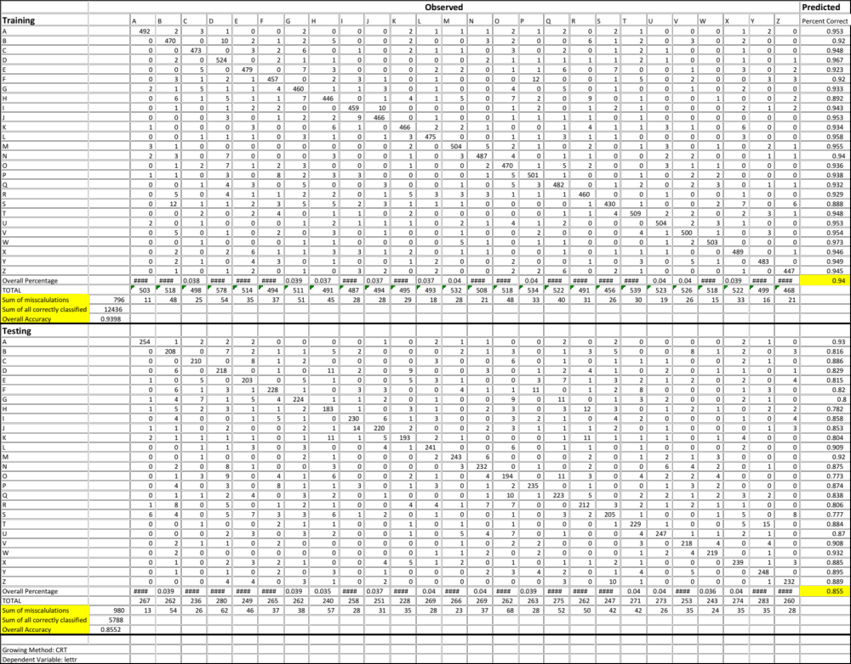
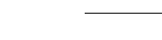

Table 2: Misclassification Matrix of the best model configuration
Table 3: classification table / misclassification matrix of the best model

  - What are the most important three attributes for recognizing the letters? The most important three attributes for recognizing letters is: xege, xybar, xegvy as seen in the model summary results – table for independent variable importance table being listed as the first three independent variables below.
Independent Variable Importance
Independent Variable | Importance | Normalized Importance
xege | 0.319 | 100.00%
xybar | 0.317 | 99.50%
xegvy | 0.299 | 93.80%
xy2br | 0.29 | 90.90%
yege | 0.288 | 90.30%
x2ybr | 0.288 | 90.20%
x2bar | 0.28 | 87.70%
y2bar | 0.276 | 86.50%
yegvx | 0.246 | 77.10%
xbar | 0.245 | 76.70%
ybar | 0.235 | 73.80%
xbox | 0.133 | 41.60%
ybox | 0.13 | 40.80%
onpix | 0.13 | 40.80%
width | 0.121 | 38.10%
height | 0.099 | 31.10%
Growing Method: CRT
Dependent Variable: lettr

Problem 2 (20points):
On the same data from Problem 1, apply a K-nearest neighbor classifier to classify the data. Report the following:
- If you are doing any data transformation, explain the transformation and why it is needed.
I did not do any data transformation because the data has already been transformed as stated in the relevant information section of the names.file description: “Each stimulus was converted into 16 primitive numerical attributes (statistical moments and edge counts) which were then scaled to fit into a range of integer values from 0 through 15.” It is often good to determine before running a K-nearest neighbor classification if the independent variables need to be scaled to prevent distance measures from being dominated by one of the other attributes.
- Report the misclassification matrix and the appropriate performance metrics for different values of K (K=1, 3, 5, and 7).
Crosstabs was performed between predicted in the columns and observed/actual on the rows for each K-value computed in SPSS. The performance metric for accuracy was calculated by hand in excel, highlighted in yellow on each table.
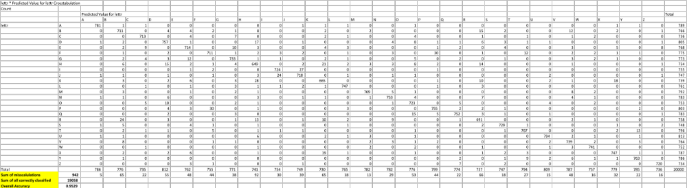
Table 4: K=1

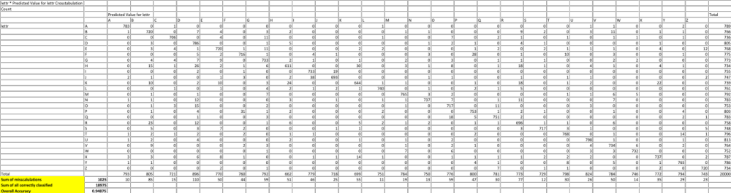
Table 5: K=3

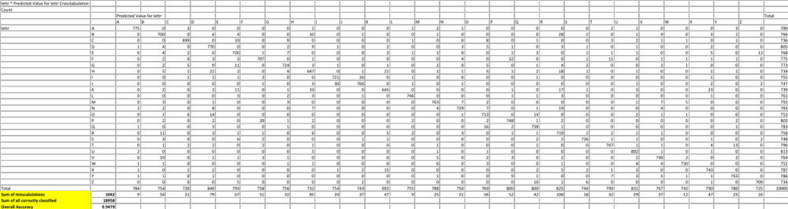

Table 6: K=5
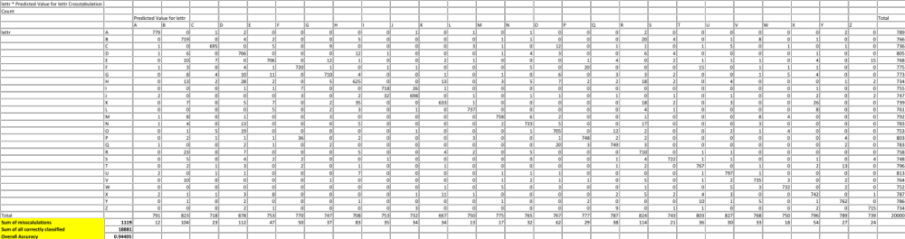

Table 7: K=7
- Interpret the results and also compare them with the ones obtained by using the decision trees. Compared with the decision trees results, for the values for the k-nearest neighbor algorithm have a higher accuracy result for every k-value that was tested. This could be an artifact of precisely choosing the correct k-value (too small = susceptible to too many noise points, too big = neighborhood may include points from other cases). I think k=1 is too small and k=3 would be the right balance to the most predictive model as you can see with the decreasing accuracy value.
In general, compared to original researchers (P. W. Frey and D. J. Slate) the use of either decision trees or k-nearest neighbor resulted in higher accuracy.
K value | Overall Accuracy
1 | 0.9529
3 | 0.94875
5 | 0.9479
7 | 0.94405
Submission Instructions
- Solve the problems and write your answers in a Word document.
- Submit your file online at the website at http://d2l.depaul.edu in the Submission page
- Keep a copy of all your submissions!
- If you have questions about the homework, email me BEFORE the deadline.

