Due Date: Friday, March 11th, by midnight , Total number of points: 50 points
Problem 1 (25 points):
Download the seeds dataset from http://archive.ics.uci.edu/ml/datasets/seeds#
- (15 points) Perform k-means clustering using all the attributes with the except of the class label, vary the number of clusters from 3 to 4 to 5 to 6 and report:
  - How the cluster centers were calculated: The clusters were calculated using the squared Euclidean distance from the center of each cluster.
  - What similarity measure was used: high intra-class similarity and low inter-class similarity.
  - For each k, report the following:
    - Final cluster centers
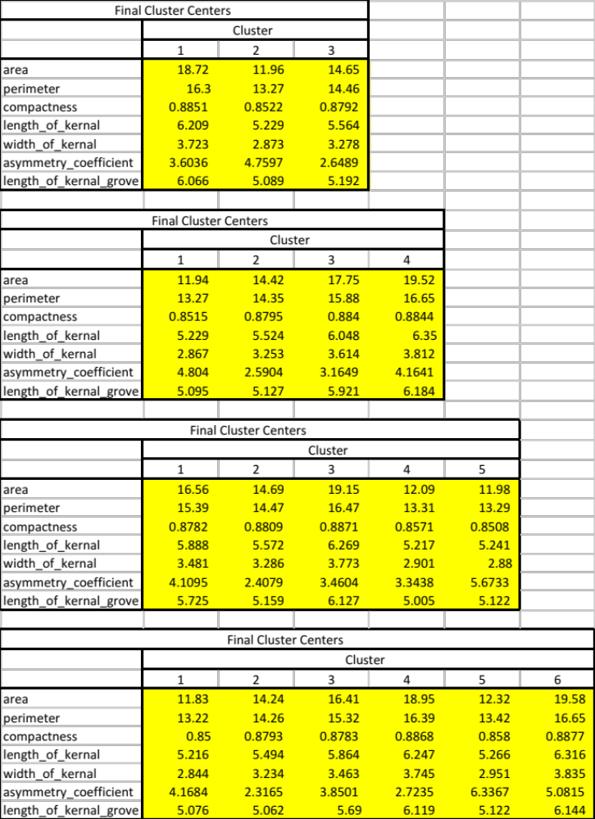

    - Number of elements in each cluster

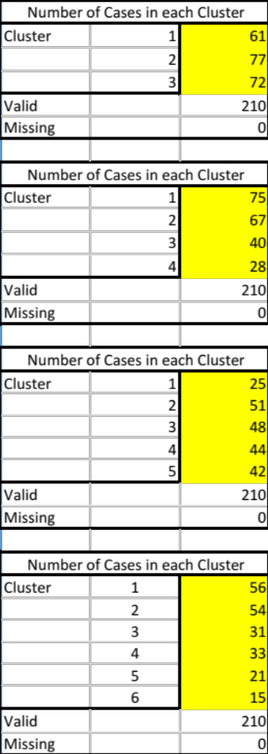

    - The class distribution within each cluster

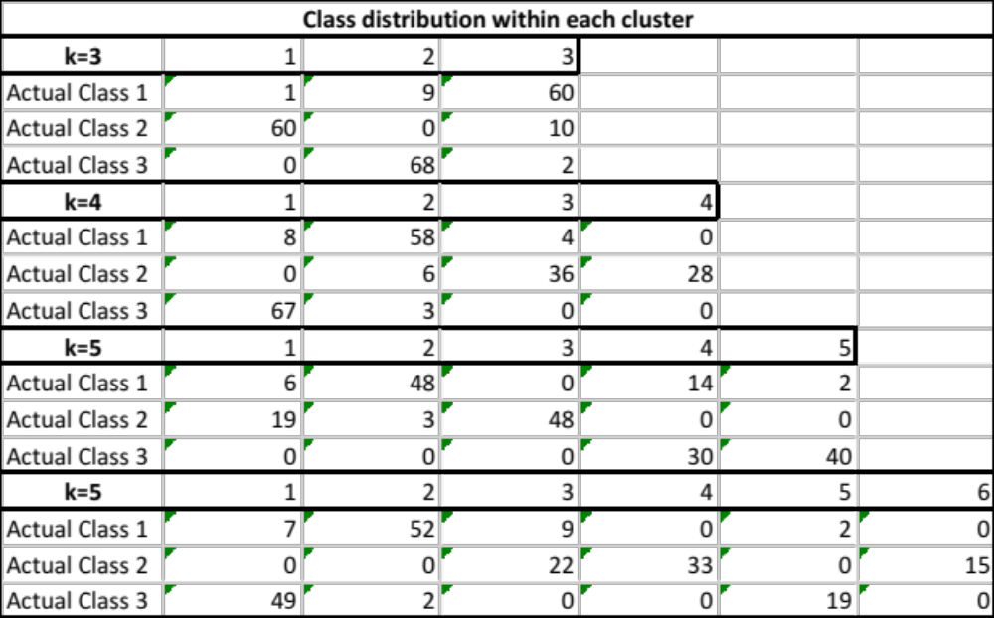

    - In your opinion, which k should be selected? Explain your selection. In my opinion I’m looking for the k number which has the purest within-class distribution from the above cross tabulation matrix. I believe that k=3 should be selected.

    - For the selected k in iv, analyze and report if the normalization of the attributes will influence the clustering results. The normalization of the attributes will influence the clustering result because of the range in values for the variables (Area versus Compactness). The final cluster centers (described above) show the value ranges.

- (10 points) Perform hierarchical clustering using all attributes except the class label as follows:
    - Apply single linkage algorithm and report (Nearest Neighbor)
      - The dendogram
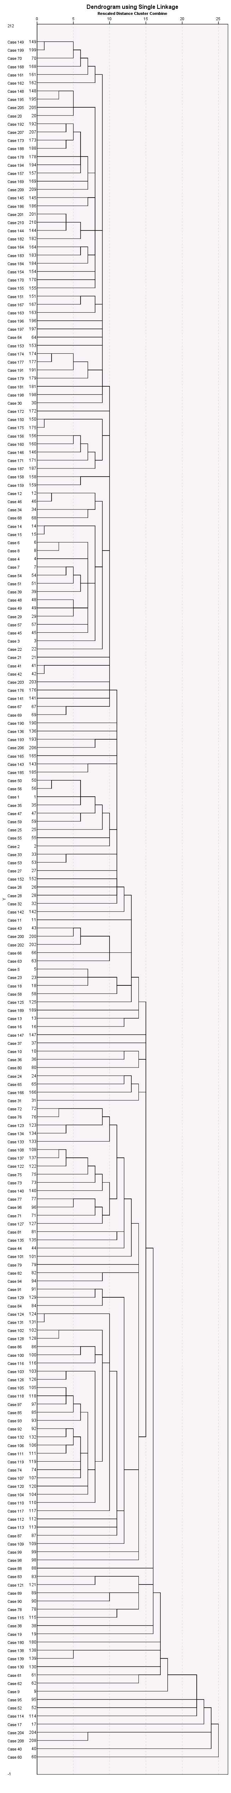

      - The class distribution at the level of the dendogram where there are only three clusters.

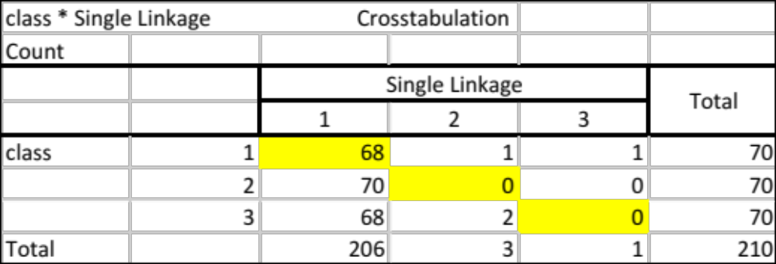

    - Apply complete linkage and report (Farthest Neighbor)
      - The dendogram

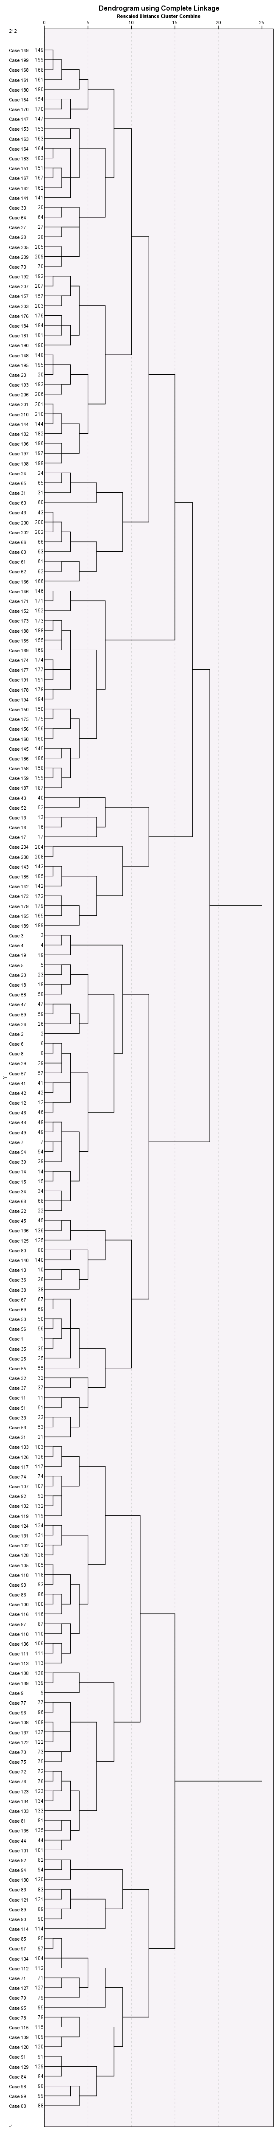

      - The class distribution at level of the dendogram where there are only three clusters.

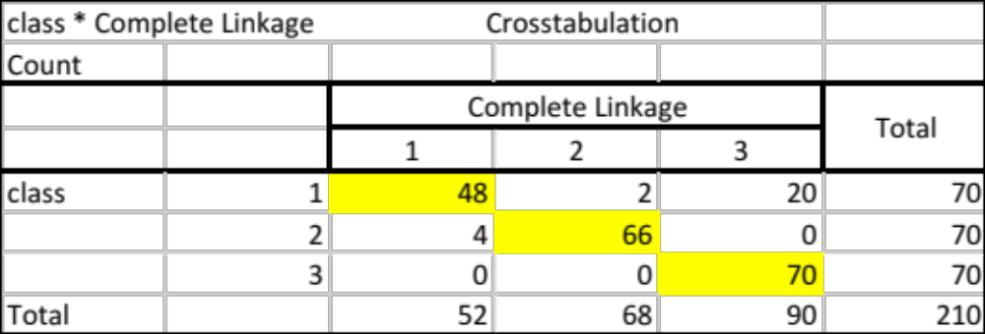

- (2.5 points) Compare the results with hierarchical clustering and k-means algorithm. The k-means clustering method produced more within-class similarity as shown by comparing the two class distribution tables above and therefore the best method to utilize would be the k=3 means method.
- (2.5 points) Create an executive summary (~half a page) that outlines the problem, summarizes the data, describes the methodology, summarizes the results, and makes recommendations. When creating it, imagine that you will give this summary to someone who is not an expert in data mining.

Problem Statement: This is a clustering analysis problem to determine and assign a label to the seeds dataset which will indicate its wheat group based on 7 continuous values.

Summary of Data: The seeds data set comes from the UCI Machine Learning Repository. The research examined a group comprised kernels belonging to three different varieties of wheat: Kama, Rosa and Canadian, 70 elements each, randomly selected for the experiment. Measurements of geometrical properties of kernels belonging to three different varieties of wheat. A soft X-ray technique and GRAINS package were used to construct all seven, real-valued attributes.
Attribute information:
To construct the data, seven geometric parameters of wheat kernels were measured:
1. area A,
2. perimeter P,
3. compactness C = 4*pi*A/P^2,
4. length of kernel,
5. width of kernel,
6. asymmetry coefficient
7. length of kernel groove.
All of these parameters were real-valued continuous.
The last attribute in the data file represents the class label.

Methods:
- Download the data from http://archive.ics.uci.edu/ml/datasets/seeds#
- Clean up data in excel, that has been shifted and add corresponding column headers (not necessary but it will make it easier)
- Open up IBM SPSS 23 and load the dataset and ensure everything transferred nicely
- For k-means clustering:
  - Analyze > Classify > k-means
  - Select all of the independent variables (except the class label) in put in the ‘variables’
  - Put in the amount of clusters on the main window
  - In the save settings:  Cluster Membership, Set max refractions to 100
  - Press OK
- For Hierarchical clustering:
  - Analyze > Classify > k-means
  - Select all of the independent variables (except the class label) in put in the ‘variables’
  - In the statistics settings:  Agglomerative,  Dendrogram
  - Select in the Methods settings: Nearest Neighbor (Single linkage), Farthest Neighbor (Complete linkage), Euclidian Distance measure, implement z-score normalization.

Results:
The results can be assessed in a variety of methods from the output tables but the cross tabulation tables from the actual and predicted from each analysis methods can lead to recommendations:
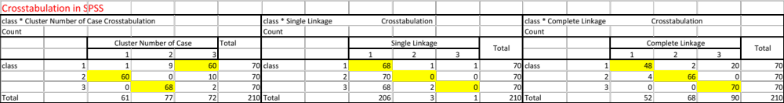

Recommendations:
According to the results my recommendation would be to proceed with (k=3) k-means clustering as it produces the purest within-class similarity for classification.
Problem 2 (25 points):
On the same data used in Problem 1, create a decision tree classification model for the three different varieties of wheat: Kama, Rosa and Canadian.
  - Use 10-fold cross validation and at least five different configurations to produce a decision tree classifier. Report the results obtained for the different configurations and chose one as being the best among the configurations you tried. Explain your answer. The tables below represent the 6 configurations I tried (with the criteria that was changed in green). The last configuration for with maximum tree depth = 25, Parent node minimum cases = 10, and Child node minimum cases = 5 is the best model compared to the other configurations. At that configuration is the point of improvement from the other previous configurations while also the percent correct does not improve as the parameters are decreased. [The appendix includes the tree diagrams and table calculations for all tested configurations]
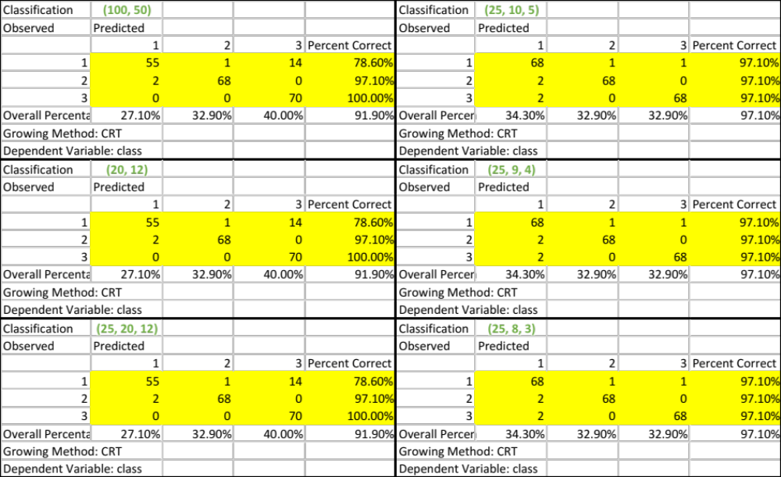
  - For the best tree configuration, report the misclassification matrix and interpret it. In your opinion, is accuracy a good way to interpret the performance of the model? If not, suggest other measures. For the misclassification table below the model configuration produces very pure within-class similarity – meaning there are very few misclassifications in the predicted space. Accuracy is a good way to interpret the model as the sample size is large, the class are evenly distributed and the cross-validation method is robust.
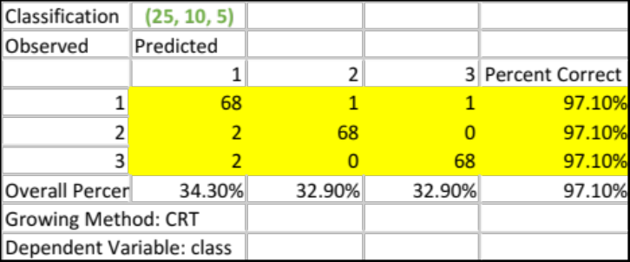

  - What are the most important three attributes for classifying the wheat data? The three most important variables for classifying the wheat data are: area, perimeter, and width of kernel as listed below in the table output.
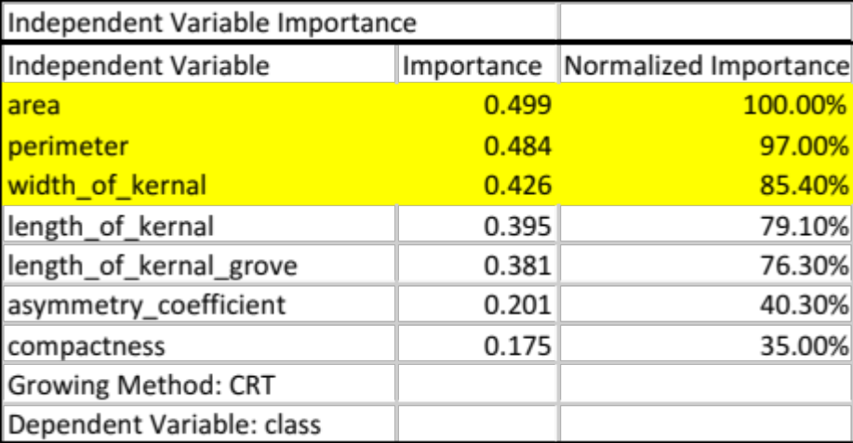
  - Create a graph that will allow you to visualize the data in the 3-dimensional space of the most important attributes. Interpret the graph.

  - Are there any other techniques that can help identify variables for data visualization? Explain your answer and include any analysis you will perform to answer this question.

Submission Instructions
- Solve the problems and write your answers in a Word document.
- Submit your file online at the website at http://d2l.depaul.edu in the Submission page
- Keep a copy of all your submissions!
- If you have questions about the homework, email me BEFORE the deadline.

