IS 467: Knowledge Discovery Technologies

SPSS® Tutorial

Tutorial Content

- Getting Started with SPSS
- Data preprocessing
Cleaning data

1 Getting Started
This tutorial is quick review of the basics features of SPSS Statistical Software. At the end of this tutorial you will be able to open an existing data file, perform data selection and transformation, use SPSS analytic tool and view result outputs.

In this section, I will guide you on the first steps of using SPSS application. Here is the list of tasks I will do in this section:
- Launch SPSS application
- Open an existing SPSS Data file
- Calculating Simple Statistics
- Viewing Result Output

1- Launching SPSS Application

The path to open SPSS Application is as follows:
Start>All Programs>Mathematics and Statistics > IBM Statistics 20
Once you launch the program the following window appears:

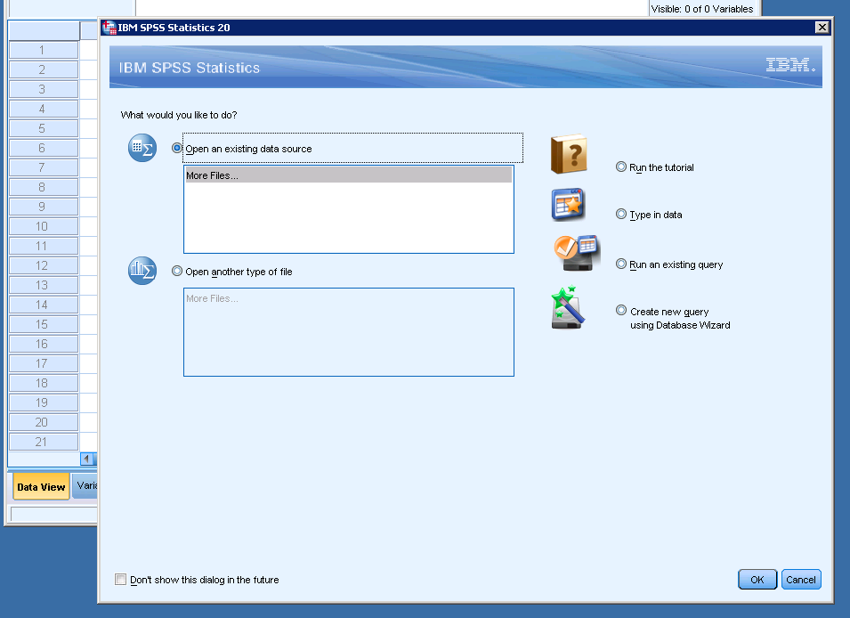v

Figure 1.1 SPSS Starting Window

Many options are available for opening SPSS:
- Run the tutorial: Very useful for learning more SPSS functionalities in a very attractive environment (very recommended).
- Type in data: Open a new data file in SPSS
- Run an existing query: You import data from a previous selection syntax
- Create a new query using Database Wizard: very powerful tool for importing data from any type of RDBMS using Microsoft ODBC (Open Database Connectivity)
- Open an existing data source: Open an existing SPSS data file (*.sav spss datafile extension)
- Open another type of file: Open other type of SPSS files (e.g. *.spo for SPSS output document)

2- Opening an existing SPSS data file
Choose “Open an existing data source”.

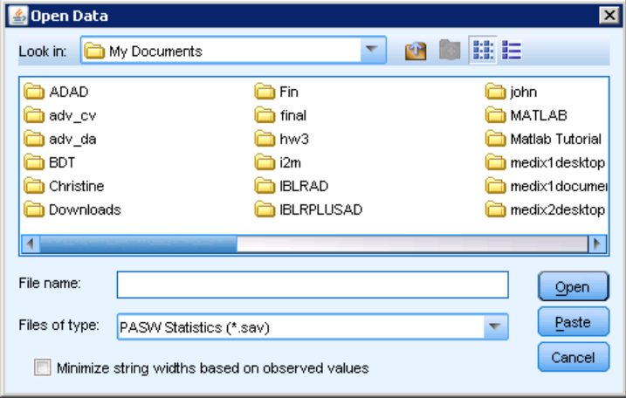
Figure 1.2 SPSS Open File Window

When you choose “open an existing data source” a window (figure 1.2) will appear. Navigate to C:\Program Files(x86)\IBM\SPSS\Statistics\20\Samples\English and select “Employee data” data file name and click on open

You will notice a window having similar environment as MS Excel. In the SPSS Data Editor window there are 2 different views (Figure 1.3):
- Data view : for visualizing the entire data set
- Variable view: for visualizing details concerning the variables.

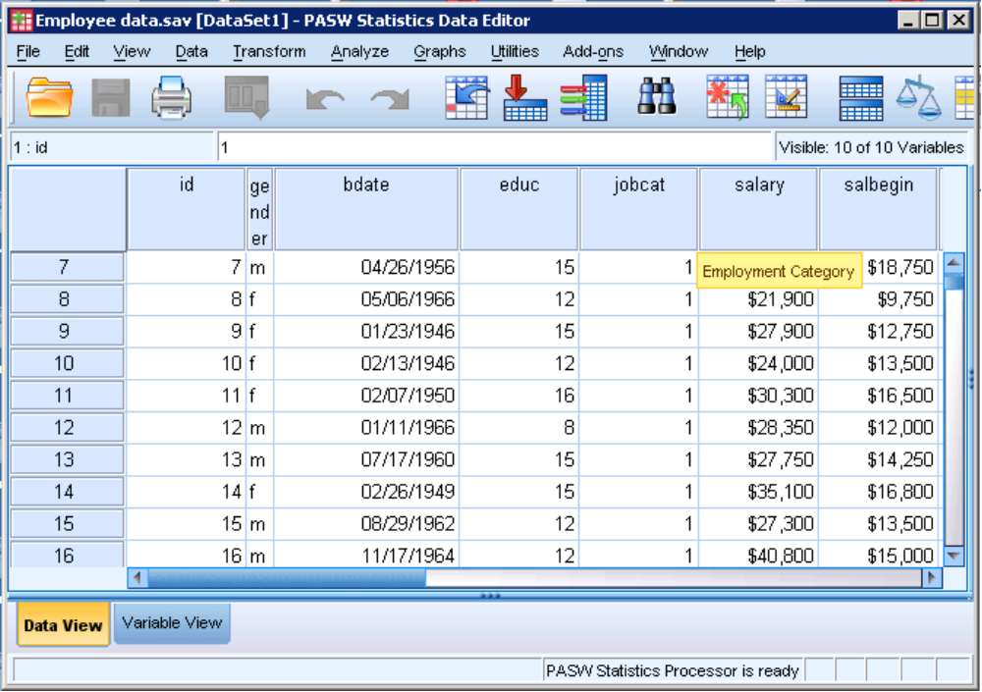
Variable view
Data view
Cases
Variables
Figure 1.3 SPSS Open Data Editor Window (Data View)

In the data view (figure 1.3) window the variables name are in the first row and each row represents one case. The missing values in a field is represented (by default) by “.” a dot.

In the variable view (figure 1.4) you can edit the characteristics of each variable: the most useful ones are:
- Name: this is should be unique and does not exceed 8 characters. (the first character of a variable name should be a letter”
- Type: determine the data type of the variable (you can choose from numeric, date, currency and string)
- Label: it is useful to specify the label of the variable for visualization
- Values: Here you specify the label of a given field value (e.g in case of “m” for gender you specify that it represent “male”)
- Missing: You specify which value to give for a missing value
- Measure: It is important to specify what kind of variable it is
  - Ordinal: the values of the variables are sorted (e.g level of satisfaction)
  - Nominal: the values of the variable are categorical (e.g gender)
  - Scale: the values of the variable are continue (e.g. salary)

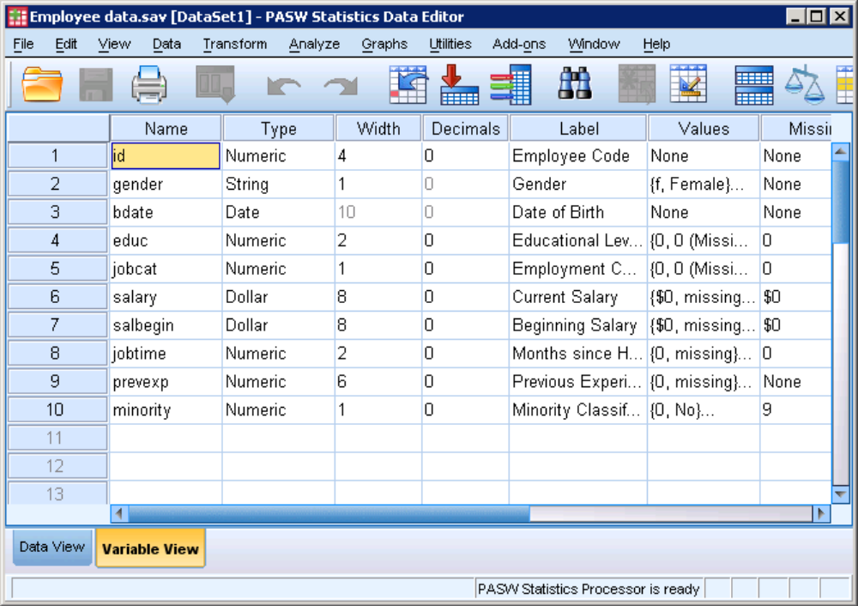
Figure 1.4 SPSS Open Data Editor Window (Variable View)

The menu bar of SPSS Data Editor is organized in the same way as the data mining process:
- File: It is used for opening/importing data from data files or databases
- Data: It is used for selecting and cleaning process
- Transform: It is used for calculating new values or transforming current values by applying logical statements.
- Analyze: It is used for applying statistical and data mining techniques and visualizing the outputs
- Graph: graphical visualization of data mining techniques.

For more information concerning the different tools available in each category, please use the help>tutorial.
After opening the SPSS data file, we will apply some statistical technique on the data and visualize the output result in the SPSS Output window.

3- Calculating Simple Statistics

The next logical step in the analysis is to apply statistical or data mining tools on the data. The “Analyze” menu in the menu bar is the best place for this purpose.
Click on “Analyze”
Select “descriptive Statistics”
Open “Frequencies…”

The opening window of “Frequencies” appears as shown in figure 1.5a.

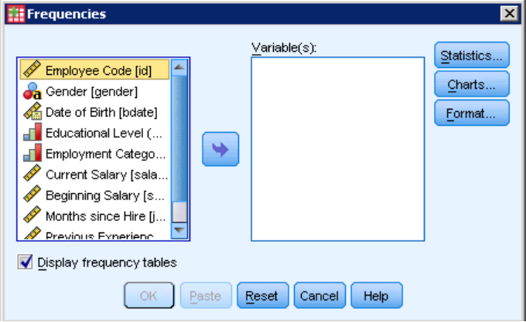
Move selected variable
List of Variables
Figure 1.5a SPSS Frequencies window

To select a variable from the variable list for analysis, click on the variable for selection then click on the move variable arrow button in the middle of the window (figure 1.5b). Then click on OK for viewing Frequency result of the Employment Category.

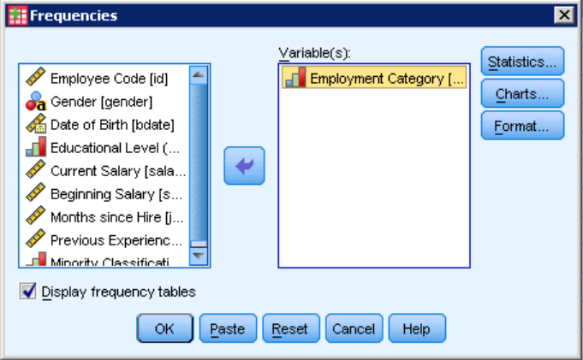
Figure 1.5b SPSS Frequencies window

4- Viewing SPSS Result Output

The SPSS Output window (figure 1.6) contains an outline and a content pane. You can click on an item in the outline pane to visualize it in the content pane.
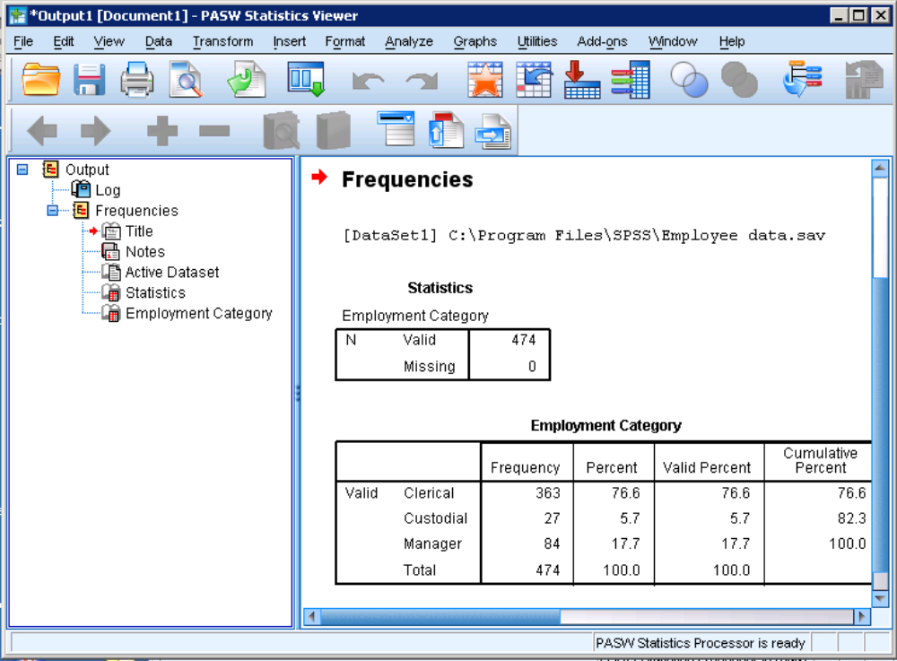
Outline Pane
Content Pane
Figure 1.6 SPSS Output window

In the SPSS Output window, you can export the results into other format (e.g html) or print them.

2 Cleaning and Preprocessing Data
1 - Outlier detection

SPSS allows user to detect outliers by converting all the scores for a variable to standard scores. The cases with absolute values of the standard scores greater than 2.5 (for datasets with 80 cases or less) or greater than 3.0 (for datasets with more than 80 cases) are potential outliers.
Click on “Analyze”
Select “descriptive Statistics”
Open “Descriptives…”

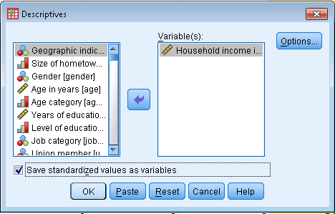
Figure 3.1 "Descriptives" window

Move the desired variable into “Variable(s)” window
Check “Save standardized values as variables” checkbox and hit OK.
New variable with prefix z will appear in the end of the list (Figure 3.2). Its marginal values available through sort ascending/descending option will determine the outlier candidates.
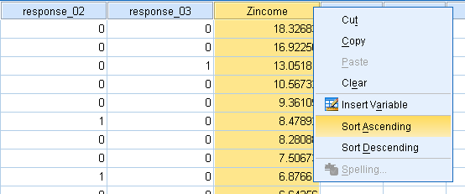
Figure 3.2 Standardized scores

2 – Filling in missing values
Click on “Transform”
Click on “Replace missing values”
In the opened window (Figure 3.3) move the desired variable to the New Variable(s) window, pick a name for a new variable that SPSS will create and chose the appropriate method for replacing the missing values in a new variable.
After it is completed hit OK.
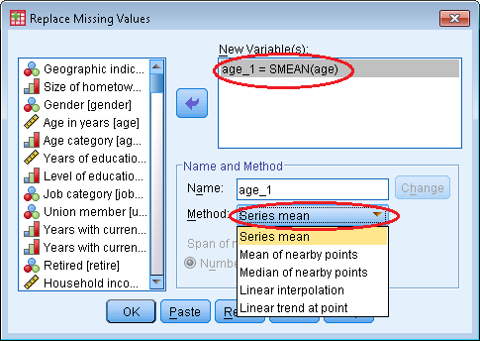
Figure 3.3 "Replace missing values" window

3 – Duplicate analysis
Click on “Data”
Click on “Identify Duplicate cases”
In opened window (Figure 3.4) move the variable whose values will define duplication into the “Define matching cases by:” window and the variable responsible for distinguishing between the duplicate and the original case into the “Sort within matching groups by” window.
Make sure that “Indicator of primary cases” checkbox is checked and hit OK.

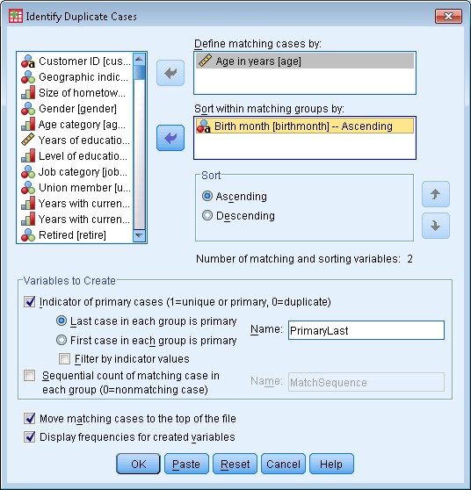
Figure 3.4 "Identify duplicate cases" window

SPSS will create a new variable in the end of the list (Figure 3.5) whose zero values will point out the duplicates in the dataset.

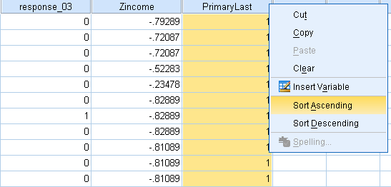
Figure 3.5 "Duplicate" variable

4 – Recoding variables (Binning)
Click on “Transform”
Click on “Recode into different variables”
In opened window (Figure 3.6) move the variable that you want to recode into “Numeric variable -> Output variable window” pick a name and label for the binned variable and click “Old and new values” button.

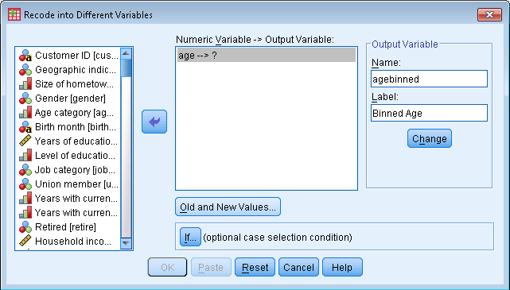
Figure 3.6 Recode window

In the new opened window (Figure 3.7) define the desired range pick a new value for that range and click Add. Repeat the procedure for all desired ranges and click Continue. Click Change and click OK.
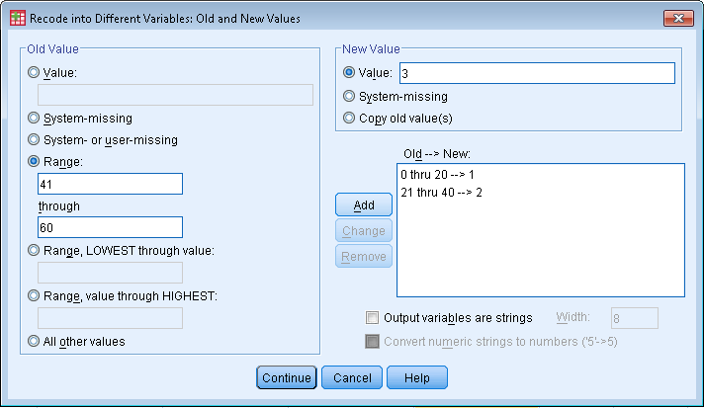
Figure 3.7 Recode window 2

5 – Computing variables
Click on “Transform”
Click on “Compute variable”
In the opened window define the name of new computed variable and its type and label. Type the equation in the “Numeric expression” window and hit OK button.

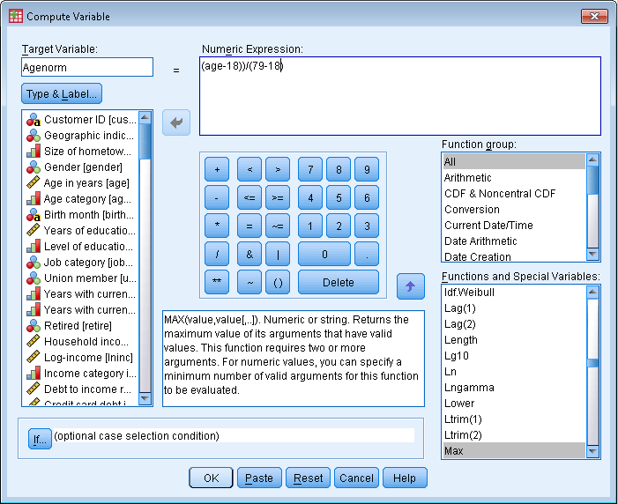
Figure 3.8 Compute window

6 – Integrating data
Having both datasets to be merged open, sort merging variable in both of them in ascending order and make sure that variable (again, in both datasets) does not have any duplicative values.
Click on “Data”
Point on “Merge files”
Click on “Add variables”
In the opened window (Figure 3.9) pick a name of the dataset that you want active dataset to be merged with and click continue.
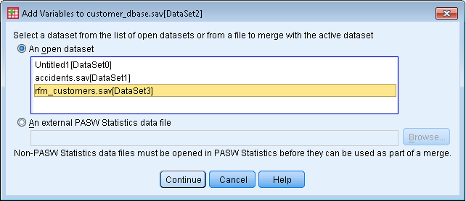
Figure 3.9 Merge Window

In the new opened window (Figure 3.10) select type of merging, move merging variable into the “Key Variables” window, edit the list of variables in new merged file in the “New active dataset” window and click OK button.

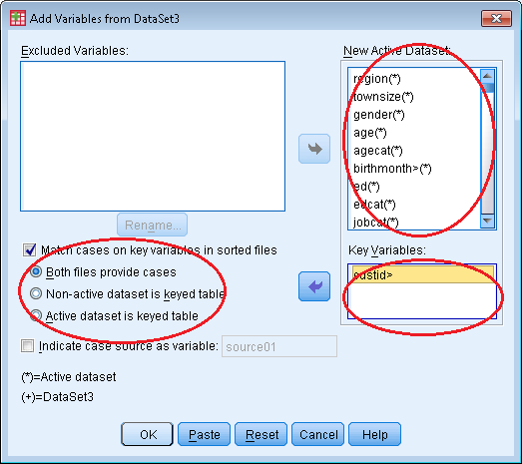
Figure 3.10 Merge window 2

