IS 467 – Knowledge Discovery Technologies
Homework 3
SPSS Print out
Descriptive Statistics
 | N | Minimum | Maximum | Mean | Std. Deviation
V1 | 300 | 0 | 1 | .28 | .451
V2 | 300 | 0 | 1 | .09 | .291
V3 | 300 | 0 | 1 | .27 | .446
V4 | 300 | 0 | 1 | .14 | .344
V5 | 300 | 0 | 1 | .69 | .462
V6 | 300 | 0 | 1 | .35 | .478
V7 | 300 | 0 | 1 | .33 | .470
V8 | 300 | 0 | 1 | .10 | .296
V9 | 300 | 0 | 1 | .38 | .485
V10 | 300 | 0 | 1 | .47 | .500
V11 | 300 | 0 | 1 | .73 | .445
V12 | 300 | 1 | 2 | 1.50 | .501
Valid N (listwise) | 300

Warnings
Gain summary Tables are not displayed because profits are undefined.
Target category gains tables are not displayed because target categories are undefined.

Model Summary
Specifications | Growing Method | CRT
Specifications | Dependent Variable | V12
Specifications | Independent Variables | V1, V2, V3, V4, V5, V6, V7, V8, V9, V10, V11
Specifications | Validation | Split Sample
Specifications | Maximum Tree Depth | 20
Specifications | Minimum Cases in Parent Node | 10
Specifications | Minimum Cases in Child Node | 5
Results | Independent Variables Included | V10, V7, V6, V1, V9, V11, V3, V5, V4, V8, V2
Results | Number of Nodes | 11
Results | Number of Terminal Nodes | 6
Results | Depth | 3

Training Sample

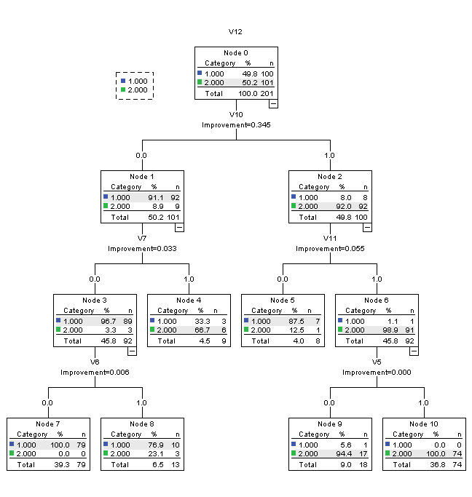

Test Sample

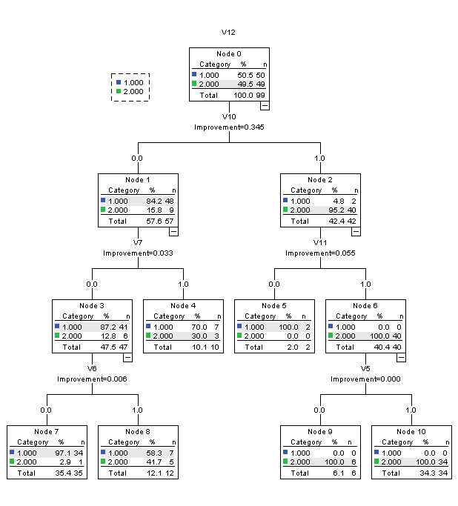

Risk
Sample | Estimate | Std. Error
Training | .040 | .014
Test | .131 | .034
Growing Method: CRT
Dependent Variable: V12

Classification
Sample | Observed | Predicted
Sample | Observed | 1 | 2 | Percent Correct
Training | 1 | 96 | 4 | 96.0%
Training | 2 | 4 | 97 | 96.0%
Training | Overall Percentage | 49.8% | 50.2% | 96.0%
Test | 1 | 43 | 7 | 86.0%
Test | 2 | 6 | 43 | 87.8%
Test | Overall Percentage | 49.5% | 50.5% | 86.9%
Growing Method: CRT
Dependent Variable: V12

