My Sql Programmes

1.b

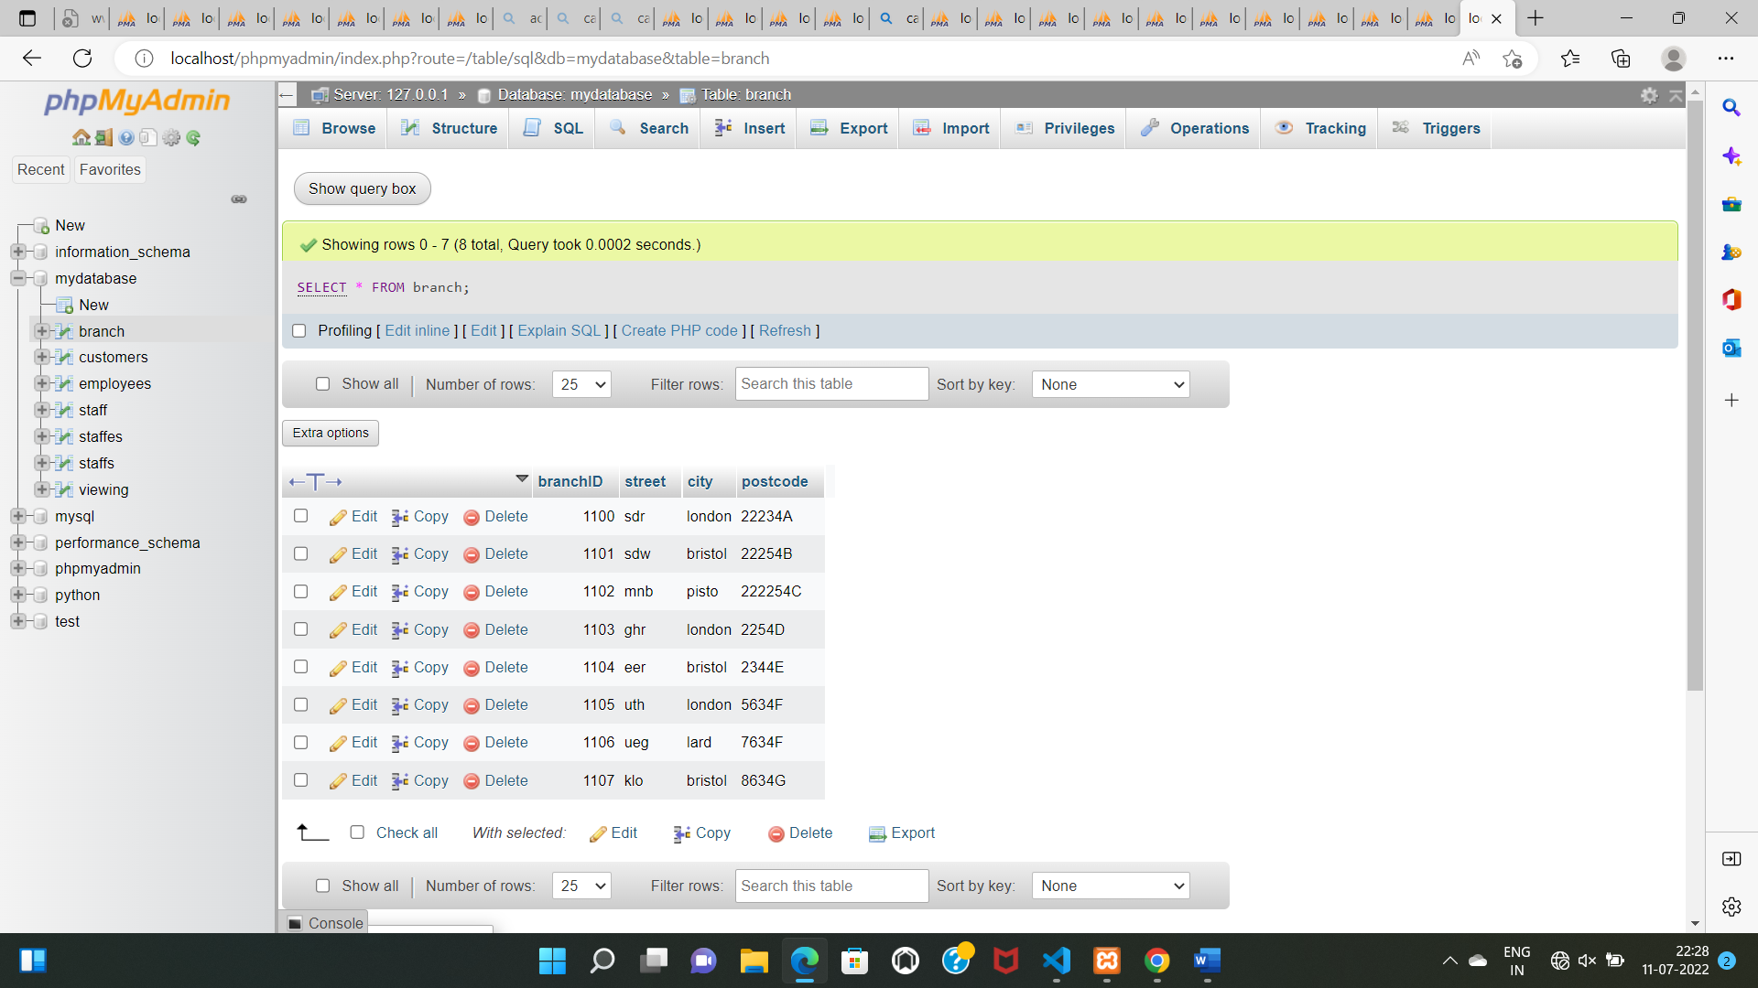

2.s

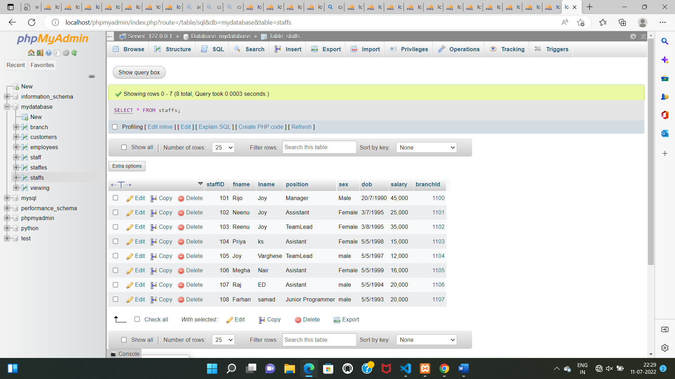

3.v

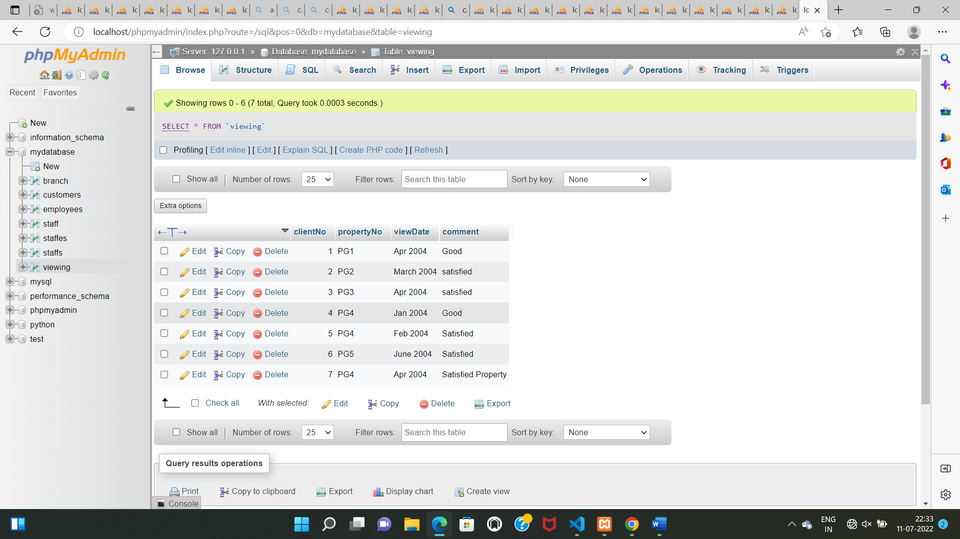

Queries and Answes

1. List The address of all branch offices in London And Bristol.