CPU & MEMORY

**Representation of Basic Information**

* The basic functional units of computer are made of electronics circuit and it works with electrical signal. We provide input to the computer in form of electrical signal and get the output in form of electrical signal
* Computer is a digital device, which works on two levels of signal. We say these two levels of signal as**High** and **Low**.
* To make it convenient for understanding, we use some logical value, say,   
                          **LOW (L)**   -   will represent    0V and   
                          **HIGH (H)**   -   will represent    5V   
   **0     means    LOW**  
  **1     means    HIGH**
* With the symbol 0 and 1, we have a mathematical system, which is knows as **binary number system**.
* Basically binary number system is used to represent the information and manipulation of information in computer. This information is basically strings of 0s and 1s.
* The smallest unit of information that is represented in computer is known as Bit ( Binary Digit ), which is either 0 or 1. Four bits together is known as **Nibble**, and Eight bits together is known as **Byte**.
* **Basic Computer Model and different units of Computer**

The model of a computer can be described by four basic units in high level abstraction which is shown in figure . These basic units are:

* + Central  Processor  Unit
  + Input  Unit
  + Output  Unit
  + Memory  Unit

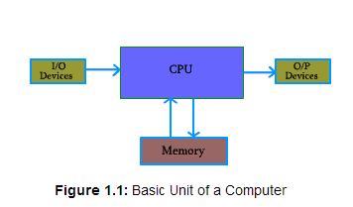

**Central Processor Unit (CPU) :**

* + Central processor unit consists of two basic blocks :
  + The program control unit has a set of registers and control circuit to generate control signals.
  + The execution unit or data processing unit contains a set of registers for storing data and an Arithmatic and Logic Unit (ALU) for execution of arithmatic and logical operations.
  + In addition, CPU may have some additional registers for temporary storage of data.

**Input Unit :**

* + With the help of input unit data from outside can be supplied to the computer. Program or data is read into main storage from input device or secondary storage under the control of CPU input instruction.
  + Example of input devices: Keyboard, Mouse, Hard disk, Floppy disk, CD-ROM drive etc.

**Output  Unit :**

* + With the help of output unit computer results can be provided to the user or it can be stored in stograge device permanently for future use. Output data from main storage go to output device under the control of CPU output instructions.
  + Example of output devices: Printer, Monitor, Plotter, Hard Disk, Floppy Disk etc.

**Memory Unit :**

* + Memory unit is used to store the data and program. CPU can work with the information stored in memory unit. This memory unit is termed as primary memory or main memory module. These are basically semi conductor memories.
  + There ate two types of semiconductor memories -
  + **Volatile Memory          :** RAM (Random Access Memory).
  + **Non-Volatile Memory :** ROM (Read only Memory),  PROM (Programmable ROM)  
                                   EPROM (Erasable PROM),  EEPROM (Electrically Erasable                                 PROM).
  + **Secondary Memory :**
    - There is another kind of storage device, apart from primary or main memory, which is known as secondary memory. **Secondary memories are non volatile memory** and it is used for permanent storage of data and program.
    - Example of secondary memories:
    - Hard Disk,  Floppy Disk,  Magenetic Tape------ These are magnetic devices,
    - CD-ROM------ is optical device
    - Thumb drive (or pen drive)------ is semiconductor memory.
    - Buses:
      * A bus is simply a common parallel path over which information is transferred from any of several sources to any of several destinations.
      * The bits are transferred simultaniously over a set of parallel lines.

**Instructions**

* + We need some instruction to work with the computer.

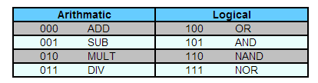

Apart from the instruction needed to perform task inside CPU, we need some more instructions for data transfer from main memory to CPU and vice versa.

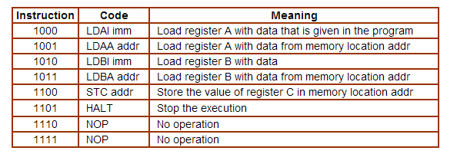

In our hypothetical machine, we use three signal lines to identify a particular instruction.

LDAI 5

LDBI 7

ADD A,B

STC

HALT

1000 0101

1001 0111

0000

1100 1111

1101

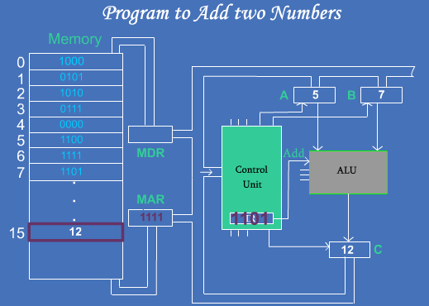

CPU

* + The Central Processing unit is the brain of the computer
  + The operation or task that must perform by CPU are:
  + **Fetch Instruction:** The CPU reads an instruction from memory.
  + **Interpret Instruction:** The instruction is decoded to determine what action is required.
  + **Fetch Data:** The execution of an instruction may require reading data from memory or I/O module.
  + **Process data:** The execution of an instruction may require performing some arithmatic or logical operation on data.
  + **Write data:** The result of an execution may require writing data to memory or an I/O module.
  + To do these tasks, it should be clear that the CPU needs to store some data temporarily.
  + It must remember the location of the last instruction so that it can know where to get the next instruction. It needs to store instructions and data temporarily while an instruction is being executed. In other words, the CPU needs a small internal memory. These storage location are generally referred as **registers.**
  + The major components of the CPU are an arithmatic and logic unit (ALU) and a control unit (CU). The ALU does the actual computation or processing of data. The CU controls the movement of data and instruction into and out of the CPU and controls the operation of the ALU.
  + The CPU is connected to the rest of the system through system bus. Through system bus, data or information gets transferred between the CPU and the other component of the system.
  + A bus is a communication pathway connecting two or moe devices
  + A key characteristic of bus is that is a shared transmission medium
  + Only two devices can actively use the bus at any given instant.
  + A bus actually consist of multiple communication lines,each line is capable of transmitting signal representing binary 1 and binary 0.
  + The system bus may have three components:
    - **Data Bus:**   
      Data bus is used to transfer the data between main memory and CPU.

The data bus typically consist of 8,16,32 separate lines.

* + - **Address Bus:**   
      Address bus is used to access a particular memory location by putting the address of the memory location.

For example if the CPU wishes to read read a word of data from memory, it it puts the address of the desired word on the address lines.

The addess lines also used to address I/O ports.

* + - **Control Bus:**   
      Control bus is used to provide the different control signal generated by CPU to different part of the system. As for example, memory read is a signal generated by CPU to indicate that a memory read operation has to be performed. Through control bus this signal is transferred to memory module to indicate the required operation.

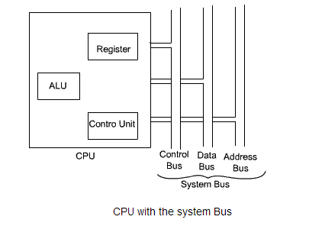

**Registers**

* + Special memory units ,called registers are used to hold information on a temperary basis as the instructions are interpredted and executed by CPU.
  + Registors are part of CPU (not main memory) of a computer
  + The length of a register,sometimes called word size ,equals the number of bits it can store.
  + With all oparameters being the same , a CPU with 32- bit regoister can process data twice larger than with 16- bit register

**Functions of commonly used registers:**

* + **Memory Address Register(MAR):**
    - It holds the address of the active memory location.
    - It is loaded from program control register when the system reads the instruction from the memory.
  + **Memory Buffer Register(MBR):**
    - It holds the address of the accessed memory word.
    - The system transfers an instruction word placed in this register to instruction register.
    - A data word placed in this register accessible for operation with accumulator register or transfer to I?O register.To store a word in memory location ,the system transfers it to MBR and then writes it in memory from MBR.
  + **Program Control Register(PC):**
    - It holds the address of next instruction for execution.
    - Normally a system stores instruction of a program in consecutive memory location and executes them in sequence unless it encounters a branch instruction.
    - The system transfers the address part of the branch instruction to the PC n that case.
  + **Program Control Register(PC):**
    - It holds the address of next instruction for execution.
    - Normally a system stores instruction of a program in consecutive memory location and executes them in sequence unless it encounters a branch instruction.
  + **Accumulator Register(A):**
    - It holds the data on which the system has to operate , intermediate instructions and results of operations performed.
    - The system uses it during the execution of most of the instructions.
    - From A the results are transferred to the main memory through MBR
  + **Instruction Register(I):**
    - It holds the current instruction under execution.
    - As soon as the instruction is placed on the IR ,its operation and address part are seperated and address part is send to MAR and the operation part is decoded and interpreted by control unit.
  + **Input/Output Register(I/O):**
    - The system uses it to communicate with I/O devices.
* **Arithmetic and logic Unit (ALU)**
  + ALU is responsible to perform the operation in the computer.
  + The basic operations are implemented in hardware level.  ALU is having collection of two types of operations:
    - Arithmetic operations
    - Logical operations
  + Consider an ALU having 4 arithmetic operations and 4 logical operation.
  + To identify any one of these four logical operations or four arithmetic operations, two control lines are needed. Also to identify the any one of these two groups- arithmetic or logical, another control line is needed. So, with the help of three control lines, any one of these eight operations can be identified.
  + Consider an ALU is having four arithmetic operations. Addition, subtraction, multiplication and division. Also consider that the ALU is having four logical operations: OR, AND, NOT & EX-OR.
* 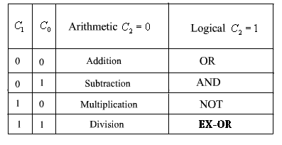
* 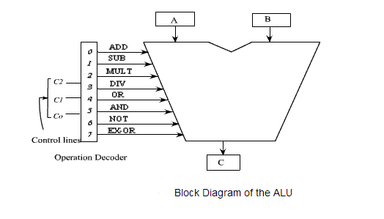

**Control Unit**

* + To execute an instruction, the control unit of the CPU must generate the required control signal in the proper sequence.
  + The control unit performs two basic tasks
  + Sequencing:Control Unit causes the CPU to step through a series of micro-operations in proper sequence,based on the instruction being executed.
  + Execution :The control unit causes each micro-operation to be performed.

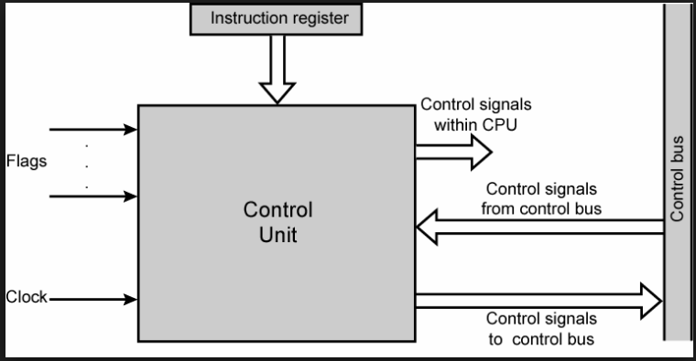

**The inputs are:**

* + Clock:
    - This is how the control unit “keeps time “.
    - the control unit causes one micro-operation or a set of micro-operations to be performed for each clock pulse.
    - Instruction Register: The opcode of the current instruction is used to determine which micro-operations to be performed during the execute cycle.
  + Flags:
    - These are needed by the control unit to determine the status of CPU and outcome of the previous ALU operations.
    - Control signals from control bus: The control bus portion of the system bus provides signal to the control unit,such as interrupt signal.

**The outputs are:**

* + - Control signal within the CPU:
    - The control signals that cause data to be moved from one register to another.
    - The control signals that activate specific ALU functions.
    - Control signal to the control bus:
    - The control. Signals to memory
    - The control signals to I/O modules.

To generate the control signal in proper sequence, a wide variety of techniques exist. Most of these techniques, howeve, fall into one of the two categories,

* **Hardwired Control**
* **Microprogrammed Control.**
* **Hardwired Control**
  + - In this hardwired control techniques, the control signals are generated by means of hardwired circuit. The main objective of control unit is to generate the control signal in proper sequence.
    - The hardwired approach uses a sequential logic to generate control signals in response to the supplied instruction.
    - The general structure is as follows:-
    - required control signals are uniquely determined by the following information:
    - Contents of the control counter.
    - Contents of the instruction register.
    - Contents of the condition code and other status flags.

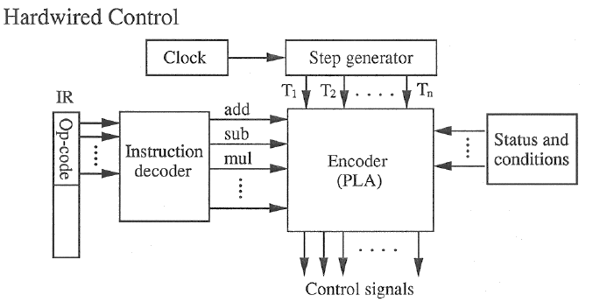

* In the above diagram the output of the instruction decoder consist of a separate line for each machine instruction.
* It is required to generate many control signals by the control unit.
* These are basically coming out from the encoder circuit of the control signal generator.
* The control signals are: *PCin*, *PCout*,  *Zin*, *Zout*, *MARin*, *ADD*, *END*, etc.

**Control sequence for an add instruction.**

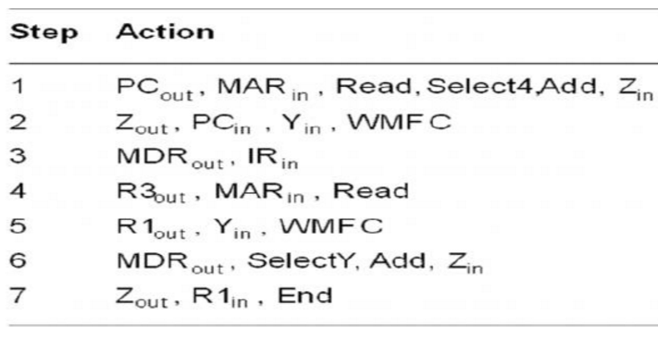

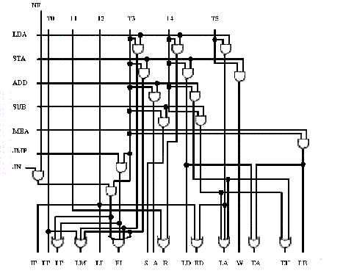

* In the above diagram output step generator provides separate signal for each micro operations in the given sequence for a particular machine instruction.
* Hardwired Control unit is the best approach when speed important.
* But difficult to design and varify.
* Inherently inflexible in the sense that changes to correct design errors or update the instruction set,reqire that control unit be redesigned.
* Complex sequencing & micro-operation logic
* Difficult to design and test
* Inflexible design
* Difficult to add new instructions

**Microprogrammed Control**

Micro programmed Control: II

In the previous discussion, to design a micro programmed control unit, we here to do the following:

* For each instruction of the CPU, we have to write a microprogram to generate the control signal. The microprograms are stored in microprogram memory (control store). The starting address of each microprogram are known to the designer
* Each microprogram is the sequence of microintructions. And these microinstructions are executed in sequence. The execution sequence is maintained by microprogram counter.
* Each microinstructions are nothing but the combination of 0’s and 1’s which is

known as control word.

* Each position of control word specifies a particular control signal. O on the control word means that a low signal value is generated for that control signal at that particular instant of time, similarly 1 indicates a high signal.

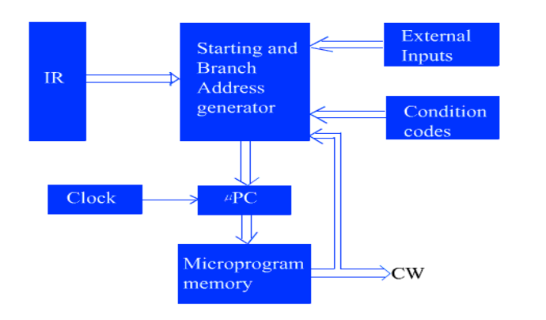

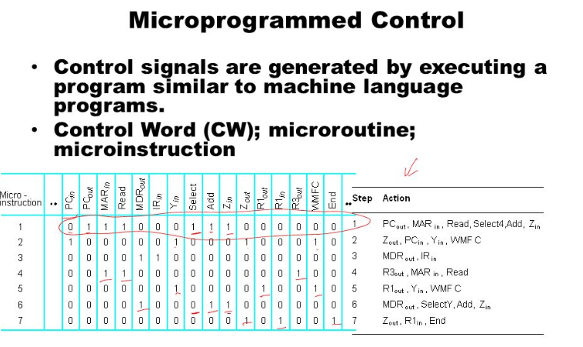

* Since each machine instruction is executed by a corresponding micro routine, it follows that a starting address for the micro routine must be specified as a function of the contents of the instruction register (IR).
* To incorporate the branching instruction, i.e., the branching within the microprogram, a branch address generator unit must be included. Both unconditional and conditional branching can be achieved with the help of microprogram. To incorporate the conditional branching instruction, it is required to check the contents of condition code and status flag.

Microprogramed controlled control unit is very much similar to CPU. In CPU the PC is used to fetch instruction from the main memory, but in case of control unit, microprogram counter is used to fetch the instruction from control store.

* Microprogramming provides a systematic, simple, flexible and relatively inexpensive method of Control Unit design,since the control function can easily be changed by changing the stored microprogram.
* Microprogrammed control unit is more costly and slow.

Memory:

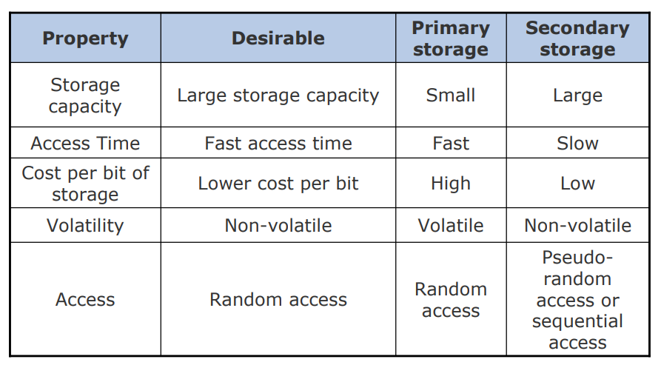

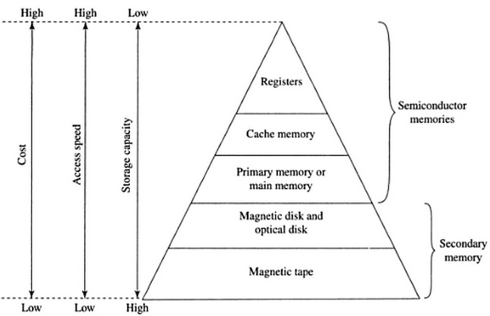

**Semiconductor Memory**

Semiconductor memories are categorized as volatile memory and non-volatile memory.

* + **RAM:**Random Access Memories are **volatile** in nature. As soon as the computer is switched off, the contents of memory are also lost.

RAM(Random Access Memory) is the internal memory of the CPU for storing data, program and program result. It is read/write memory which stores data until the machine is working. As soon as the machine is switched off, data is erased.

* + **ROM:**Read only memories are **non volatile** in nature. The storage is permanent, but it is read only memory. We can not store new information in ROM.
* The permanent information are kept in ROM and the user space is basically in RAM.
* The smallest unit of information is known as bit (binary digit), and in one memory cell we can store one bit of information. 8 bit together is termed as a byte.
* The maximum size of main memory that can be used in any computer is determined by the addressing scheme.
* A computer that generates 16-bit address is capable of addressing upto 216  which is equal to 64K memory location. Similarly, for 32 bit addresses, the total capacity will be 232 which is equal to 4G memory location.

**Binary Storage Cell:**

* The binary storage cell is the basic building block of a memory unit.
* The storage cells are made up of **flip-flops** fabricated with **transistors**.
* By appropriate variation in the interconnection of binary cells it is possible to organise different types of memory.
* This interconnection of cell is called register.
* A group of registers may be interconnected to form a memory.

A single Binary Cell :

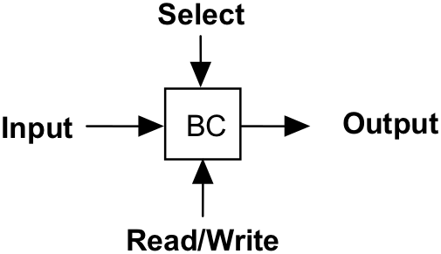

* 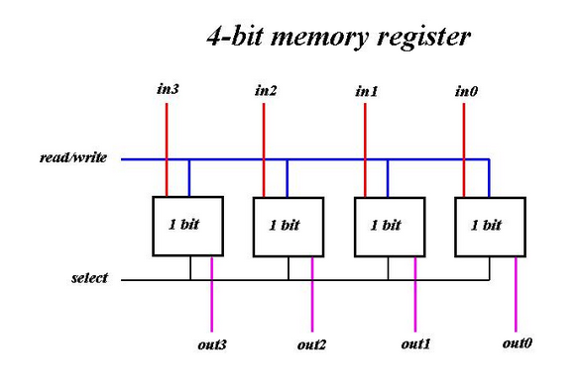

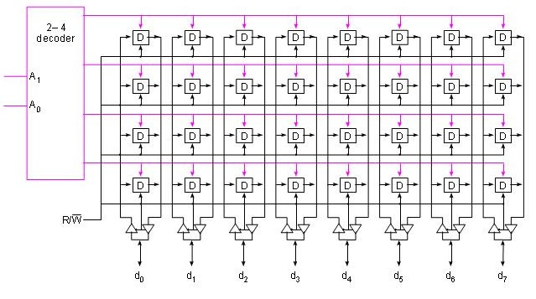

* The two basic types of semi conductor memory used in computer are:-
  + **RAM :** Random access memory; which is volatile in nature.   
    **ROM :** Read only memory; which is non-volatile.

**RAM**

* + RAM possesses Random Access property.
  + Ram is volatile
  + The basic storage cells are made up of **flip-flops** fabricated with **transistors**.RAM is an array of these
    - storage cells as many flip-flops as the bit storage capacity of RAM which is usually a large number.
  + RAMs are manufactured using Bipolar technology where speed is the concern.
  + But MOS technology is the preferred because it consumes less power and it has high packing density.
  + **The storage cell do not exactly matches with a stand alone starage flip flop circuit,but it is close to SR-latch.It requires additional circuitry also.**
  + **Static RAM**
* The word **static** indicates that the memory retains its contents as long as power is being supplied. However, data is lost when the power gets down due to volatile nature.
* SRAM chips use a matrix of 6-transistors and no capacitors. Transistors do not require power to prevent leakage, so SRAM need not have to be refreshed on a regular basis.
* Because of the extra space in the matrix, SRAM uses more chips than DRAM for the same amount of storage space, thus making the manufacturing costs higher. So SRAM is used as cache memory and has very fast access.
  + - In an SRAM, binary values are stored using traditional flip-flop constructed with the help of transistors.
    - A static RAM will hold its data as long as power is supplied to it.

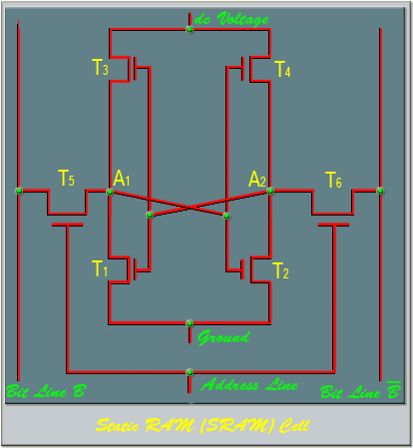

* + - Four transistors (T1, T2, T3, T4) are cross connected in an arrangement that produces a stable logic state.   
      In logic state 1, point A1 is high and point A2 is low; in this state T1 and T4 are off, and T2 and T3 are on .  
      In logic state 0, point A1 is low and point A2 is high; in this state T1 and T4 are on, and T2 and T3 are off .   
      Both states are stable as long as the dc supply voltage is applied.
    - The address line is used to open or close a switch which is nothing but another transistor. The address line controls two transistors(T5 and T6).   
      When a signal is applied to this line, the two transistors are switched on, allowing a read or write operation.   
      For a write operation, the desired bit value is applied to line B, and its complement is applied to line . This forces the four transistors(T1, T2, T3, T4) into the proper state.
    - For a read operation, the bit value is read from the line B. When a signal is applied to the address line, the signal of point A1 is available in the bit line B.
* It has long life
* There is no need to refresh
* Faster
* Used as cache memory
* Large size
* Expensive
* High power consumption

**DRAM**

**A DRAM is made with cells that store data as charge on capacitors.**

* + The presence or absence of charge in a capacitor is interpreted as binary 1 or 0.
  + Because capacitors have a natural tendency to discharge due to leakage current, dynamic RAM require periodic charge refreshing to maintain data storage.
  + The term dynamic refers to this tendency of the stored charge to leak away, even with power continuously applied.

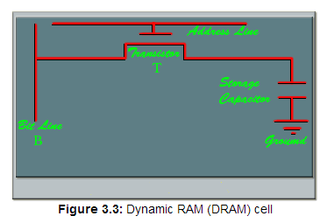

* + For the write operation, a voltage signal is applied to the bit line B, a high voltage represents 1 and a low voltage represents 0. A signal is then applied to the address line, which will turn on the transistor T, allowing a charge to be transferred to the capacitor.
  + For the read operation, when a signal is applied to the address line, the transistor T turns on and the charge stored on the capacitor is fed out onto the bit line B and to a sense amplifier.
  + The sense amplifier compares the capacitor voltage to a reference value and determines if the cell contains a logic 1 or a logic 0.
  + The read out from the cell discharges the capacitor, widh must be restored to complete the read operation.
  + Due to the discharge of the capacitor during read operation, the read operation of DRAM is termed as destructive read out
* It has short data lifetime
* Need to be refreshed continuously
* Slower as compared to SRAM
* Used as RAM
* Lesser in size
* Less expensive
* Less power consumption

**SRAM Versus DRAM :**

* Both static and dynamic RAMs are volatile, that is, it will retain the information as long as power supply is applied.
* A dynamic memory cell is simpler and smaller than a static memory cell. Thus a DRAM is more dense,   
  i.e., packing density is high(more cell per unit area). DRAM is less expensive than corresponding SRAM.
* DRAM requires the supporting refresh circuitry. For larger memories, the fixed cost of the refresh circuitry is more than compensated for by the less cost of DRAM cells
* SRAM cells are generally faster than the DRAM cells. Therefore, to construct faster memory modules(like cache memory) SRAM is used.

AM(Random Access Memory) is the internal memory of the CPU for storing data, program and program result. It is read/write memory which stores data until the machine is working. As soon as the machine is switched off, data is erased.

Access time in RAM is independent of the address that is, each storage location inside the memory is as easy to reach as other locations and takes the same amount of time. Data in the RAM can be accessed randomly but it is very expensive.

RAM is volatile, i.e. data stored in it is lost when we switch off the computer or if there is a power failure. Hence a backup uninterruptible power system(UPS) is often used with computers. RAM is small, both in terms of its physical size and in the amount of data it can hold.

RAM is of two types

* Static RAM (SRAM)
* Dynamic RAM (DRAM)

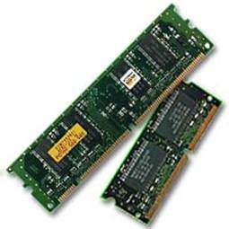

Static RAM (SRAM)

The word **static** indicates that the memory retains its contents as long as power is being supplied. However, data is lost when the power gets down due to volatile nature. SRAM chips use a matrix of 6-transistors and no capacitors. Transistors do not require power to prevent leakage, so SRAM need not have to be refreshed on a regular basis.

Because of the extra space in the matrix, SRAM uses more chips than DRAM for the same amount of storage space, thus making the manufacturing costs higher. So SRAM is used as cache memory and has very fast access.

Characteristic of the Static RAM

* It has long life
* There is no need to refresh
* Faster
* Used as cache memory
* Large size
* Expensive
* High power consumption

Dynamic RAM (DRAM)

DRAM, unlike SRAM, must be continually **refreshed** in order to maintain the data. This is done by placing the memory on a refresh circuit that rewrites the data several hundred times per second. DRAM is used for most system memory because it is cheap and small. All DRAMs are made up of memory cells which are composed of one capacitor and one transistor.

Characteristics of the Dynamic RAM

* It has short data lifetime
* Need to be refreshed continuously
* Slower as compared to SRAM
* Used as RAM
* Lesser in size
* Less expensive
* Less power consumption

ROM

ROM stands for Read Only Memory. The memory from which we can only read but cannot write on it. This type of memory is non-volatile. The information is stored permanently in such memories during manufacture. A ROM, stores such instructions that are required to start a computer. This operation is referred to as bootstrap. ROM chips are not only used in the computer but also in other electronic items like washing machine and microwave oven.

* MROM (Masked ROM)
* PROM: Programmable Read Only Memory; it can be programmed once as per user requirements.
* EPROM: Erasable Programmable Read Only Memory; the contents of the memory can be erased and store new data into the memory. In this case, we have to erase whole information.
* EEPROM: Electrically Erasable Programmable Read Only Memory; in this type of memory the contents of a particular location can be changed without effecting the contents of other location.

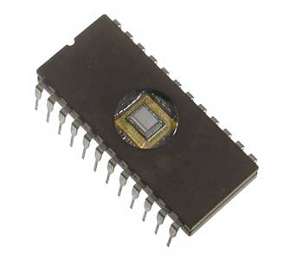

Following are the various types of ROM

ROM chips contain a grid of rows and columns to turn ON or OFF. It uses a diode to connect the lines if the value is 1. If the value is 0, then these lines are not connected at all. Each element of the array corresponds to one storage element in the memory chip.

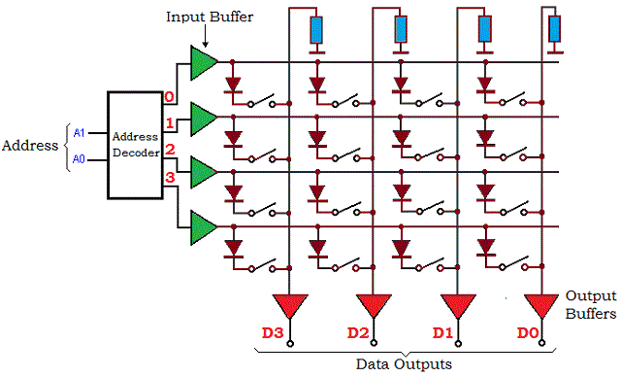

MROM (Masked ROM)

The very first ROMs were hard-wired devices that contained a pre-programmed set of data or instructions. These kind of ROMs are known as masked ROMs which are inexpensive.

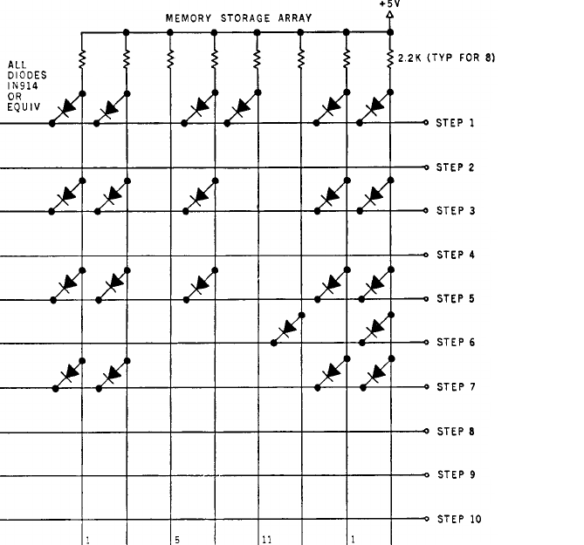

PROM (Programmable Read only Memory)

PROM is read-only memory that can be modified only once by a user. The user buys a blank PROM and enters the desired contents using a PROM program. Inside the PROM chip there are small fuses which are burnt open during programming. It can be programmed only once and is not erasable.

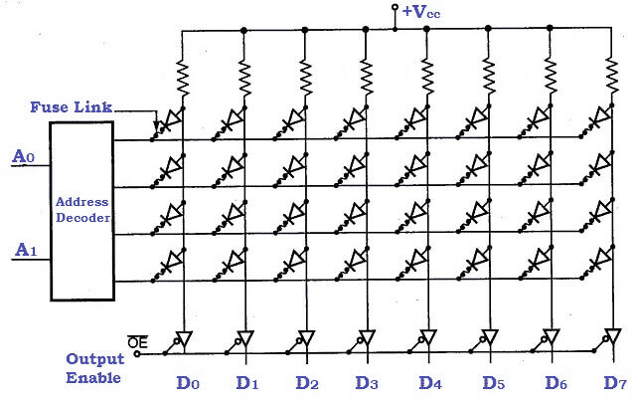

EPROM(Erasable and Programmable Read Only Memory)

The EPROM can be erased by exposing it to ultra-violet light for a duration of up to 40 minutes. Usually, an EPROM eraser achieves this function. During programming, an electrical charge is trapped in an insulated gate region. The charge is retained for more than ten years because the charge has no leakage path. For erasing this charge, ultra-violet light is passed through a quartz crystal window(lid). This exposure to ultra-violet light dissipates the charge. During normal use the quartz lid is sealed with a sticker.

EEPROM(Electrically Erasable and Programmable Read Only Memory)

The EEPROM is programmed and erased electrically. It can be erased and reprogrammed about ten thousand times. Both erasing and programming take about 4 to 10 ms (milli second). In EEPROM, any location can be selectively erased and programmed. EEPROMs can be erased one byte at a time, rather than erasing the entire chip. Hence, the process of re-programming is flexible but slow.

Advantages of ROM

The advantages of ROM are as follows:

* Non-volatile in nature
* These cannot be accidentally changed
* Cheaper than RAMs
* Easy to test
* More reliable than RAMs
* These are static and do not require refreshing
* Its contents are always known and can be verified

EEPROM vs Flash

Flash is a very popular term when it comes to storage media as it is used by portable devices like phones, tablets, and media players. Flash actually is an offspring of EEPROM, which stands for Electrically Erasable Programmable Read-Only Memory. The main difference between EEPROM and Flash is the type of logic gates that they use. While EEPROM uses the faster NOR (a combination of Not and OR), Flash uses the slower NAND (Not and AND) type. The NOR type is a lot faster than the NAND type but there is the matter of affordability as the former is significantly more expensive than the NAND type.

Another advantage of EEPROM over Flash is in how you can access and erase the stored data. EEPROM can access and erase the data byte-wise or a byte at a time. In comparison, Flash can only do so block-wise. In order to simplify the whole thing, individual bytes are grouped into a smaller number of blocks, which can have thousands of bytes in each block. This is a bit problematic when you only want to read or write to a single byte at a time; which is what’s typically needed in executing the code of a program. This is a reason why Flash cannot be used in electronic circuits that require byte-wise access to data.

EEPROM was designed to be read a lot more than it is written. This is in-line with programming for electronic circuits where you write to the chip a number of times while testing the program. Then, it is stored for good, only to be read every time the data is needed. This is not very suitable for storage media where data is routinely written and read.

In typical use, Flash is used mainly to refer to storage media and can range anywhere from a GB to hundreds of GB. In contrast, EEPROM is usually reserved for permanent code storage in electronic chips. Typical values range from kilobytes to a couple of megabytes.

Summary:

1.Flash is just one type of EEPROM

2.Flash uses NAND type memory while EEPROM uses NOR type

3.Flash is block-wise erasable while EEPROM is byte-wise erasable

4.Flash is constantly rewritten while other EEPROMs are seldom rewritten

5.Flash is when large amounts are needed while EEPROM is used when only small amounts are needed

Read more: Difference Between EEPROM and Flash | Difference Between http://www.differencebetween.net/technology/hardware-technology/difference-between-eeprom-and-flash/#ixzz4w1LEjgUI